Valuation Report of the Immovable Property

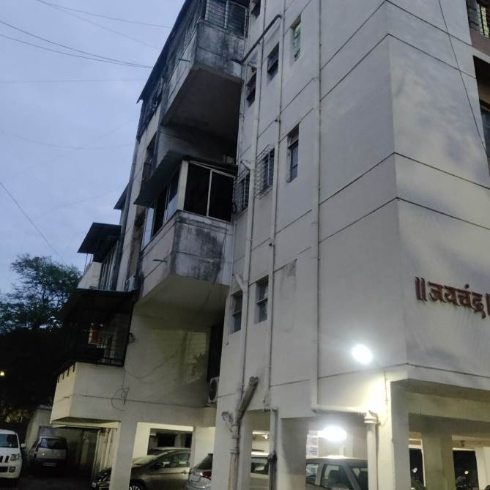

Details of the property under consideration:

Name of Owner: Mr. Vikas Dattatray Dangat

Residential Flat No. 2, Stilt Floor, “Jaychandra Co-op. Hsg. Soc. Ltd.”, Bavdhan Khurd Pune,
Taluka - Mulshi, Pune – 411021, State - Maharashtra, Country – India.

Longitude Latitude: 18°30’51.4”N 73°46’48.2”E

Valuation Done for:

Union Bank of India
SAMB Fort Branch
Bharat House, Ground floor, 104, M. S. Marg, Fort, Mumbai - 400001,
State - Maharashtra, Country - India

Vastu/Mumbai/06/2023/31767/2300955
05/19-63-SKVU Date: 05.06.2023

VALUATION OPINION REPORT

This is to certify that the property bearing Residential Flat No. 2, Stilt Floor, “Jaychandra Co-op. Hsg. Soc. Ltd.”, Bavdhan Khurd Pune, Taluka - Mulshi, Pune – 411021, State - Maharashtra, Country – India belongs to Mr. Vikas Dattatray Dangat.

Boundaries of the property.

North | : | Sagar CHSL
South | : | Garden
East | : | Open Plot
West | : | Lane 4B Road
Considering various parameters recorded, existing economic scenario, and the information that is available with reference to the development of neighborhood and method selected for valuation, we are of the opinion that, the property premises can be assessed and valued for SARFAESI Securitisation and Reconstruction of Financial Assets and Enforcement of Security Interest Act, 2002 purpose at ` 42,04,746.00 (Rupees Forty Two Lakh Four Thousand Seven Hundred Forty Six Only).

The valuation of the property is based on the documents produced by the concern. Legal aspects have not been taken into considerations while preparing this valuation report.

Hence certified

Sharadkumar B. Chalikwar
Govt. Reg. Valuer
Chartered Engineer (India)
Reg. No. (N) CCIT/1-14/52/2008-09
Encl: Valuation report.

Vastukala Consultants (I) Pvt. Ltd.
121, 1st Floor, Ackruti Star, Central Road, MIDC, Andheri (E), Mumbai - 400 093

To,
The Branch Manager,
Union Bank of India
SAMB – Fort Branch
Bharat House, Ground Floor, 104, M. S. Marg, Fort,
Mumbai - 400001, State - Maharashtra, Country - India
VALUATION REPORT (IN RESPECT OF FLAT)
I | General
1. | Purpose for which the valuation is made |  |  | : | As per the request from Union Bank of India, SAMB Fort Branch to assess fair market value of the property for SARFAESI Securitisation and Reconstruction of Financial Assets and Enforcement of Security Interest Act, 2002 purpose
2. | a) |  | Date of inspection | : | 14.12.2022
 | b) |  | Date on which the valuation is made | : | 05.06.2023
3. | List of documents produced for perusal:  - Copy of Agreement for Sale dated 07.01.2000.  - Copy of Occupancy Certificate No. BCO / 54 / 6 / 42 dated 17.04.2002 issued by Pune Municipal Corporation (Final Document received on 01.06.2023).  - Copy of Commencement Certificate No. 2004 dated 05.12.1998 issued by Pune Municipal Corporation.  - Copy of Share Certificate No. 002 dated 01.07.2002 in the name of Mr. Vikas Dattatray Dangat issued by Jaychandra Co-op. Hsg. Soc. Ltd.
4. | Name of the owner(s) and his / their address (es) with Phone no. (details of share of each owner in case of joint ownership) |  |  | : | Mr. Vikas Dattatray Dangat  Address: Residential Flat No. 2, Stilt Floor, “Jaychandra Co-op. Hsg. Soc. Ltd.”, Bavdhan Khurd Pune, Taluka - Mulshi, Pune – 411021, State - Maharashtra, Country – India.  Contact Person: Mr. Pranav (Son of Owner)  Contact No.: 98600 99090  Sole Ownership
5. | Brief description of the property (Including Leasehold / freehold etc.) |  |  | : | The property is a Residential Flat located on Stilt Floor. The composition of Flat consists of 1 Bedroom + Living Room + Kitchen + WC + Bath + Balcony + Passage (i.e., 1BHK + WC + Bath). The property is 11.1 Km. travelling distance from nearest railway station Shivaji Nagar.
6. | Location of property |  |  | :
 | a) | Plot No. / Survey No. |  | : | Plot No. 5C, Survey No 13, Hissa No. 1
 | b) | Door No. |  | : | Residential Flat No. 2
 | c) | C.T.S. No. / Village |  | : | Village - Bavdhan Khurd Pune
 | d) | Ward / Taluka |  | : | Taluka – Mulshi
 | e) | Mandal / District |  | : | District – Pune
 | f) | Date of issue and validity of layout of approved map / plan |  | : | As Occupancy Certificate is available, we assumed that the construction is as per approved plan.
 | g) | Approved map / plan issuing authority |  | :
 | h) | Whether genuineness or authenticity of approved map/ plan is verified |  | :
 | i) | Any other comments by our empanelled valuers on authentic of approved plan |  |  | N.A.
7. | Postal address of the property |  |  | : | Residential Flat No. 2, Stilt Floor, “Jaychandra Co-op. Hsg. Soc. Ltd.”, Bavdhan Khurd Pune, Taluka - Mulshi, Pune – 411021, State - Maharashtra, Country – India.
8. | City / Town |  |  | : | Bavdhan Khurd Pune
 | Residential area |  |  | : | Yes
 | Commercial area |  |  | : | No
 | Industrial area |  |  | : | No
9. | Classification of the area |  |  | :
 | i) High / Middle / Poor |  |  | : | Middle Class
 | ii) Urban / Semi Urban / Rural |  |  | : | Urban
10. | Coming under Corporation limit / Village Panchayat / Municipality |  |  | : | Village – Bavdhan Khurd Pune  Pune Municipal Corporation
11. | Whether covered under any State / Central Govt. enactments (e.g., Urban Land Ceiling Act) or notified under agency area/ scheduled area / cantonment area |  |  | : | No
12. | Boundaries of the property |  |  |  | As per Site |  | As per Documents
 | North |  |  |  | Sagar CHSL |  | Plot No. 5B
 | South |  |  |  | Garden |  | Road & Survey No. 14
 | East |  |  |  | Open Plot |  | Survey No. 13/2
 | West |  |  |  | Lane 4B Road |  | 25 Ft. Internal Road
13 | Dimensions of the site |  |  |  | N. A. as property under consideration is a Residential Flat in a building.
 |  |  |  |  | A As per the Deed | B Actuals
 | North |  |  | : | - | -
 | South |  |  | : | - | -
 | East |  |  | : | - | -
 | West |  |  | : | - | -
14. | Extent of the site |  |  | : | Carpet Area in Sq. Ft. = 362.00  Terrace Area in Sq. Ft. = 54.00  Total Carpet Area in Sq. Ft. = 416.00  (Area as per actual site measurement)  Carpet Area in Sq. Ft. = 386.00  Terrace Area in Sq. Ft. = 56.00  Total Carpet Area in Sq. Ft. = 442.00  (Area as per Agreement for Sale)  Built Up Area in Sq. Ft. = 483.00  (Area as per Agreement for Sale)
14.1 | Latitude, Longitude & Co-ordinates of Flat |  |  | : | 18°30’51.4”N 73°46’48.2”E
15. | Extent of the site considered for Valuation (least of 13A& 13B) |  |  | : | Carpet Area in Sq. Ft. = 386.00  Terrace Area in Sq. Ft. = 56.00  Total Carpet Area in Sq. Ft. = 442.00  (Area as per Agreement for Sale)
16 | Whether occupied by the owner / tenant? If occupied by tenant since how long? Rent received per month. |  |  | : | Vacant
II | APARTMENT BUILDING
 | Nature of the Apartment |  |  | : | Residential
 | Location |  |  | :
 | C.T.S. No. |  |  | : | Plot No. 5C, Survey No 13, Hissa No. 1 of Village - Bavdhan Khurd Pune
 | Block No. |  |  | : | -
 | Ward No. |  |  | : | -
 | Village / Municipality / Corporation |  |  | : | Village – Bavdhan Khurd Pune  Pune Municipal Corporation
 | Door No., Street or Road (Pin Code) |  |  | : | Residential Flat No. 2, Stilt Floor, “Jaychandra Co-op. Hsg. Soc. Ltd.”, Bavdhan Khurd Pune, Taluka - Mulshi, Pune – 411021, State - Maharashtra, Country – India.
 | Description of the locality Residential / Industrial / Mixed |  |  | : | Residential
 | Year of Construction |  |  | : | 2002 (As per Occupancy Certificate)
 | Number of Floors |  |  | : | Stilt + 3 Upper Floors
 | Type of Structure |  |  | : | R.C.C. Framed Structure
 | Number of Dwelling Flats in the building |  |  | : | 5 Flats on Stilt Floor
 | Quality of Construction |  |  | : | Normal
 | Appearance of the Building |  |  | : | Normal
 | Maintenance of the Building |  |  | : | Normal
 | Facilities Available |  |  | :
 | Lift |  |  | : | No Lift
 | Protected Water Supply |  |  | : | Municipal Water supply
 | Underground Sewerage |  |  | : | Connected to Municipal Sewerage System
 | Car parking - Open / Covered |  |  | : | Along with One Car Parking
 | Is Compound wall existing? |  |  | : | Yes
 | Is pavement laid around the building |  |  | : | Yes

III | FLAT
1 | The floor in which the Flat is situated | : | Stilt Floor
2 | Door No. of the Flat | : | Residential Flat No. 2, Stilt Floor, “Jaychandra Co-op. Hsg. Soc. Ltd.”, Bavdhan Khurd Pune, Taluka - Mulshi, Pune – 411021, State - Maharashtra, Country – India.
3 | Specifications of the Flat | :
 | Roof | : | R.C.C. Slab
 | Flooring | : | Mosaic flooring
 | Doors | : | Teak wood door framed with flush doors
 | Windows | : | Powder coated aluminum sliding windows
 | Fittings | : | Open plumbing with C.P. fittings. Casing capping wiring
 | Finishing | : | Cement Plastering
4 | House Tax | :
 | Assessment No. | : | Details not provided
 | Tax paid in the name of: | : | Details not provided
 | Tax amount: | : | Details not provided
5 | Electricity Service connection No.: | : | Details not provided
 | Meter Card is in the name of: | : | Details not provided
6 | How is the maintenance of the Flat? | : | Normal
7 | Sale Deed executed in the name of | : | Mr. Vikas Dattatray Dangat
8 | What is the undivided area of land as per Sale Deed? | : | Details not available
9 | What is the plinth area of the Flat? | : | Built Up Area in Sq. Ft. = 483.00  (Area as per Agreement for Sale)
10 | What is the floor space index (app.) | : | As per PMC norms
11 | What is the Carpet Area of the Flat? | : | Carpet Area in Sq. Ft. = 362.00  Terrace Area in Sq. Ft. = 54.00  Total Carpet Area in Sq. Ft. = 416.00  (Area as per actual site measurement)  Carpet Area in Sq. Ft. = 386.00  Terrace Area in Sq. Ft. = 56.00  Total Carpet Area in Sq. Ft. = 442.00  (Area as per Agreement for Sale)
12 | Is it Posh / I Class / Medium / Ordinary? | : | Medium
13 | Is it being used for Residential or Industrial purpose? | : | Residential
14 | Is it Owner-occupied or let out? | : | Vacant
15 | If rented, what is the monthly rent? | : | ` 8,500.00 Expected rental income per month.
IV | MARKETABILITY | :
1 | How is the marketability? | : | Good
2 | What are the factors favouring for an extra Potential Value? | : | Located in developed area
3 | Any negative factors are observed which affect the market value in general? | : | No
V | Rate | :
1 | After analyzing the comparable sale instances, what is the composite rate for a similar Flat with same specifications in the adjoining locality? - (Along with details / reference of at - least two latest deals / transactions with respect to adjacent properties in the areas) | : | ` 9,500.00 to ` 10,500.00 per Sq. Ft. on Carpet Area
2 | Assuming it is a new construction, what is the adopted basic composite rate of the Flat under valuation after comparing with the specifications and other factors with the Flat under comparison (give details). | : | ` 10,300.00 per Sq. Ft.
3 | Break – up for the rate | :
 | I. Building + Services | : | ` 2,500.00 per Sq. Ft.
 | II. Land + others | : | ` 7,800.00 per Sq. Ft.
4 | Guideline rate obtained from the Registrar's Office (an evidence thereof to be enclosed) | : | ` 77,770.00 per Sq. M. i.e.  ` 7,225.00 per Sq. Ft.
 | Guideline rate obtained from the Registrar's Office (after Depreciation) | : | ` 65,603.00 per Sq. M. i.e.  ` 6,095.00 per Sq. Ft.
 | In case of variation of 20% or more in the valuation proposed by the Valuer and the Guideline value provided in the State Govt. notification or Income Tax Gazette justification on variation has to be given | : | It is a foregone conclusion that market value is always more than the RR price. As the RR Rates area Fixed by respective State Government for computing Stamp Duty / Rgstn. Fees. Thus, the differs from place to place and Location, Amenities per se as evident from the fact than even RR Rates Decided by Government Differs.
VI | COMPOSITE RATE ADOPTED AFTER DEPRECIATION
a | Depreciated building rate | :
 | Replacement cost of Flat with Services (v(3)i) | : | ` 2,500.00 per Sq. Ft.
 | Age of the building | : | 21 years
 | Life of the building estimated | : | 39 years Subject to proper, preventive periodic maintenance & structural repairs.
 | Depreciation percentage assuming the salvage value as 10% | : | 31.50%
 | Depreciated Ratio of the building | :
b | Total composite rate arrived for Valuation | :
 | Depreciated building rate VI (a) | : | ` 1,713.00 per Sq. Ft.
 | Rate for Land & other V (3) ii | : | ` 7,800.00 per Sq. Ft.
 | Total Composite Rate | : | ` 9,513.00 per Sq. Ft. (Including Car Parking)
 | Remarks:

Details of Valuation:

Sr. No. | Description | Qty. | Rate per  Unit (`) | Estimated  Value (`)
1 | Present total value of the Flat | 442.00 Sq. Ft. | 9,513.00 | 42,04,746.00
2 | Wardrobes
3 | Showcases /
4 | Kitchen arrangements
5 | Superfine finish
6 | Interior Decorations
7 | Electricity deposits / electrical fittings, etc.
8 | Extra collapsible gates / grill works etc.
9 | Potential value, if any
10 | Others
 | Total Value of the Property |  |  | 42,04,746.00
 | The realizable value of the property |  |  | 35,74,034.00
 | Distress value of the property |  |  | 29,43,322.00
 | Insurable value of the property |  |  | 12,07,500.00
 | Guideline value of the property |  |  | 29,43,885.00

The sales comparison approach uses the market data of sale prices to estimate the value of a real estate property. Property valuation in this method is done by comparing a property to other similar properties that have been recently sold. Comparable properties, also known as comparables, or comps, must share certain features with the property in question. Some of these include physical features such as square footage, number of rooms, condition, and age of the building; however, the most important factor is no doubt the location of the property. Adjustments are usually needed to account for differences as no two properties are exactly the same. To make proper adjustments when comparing properties, real estate appraisers must know the differences between the comparable properties and how to value these differences. The sales comparison approach is commonly used for Residential Flat, where there are typically many comparables available to analyze. As the property is a Residential Flat, we have adopted Sale Comparison Approach Method for the purpose of valuation .The Price for similar type of property in the nearby vicinity is in the range of ` 9,500.00 to ` 10,500.00 per Sq. Ft. on Carpet Area. Considering the rate with attached report, current market conditions, demand and supply position, Flat size, location, upswing in real estate prices, sustained demand for Residential Flat, all round development of Industrial application in the locality etc. We estimate ` 9,513.00 per Sq. Ft. on Carpet Area for valuation.
Impending threat of acquisition by government for road widening / publics service purposes, sub merging & applicability of CRZ provisions (Distance from sea-cost / tidal level must be incorporated) and their effect on
- Saleability | Normal
- Likely rental values in future in | ` 8,500.00 Expected rental income per month.
- Any likely income it may generate | Rental Income

Actual Site Photographs
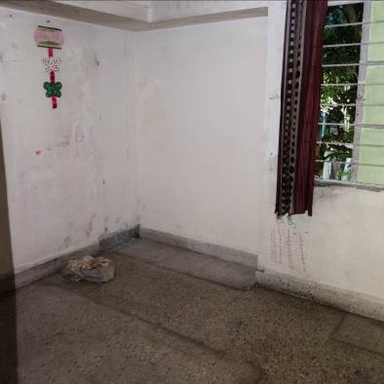
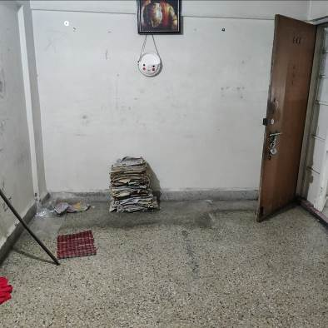
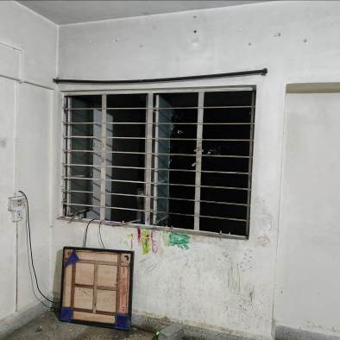

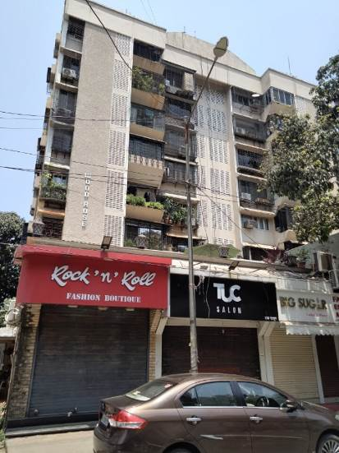
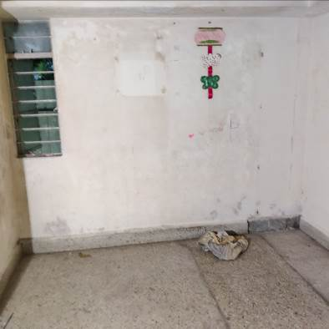
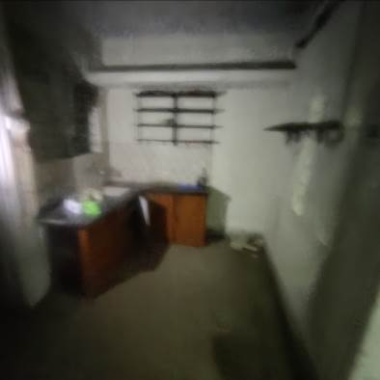
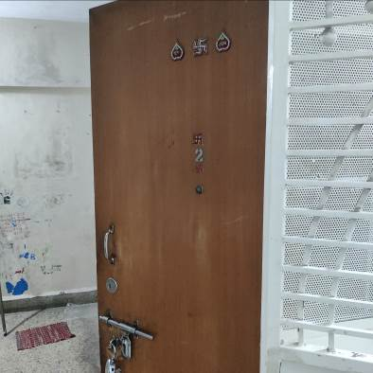

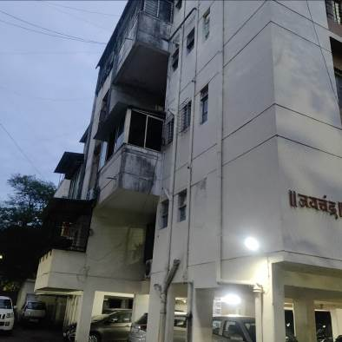
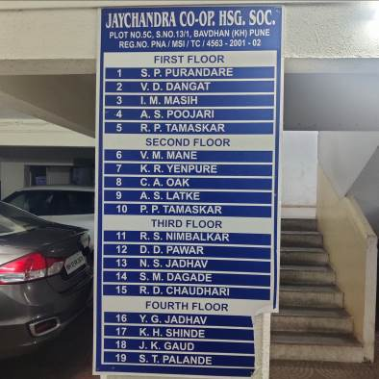
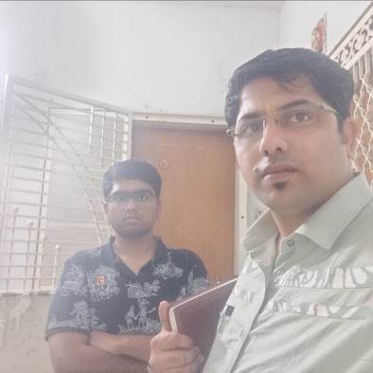

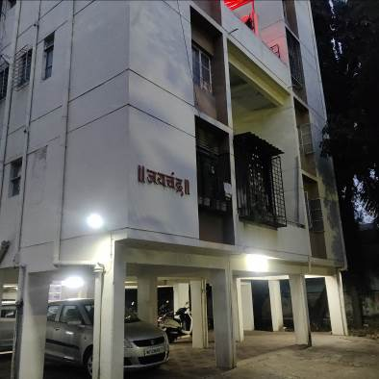
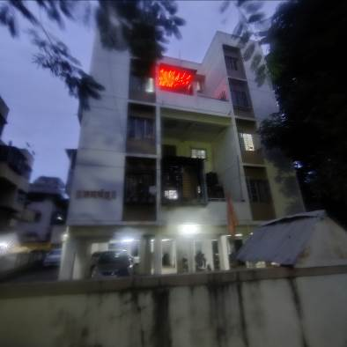
Route Map of the property
site u/r
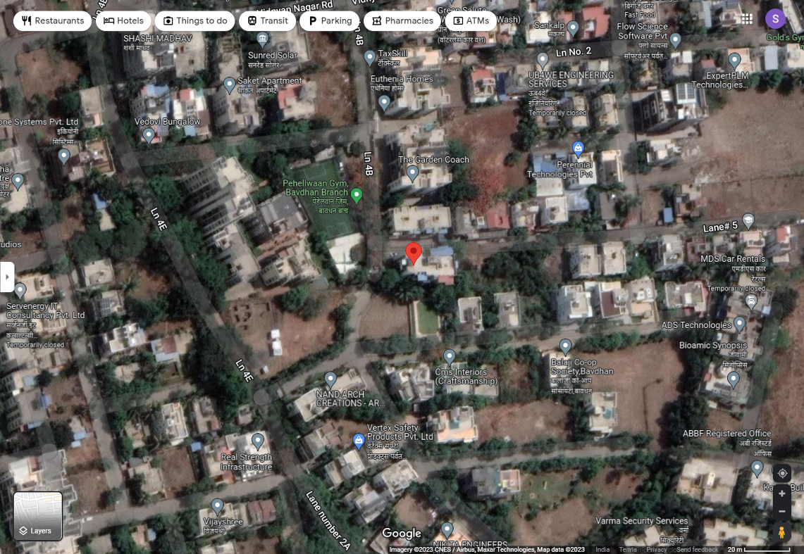

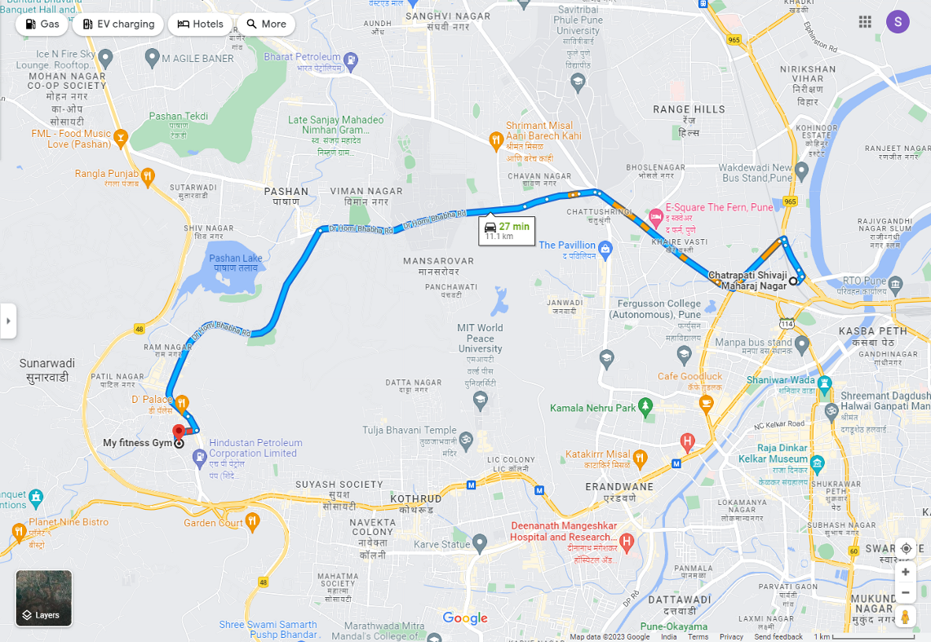

Longitude Latitude: 18°30’51.4”N 73°46’48.2”E

Note: The Blue line shows the route to site from nearest railway station (Shivaji Nagar – 11.1 Km.)
Ready Reckoner

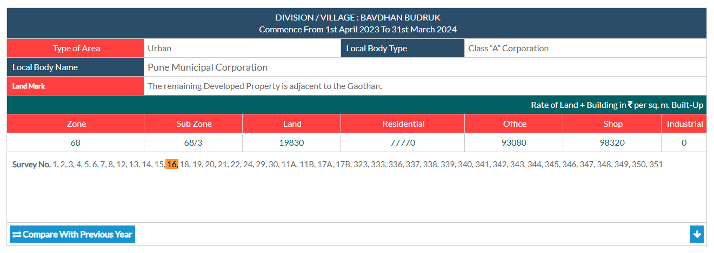

Price Indicators
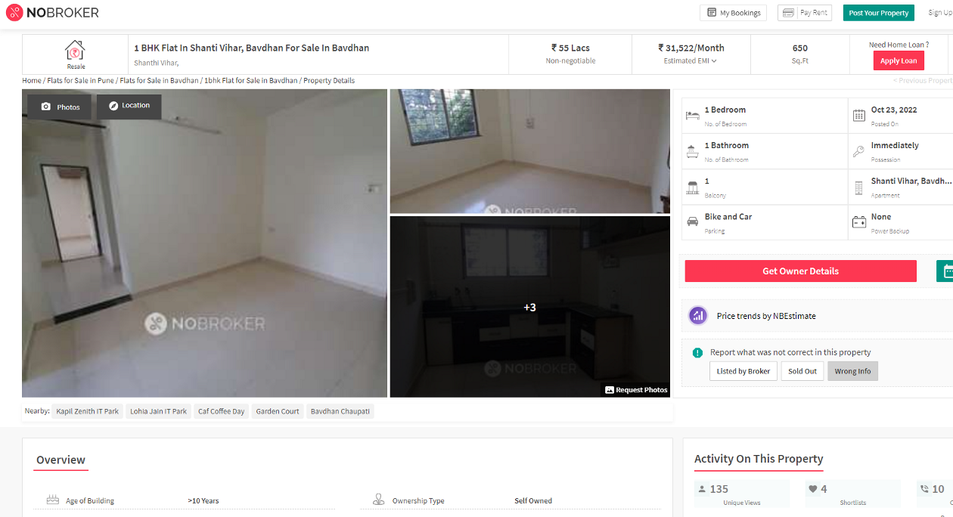

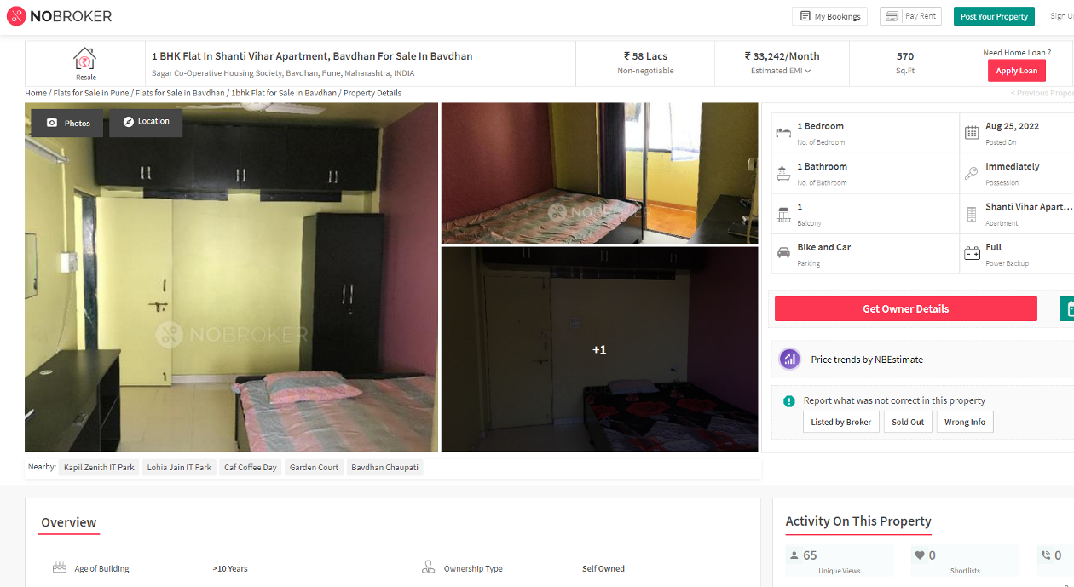
Price Indicators

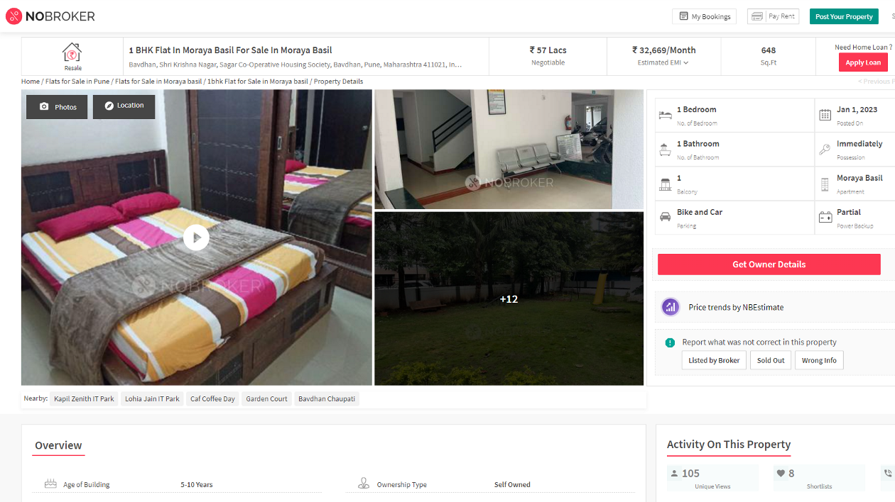

Justification for price / rate

The Market Value of the property is based on facts of markets discovered by us during our enquiries, however the government rate value in this case is less than the market value arrived by us. We are of the opinion that the value arrive by us will prove to be correct if an Auction of the subject property is carried out. As far as Market Value in Index II is concerned, it is not possible to comment on same, may be government rates are fixed by sampling during same point of time in part and whereas, Market values change every month.

In most of the cases the actual deal amount or Transaction value is not reflected in Index II because of various Market practices. As Valuer, we always try to give a value which is correct reflection of actual transaction value irrespective of any factors in market.

We hope this will satisfy your requirements.
As a result of my appraisal and analysis, it is my considered opinion that the present fair market value of the above property in the prevailing condition with aforesaid specifications is ` 42,04,746.00 (Rupees Forty Two Lakh Four Thousand Seven Hundred Forty Six Only). The Realizable Value of the above property is ` 35,74,034.00 (Rupees Thirty Five Lakh Seventy Four Thousand Thirty Four Only) and The distress value ` 29,43,322.00 (Rupees Twenty Nine Lakh Forty Three Thousand Three Hundred Twenty Two Only).

Place: Mumbai
Date: 05.06.2023

Sharadkumar B. Chalikwar
Govt. Reg. Valuer
Chartered Engineer (India)
Reg. No. (N) CCIT/1-14/52/2008-09

The undersigned has inspected the property detailed in the Valuation Report dated _______________________

on ____________________. We are satisfied that the fair and reasonable market value of the property is `_________________________ (Rupees ________________________________________________________

________________________________________only).

Date
Signature
(Name of the Branch Manager with office Seal)

Enclosures
 | Declaration From Valuers (Annexure- II) | Attached
 | Model code of conduct for valuer - (Annexure III) | Attached

Annexure-II

DECLARATION FROM VALUERS

I, hereby declare that:

- The information furnished in my valuation report dated 05.06.2023 is true and correct to the best of my knowledge and belief and I have made an impartial and true valuation of the property.

- I have no direct or indirect interest in the property valued;

- I/ my authorized representative have personally inspected the property on 14.12.2022 The work is not sub - contracted to any other valuer and carried out by myself.

- I have not been convicted of any offence and sentenced to a term of Imprisonment;

- I have not been found guilty of misconduct in my professional capacity.

- I have read the Handbook on Policy, Standards and procedure for Real Estate Valuation, 2011 of the IBA and this report is in conformity to the "Standards" enshrined for valuation in the Part - B of the above handbook to the best of my ability.

- I have read the International Valuation Standards (IVS) and the report submitted to the Bank for the respective asset class is in conformity to the "Standards" as enshrined for valuation in the IVS in "General Standards" and "Asset Standards" as applicable. The valuation report is submitted in the prescribed format of the bank.

- I abide by the Model Code of Conduct for empanelment of valuer in the Bank. (Annexure III - A signed copy of same to be taken and kept along with this declaration)

- I am registered under Section 34 AB of the Wealth Tax Act, 1957.

- I am Chairman & Managing Director of the company, who is competent to sign this valuation report.

- Further, I hereby provide the following information.

Sr.  No. | Particulars | Valuer comment
 | Background information of the asset being valued; | The property under consideration was owned by Mr. Vikas Dattatray Dangat.
 | Purpose of valuation and appointing authority | As per the request from Union Bank of India, SAMB, Mumbai to assess fair market value of the property for SARFAESI Securitization and Reconstruction of Financial Assets and Enforcement of Security Interest Act, 2002 purpose
 | Identity of the valuer and any other experts involved in the valuation; | Sharadkumar B. Chalikwar – Regd. Valuer  Manoj B. Chalikwar – Regd. Valuer  Prayush Parekh – Sr. Valuation Engineer  Vinita Surve – Technical Manager  Shyam Kajvilkar – Technical Officer
 | Disclosure of valuer interest or conflict, if any; | We have no interest, either direct or indirect, in the property valued. Further to state that we do not have relation or any connection with property owner / applicant directly or indirectly. Further to state that we are an independent Valuer and in no way related to property owner / applicant
 | Date of appointment, valuation date and date of report; | Date of Appointment – 14.12.2022  Valuation Date – 05.06.2023  Date of Report – 05.06.2023
 | Inspections and/or investigations undertaken; | Physical Inspection done 14.12.2022
 | Nature and sources of the information used or relied upon; | Market Survey at the time of site visit  Ready Reckoner rates / Circle rates  Online search for Registered Transactions  Online Price Indicators on real estate portals  Enquiries with Real estate consultants  Existing data of Valuation assignments carried out by us
 | Procedures adopted in carrying out the valuation and valuation standards followed; | Sales Comparative Method
 | Restrictions on use of the report, if any; | This valuation is for the use of the party to whom it is addressed and for no other purpose. No responsibility is accepted to any third party who may use or rely on the whole or any part of this valuation. The valuer has no pecuniary interest that would conflict with the proper valuation of the property.
 | major factors that were taken into account during the valuation; | current market conditions, demand and supply position, Residential Flat size, location, upswing in real estate prices, sustained demand for Residential Flat, all round development of Industrial and commercial application in the locality etc.
 | Caveats, limitations and disclaimers to the extent they explain or elucidate the limitations faced by valuer, which shall not be for the purpose of limiting his responsibility for the valuation report. | Attached

Assumptions, Disclaimers, Limitations & Qualifications

Value Subject to Change
The subject appraisal exercise is based on prevailing market dynamics as on 05th June 2023 and does not take into account any unforeseeable developments which could impact the same in the future.
Our Investigations
We are not engaged to carry out all possible investigations in relation to the subject property. Where in our report we identify certain limitations to our investigations, this is to enable the reliant party to instruct further investigations where considered appropriate or where we recommend as necessary prior to reliance. Vastukala Consultants India Pvt. Ltd. (VCIPL) is not liable for any loss occasioned by a decision not to conduct further investigations
Assumptions
Assumptions are a necessary part of undertaking valuations. VCIPL adopts assumptions for the purpose of providing valuation advise because some matters are not capable of accurate calculations or fall outside the scope of our expertise, or out instructions. The reliant party accepts that the valuation contains certain specific assumptions and acknowledge and accept the risk of that if any of the assumptions adopted in the valuation are incorrect, then this may have an effect on the valuation.
Information Supplied by Others
The appraisal is based on the information provided by the client. The same has been assumed to be correct and has been used for appraisal exercise. Where it is stated in the report that another party has supplied information to VCIPL, this information is believed to be reliable but VCIPL can accept no responsibility if this should prove not to be so.
Future Matters
To the extent that the valuation includes any statement as to a future matter, that statement is provided as an estimate and/or opinion based on the information known to VCIPL at the date of this document. VCIPL does not warrant that such statements are accurate or correct.
Map and Plans
Any sketch, plan or map in this report is included to assist the reader while visualising the property and assume no responsibility in connection with such matters.
Site Details
Based on inputs received from Client's representative and site visit conducted, we understand that the subject property is Residential Flat, admeasuring 442.00 Sq. Ft. Total Carpet Area in the name Mr. Vikas Dattatray Dangat. Further, VCIPL has assumed that the subject property is free from any encroachment and is available as on the date of the appraisal.

Property Title
Based on our discussion with the Client, we understand that the subject property is owned by Mr. Vikas Dattatray Dangat. For the purpose of this appraisal exercise, we have assumed that the subject property has a clear title and is free from any encumbrances, disputes and claims. VCIPL has made no further enquiries with the relevant local authorities in this regard and does not certify the property as having a clear and marketable title. Further, no legal advice regarding the title and ownership of the subject property has been obtained for the purpose of this appraisal exercise. It has been assumed that the title deeds are clear and marketable.
Environmental Conditions
We have assumed that the subject property is not contaminated and is not adversely affected by any existing or proposed environmental law and any processes which are carried out on the property are regulated by environmental legislation and are properly licensed by the appropriate authorities.

Area
Based on the information provided by the Client's representative, we understand that the Residential Flat, admeasuring 442.00 Sq. Ft. Total Carpet Area

Condition & Repair
In the absence of any information to the contrary, we have assumed that there are no abnormal ground conditions, nor archaeological remains present which might adversely affect the current or future occupation, development or value of the property. The property is free from rat, infestation, structural or latent defect. No currently known deleterious or hazardous materials or suspect techniques will be used in the construction of or subsequent alteration or additions to the property and comments made in the property details do not purport to express an opinion about , or advise upon, the condition of uninspected parts and should not be taken as making an implied representation or statement about such parts
Valuation Methodology
For the purpose of this valuation exercise, the valuation methodology used is Direct Comparison Approach Method and proposed Highest and Best Use model is used for analysing development potential.
The Direct Comparison Approach involves a comparison of the property being valued to similar properties that have actually been sold in arms - length transactions or are offered for sale. This approach demonstrates what buyers have historically been willing to pay (and sellers willing to accept) for similar properties in an open and competitive market and is particularly useful in estimating the value of the Flat and properties that are typically traded on a Flat basis.
In case of inadequate recent transaction activity in the subject micro-market, the appraiser would collate details of older transactions. Subsequently, the appraiser would analyse rental / capital value trends in the subject micro-market in order to calculate the percentage increase / decrease in values since the date of the identified transactions. This percentage would then be adopted to project the current value of the same.
Where reliance has been placed upon external sources of information in applying the valuation methodologies, unless otherwise specifically instructed by Client and/or stated in the valuation, VCIPL has not independently verified that information and VCIPL does not advise nor accept it as reliable. The person or entity to whom the report is addressed acknowledges and accepts the risk that if any of the unverified information in the valuation is incorrect, then this may have an effect on the valuation.
Not a Structural Survey
We state that this is a valuation report and not a structural survey
Other
All measurements, areas and ages quoted in our report are approximate
Legal
We have not made any allowances with respect to any existing or proposed local legislation relating to taxation on realization of the sale value of the subject property. VCIPL is not required to give testimony or to appear in court by reason of this appraisal report, with reference to the property in question, unless arrangement has been made thereof. Further, no legal advice on any aspects has been obtained for the purpose of this appraisal exercise
Property specific assumptions
Based on inputs received from the client and site visit conducted, we understand that the subject property is Residential Flat, admeasuring 442.00 Sq. Ft. Total Carpet Area.

ASSUMPTIONS, CAVEATS, LIMITATION AND DISCLAIMERS
1. We assume no responsibility for matters of legal nature affecting the property appraised or the title thereto, nor do we render our opinion as to the title, which is assumed to be good and marketable.
2. The property is valued as though under responsible ownership.
3. It is assumed that the property is free of liens and encumbrances.
4. It is assumed that there are no hidden or unapparent conditions of the subsoil or structure that would render it more or less valuable. No responsibility is assumed for such conditions or for engineering that might be required to discover such factors.
5. There is no direct/ indirect interest in the property valued.
6. The rates for valuation of the property are in accordance with the Govt. approved rates and prevailing market rates.

DEFINITION OF VALUE FOR THIS SPECIFIC PURPOSE

This exercise is to assess Fair Market Value of the property under reference for SARFAESI Securitisation and Reconstruction of Financial Assets and Enforcement of Security Interest Act, 2002 purpose as on 05th June 2023.

The term Fair Market Value is defined as

“The most probable price, as of a specified date, in cash, terms equivalent to cash, or in other precisely revealed terms for which the specified property rights would sell after reasonable exposure in a competitive market under all conditions requisite to a fair sale, with the buyer and seller each acting prudently knowledgeably and for self interest assuming that neither is under undue duress”.

Fundamental assumptions and conditions presumed in this definition are:

1. Buyer and seller are motivated by self-interest.
2. Buyer and seller are well informed and are acting prudently.
3. The property is exposed for a reasonable time on the open market.
4. Payment is made in cash or equivalent or in specified financing terms.

DECLARATION OF PROFESSIONAL FEES CHARGED

We hereby declare that, our professional fees are not contingent upon the valuation findings. However, if the statute AND/OR clients demands that, the fees should be charged on the percentage of assessed value then, with the full knowledge of the AND/OR end user, it is being charged accordingly.

VALUATION OF THE PROPERTY PREMISES

Considering various parameters recorded herein above, existing economic scenario, and the information that is available with reference to the development of neighborhood and method selected for valuation, we are of the opinion that, the property premises can be assessed and valued for this particular purpose at ` 42,04,746.00 (Rupees Forty Two Lakh Four Thousand Seven Hundred Forty Six Only).

Sharadkumar B. Chalikwar
Govt. Reg. Valuer
Chartered Engineer (India)
Reg. No. (N) CCIT/1-14/52/2008-09

