5th LENDERS INDEPENDENT ENGINEER REPORT
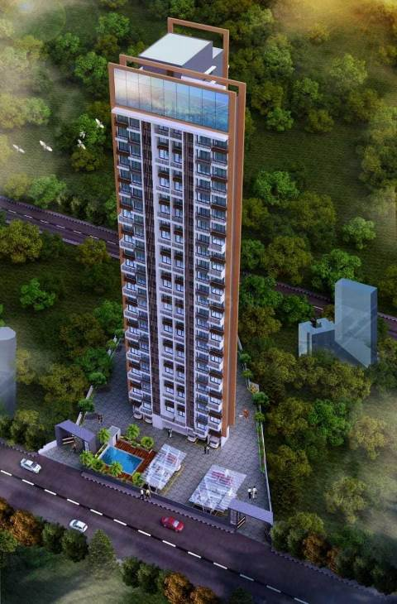

Details of the property under consideration:

Name of Project: 27 East

"27 East", Proposed Residential Building on plot bearing on S. No. 139 (Old), 14 (New), H. No. 9 &10, Mouje – Sagaon, Dombivli (East), Taluka – Kalyan, District – Thane, Pin Code – 421 204, State - Maharashtra, Country – India

Latitude Longitude: 19°12'22.2"N 73°05'48.4"E

Valuation Prepared for:

State Bank of India
Diamond Garden Chembur Branch
Unit No. 11, Building No. 11, Ground Floor, Corporate Park, Sion Trombay Road,
Chembur, Mumbai, Pin Code – 400 071, State - Maharashtra, Country – India.

Vastu/Mumbai/05/2023/31752/2300939
05/03-47-PY
Date: - 05.06.2023

FIFTH LENDERS INDEPENDENT ENGINEER REPORT

To,
State Bank of India
Diamond Garden Chembur Branch
Unit No. 11, Building No. 11, Ground Floor,
Corporate Park, Sion Trombay Road, Chembur,
Mumbai, Pin Code – 400 071,
State - Maharashtra, Country – India.

Subject: Construction of Proposed Residential Building "27 East", Proposed Residential Building on plot bearing on S. No. 139 (Old), 14 (New), H. No. 9 &10, Mouje – Sagaon, Dombivli (East), Taluka – Kalyan, District – Thane, Pin Code – 421 204, State - Maharashtra, Country – India.

Ref: You’re Request for Lenders Independent Engineer Report of under Construction Building.
Dear Sir,
The Construction work as per approved plan was in progress during the site visit on 27th April 2023. Total expenditure occurred as on 31/03/2023 on this project by M/s. Rashi Developers is ` 44.50 Cr. & as per CA Certificate actual total expenditure occurred as on 31/03/2023 is ` 44.94 Cr. Hence, release of Balance Amount as requested by M/s. Rashi Developers is hereby recommended.
DECLARATION
- The information furnished in the report is based on our 5th site visit Dated 27/04/2023 & Document Provided by Client.
- Vastukala 4th LIE Report of the project dated 28/11/2022.
- I have no direct and indirect interest in the property examined for report.
- I have not been found guilty of misconduct in my professional capacity.

Sharadkumar B. Chalikwar
Govt. Reg. Valuer
Chartered Engineer (India)
Reg. No. (N) CCIT/1-14/52/2008-09
Encl.: LIE report

Purpose & Methodology
• State Bank of India Banks and financial institutions require monitoring & an independent review of the progress of the sanctioned projects
VCIPL undertakes such study to independently review the progress of the project and put forward a comprehensive analysis

Advantages:
- Assurance on present practices
- Identification of risk
- Analyzing the performance of third parties
- Recommendations

The Methodology
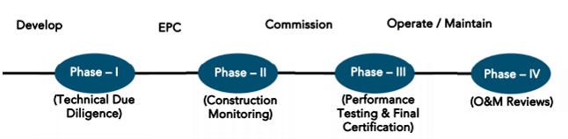
FIFTH LENDERS INDEPENDENT ENGINEER REPORT
OF
"27 East"
"27 East", Proposed Residential Building on plot bearing on S. No. 139 (Old), 14 (New), H. No. 9 & 10,
Mouje – Sagaon, Dombivli (East), Taluka – Kalyan, District – Thane, Pin Code – 421 204,
State - Maharashtra, Country - India

Latitude Longitude: 19°12'22.2"N 73°05'48.4"E

NAME OF DEVELOPER: M/s. Rashi Developers
Pursuant to instructions from State of India, Diamond Garden Chembur Branch, Mumbai we have duly visited, inspected, surveyed & assessed the above said property on 27th April 2023 to determine the fair & reasonable market value of the said property/project as on Quarter ending 31st March 2023 for LIE purpose.

1. Location Details:
Proposed Residential Building on plot bearing on S. No. 139 (Old), 14 (New), H. No. 9 & 10, Mouje – Sagaon, Dombivli (East), Taluka – Kalyan, District – Thane, Pin Code – 421 204. It is about 2.10 Km. travel distance from Dombivli Railway station. Surface transport to the property is by buses, Auto, taxis & private vehicles. The property is in developed locality. All the amenities like shops, banks, hotels, markets, schools, hospitals, etc. are all available in the nearby locality. The locality is higher middle class & developed.

2. Developer Details:
Name of builder | M/s. Rashi Developers
Project Rera Registration Number | P51700028466
Registered office address | Office No. 72A, Mittal Tower, Nariman Point, Mumbai, Pin Code – 400021, State - Maharashtra, Country – India
Contact details | Contact Person:  Mr. Nikhil (Accountant)  Mobile No. 9022477512  Mrs. Tripuati Nikam (Project Engineer)  Mobile No. 9082558371  Mr. Rohan Deshnehare (Site Engineer)  Mobile No. 7738209289
E – mail ID and website
3. Boundaries of the Property:
Direction | Particulars
On or towards North | Dortmund Laboratories Pvt. Ltd.
On or towards South | S R Fragrance
On or towards East | Gymkhana Road
On or towards West | Patharli Road

Introduction
As per Information on site M/s. Rashi Developers has acquired land by Conveyance Deed Date 05.01.2017 admeasuring area is 1,917.60 Sq. M. bearing Survey No. 139 (Old), 14 (New), H. No. 9 & 10, Mouje – Sagaon, Dombivli (East), Taluka – Kalyan, District – Thane, Pin Code – 421 204. For the Proposed Residential Building.

Area Statement:

Land:
Date | Particular | Area in Sq. M.
10.01.2017 | Survey No. 139 (Old), 14 (New) | 1,917.60

- Copy of Conveyance Deed dated 05.01.2017 b/w Mr. Rajiv Krishnagopal Agrawal, Mr. Amit Ramgopal Agrawal, Mr. Mohit Ramgopal Agarwal & Mr. Madhur Ashokkumar Agarwal (The Vendors) And M/s. Rashi Developers (The Purchasers).

Building Area:
Sr. No. | Area Statement | Area in Sq. M.
1 | Area of Plot as per 7/12 | 2,200.00
2 | Area of Plot as per Triangulation Method | 2,111.78
3 | Deduction Area
a | Area under existing road | 135.22
b | Area under 24M wide proposed road (setback area) | 58.96
c | Any reservation | -
4 | Total Deduction Area | 194.18
5 | Balance Area of Plot | 1,917.60
6 | Deduction for
a | Recreational Ground | 287.64
b | Internal Road | -
7 | Permissible Basic FSI | 0.95
8 | Total Permissible FSI Area | 1,821.72
9 | Permissible TDR | 1.15
10 | Permissible TDR Area | 2,205.24
11 | DR on 24M wide proposed Area | 117.92
12 | Total Permissible Area | 4,026.96
13 | Total Proposed Area | 4,015.54
14 | Existing Floor Area | -
15 | Excess Balcony Area | -
16 | Total Balance Area | 11.42
Balcony Area Statement
A | Permissible Balcony Area | As shown in Plan
B | Proposed Balcony Area
C | Excess Balcony Area
Tenement Statement
A | Proposed Area | 4,015.54
B | Less Deduction of Non - Residential Area | -
C | Area of Tenement | 4,015.54
D | Tenement Permissible | -
E | Tenement Proposed | 92.00
F | Tenement Existing | -
G | Total No. of Tenement | 92.00
Parking Statement
A | Parking Required by Rule | As shown in Plan
i | Car
ii | Scooter
iii | Cycle

List of Approvals:
- Copy of Approved Plans No. KDMP/NRV/BP/27 Village/2018-19/24/139 dated 10.01.2020 issued by Kalyan Dombivli Municipal Corporation (KDMC).
Approval Upto: Stilt Floor + 1st to 25th Residential Floor + 26th Amenities Floor.
- Copy of Commencement Certificate No. KDMP/NRV/BP/27 Village/2018-19/24/139 dated 10.01.2020 issued by Kalyan Dombivli Municipal Corporation (KDMC).
(This CC is now endorsed for the work of Stilt Floor + 1st to 25th Residential Floor + 26th Amenities Floor)

LEVEL OF COMPLETION:

Sales Building
Sr. No | Floor No. | Construction Area in Sq. M. | Completed Area in Sq. M. | Work Completion 4th LIE Report as on 28.11.2022 | Work Completion as on 07.07.2022
1 | Ground Floor | 214.36 | 214.36 | Slab work, Block work, internal plaster work, internal painting door & window installation, flooring works are completed | Slab work, Block work, internal plaster work, internal painting door & window installation, flooring works are completed
2 | 1st Floor | 363.66 | 363.66 | Slab work, Block work, internal plaster work, internal painting door & window installation, flooring, electrical & plumbing works are completed, Lift & Staircase work is pending. | Slab work, Block work, internal plaster work, internal painting door & window installation, flooring, electrical & plumbing works are completed, Lift & Staircase work is pending.
3 | 2nd Floor | 363.66 | 363.66 | Slab work, Block work, Internal plaster work, Kitchen platform work are completed, door & window frames, Gypsum, Kitchen Platform, Flooring & Toilet Tiling works are completed. | Slab work, Block work, Internal plaster work, Kitchen platform work are completed, door & window frames, Gypsum, Kitchen Platform, Flooring & Toilet Tiling works are completed.
3 | 3rd Floor | 363.66 | 363.66 | Slab work, Block work, Internal plaster work, Kitchen platform work are completed, door & window frames, Gypsum, Kitchen Platform, Flooring & Toilet Tiling works are completed. | Slab work, Block work, Internal plaster work, Kitchen platform work are completed, door & window frames, Gypsum, Kitchen Platform, Flooring & Toilet Tiling works are completed.
4 | 4th Floor | 363.66 | 363.66 | Slab work, Block work, Internal plaster work, Kitchen platform work are completed, door & window frames, Gypsum, Kitchen Platform, Flooring & Toilet Tiling works are completed. | Slab work, Block work, Internal plaster work, Kitchen platform work are completed, door & window frames, Gypsum, Kitchen Platform, Flooring & Toilet Tiling works are completed.
5 | 5th Floor | 372.48 | 372.48 | Slab work, Block work, Internal plaster work, Kitchen platform work are completed, door & window frames, Gypsum, Kitchen Platform, Flooring & Toilet Tiling works are completed. | Slab work, Block work, Internal plaster work, Kitchen platform work are completed, door & window frames, Gypsum, Kitchen Platform, Flooring & Toilet Tiling works are completed.
6 | 6th Floor | 363.66 | 363.66 | Slab work, Block work, Internal plaster work, Kitchen platform work are completed, door & window frames, Gypsum, Kitchen Platform, Flooring & Toilet Tiling works are completed. | Slab work, Block work, Internal plaster work, Kitchen platform work are completed, door & window frames, Gypsum, Kitchen Platform, Flooring & Toilet Tiling works are completed.
7 | 7th Floor | 363.66 | 363.66 | Slab work, Block work, Internal plaster work, Kitchen platform work are completed, door & window frames, Gypsum, Kitchen Platform, Flooring & Toilet Tiling works are completed. | Slab work, Block work, Internal plaster work, Kitchen platform work are completed, door & window frames, Gypsum, Kitchen Platform, Flooring & Toilet Tiling works are completed.
8 | 8th Floor | 373.75 | 373.75 | Slab work, Block work, Internal plaster work, Kitchen platform work are completed, door & window frames, Gypsum, Flooring & Toilet Tiling works are completed. Flat No. 803 & 804 are Sample Flat | Slab work, Block work, Internal plaster work, Kitchen platform work are completed, door & window frames, Gypsum, Flooring & Toilet Tiling works are completed. Flat No. 803 & 804 are Sample Flat
9 | 9th Floor | 363.66 | 363.66 | Slab work, Block work, Internal plaster work, Kitchen platform work are completed, door & window frames, Gypsum, Flooring & Toilet Tiling works are completed. | Slab work, Block work, Internal plaster work, Kitchen platform work are completed, door & window frames, Gypsum, Flooring & Toilet Tiling works are completed.
10 | 10th Floor | 363.66 | 363.66 | Slab work, Block work, Internal plaster work, Kitchen platform work are completed, door & window frames, Gypsum, Flooring & Toilet Tiling works are completed. | Slab work, Block work, Internal plaster work, Kitchen platform work are completed, door & window frames, Gypsum, Flooring & Toilet Tiling works are completed.
11 | 11th Floor | 363.66 | 363.66 | Slab work, Blockwork, Plaster works, Door Frame & Gypsum works are completed | Slab work, Blockwork, Plaster works, Door Frame & Gypsum works are completed
12 | 12th Floor | 331.22 | 331.22 | Slab work, Blockwork, Plaster works, Door Frame & Gypsum works are completed | Slab work, Blockwork, Plaster works, Door Frame & Gypsum works are completed
13 | 13th Floor | 363.66 | 363.66 | Slab work, Blockwork, Plaster works, Door Frame & Gypsum works are completed | Slab work, Blockwork, Plaster works, Door Frame & Gypsum works are completed
14 | 14th Floor | 363.66 | 363.66 | Slab work, Blockwork, Plaster works, Door Frame & Gypsum works are completed | Slab work, Blockwork, Plaster works, Door Frame & Gypsum works are completed
15 | 15th Floor | 363.66 | 363.66 | Slab work, Blockwork, Plaster works, Door Frame & Gypsum works are completed | Slab work, Blockwork, Plaster works, Door Frame & Gypsum works are completed
16 | 16th Floor | 363.65 | 363.65 | Slab work, Blockwork, Plaster works, Door Frame & Gypsum works are completed | Slab work, Blockwork, Plaster works, Door Frame & Gypsum works are completed
17 | 17th Floor | 373.75 | 373.75 | Slab work, Blockwork, Plaster works, Door Frame & Gypsum works are completed | Slab work, Blockwork, Plaster works, Door Frame & Gypsum works are completed
18 | 18th Floor | 363.65 | 363.65 | Slab work, Blockwork & 90% Plaster works, Door Frame works are completed | Slab work, Blockwork & 90% Plaster works, Door Frame works are completed
19 | 19th Floor | 372.48 | 372.48 | Slab work, Blockwork & 90% Plaster works, Door Frame works are completed | Slab work, Blockwork & 90% Plaster works, Door Frame works are completed
20 | 20th Floor | 372.48 | 372.48 | Slab work, Blockwork & 90% Plaster works, Door Frame works are completed | Slab work, Blockwork & 90% Plaster works, Door Frame works are completed
21 | 21st Floor | 363.66 | 363.66 | Slab work, Blockwork & 90% Plaster works, Door Frame works are completed | Slab work, Blockwork & 90% Plaster works, Door Frame works are completed
22 | 22nd Floor | 372.91 | 372.91 | Slab work, Blockwork & 90% Plaster works, Door Frame works are completed | Slab work, Blockwork & 90% Plaster works, Door Frame works are completed
23 | 23rd Floor | 363.66 | 363.66 | Slab work, Blockwork are completed | Slab work, Blockwork are completed
24 | 24th Floor | 363.66 | 363.66 | Slab work is completed & 50% blockwork is completed | Slab work is completed & 50% blockwork is completed
25 | 25th Floor | 372.48 | 372.48 | Slab work is completed | Slab work is completed
26 | 26th Floor | 184.77 | 184.77 | Slab work is completed | Slab work is completed
27 | Terrace | 72.33
28 | Swimming Pool | 155.62
Total |  | 9,750.83 | 9,522.88
As per 4th LIE Report Dated 28.11.2022 |  | 9,750.83 | 8,601.97
Difference |  | - | 920.91

- As per site inspection, slab work is completed upto 29th Floor.
- Building approval drawings submitted to us has building permission upto 26th Floor only.
- Revised building permission for additional upper floors in not provided to us.
- Accordingly, we have considered construction area upto 26th Floor only for present LIE report.
- It is advised to obtain revised approved plans for upper floors to monitor building approval status.
- We have requested to client for revised approved plans but they refused to provide the same stating, the project approval from SBI is only till 26th floor.

Details of the Project as Financed By SBI:

Project Cost: (as per C.A. Certificate)
Particulars | Estimated Cost (in Cr.) | Incurred Cost  (In Cr.) 31.03.2023 by  M/s. Lalit Parmar & Co. | Incurred Cost  (In Cr.) 30.09.2022 by  M/s. Lalit Parmar & Co. | Net
Land Cost | 6.33 | 5.99 | 5.99 | -
TDR Cost | 1.25 | 1.21 | 1.21 | -
Construction cost of Building | 28.91 | 24.65 | 15.04 | 9.61
Premium Cost / FSI / GOM Charges / fees / security Deposits | 2.21 | 2.28 | 2.28 | -
On- site expenditure for development / Professional / Marketing / Advance for Project/ Administrative Cost/ Fixed Assets | 4.81 | 4.21 | 3.57 | 0.64
Interest Cost | 6.25 | 6.60 | 5.17 | 1.43
Contingency Cost | 0.58 | - | - | -
Total | 50.34 | 44.94 | 33.26 | 11.68

- The Builder has incurred about 24.65 Cr. as construction cost, 4.21 Cr. for admin cost & 6.60 Cr. for interest cost in last quarter till 31.03.2023 as per C.A. certificate issued by M/s. Lalit Parmar & Co. dated 15.05.2023.

Project Cost: (as per Bills):
Particulars | Incurred Cost (in Cr.)
 | 31.03.2023 as per Bill (Inclusive GST) | 30.09.2022 as per Bill (Inclusive GST) | Net
Land Cost | 6.33 | 6.33 | -
TDR Cost | 1.25 | 1.25 | -
Construction cost of Building | 23.87 | 14.53 | 9.34
Premium Cost / FSI / GOM Charges / fees / security Deposits | 1.75 | 1.75 | -
On- site expenditure for development / Professional / Marketing / Advance for Project/ Administrative Cost/ Fixed Assets | 6.58 | 5.09 | 1.50
Interest Cost | 4.71 | 4.40 | 0.31
Contingency Cost | - | - | -
Total | 44.50 | 33.35 | 11.15
Note: The unsecured loan interest cost after santioned of bank loan is not accounted in this LIE Report.

Land Cost:
Sr. No. | Date | Description | Total Cost in ` | Incurred Cost in `
1 | 05.01.2017 | Land Cost | 5,76,00,000.00 | 5,76,00,000.00
2 |  | Stamp Duty | 34,86,000.00 | 34,86,000.00
3 |  | Reg. Fees | 30,000.00 | 30,000.00
4 |  |  | 30,000.00 | 30,000.00
5 |  |  | 1,160.00 | 1,160.00
6 |  | Other Direct Expenses | 12,55,000.00 | 12,55,000.00
7 |  | Interest & Prof. Charges | 8,97,959.00 | 8,97,959.00
Total |  |  | 6,33,00,119.00 | 6,33,00,119.00
As per conveyance deed.

TDR Purchase Cost:
Sr. No. | Date | Description | Total Cost | Incurred Cost
1 | 06.07.2019 | TDR Cost | 1,21,09,500.00 | 1,21,09,500.00
2 |  | Stamp Duty | 3,63,300.00 | 3,63,300.00
3 |  | Reg. Fees | 30,000.00 | 30,000.00
4 |  |  | 30,000.00 | 30,000.00
5 |  |  | 460.00 | 460.00
Total |  |  | 1,25,33,260.00 | 1,25,33,260.00
As per TDR Purchase Agreement.
Summary of Bills
Sr. No. | Particulars | Amount in ` (till 31.03.2023) | Amount in ` (in Cr.) | Amount in ` (till 30.09.2022) | Amount in ` (in Cr.) | Net in ` (in Cr.)
1 | Construction Cost | 23,87,40,090.00 | 23.87 | 14,53,30,195.00 | 14.53 | 9.34
2 | Premium Cost / FSI / GOM Charges / fees / security Deposits | 1,74,65,536.00 | 1.75 | 1,74,65,536.00 | 1.75 | -
3 | Professional Cost | 1,19,20,596.00 | 1.19 | 96,46,207.00 | 0.96 | 0.23
4 | Administrative Cost | 3,98,29,790.00 | 3.98 | 3,23,39,311.00 | 3.23 | 0.75
5 | Marketing Cost | 1,40,88,853.00 | 1.41 | 88,68,334.00 | 0.89 | 0.52
TOTAL |  | 32,20,44,865.00 | 32.20 | 21,36,49,583.00 | 21.36 | 10.84
Note: Bills were provided by the client up to 31.03.2023

Interest Cost:
Sr. No | Particulars | Estimate Amount in ` | Incurred Amount in ` (till 31.03.2022) | Incurred Amount in ` (till 30.09.2022)) | Net | Balance Amount in `
1 | Interest Cost | 6,25,00,000.00 | 4,71,03,294.00 | 4,40,24,720.00 | 30,78,574.00 | 1,53,96,706.00
TOTAL |  | 6,25,00,000.00 | 4,71,03,294.00 | 4,40,24,720.00 | 30,78,574.00 | 1,53,96,706.00

Note: Incurred interest amount in Unsecured loan is ` 3,79,02,682.00 as per corrected in this quarter LIE Report & incurred interest amount in bank loan is ` 92,00,612.00
Interest Cost is based on discussion with the client.

Cost of Construction as on 31st March 2023:
Plinth Area Calculation
Sr. No. | Floor No. | Construction Area in Sq. M. | Completed area (Sq. M.) | Rate per Sq. M. | Full Value after completion | Percentage of work completed | Actual Expenditure till 30.09.2022 in `
1 | Ground Floor | 214.36 | 214.36 | 27,000.00 | 57,87,720.00 | 85.00% | 49,19,562.00
2 | 1st Floor | 363.66 | 363.66 | 27,000.00 | 98,18,820.00 | 90.00% | 88,36,938.00
3 | 2nd Floor | 363.66 | 363.66 | 27,000.00 | 98,18,820.00 | 86.00% | 84,44,185.00
3 | 3rd Floor | 363.66 | 363.66 | 27,000.00 | 98,18,820.00 | 86.00% | 84,44,185.00
4 | 4th Floor | 363.66 | 363.66 | 27,000.00 | 98,18,820.00 | 86.00% | 84,44,185.00
5 | 5th Floor | 372.48 | 372.48 | 27,000.00 | 1,00,56,960.00 | 86.00% | 86,48,986.00
6 | 6th Floor | 363.66 | 363.66 | 27,000.00 | 98,18,820.00 | 86.00% | 84,44,185.00
7 | 7th Floor | 363.66 | 363.66 | 27,000.00 | 98,18,820.00 | 86.00% | 84,44,185.00
8 | 8th Floor | 373.75 | 373.75 | 27,000.00 | 1,00,91,250.00 | 86.00% | 86,78,475.00
9 | 9th Floor | 363.66 | 363.66 | 27,000.00 | 98,18,820.00 | 86.00% | 84,44,185.00
10 | 10th Floor | 363.66 | 363.66 | 27,000.00 | 98,18,820.00 | 86.00% | 84,44,185.00
11 | 11th Floor | 363.66 | 363.66 | 27,000.00 | 98,18,820.00 | 80.00% | 78,55,056.00
12 | 12th Floor | 331.22 | 331.22 | 27,000.00 | 89,42,940.00 | 80.00% | 71,54,352.00
13 | 13th Floor | 363.66 | 363.66 | 27,000.00 | 98,18,820.00 | 80.00% | 78,55,056.00
14 | 14th Floor | 363.66 | 363.66 | 27,000.00 | 98,18,820.00 | 80.00% | 78,55,056.00
15 | 15th Floor | 363.66 | 363.66 | 27,000.00 | 98,18,820.00 | 80.00% | 78,55,056.00
16 | 16th Floor | 363.65 | 363.66 | 27,000.00 | 98,18,550.00 | 80.00% | 78,54,840.00
17 | 17th Floor | 373.75 | 373.75 | 27,000.00 | 1,00,91,250.00 | 75.00% | 73,63,913.00
18 | 18th Floor | 363.65 | 363.65 | 27,000.00 | 98,18,550.00 | 75.00% | 73,63,913.00
19 | 19th Floor | 372.48 | 372.48 | 27,000.00 | 1,00,56,960.00 | 75.00% | 75,42,720.00
20 | 20th Floor | 372.48 | 372.48 | 27,000.00 | 1,00,56,960.00 | 75.00% | 75,42,720.00
21 | 21st Floor | 363.66 | 363.66 | 27,000.00 | 98,18,820.00 | 75.00% | 73,64,115.00
22 | 22nd Floor | 372.91 | 372.91 | 27,000.00 | 1,00,68,570.00 | 68.00% | 68,46,628.00
23 | 23rd Floor | 363.66 | 363.66 | 27,000.00 | 98,18,820.00 | 68.00% | 66,76,798.00
24 | 24th Floor | 363.66 | 363.66 | 27,000.00 | 98,18,820.00 | 68.00% | 66,76,798.00
25 | 25th Floor | 372.48 | 372.48 | 27,000.00 | 1,00,56,960.00 | 68.00% | 68,38,733.00
26 | 26th Floor | 184.77 | 184.77 | 27,000.00 | 49,88,790.00 | 68.00% | 33,92,377.00
27 | Terrace | 72.33 | 72.33 | 27,000.00 | 19,52,910.00 | 60.00% | 11,71,746.00
28 | Swimming Pool | 155.62 |  | 27,000.00 | 42,01,624.00 | - | -
29 | Stack Parking | 86 Nos. |  | 3,00,000.00 | 2,58,00,000.00
Total |  | 9,750.83 | 6,756.78 |  | 28,90,72,294.00 | 71.30% | 20,61,12,220.00

Note:

Details of work completed is as per site visit dated 27.04.2024 but report is prepared for 31st March quarter 2023.

As per site inspection, slab work is completed upto 29th Floor.

Building approval drawings submitted to us has building permission upto 26th Floor only.

Revised building permission for additional upper floors in not provided to us.

Accordingly, we have considered construction area upto 26th Floor only for present LIE report.

It is advised to obtain revised approved plans for upper floors to monitor building approval status.

We have requested to client for revised approved plans but they refused to provide the same stating, the project approval from SBI is only till 26th floor.

Particulars | Estimated Cost  (In Cr.) | Incurred Cost (in Cr.) |  |  | Net after previous report
 |  | Issued dated 15.05.2023 till 31.03.2023 as per CA | As per Bills upto 31.03.2023 | As per 4th LIE Report Bills upto 30.09.2022
Land Cost | 6.33 | 5.99 | 6.33 | 6.33 | -
TDR Cost | 1.25 | 1.21 | 1.25 | 1.25 | -
Construction cost of Building | 28.91 | 24.65 | 23.87 | 14.53 | 9.34
Premium Cost / FSI / GOM Charges / fees / security Deposits | 2.21 | 2.28 | 1.75 | 1.75 | -
On- site expenditure for development / Professional / Marketing / Advance for Project/ Administrative Cost/ Fixed Assets | 4.81 | 4.21 | 6.58 | 5.09 | 1.50
Interest Cost | 6.25 | 6.60 | 4.71 | 4.40 | 0.31
Contingency Cost | 0.58 | - | - | - | -
Total | 50.34 | 44.94 | 44.50 | 33.35 | 11.15
Note:
Interest Amount of Unsecured loan is accounted upto santionced of the bank loan in this LIE report. As per plinth area, calculation the work completed is up to 71.30% of total work, which comes to ` 20.61 Cr. However, company has incurred cost of ` 23.87 Cr. till 31.03.2023 Which is inclusive of material on site.

Comparison of Cost incurred on dated 31.03.2023 & 30.09.2022
Particulars | 31.03.2023 as per Bill | 30.09.2022 as per Bill | Net | % of net amount
Land Cost | 6.33 | 6.33 | - | 0.00%
TDR Cost | 1.25 | 1.25 | - | 0.00%
Construction cost of Building | 23.87 | 14.53 | 9.34 | 5.49%
Premium Cost / FSI / GOM Charges / fees / security Deposits | 1.75 | 1.75 | - | 0.00%
On- site expenditure for development / Professional / Marketing / Advance for Project/ Administrative Cost/ Fixed Assets | 6.58 | 5.09 | 1.50 | 2.04%
Interest Cost | 4.71 | 4.40 | 0.31 | 0.51%
Contingency Cost | - | - | - | 0.00%
Total | 44.50 | 33.35 | 11.15 | 100.00%

% of Fund Utilised till 31st March 2023
Particulars | Estimated Project Cost  (in Cr.) | Incurred cost as on 31.03.2023 | % of Incurred Cost | % of Estimated Project Cost
Land Cost | 6.33 | 6.33 | 100.00% | 12.57%
TDR Cost | 1.25 | 1.25 | 100.00% | 2.49%
Construction cost of Building | 28.91 | 23.87 | 82.587% | 47.43%
Premium Cost / FSI / GOM Charges / fees / security Deposits | 2.21 | 1.75 | 79.03% | 3.47%
On- site expenditure for development / Professional / Marketing / Advance for Project/ Administrative Cost/ Fixed Assets | 4.81 | 6.58 | 136.88% | 13.08%
Interest Cost | 6.25 | 4.71 | 75.37% | 9.36%
Contingency Cost | 0.58 | - | 0.00% | 0.00%
Total | 50.34 | 44.50 | 88.40% | 88.40%
Based on above Calculation it is found that total Project cost incurred is 88.40% of the Total Project Cost.

Means of Finance:
Sr. No. | Particulars | Exp. Cumulative (Cr.)
 | Equity share capital / Quassi Loan from Promoter | 5.64
 | Sales (Advance from customer) | 17.25
 | Unsecured Loan Amount | 17.00
 | Bank Laon Amount | 5.05
 | Total | 44.94
The Details of the Means of Finance are provided by Client as on 31.03.2023.

Mandatory Arrangements:
Sr. No. | Particulars | Status
 | Rainwater Harvesting | To be executed after RCC Structure
 | Firefighting System | To be executed after RCC Structure
 | Solid Waste Management | To be executed after RCC Structure

Quality of Construction:
Sr. No. | Particulars | Status
 | Soundness of Structures | Executing as per approved Structural Design
 | Look of Structures | Good
 | Quality of Material Used | Good
 | Safety Measures for Construction/labour | Taken Care by Contractor

Schedule V/s. Actual Progress:
Activity | Date of Implementation | Date of Completion | Status
Land |  |  | Completed
Development of Land |  |  | Completed
Foundation Work |  |  | Completed
Ground Floor Slab |  |  | Slab work is completed
1st Floor Slab |  |  | Slab work is completed
2nd Floor Slab |  |  | Slab work is completed
3rd Floor Slab |  |  | Slab work is completed
4th Floor Slab |  |  | Slab work is completed
5th Floor Slab |  |  | Slab work is completed
6th Floor Slab |  |  | Slab work is completed
7th Floor Slab |  |  | Slab work is completed
8th Floor Slab |  |  | Slab work is completed
9th Floor Slab |  |  | Slab work is completed
10th Floor Slab |  |  | Slab work is completed
11th Floor Slab |  |  | Slab work is completed
12th Floor Slab |  |  | Slab work is completed
13th Floor Slab |  |  | Slab work is completed
14th Floor Slab |  |  | Slab work is completed
15th Floor Slab |  |  | Slab work is completed
16th Floor Slab |  |  | Slab work is completed
17th Floor Slab |  |  | Slab work is completed
18th Floor Slab |  |  | Slab work is completed
19th Floor Slab |  |  | Slab work is completed
20th Floor Slab |  |  | Slab work is completed
21st Floor Slab |  |  | Slab work is completed
22nd Floor Slab |  |  | Slab work is completed
23rd Floor Slab |  |  | Slab work is completed
24th Floor Slab |  |  | Slab work is completed
25th Floor Slab |  |  | Slab work is completed
26th Floor Slab |  |  | Slab work is completed
27th Floor Slab |  |  | Slab work is completed
28th Floor Slab |  |  | Slab work is completed
29th Floor Slab |  |  | Slab work is completed
Swimming Pool
Block work / Internal Plaster work |  |  | Ground to 23rd floor block work is completed and 24th floor block work is in progress
Terrace Parapet wall / Overhead water tank / Lift Machine room / compound wall / External Plaster work
Electric Work
Water Proofing |  |  | Ground to 8th floor work is completed
Plumbing Work
Tiling / Marble Flooring |  |  | Ground to 10th floor work is completed
Door Frames |  |  | Ground to 23rd floor door frames wok is completed
Window Installation |  |  | Ground to 23rd floor window frames wok is completed
Staircase Flooring
Staircase Railing
Refuge Area Flooring
Internal Painting
External Painting
Lift Work
Fire Fighting Installation
Stack Parking
CP Fitting & Sanitary Work
Final Finishing & Fitting
- Work schedule is not provided by the client.
- As per site inspection, slab work is completed upto 29th Floor.
- Building approval drawings submitted to us has building permission upto 26th Floor only.
- Revised building permission for additional upper floors in not provided to us.
- Accordingly, we have considered construction area upto 26th Floor only for present LIE report.
- It is advised to obtain revised approved plans for upper floors to monitor building approval status.
- We have requested to client for revised approved plans but they refused to provide the same stating, the project approval from SBI is only till 26th floor.

Action initiated to complete the project in time:
For Sales Building: OHT water tank slab work is completed. Building Internal work is in progress.

The developers have Major work on themselves only hence (all Manpower (Labour Contractor) and material resources) shall be enhanced by the Developer to meet the TimeLine. Detail periodically progress report needs to be checked for timely completion of project.
Multiple activists to be done for achieving the timely progress & detail periodically bar chart is to be submitted for the further next quarter.

Comments related to cost overrun if any:
The cost of Sales Building is ` 50.34 Cr.

Balance investment required for completion of project:
We opinion amount of ` 5.84 Cr. Will be required to complete the Project.

Mandatory Approval Status:
Sr. No. | Particulars | Name of Department | Status | Order Details
1 | IOD of Building | Kalyan Dombivli Municipal Corporation (KDMC). | Obtained and available at site | KDMP/NRV/BP/27 Village/2018-19/24/139 dated 10.01.2020
2A | First C.C. | Kalyan Dombivli Municipal Corporation (KDMC). | Obtained and available at site | KDMP/NRV/BP/27Village/2018-19/24/139 dated 10.01.2020. This CC is now endorsed for the work of Stilt Floor + 1st to 25th Residential Floor + 26th Amenities Floor
3B | Occupancy | Kalyan Dombivli Municipal Corporation (KDMC). | Pending (Project is not completed)

Status Insurance Coverage:
Information not provided

Assumptions & Remarks:
- The adequacy of Engineering / Structural design is beyond the scope of our assignment.
- Estimated project completion date is 30/06/2025 for Sales Building respectively. The cost is certified based on the assumptions that the project will be completed within period. Few assumptions were made regarding inflation & cost rise etc. during construction period.

Sharadkumar B. Chalikwar
Govt. Reg. Valuer
Chartered Engineer (India)
Reg. No. (N) CCIT/1-14/52/2008
About the Project:
1. Introduction
a) | Project Name  (With Address & Phone Nos.) | "27 East", Proposed Residential Building on plot bearing on S. No. 139 (Old), 14 (New), H. No. 9 & 10, Mouje – Sagaon, Dombivli (East), Taluka – Kalyan, District – Thane, Pin Code – 421 204, State - Maharashtra, Country – India.  Contact Person:  Mrs. Tripuati Nikam (Project Engineer)  Mobile No. 9082558371  Mr. Rohan Deshnehare (Site Engineer)  Mobile No. 7738209289
b) | Purpose of Valuation | As per request from State Bank of India, SIB Ghatkopar Branch to assess fair market value of the Project for LIE purpose.
c) | Date of Inspection of Property | 27.04.2023
d) | Date of LIE Report | 05.06.2023
e) | Name of the Developer of Property  (in case of developer built properties) | M/s. Rashi Developers  Office No. 72A, Mittal Tower, Nariman Point, Mumbai, Pin Code – 400021, State - Maharashtra, Country – India.
2. Physical Characteristics of the Property
a) | Location of the Property | "27 East", Proposed Residential Building on plot bearing on S. No. 139 (Old), 14 (New), H. No. 9 & 10, Mouje – Sagaon, Dombivli (East), Taluka – Kalyan, District – Thane, Pin Code – 421 204, State - Maharashtra, Country – India.
 | Brief description of the property
TYPE OF THE BUILDING
- Sales Building

No. of Floors | Stilt Floor + 1st to 25th Residential Floor + 26th Amenities Floor
Building type | Residential Sale building

Sales Building work is given on contract based for RCC contract. Developer has grant to the contractor do the work of construction and completion includes Concrete work, Reinforcement work, Masonry, Internal Plaster, External Plaster and other miscellaneous work such as repairing, joints b/w concrete and masonry surface, etc. Bill must be paid on measurement of construction area inclusive of Steel & Cement Material.
Lift & lift installation contract is not finalized till now.
Firefighting work contract is not finalized.

PROPOSED DATE OF COMPLETION & FUTURE LIFE:
Expected completion date as per RERA is 30th June 2025

About "27 EAST" Project:
27 East is strategically located in Dombivli East and is a well-planned project. There are in total 92 units in this project. It is a beautifully constructed Residential property that is sure to please you. The units are all Under Construction. The different types of units available are Flat, which have been designed to offer complete satisfaction. The property units offer a comfortable space, and vary in size from 1 BHK Flat (479. 00 Sq. Ft.), 2 BHK Flat (691. 0 Sq. Ft. - 718. 0 Sq. Ft.). The prices of this meticulously planned project lie in the range of Rs. 51. 4 Lakh - 77. 1 Lakh.

This well-designed site has 1 tower, each with its own advantage. Its possession date is 01 December 2024. This project has been developed by the well-known builder Rashi Developers.

At 27 East you get to enjoy the best of facilities and amenities, such as Lift, Swimming Pool, Gymnasium, Security, CCTV Camera, Kids play area. The complete address of the site is Survey No. 14, Near Sarita Ice Factory, Sagaon, Manpada East, Dombivli East, Thane. Its pin code is 421201. Enjoy the comforts of living in 27 East with all modern conveniences at your disposal.
 | Nearby landmark | Near Ice factory
 | Postal Address of the Property | "27 East", Proposed Residential Building on plot bearing on S. No. 139 (Old), 14 (New), H. No. 9 & 10, Mouje – Sagaon, Dombivli (East), Taluka – Kalyan, District – Thane, Pin Code – 421 204, State - Maharashtra, Country - India
 | Area of the plot/land  (Supported by a plan) | Plot Area: 1,917.60 Sq. M.
 | Type of Land: Solid, Rocky, Marsh land, reclaimed land, Water-logged, Land locked. | Solid land
 | Independent access/approach to the property etc. | Yes
 | Google Map Location of the Property with a neighborhood layout map | Provided
 | Details of roads abutting the property | 18.00 Mt. wide Road
 | Description of adjoining property | Located in Middle-class locality
 | Plot No. Survey No. | S. No. 139 (Old), 14 (New), H. No. 9 & 10
 | Ward/Village/Taluka | -
 | Sub-Registry/Block | Mumbai – 1
 | District | District - Thane
b) | Boundaries of the Plot
 | As per Agreement | As per RERA Certificate | Actual
North | Details not available | Dortmund Laboratories Pvt. Ltd. | Dortmund Laboratories Pvt. Ltd.
South | Details not available | W263 plot of MIDC | S R Fragrance
East | Details not available | 19 M wide MIDC road | Gymkhana Road
West | Details not available | 24 M wide proposed DP Road | Patharli Road

4. Document Details and Legal Aspects of Property:
a) | Ownership Documents (Building Permission, Commencement Certificate & Status of Plan)
 | Sale Deed, Gift Deed, Lease Deed
 | - Copy of Conveyance Deed dated 05.01.2017 b/w Mr. Rajiv Krishnagopal Agrawal, Mr. Amit Ramgopal Agrawal, Mr. Mohit Ramgopal Agarwal & Mr. Madhur Ashokkumar Agarwal (The Vendors) And M/s. Rashi Developers (The Purchasers)
 | - Copy of Agreement for Assignment of TDR dated 06.07.2019 b/w Mrs. Mangala alias Geeta Sadashiv Patil, Mrs. Sajanabai alias Sadhana Ramchandra Patil, Mrs. Reshma Pravin Bhoir & Mrs. Roshani Rakesh Khade (The Vendors) AND M.s, Rashi Developers (The Puchasers)
 | - Copy of TDR Certificate No. KDMP/NRV/HVH/1060 dated 21.06.2019 issued by Kalyan Dombivli Municipal Corporation (KDMC).
 | - Copy of 7/12 Extract.
 | - Copy of N. A. Order Certificate No. MAHSOOL/T – 2/Jaminabab/ Rupatarankara/ASR/205/18 dated 08.06.2018 issued by Tahsildar Kalyan.
- Copy of Commencement Certificate No. KDMP/NRV/BP/27Village/2018-19/24/139 dated 10.01.2020 issued by Kalyan Dombivli Municipal Corporation (KDMC).
(This CC is now endorsed for the work of Stilt Floor + 1st to 25th Residential Floor + 26th Amenities Floor)
 | - 7. Copy of Fire NOC Certificate No. FIRE/HQ/KDMP/OW/2019/972 dated 30.11.2019 issued by Kalyan Dombivli Municipal Corporation (KDMC).
- Copy of Approved Plans No. KDMP/NRV/BP/27 Village/2018-19/24/139 dated 10.01.2020 issued by Kalyan Dombivli Municipal Corporation (KDMC).
Approval Upto: Stilt Floor + 1st to 25th Residential Floor + 26th Amenities Floor.
 | - Copy of CA Certificate dated 20.08.2021 issued by M/s. Ketan Kataria & Associates.
 | - Copy of CA Certificate dated 22.06.2021 issued by M/s. Ketan Kataria & Associates.
 | - Copy of Title Report dated 08.03.2017 issued by Mr. Abhijit A. Chitnis.
 | - Copy of Search Report dated 21.02.2017 issued by Mr. Mayur N. Surte.
 | - Copy of RERA Certificate No. P51700028466 dated 02.03.2021 issued by Maharashtra Real Estate Regulatory Authority.
 | - Copy of Architect Certificate dated 31.05.2021 issued by M/s. The Firm Architecture.
 | - Copy of Engineer Certificate dated 31.05.2021 issued by Mr. Sandeep S. Samel.
 | - Copy of Revised RERA Certificate No. P51700028466 dated 08.09.2021 issued by Maharashtra Real Estate Regulatory Authority.
 | - Copy of Architect Certificate dated 31.12.2021 issued by M/s. The Firm Architecture.
 | - Copy of Engineer Certificate dated 28.01.2022 issued by Mr. Sandeep S. Samel.
 | - Copy of CA Certificate dated 01.02.2022 issued by M/s. Lalit Parmar & Co.
 | - Copy of Bill till 31.12.2021
 | - Copy of Architect Certificate dated 31.03.2022 issued by M/s. The Firm Architecture.
 | - Copy of Engineer Certificate dated 14.04.2022 issued by Mr. Sandeep S. Samel.
 | - Copy of CA Certificate dated 21.04.2022 issued by M/s. Lalit Parmar & Co.
 | - Copy of Bills From 01.01.2022 to 31.03.2022
 | - Copy of Architect Certificate dated 30.06.2022 issued by M/s. The Firm Architecture.
 | - Copy of Engineer Certificate dated 18.08.2022 issued by Mr. Sandeep S. Samel.
 | - Copy of CA Certificate dated 23.08.2022 issued by M/s. Lalit Parmar & Co.
 | - Copy of Bills From 01.04.2022 to 30.06.2022
 | - Copy of Architect Certificate dated 30.09.2022 issued by M/s. The Firm Architecture.
 | - Copy of CA Certificate dated 18.11.2022 issued by M/s. Lalit Parmar & Co.
 | - Copy of Bills From 01.07.2022 to 30.09.2022
 | - Copy of Architect Certificate dated 30.09.2022 issued by M/s. The Firm Architecture.
 | - Copy of CA Certificate dated 18.11.2022 issued by M/s. Lalit Parmar & Co.
 | - Copy of Bills From 01.07.2022 to 30.09.2022

b) | Documents verified for present LIE report
 | - Copy of CA Certificate dated 15.05.2023 issued by M/s. Lalit Parmar & Co.
 | - Copy of CA Certificate dated 09.02.2023 issued by M/s. Lalit Parmar & Co.
 | - Copy of CA Certificate (Form 3) dated 29.04.2023 issued by M/s. Lalit Parmar & Co.
 | - Copy of CA Certificate (Form 3) dated 25.01.2023 issued by M/s. Lalit Parmar & Co.
 | - Copy of Bills From 01.10.2022 to 31.03.2023

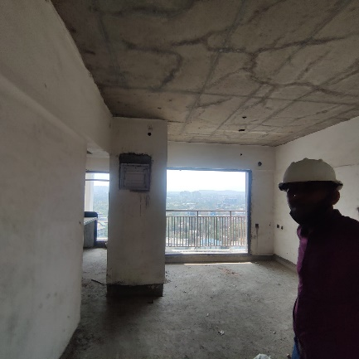
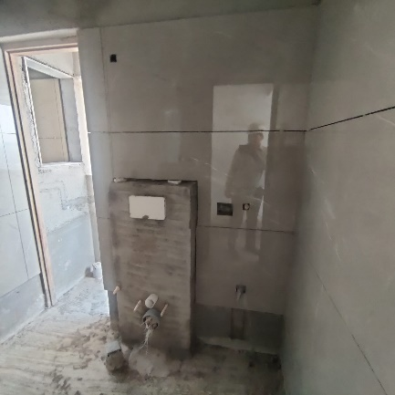
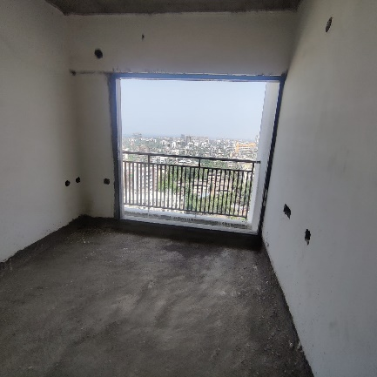
Actual Site Photographs as on 27.04.2023
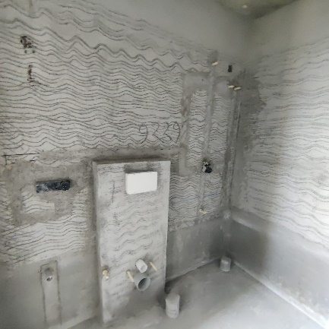
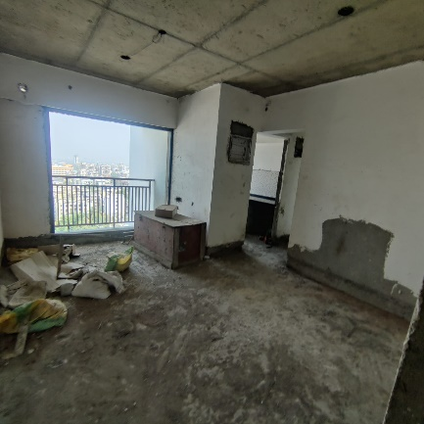
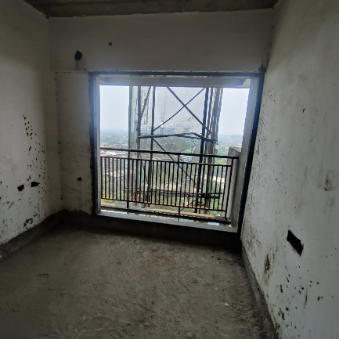
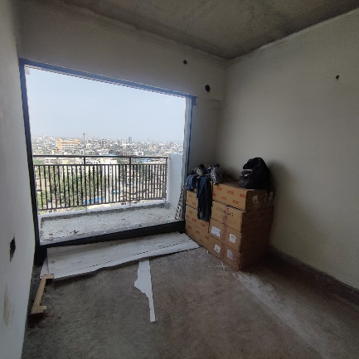
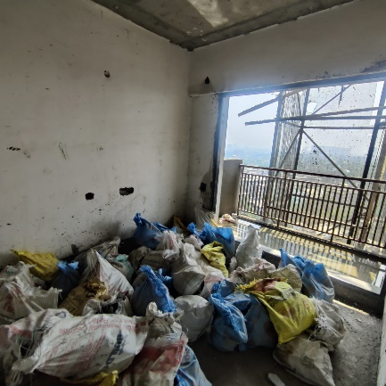
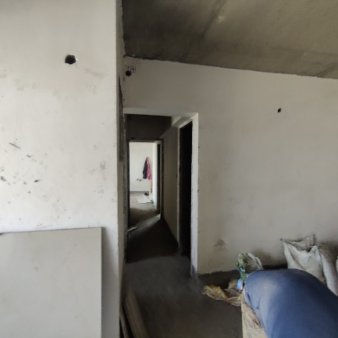
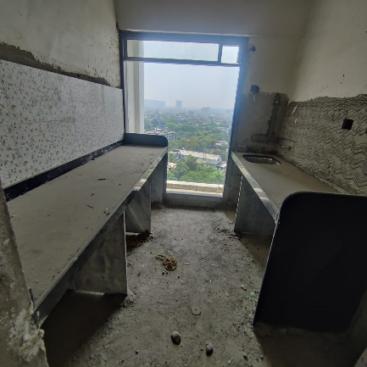
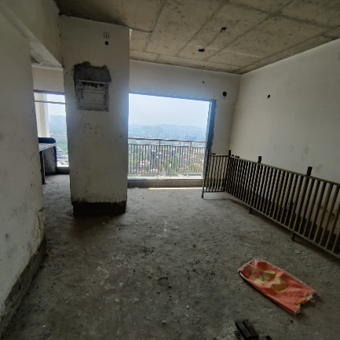
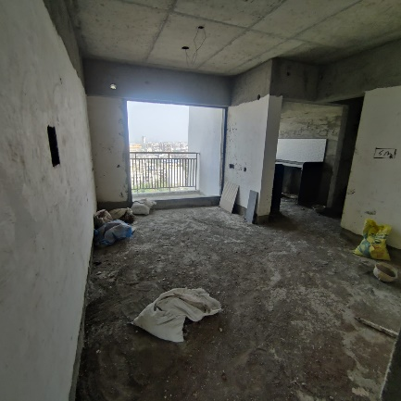
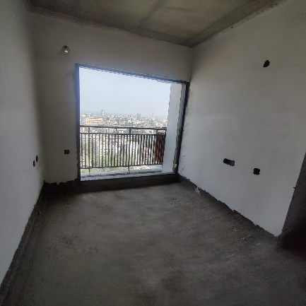
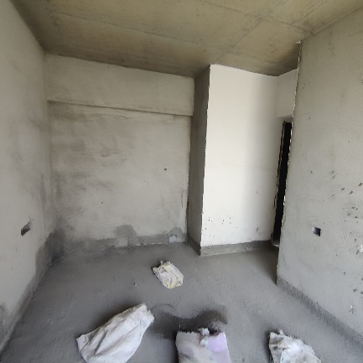
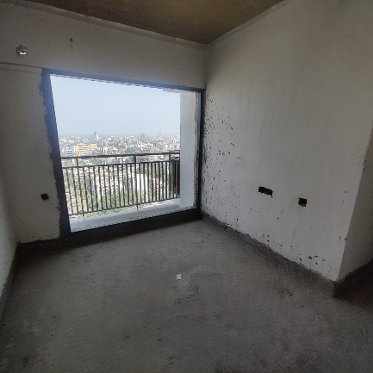
Actual Site Photographs as on 27.04.2023

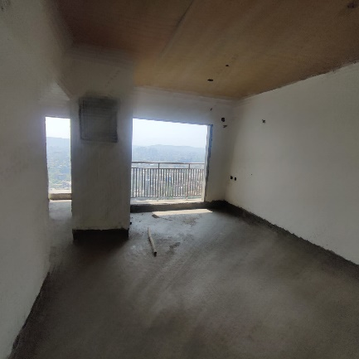
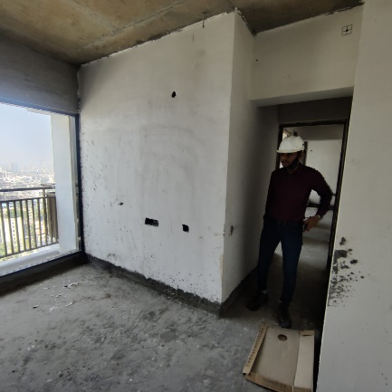
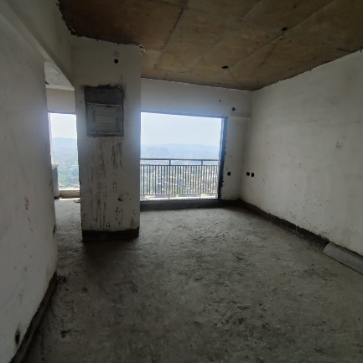
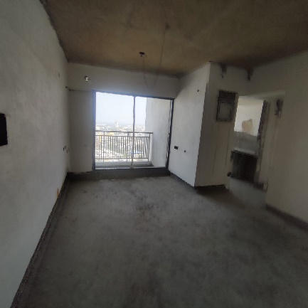
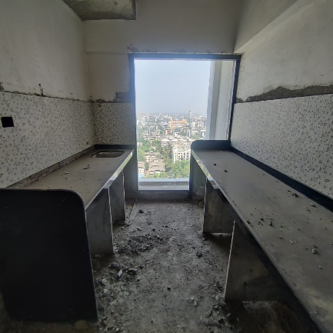
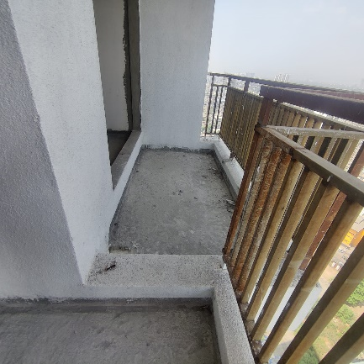
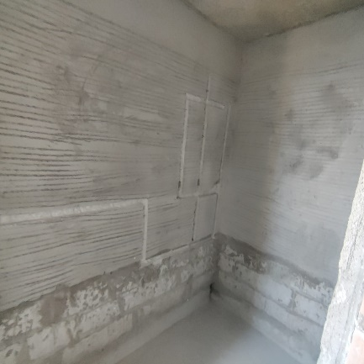
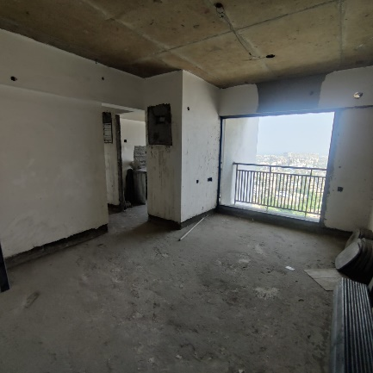
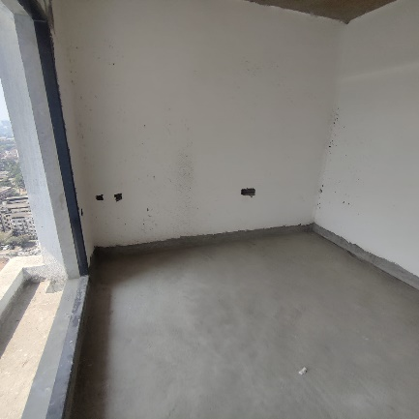
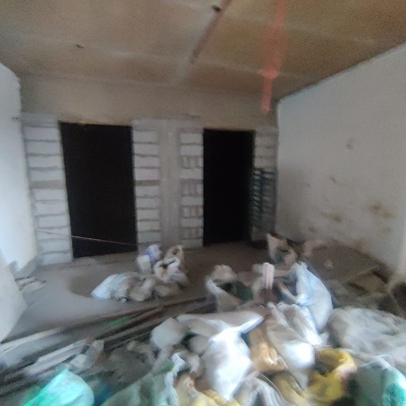
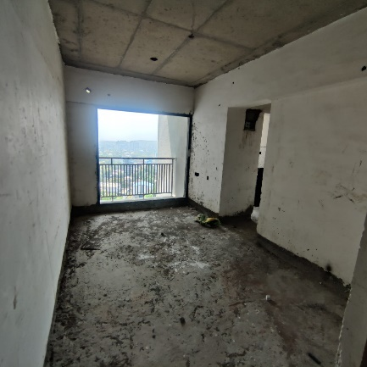
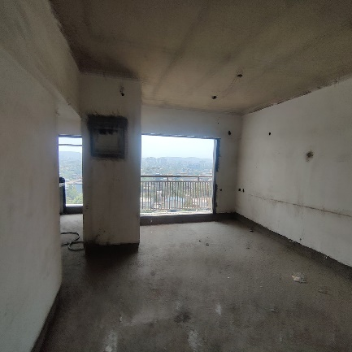
Actual Site Photographs as on 27.04.2023

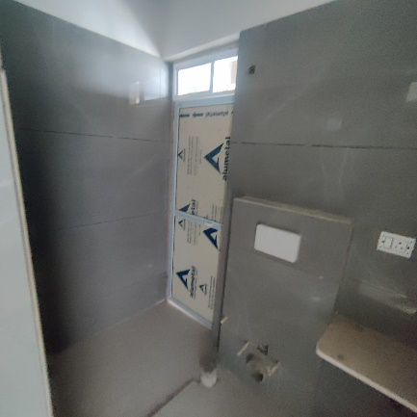
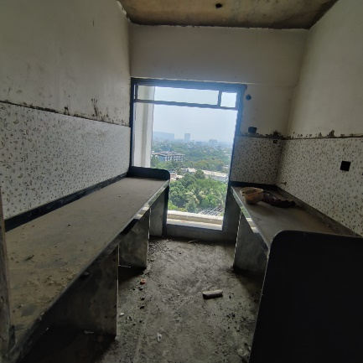
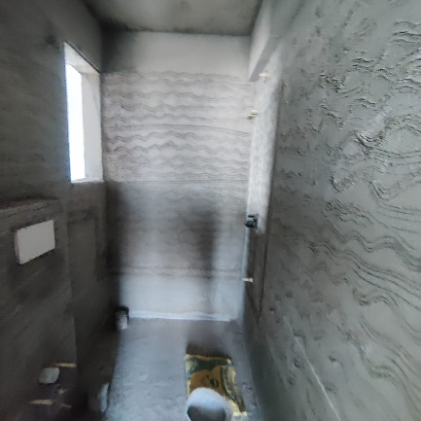
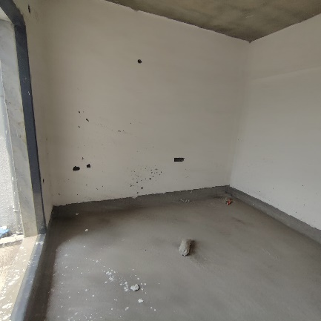
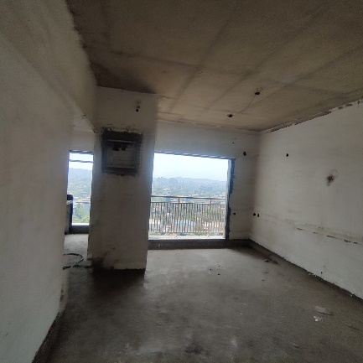
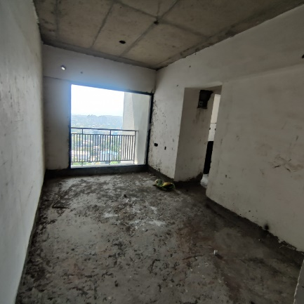
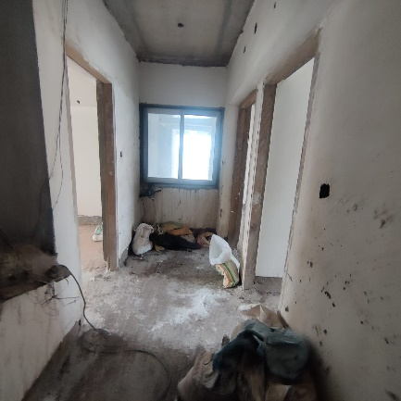
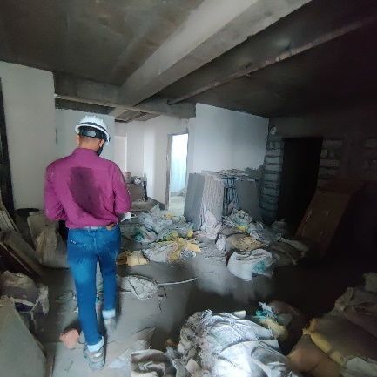
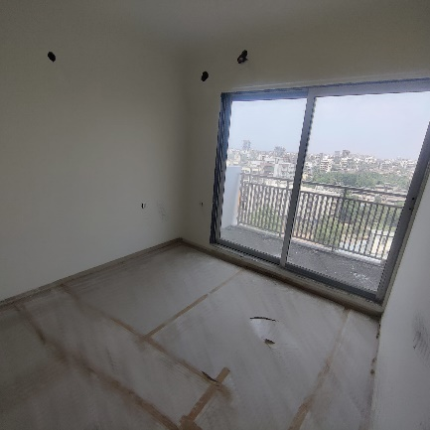

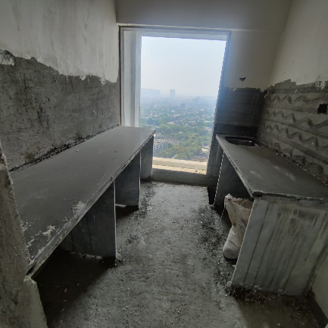
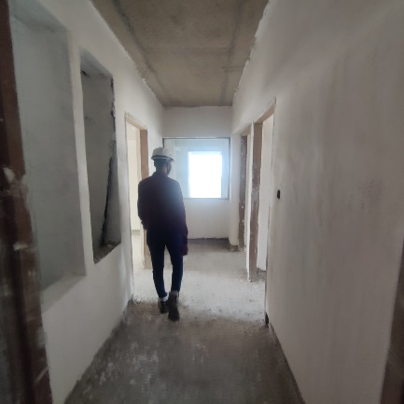
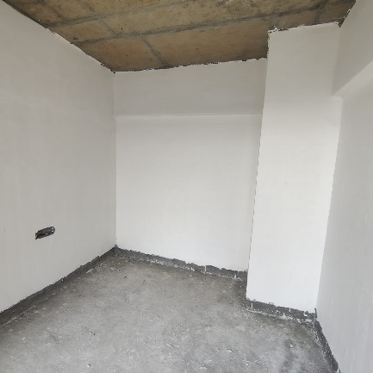
Actual Site Photographs as on 27.04.2023

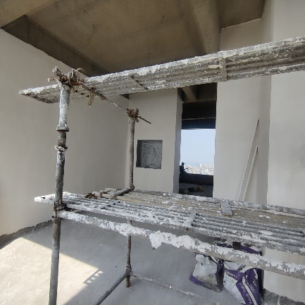
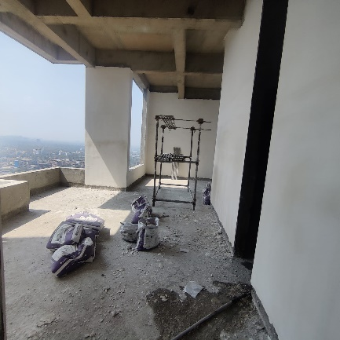
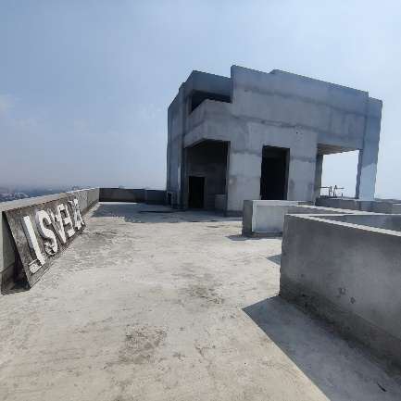
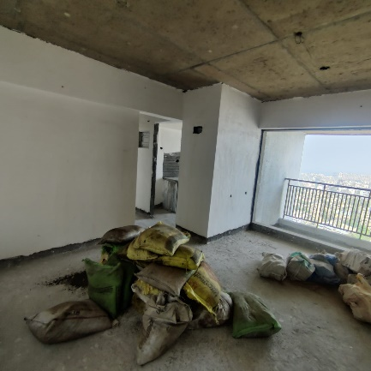
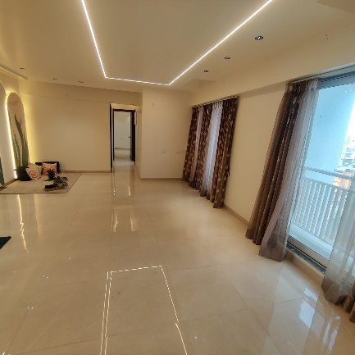
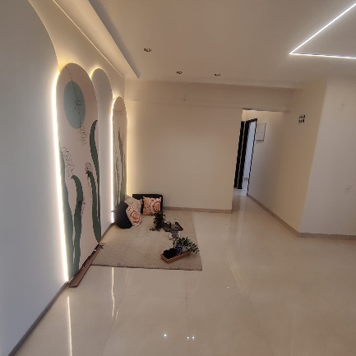
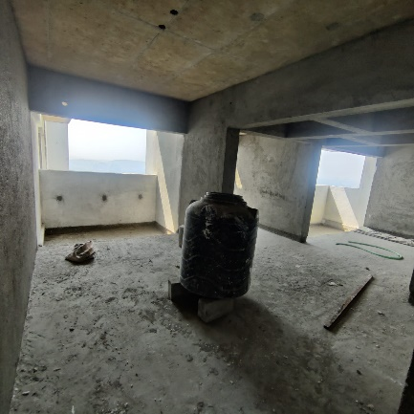
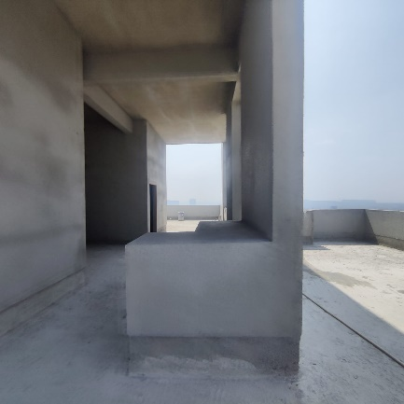
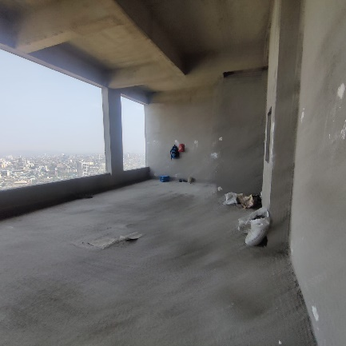

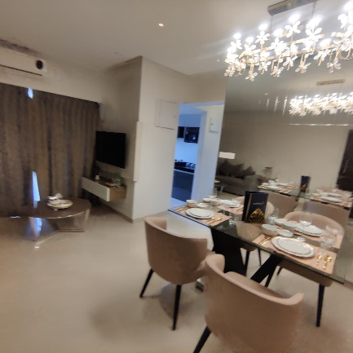
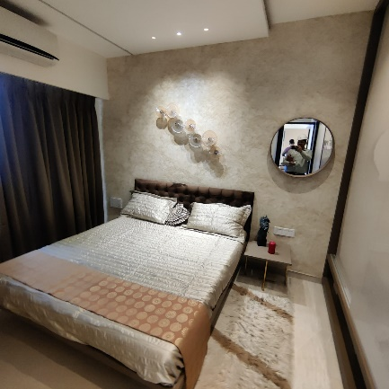
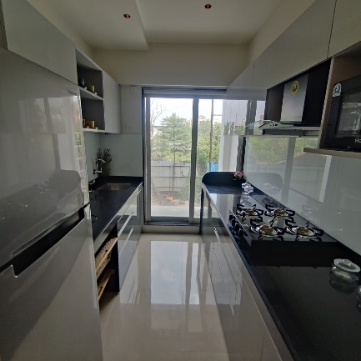
Actual Site Photographs as on 27.04.2023

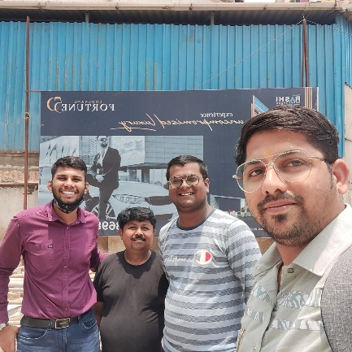
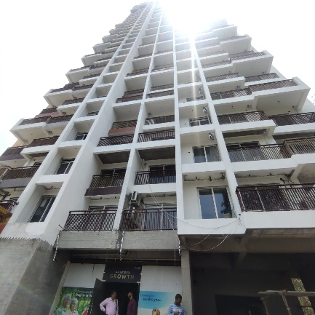
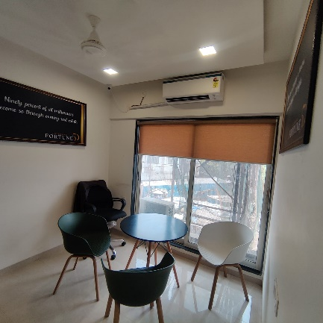
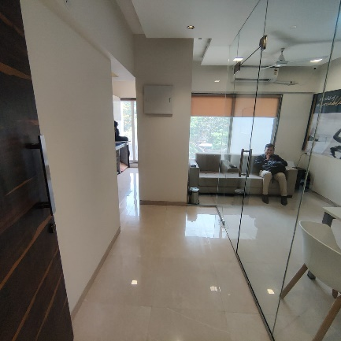
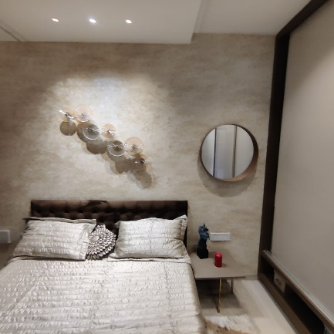
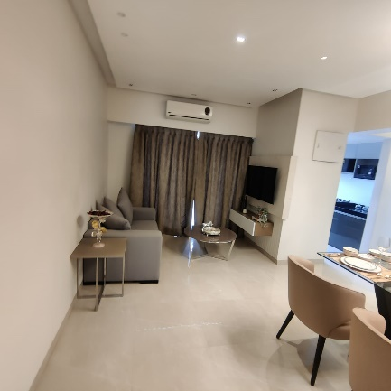
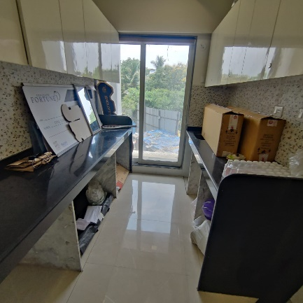
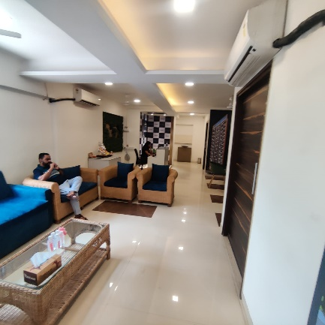
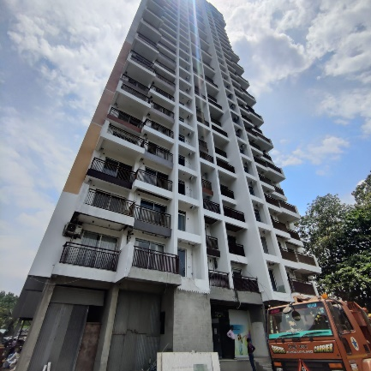

Route Map of the property
Site u/r
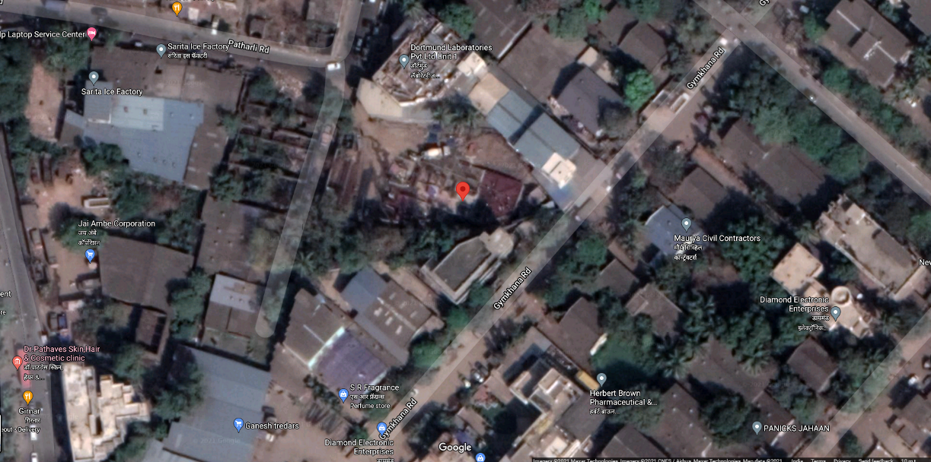

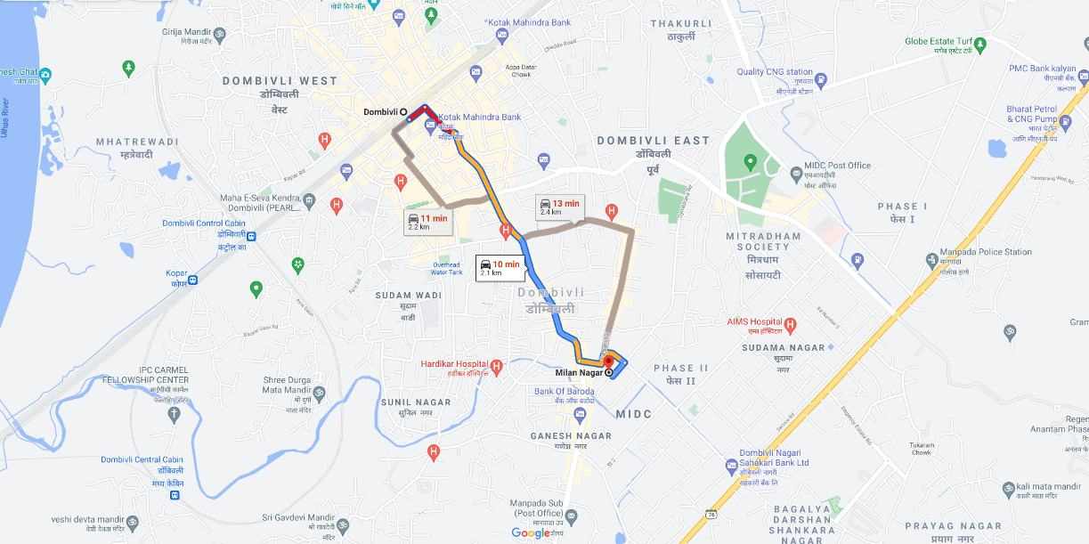

Latitude Longitude: 19°12'22.2"N 73°05'48.4"E

Note: The Blue line shows the route to site from nearest railway station (Dombivli – 2.10 Km.)

CA Certificate Dated 29.04.2023 till 31.03.2023
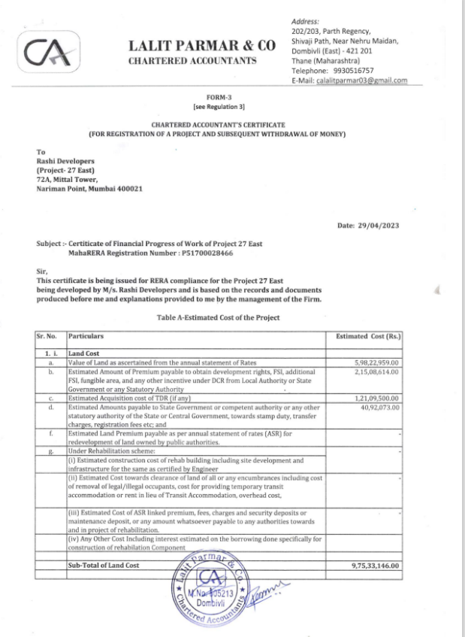

CA Certificate Dated 29.04.2023 till 31.03.2023
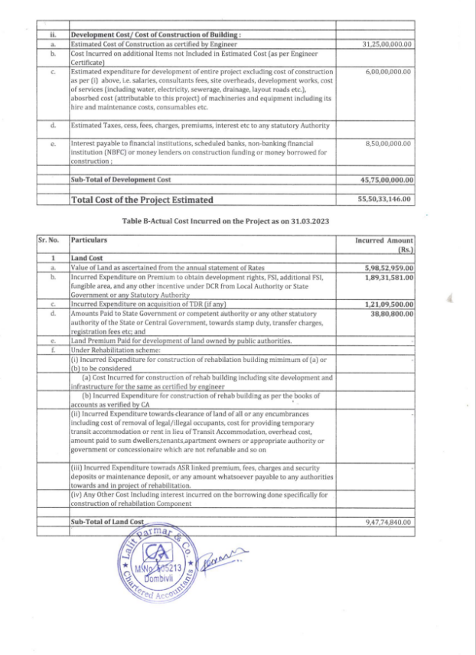

CA Certificate Dated 29.04.2023 till 31.03.2023
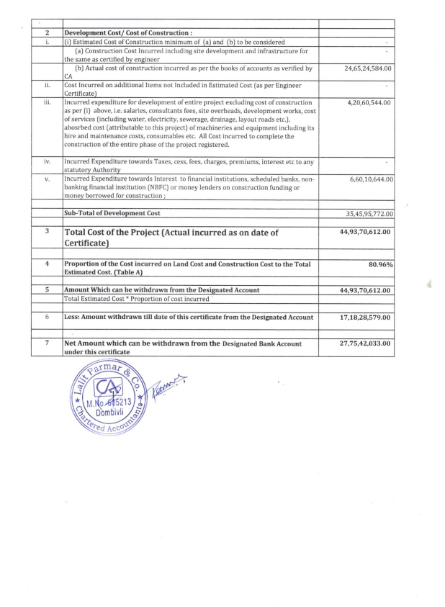

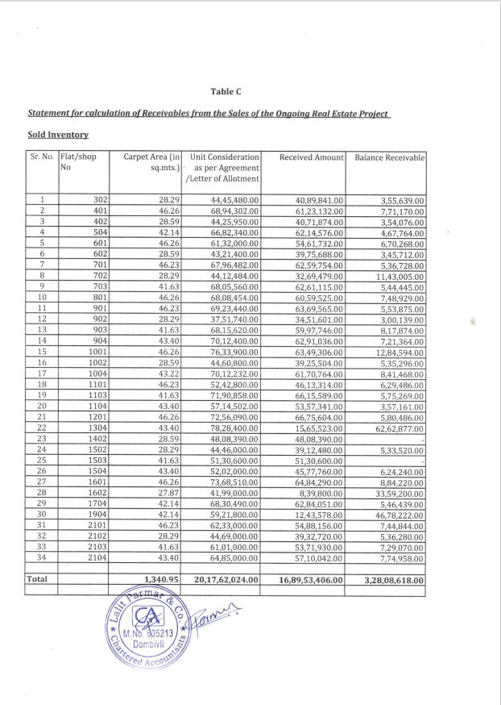
CA Certificate Dated 29.04.2023 till 31.03.2023

CA Certificate Dated 29.04.2023 till 31.03.2023
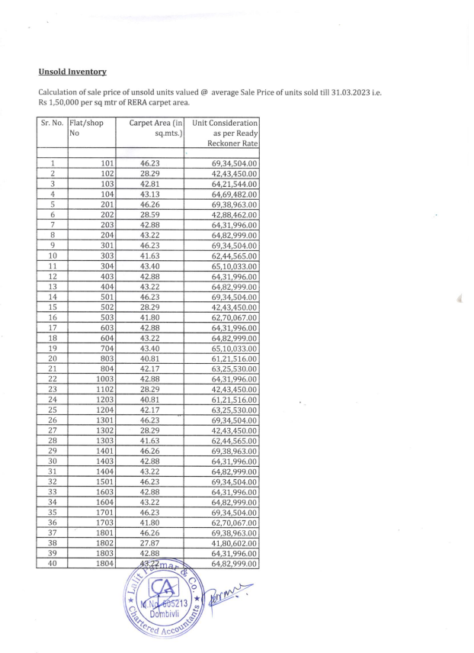

CA Certificate Dated 29.04.2023 till 31.03.2023
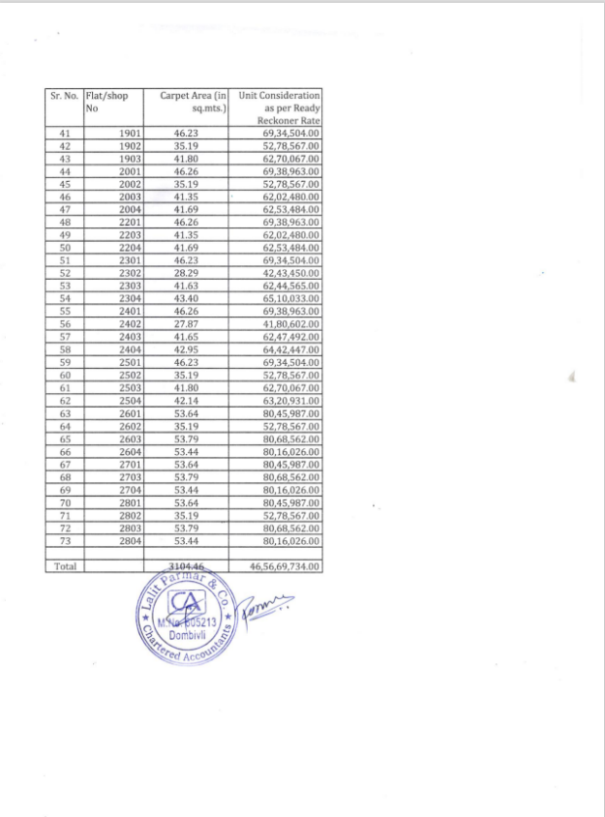
CA Certificate Dated 29.04.2023 till 31.03.2023
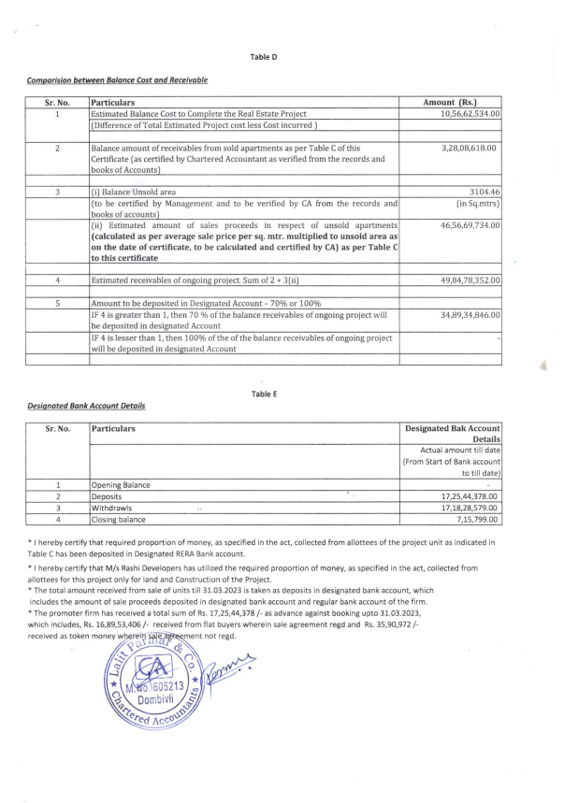

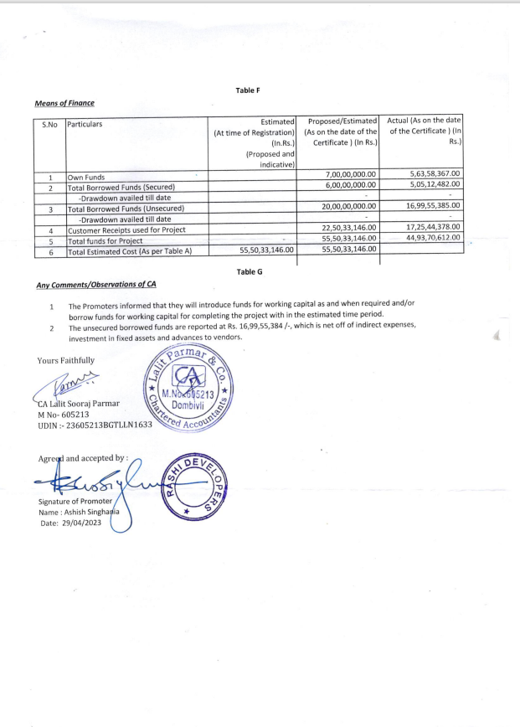
CA Certificate Dated 29.04.2023 till 31.03.2023

