Vastu/Mumbai/06/2023/31714/2300963

06/03-71-NIP

Date: 06.06.2023

**Structural Stability Report**

Structural Observation Report of Residential Flat No. 701, 7th Floor, C Wing, Building No. 1, **“N. G. Suncity Phase - I Co-op. Hsg. Soc. Ltd.”**, Thakur Village, Village – Poisar, Kandivali (East), Mumbai – 400 101, State – Maharashtra, Country – India.

**Name of Owner**: **Mr. Suresh D. Pathak & Mrs. Suman S. Pathak.**

This is to certify that on visual inspection, it appears that the structure of the building **" N. G. Suncity Phase - I Co-op. Hsg. Soc. Ltd.",** is in normal condition and the future life can be reasonably takes under normal working condition and with proper periodic repairs & maintenance is about 42 years.

**General Information**:

|  |  |  |
| --- | --- | --- |
| **A.** | **Introduction** | |
| 1 | Name of Building | **“N. G. Suncity Phase - I Co-op. Hsg. Soc. Ltd.”** |
| 2 | Property Address | Residential Flat No. 701, 7th Floor, C Wing, Building No. 1, **“N. G. Suncity Phase - I Co-op. Hsg. Soc. Ltd.”**, Thakur Village, Village – Poisar, Kandivali (East), Mumbai – 400 101, State – Maharashtra, Country – India |
| 3 | Type of Building | Residential use |
| 4 | No. of Floors | Ground + 8 Upper Floors |
| 5 | Whether stilt / podium / open parking provided | Covered Parking space |
| 6 | Type of Construction | R.C.C. Framed Structure |
| 7 | Type of Foundation | R.C.C. Footing |
| 8 | Thickness of the External Walls | 9” thick brick walls both side plastered |
| 9 | Type of Compound | Brick Masonry Walls |
| 10 | Year of Construction | 2005 (Occupancy Certificate) |
| 11 | Present age of building | 18 Years |
| 12 | Residual age of the building | 42 years Subject to proper, preventive periodic maintenance & structural repairs. |
| 13 | No. of flats (Per Floor) | 5 Flats on 7th Floor |
| 14 | Methodology adopted | As per visual site inspection |

|  |  |  |
| --- | --- | --- |
| **B.** | **External Observation of the Building** | |
| 1 | Plaster | Normal Condition |
| 2 | Chajjas | Normal Condition |
| 3 | Plumbing | Normal Condition |
| 4 | Cracks on the external walls | Not Found |
| 5 | Filling cracks on the external walls | Not Found |
| 6 | Cracks on columns & beams | Not Found |
| 7 | Vegetation | Not Found |
| 8 | Leakages of water in the drainage pipes or water pipes | Not Found |
| 9 | Dampness external in the wall due to leakages | Found |
| 10 | Any other observation about the condition of external side of the building | The external condition is Normal |
| **C** | **Internal Observation of the common areas of the building and captioned premises** | |
| 1 | Beams (Cracks & Leakages) | Normal Condition |
| 2 | Columns (Cracks & Leakages) | Normal Condition |
| 3 | Ceiling (Cracks & Leakages) | Normal Condition |
| 4 | Leakages inside the property | Not Found |
| 5 | Painting inside the property | Good |
| 6 | Maintenance of staircase & cracks | Normal |

|  |  |  |
| --- | --- | --- |
| **D** | **Common Observation** | |
| 1 | Structural Audit of the Building Under Bye – Laws No. 77 of the Model Bye Laws (Co-Operative Societies Act / Rules) | As per Bye Laws No. 77 of Co-Op. Societies Bye Laws under the Act the society shall conduct a Structural Audit of the building of the society as follows |
| 2 | Remark | No Structural Audit Report is furnished for the perusal |

|  |  |
| --- | --- |
| **E** | **Conclusion** |
| The captioned building is having Ground + 8 upper ﬂoors which is constructed in year 2005 (as per Occupancy Certificate). Estimated future life under present circumstances is about 37 years subject to proper, preventive periodic maintenance & structural repairs.  The inspection dated 03.06.2023 reveals no structural damage or deterioration to the building. The building as well as the property is maintained normally and will stand future life subject to proper, preventive periodic maintenance & structural repairs. The internal crack in one column/wall needs immediate structural repairs.  Our Observations about the structure are given as above.  `  The above assessment is based on visual inspection only. | |

## Sharadkumar B. Chalikwar

Govt. Reg. Valuer

Chartered Engineer (India)

Reg. No. (N) CCIT/1-14/52/2008-09

SBI Empanelment No.: SME / TCC / 2016-17 / 156 / Sr. No. - 193

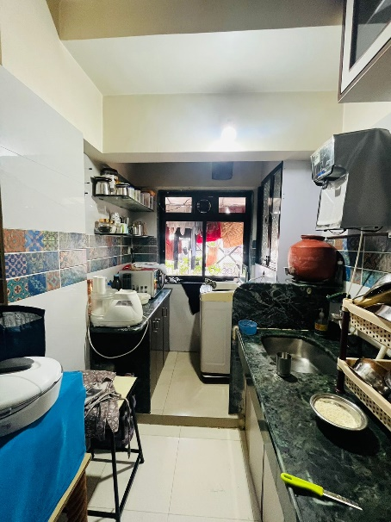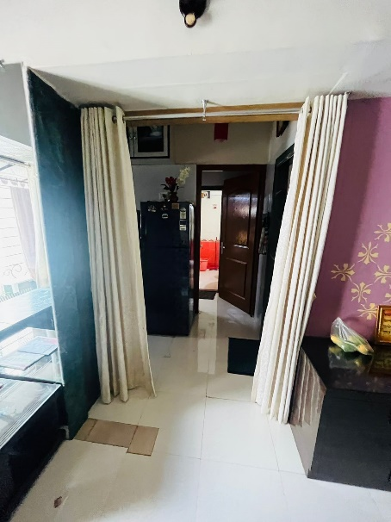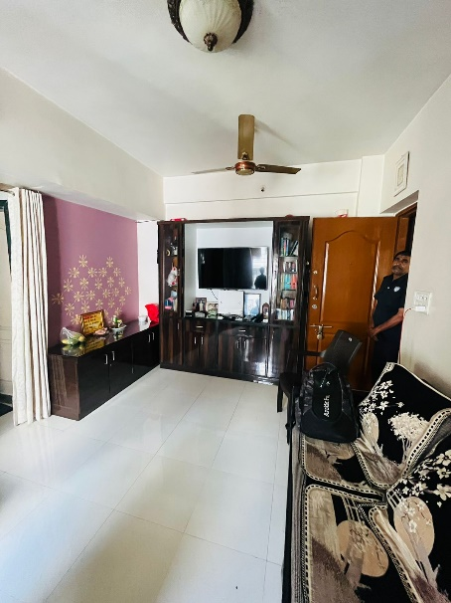**Actual site photographs**

