Vastu/Nashik/05/2023/31500/2300754
24/03-365-SKVS
Date: 24.05.2023

To,
Union Bank of India
Nashik City Branch
Navondar Sankul, 1366, M-1,
RACCA Colony, Sharanpur Road, Nashik,
PIN – 422002, State - Maharashtra, Country – India.

Sub: Vetting of Estimates

Sir,

With reference to above subject, we have evaluated the estimates for Construction of Residential Bungalow bearing Plot No. 8, Ground Floor, “The Aishwarya Co-op. Hsg. (Service) Soc. Ltd.”, Plot No. 1207, Near National High School, GIDC, Ankleshwar, Taluka – Ankleshwar, District – Bharuch, PIN – 393001, State - Gujarat, Country – India belonging to Mrs. Vijaya Ranoji Bhalerao.

We have verified the rates quoted by New Era dated 05.04.2023, which is as per current market rates. The estimated amount is ` 15,17,500.00 (Amount in words Fifteen Lakh Seventeen Thousand Five Hundred Only).

The quotation is valid upto 05.07.2023.

Thanking you

Sincerely yours

Manoj B. Chalikwar
Registered Valuer
Chartered Engineer (India)
Reg. No. CAT-I-F-1763
UBI Empanelment No.: RO/CR/30/25/2020-21
Encl: Estimate

Quotation
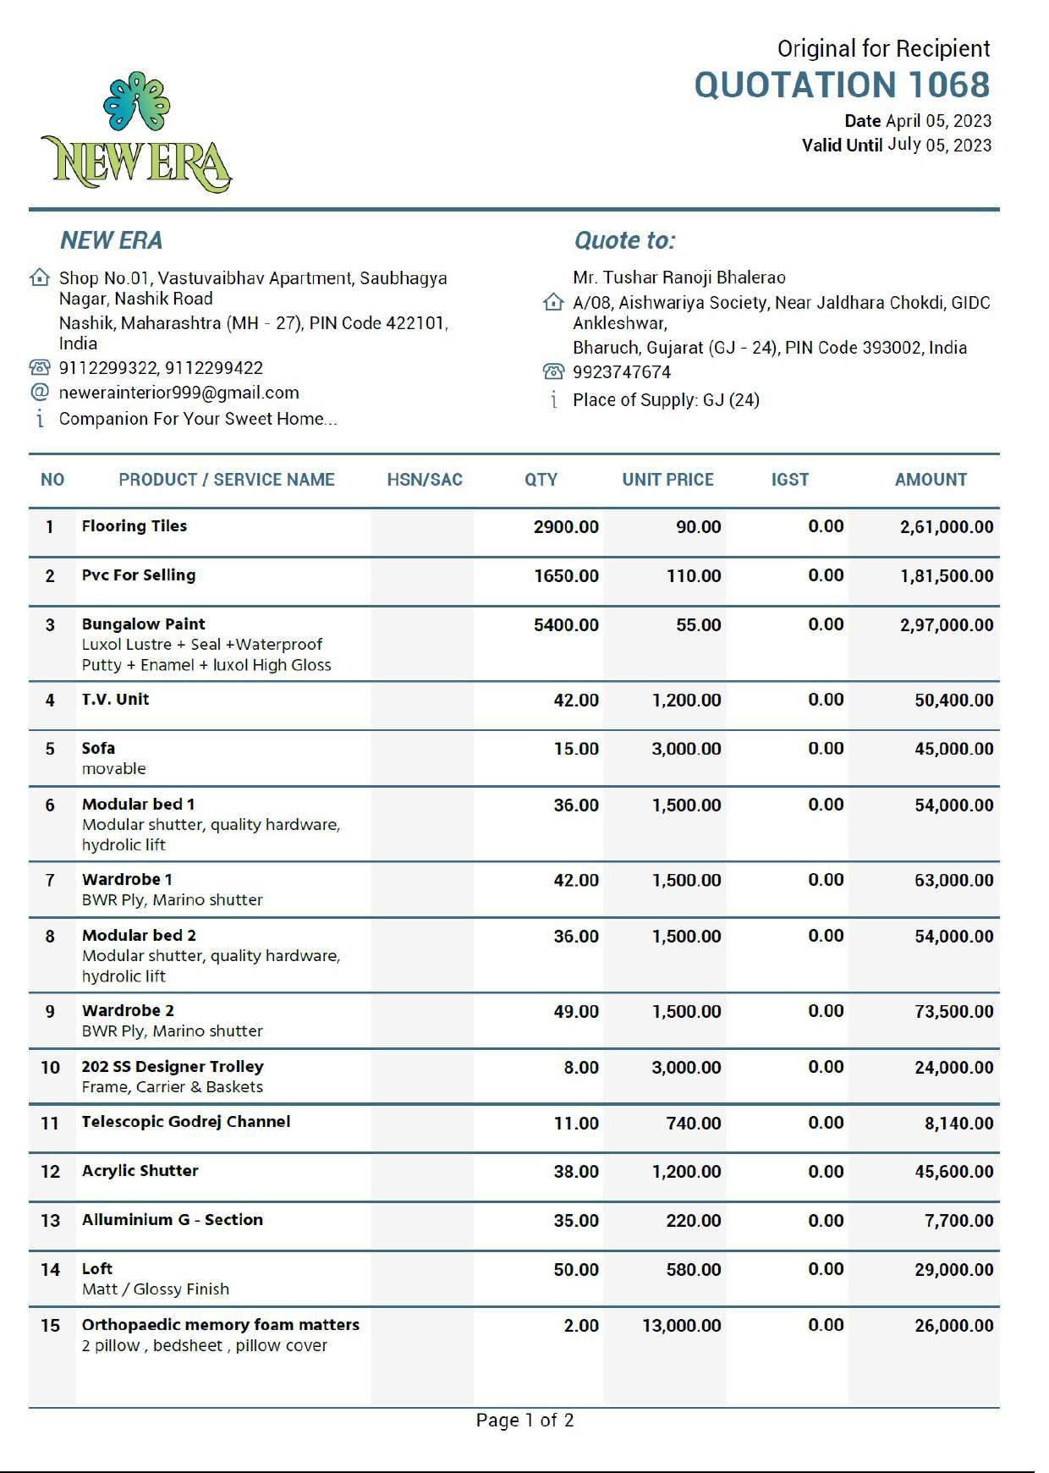

Quotation
