Vastu/Nashik/06/2023/31413/2300892
01/01-01-RPV
Date: 01.06.2023

To,
The Branch Manager
Union Bank of India
Gangapur Road Branch
Shree Ganesh Avenue, Gangapur Road,
Nashik - 422 013, State – Maharashtra, Country – India

Sub: Vetting of Extra Amenities

Sir,

With reference to above subject, we have evaluated the Extra Amenities for Residential Flat No. 403, 4th Floor, B-Wing, "Jagruti Co. Op. Hsg. Soc. Ltd.", Survey No. 552 / 1A / 6, Plot No. 2 / 9 / 10, Near Bagga Sweets, Shingada Talav, Renuka Nagar, Gadkari Chowk, Pune Road, Village – Nashik, Taluka & District - Nashik, PIN Code – 422 011, State – Maharashtra, Country – India belongs M/s. Mayur Builder & Developers. Name of Proposed Purchaser: Mr. Akshay Mukesh Merchant & Mrs. Diksha Akshay Merchant.

We have verified the rates quoted as per current market rates. Details of work and Extra Amenities considered as per copy of Agreement for Extra Amenities between Mr. Akshay Mukesh Merchant (First Party) and Mr. Palak Kalpesh Mehta (Second Party) received on dated 31.06.2023. The Extra Amenities amount is Rs. 6,00,000/- (Rupees Six Lakh Only).

The said Cost Vetting Certificate is valid upto next 6 months Only.

Thanking you

Sincerely yours

Sharadkumar B. Chalikwar
Govt. Reg. Valuer
Chartered Engineer (India)
Reg. No. (N) CCIT/1-14/52/2008-09

Agreement for Extra Amenities
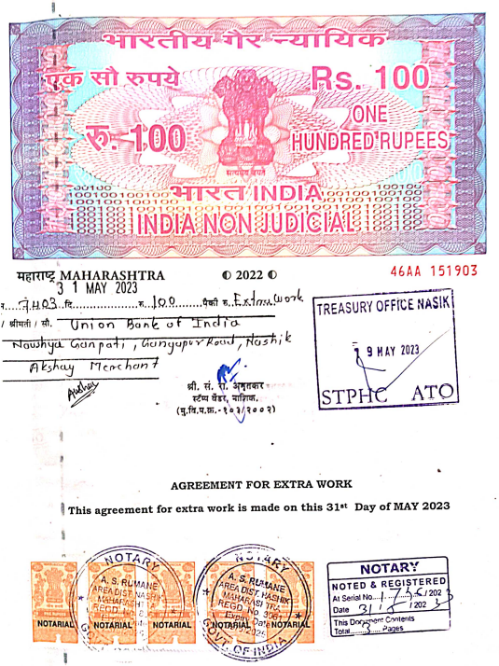
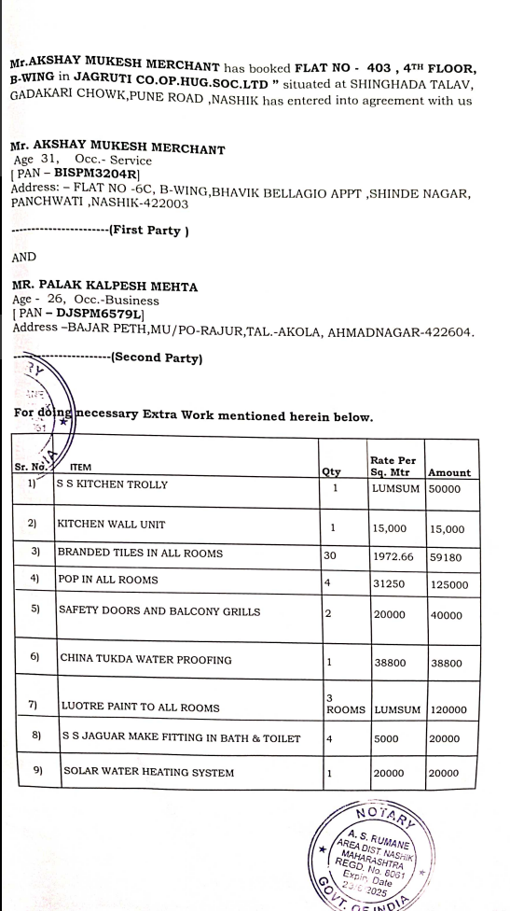

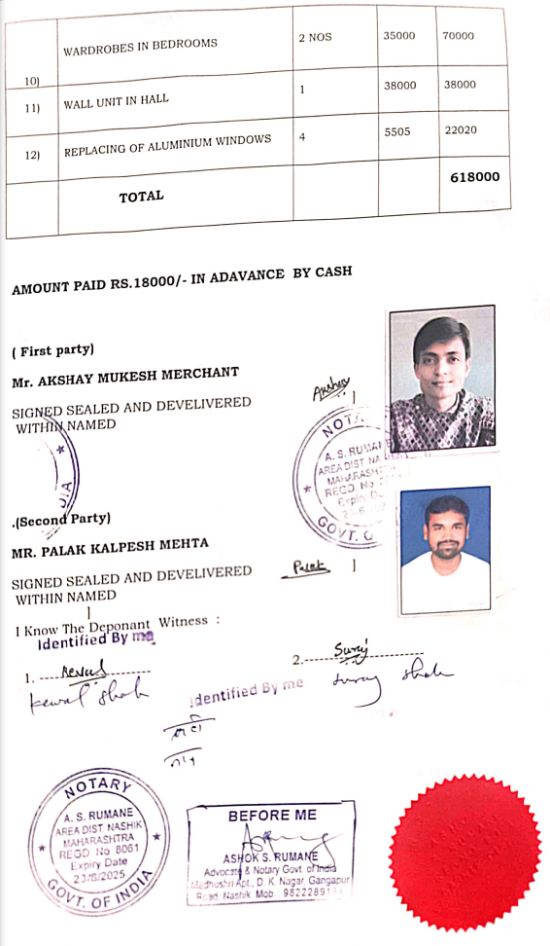

The Extra Amenities amount is Rs. 6,00,000/- (Rupees Six Lakh Only)

