Valuation Report of the Immovable Property
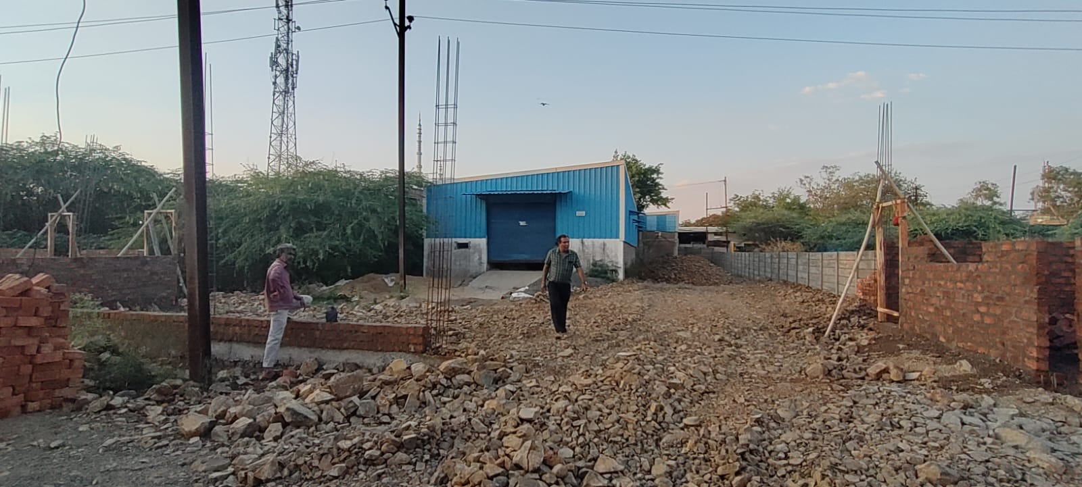

Details of the property under consideration:

Name of Owner: M/s. Shree Om Packaging

Industrial Land & TIN Shed on Plot No. 35 - B, Industrial Area Ujjain Road,
Amlavati, Village Dewas, Tehsil & District - Dewas, PIN – 455 001,
State – Madhya Pradesh, Country – India

Latitude Longitude - 22°58'48.7"N 76°02'43.4"E

Valuation Done for:

Bank of Maharashtra
Annapurna Indore Branch
56, Sudama Nagar, Annapurna Road, Indore, PIN – 452 009
State – Madhya Pradesh, Country – India

Vastu/Indore/05/2023/31388/2300772
22/24-471-AKSJAA
Date: 25.05.2023

VALUATION OPINION REPORT

The Residential property bearing Industrial Land & TIN Shed on Plot No. 35 - B, Industrial Area Ujjain Road, Amlavati, Village Dewas, Tehsil & District - Dewas, PIN – 455 001, State – Madhya Pradesh, Country – India belongs to M/s. Shree Om Packaging.

Boundaries of the property:
Boundaries | :
North | : | Road
South | : | Road
East | : | Plot No. 35A
West | : | Open Space & Nala

Considering various parameters recorded, existing economic scenario, and the information that is available with reference to the development of neighborhood and method selected for valuation, we are of the opinion that, the property premises can be assessed and valued for banking purpose at ` 1,67,38,648/- (Rupees One Crore Sixty Seven Lakh Thirty Eight Thousand Six Hundred Forty Eight Only).

The valuation of the property is based on the documents produced by the concern. Legal aspects have not been taken into considerations while preparing this valuation report.

Hence certified

Sharadkumar B. Chalikwar
Govt. Reg. Valuer
Chartered Engineer (India)
Reg. No. (N) CCIT/1-14/52/2008-09
Encl.: Valuation Report

VALUATION REPORT IN RESPECT OF IMMOVABLE PROPERTY

1. | Date of Inspection | : | 08.05.2023
2. | Purpose of valuation | : | As per request from Bank of Maharashtra, Annapurna Indore Branch to assess Fair Market Value of the property under reference for Banking purpose.
3. | Name and address of the Valuer. | : | Sharadkumar B. Chalikwar  Vastukala Consultants (I) Pvt. Ltd.  106, 1st Floor, Gold Star Tower, Opp. Treasure Island Mall, M.G. Road, Indore – 452 001
4. | Copy Of Documents Handed Over to The Valuer by The Bank | : | Amended Deed, E-Registration No. MP108942023A11797597 dated 03.05.2023 between Governor of Madhya Pradesh acting through General Manager, District Trade & Industries Centre, Dewas (the Lessor) AND M/s. Shree Om Packaging (the Lessee).
5. | Details of enquiries made/ visited to govt. Offices for arriving fair market value. | : | Market analysis and as per sub-registrar value.
6. | Factors for determining its market value. | : | Location, development of surrounding area, facilities provided and its prevailing market rate.
7. | Any Critical Aspects Associated with Property | : | No
8. | Present/Expected Income from the property | : | N.A.
 | Property Details: | :
9. | Name(s) of the Leaser and Postal address of the property under consideration. | : | M/s. Shree Om Packaging
 |  | : | Industrial Land & TIN Shed on Plot No. 35 - B, Industrial Area Ujjain Road, Amlavati, Village Dewas, Tehsil & District - Dewas, PIN – 455 001, State – Madhya Pradesh, Country - India.  Contact Person:  Mr. Vinay Panchal (Self)  Contact No.: +91 7747011067
10. | If the property is under joint ownership/ co-ownership share of each such owner/ are the share is undivided. | : | Proprietorship Concern
11. | Brief description of the property:  The immovable property comprising of Leasehold Industrial Land & TIN Shed thereof. The property is located in a developed industrial area having basic infrastructure, well connected by road and train. It is located at 3.8 KM. travelling distance from Dewas Junction Railway Station. The land is demarcated by RCC compound wall around the land except front side.  As per Amended Deed, the land has been allotted for the first 30 years to the lessee M/s. Shree Om Packaging to establishing & operating the manufacturing unit. Commencing from 19.04.2023 and ending on 24.02.2045. As per site information, the lease is renewable after expiry.  Land:  As per Amended Deed, the land area is 936.80 Sq. M. (17.07 X 54.88) equivalent to 10,084.00 Sq. Ft., which is considered for valuation.  Structure:  The property consists of Ground Floor Industrial Tin Shed with partly brick masonry wall above colour coated M.S. sheet cladding and roofing.  The composition of the TIN shed is having large working area for the purpose of establishing and operating the Manufacturing unit.  As per site measurement, the constructed TIN Shed Area is 6,009.00 Sq. Ft.  As per Amended Deed, the Shed Area is 464.68 Sq. M. equivalent to 5,002.00 Sq. Ft. which is considered for the purpose of valuation.
12. | Location of the property. (C.T.S. No., Survey No., Hissa No., Plot No., etc.). | : | Plot No. 35 - B
13. | Boundaries of the property | : | As per Actual at Site |  |  | As per Sale Deed
13. | North | : | Road |  |  | 60’ Wide Road
13. | South | : | Road |  |  | 40’ Wide Road
13. | East | : | Plot No. 35A |  |  | Plot No. 35A
13. | West | : | Open Space & Nala |  |  | Open Space & Nala
14. | Route map | : | Enclosed
15. | Any specific identification marks | : | Nearby Electrical Clinic
16. | Whether covered under Corporation/ Panchayat/ Municipality. | : | Nagar Palika Nigam Dewas
17. | Whether covered under any land ceiling of State/ Central Government. | : | No
18. | Is the land freehold/ leasehold? | : | Leasehold
19. | Are there any restrictive covenants in regard to use of Land? If so attach a copy of the covenant. | : | Industrial
20. | Type of the property- Whether | :
 | Residential | : | No
 | Industrial | : | Yes
 | Commercial | : | No
 | Institutional | : | No
 | Government | : | No
 | Non – Government | : | No
 | Other (Specify) | : | N.A.
21. | In case of Agricultural land
 | Any conversion to House site is obtained | : | N.A.
 | Whether the land is dry or wet. | : | N.A.
 | Availability of irrigation facilities | : | N.A.
 | Type of crops grown | : | N.A.
 | Annual yield or income. | : | N.A.
22. | Year of acquisition/ purchase. | : | Amended Deed, E-Registration No. MP108942023A11797597 dated 03.05.2023
23. | Whether the property is occupied by owner or tenant. If occupied by tenant since how long he is staying, and the amount of rent being paid. | : | Vacant under owner possession
24. | Classification of the site. | :
 | a. Population group. | : | Urban
 | b. High/ Middle/ Poor class | : | Middle class
 | c. Residential/ nonresidential. | : | Industrial
 | d. Development of surrounding area. | : | Developed
 | e. Possibility of any threat to the property. (Floods, calamities etc.). | : | No
25. | Proximity of civic amenities.  (Like school, hospital, bus stop, market etc.). | : | All available nearby
26. | Level of the land (Plain, rock etc.) | : | Plain
27. | Terrain of the Land. | : | Leveled
28. | Shape of the land (Square/ rectangle etc.). | : | Rectangular (As per site)
29. | Type of use to which it can be put (for construction of house, factory etc.). | : | Industrial
30. | Any usage restrictions on the property. | : | Industrial
31. | Whether the plot is under town planning approved layout? | : | Under Nagar Palika Nigam (Dewas)
32. | Whether the building is intermittent or corner? | : | Intermittent
33. | Whether any road facility is available? | : | Yes
34. | Type of road available (B.T. / Cement Road etc.). | : | B.T. Road
35. | Front Width of the Road? | : | More than 20 ft.
36. | Source of water & water potentiality. | : | Borewell
37. | Type of Sewerage System. | : | Sewerage line
38. | Availability of power supply. | : | Yes
39. | Advantages of the site. | : | Located in a developed Industrial Area Ujjain Road Dewas
40. | Disadvantages of the site. | : | None
41. | Give instances of sales of immovable property in the locality on a separate sheet, indicating the name & address of the property, registration No. sale price and area of land sold. | : | As per Sub-Registrar of Assurance records
 | Valuation of the property:
42. | 1) Dimensions of the plot | : | North - South = 17.07 M.  East - West = 54.88 M.
43. | 2) Total area of the plot | : | 10,084.00 Sq. Ft.  (As per Amended Deed)
44. | 3) Prevailing Market Rate/Price trend of the Property in the locality/city from property search sites viz magickbricks.com, 99acres.com, makaan.com etc. if available | : | ` 1,000/- to ` 1,500/- per Sq. Ft. for Industrial land
45. | 4) Government Rate obtained from the online government records of Land | : | ` 7,000/- per Sq. M.  i.e. ` 650/- per Sq. Ft.
46. | Building |  | ` 600/- per Sq. Ft. on Built-up Area
Structure
Floor | BUA Area in  Sq. Ft. | Year Of Const | Total Life of Structure | Replacement Rate (`) | Age Of Build. | Dep. Rate (`) | Dep. Value  (`)
Ground | 5,002.00 | 2016 | 43 Years | 600/- | 7 Years | 524/- | 26,21,048/-
Total |  |  |  |  |  |  | 26,21,048/-

47. | - Government Value
 | Particulars | : | Area in Sq. Ft. |  | Rate in ` |  | Value in `
 | Land | : | 10,084 |  | 650/- |  | 65,54,600/-
 | Structure |  | As per valuation table |  |  |  | 26,21,048/-
 | Total |  |  |  |  |  | 91,75,648/-
 | 5) Assessed/ adopted rate of valuation. |  | ` 1,400.00 per Sq. Ft. for Industrial Land.
48. | - Fair Market Value
 | Particulars | : | Area in Sq. Ft. | Rate in ` |  |  |  | Value in `
 | A) Land |  | 10,084.00 | 1,400/- |  |  |  | 1,41,17,600/-
 | B) Building |  | As per valuation table |  |  |  |  | 26,21,048/-
 | 6) Total Value (A + B) |  |  |  |  |  |  | 1,67,38,648/-
 | a. Technical details of the Plot:
49. | Type of Plot (Residential/ Commercial/ Industrial). | : | Industrial
50. | Year of construction. | : | 2016  Age of the structure – 07 Years
51. | Future life of the property. | : | 43 years, Subject to proper, preventive periodic Maintenance & structural repairs
52. | No. of floors and height of each floor including basement. | : | Ground floor TIN shed
53. | Plinth area of each floor | : | TIN Shed Constructed Area = 5,002.00 Sq. Ft.  (As per Amended Deed)
54. | Type of construction.  (Load bearing/ R.C.C. / Steel framed). |  | M.S. structure
 | Condition of the building. | :
55. | External (excellent/ good/ normal/ poor). | : | Normal
56. | Internal (excellent/ good/ normal/ poor). | : | Normal
 | Remarks: | :
57. | b. Specifications of Construction:
 | Foundation. | : | R.C.C.
 | Basement. | : | N.A.
 | Superstructure. | : | M.S. Framed structure with partly brick masonry wall upto 7’0” above colour coated MS sheet cladding and roofing.
 | Joinery/ Doors & Windows. | : | M.S. rolling shutters
 | RCC work. | : | R.C.C. Foundation
 | Plastering. | : | Partly Cement Plastering above G.I. sheet cladding
 | Flooring, Skirting. | : | P.C.C. Flooring
 | Kitchen Pantry Platform | : | N.A.
 | Whether any weather proof course is provided. | : | N.A.
 | Drainage. | : | Connected to Gram Panchayat Sewage System
 | Compound wall (Height, length and type of construction). | : | RCC compound wall around the land
 | Electric installation (Type of wire, Class of fittings) | : | Industrial wiring  As per requirements
 | Plumbing installation (No. of water closets & wash basins etc.) | : | As per requirements
 | Bore well. | : | Yes
 | Wardrobes, if any. | : | No
 | Development of open area | : | Open levelled

 | Summary of Valuation | :
 | Total Value of the Property | : | ` 1,67,38,648/-
 | Realizable Value | : | ` 1,50,64,783/-
 | Forced/ Distress Sale value. | : | ` 1,33,90,918/-
 | Insurable value of the property  (Full Replacement Cost (30,01,200/-) – Subsoil structure cost (15%) | : | ` 25,51,020/-
 | Remarks: | :

1,

Justification for price /rate
The Market Value of the property is based on facts of markets discovered by us during our enquiries, however the government rate value in this case is less than the market value arrived by us. We are of the opinion that the value arrive by us will prove to be correct if an Auction of the subject property is carried out. As far as Market Value in Index II is concerned, it is not possible to comment on same, may be government rates are fixed by sampling during same point of time in part and whereas, Market values change every month.

In most of the cases the actual deal amount or Transaction value is not reflected in Index II because of various Market practices. As Valuer, we always try to give a value which is correct reflection of actual transaction value irrespective of any factors in market.
Actual site photographs
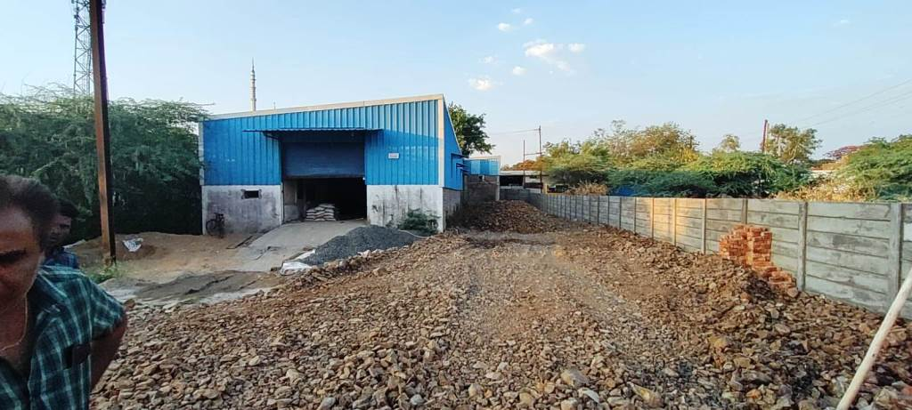
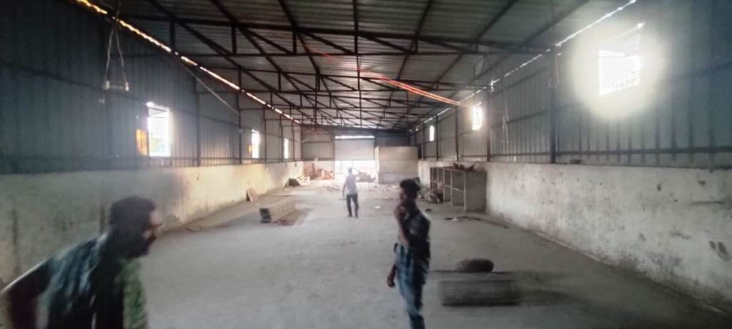

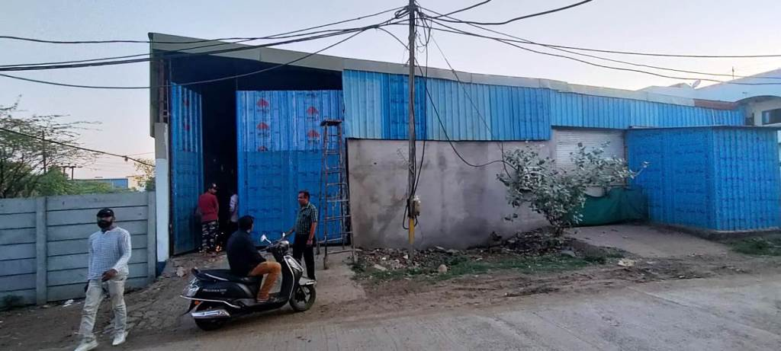
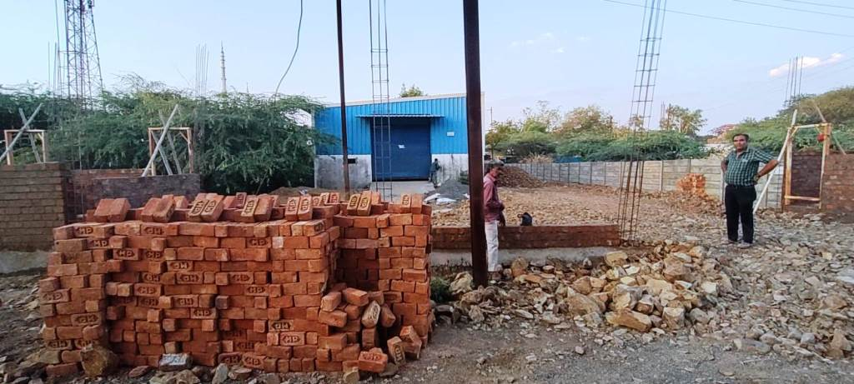

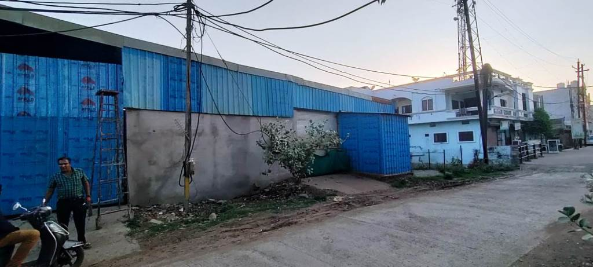
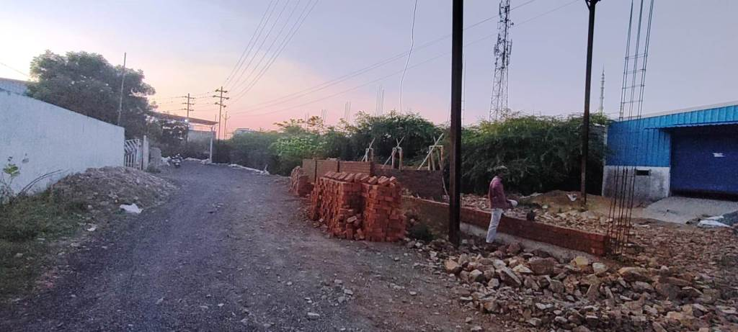

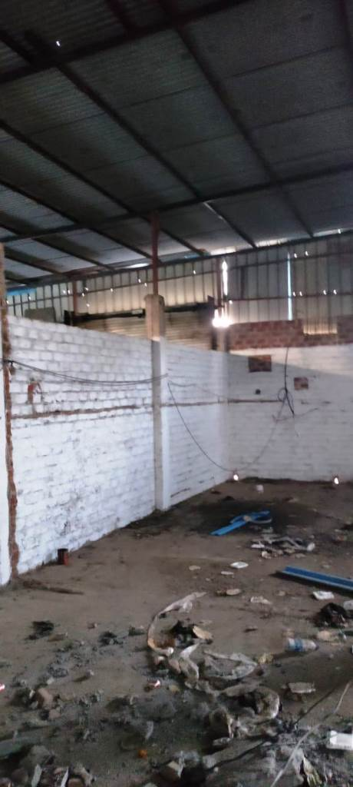
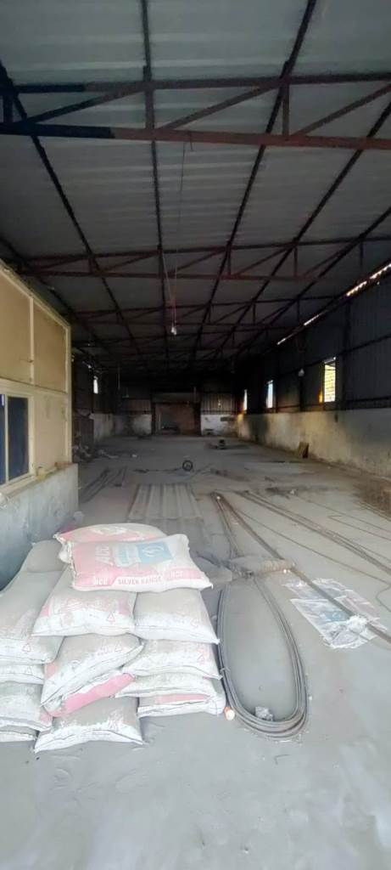
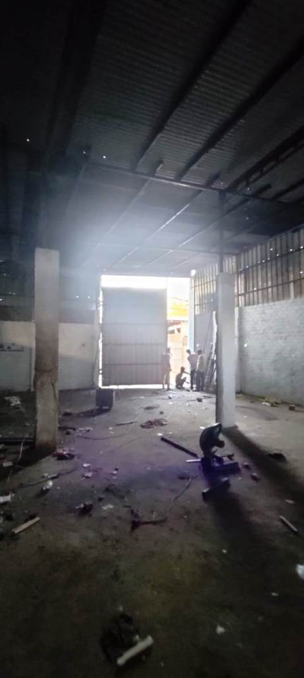

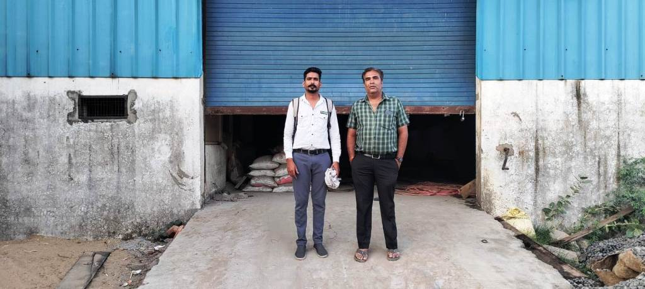

Route Map of the property
Site u/r
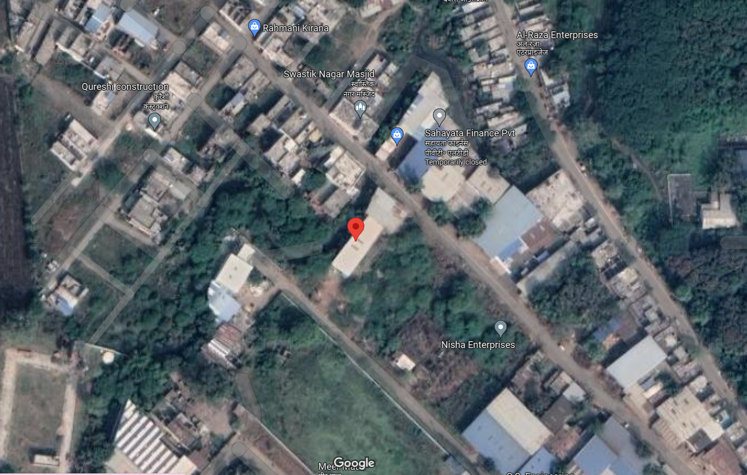

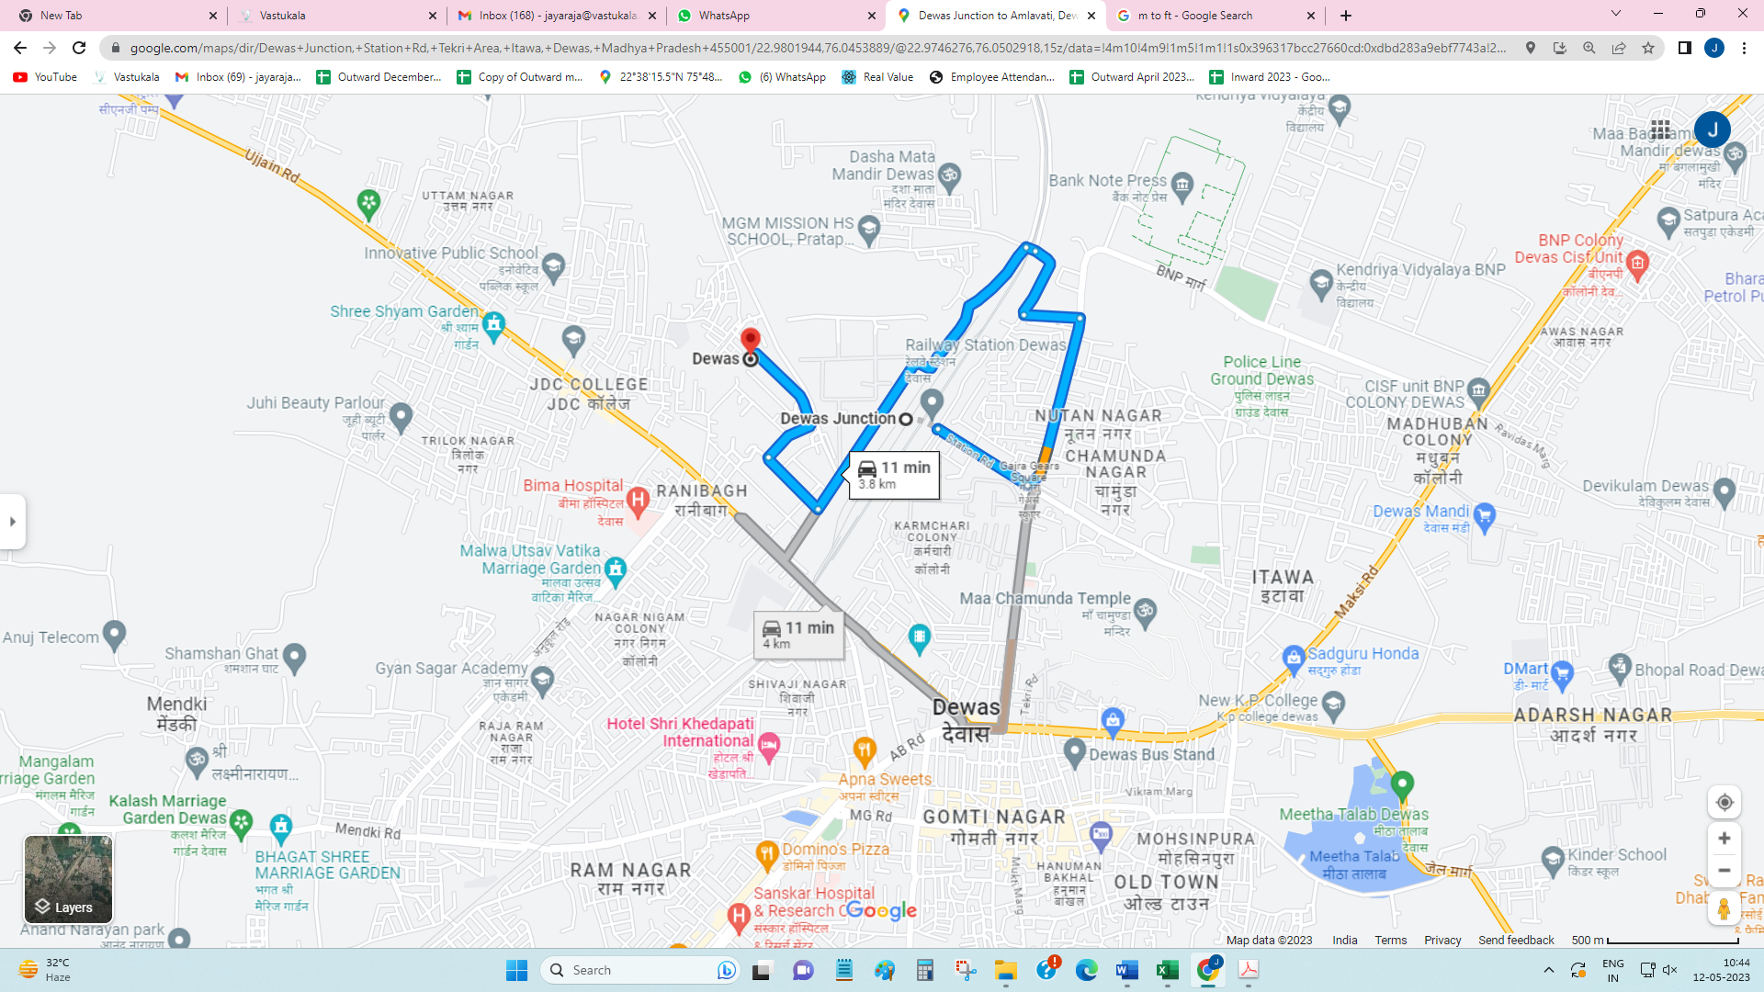

Latitude Longitude - 22°58’48.7”N 76°02’43.4”E
Note: The Blue line shows the route to site from nearest railway station (Dewas Junction – 3.8 KM.)

Government Guideline Rate
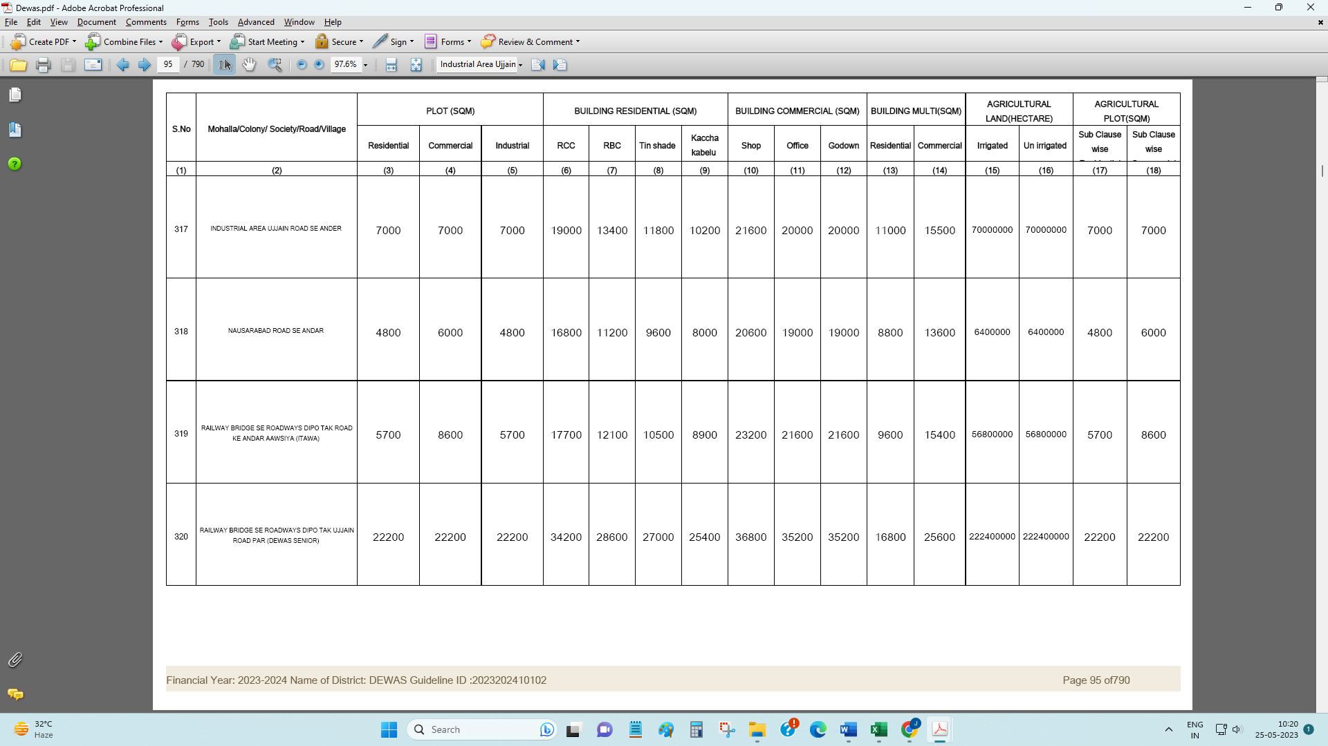

DEFINITION OF VALUE FOR THIS SPECIFIC PURPOSE

This exercise is to assess Fair Market Value of the property under reference for purpose as on 25th May 2023.

The term Fair Market Value is defined as

"The most probable price, as of a specified date, in cash, terms equivalent to cash, or in other precisely revealed terms for which the specified property rights would sell after reasonable exposure in a competitive market under all conditions requisite to a fair sale, with the buyer and seller each acting prudently knowledgeably and for self-interest assuming that neither is under undue duress"

Fundamental assumptions and conditions presumed in this definition are:

- Buyer and seller are motivated by self-interest.

- Buyer and seller are well informed and are acting prudently.

- The property is exposed for a reasonable time on the open market.

- Payment is made in cash or equivalent or in specified financing terms.

ASSUMPTIONS, CAVEATS, LIMITATION AND DISCLAIMERS
- We assume no responsibility for matters of legal nature affecting the property appraised or the title thereto, nor do we render our opinion as to the title, which is assumed to be good and marketable.
- The property is valued as though under responsible ownership.
- It is assumed that there are no hidden or unapparent conditions of the subsoil or structure that would render it more or less valuable. No responsibility is assumed for such conditions or for engineering that might be required to discover such factors.
- There is no direct/ indirect interest in the property valued.
- The rates for valuation of the property are in accordance with the Govt. approved rates and prevailing market rates.

Sharadkumar B. Chalikwar
Govt. Reg. Valuer
Chartered Engineer (India)
Reg. No. (N) CCIT/1-14/52/2008-09

