WORK PROGRESS REPORT
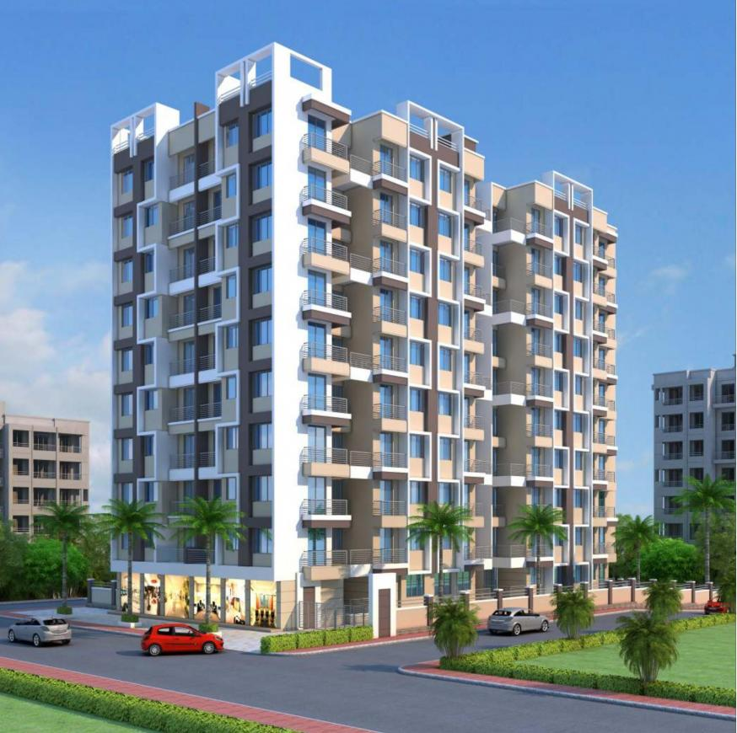

Details of the property under consideration:

Name of Project: "JP Symphony Building. No. 5"

“JP Symphony Building. No. 5”, Proposed Residential Buildings on Survey No. 138, Hissa No. 1,
Survey No. 139, Hissa No. 12, CTS No. 9467, 9469, Gaikwad Pada, Kailash Colony, Mouje – Ambernath,
Taluka – Ambernath, District – Thane, Pin Code – 421 501, State – Maharashtra, Country – India

Latitude Longitude: 19°11'27.6"N 73°10'12.7"E

Bank of India
SME City Centre Branch
Sector No. 11, Plot No. 11, Bank of India Bldg,
Ground Floor, C. B. D. Belapur, Navi Mumbai,
Pin Code – 400 614, State - Maharashtra, Country – India

Vastu/BOI/MUMBAI/31261/2300426
04/04-47-PY
Date: 05.05.2023

Work Progress Report

The property bearing “JP Symphony Building. No. 5”, Proposed Residential Buildings on Survey No. 138, Hissa No. 1, Survey No. 139, Hissa No. 12, CTS No. 9467, 9469, Gaikwad Pada, Kailash Colony, Mouje – Ambernath, Taluka – Ambernath, District – Thane, Pin Code – 421 501, State – Maharashtra, Country – India belongs to M/s. Risali Developers.

Boundaries of the property.
North | Internal Road & JP Symphony Building 1 & 2
South | Open Plot
East | Open Plot
West | JP Symphony Building

The project proposed is under construction, which is considered for project approval. Building consists of proposed Stilt Floor + 1st to 7th Upper Residential Floors. The work completion stage is as follows:
Sr. No. | Particulars | Final Percentage | Actual Percentage | Remark
1 | RCC Footing/Foundation | 5.00 | 5.00 | Completed
2 | RCC Plinth | 5.00 | 5.00 | Completed
3 | Full Building RCC | 40.00 | 40.00 | All the floor slab work is completed
4 | Internal Brick work | 7.00 | 7.00 | Brick work is completed
5 | External Brickwork | 7.00 | 7.00 | Brick work is completed
6 | Internal plastering | 3.50 | 3.50 | Plastering work is completed
7 | External plastering | 3.50 | 3.50 | Plastering work is completed
8 | Doors & Windows | 5.00 | -
9 | Flooring, Tiling, Kitchen Platform | 10.00 | 1.50 | 1st Floor tiling, flooring & passage work is completed and 1st to 5th floor Kitchen platform partial completed & 6th & 7th floor kitchen platform is completed
10 | Internal painting | 1.50 | -
11 | External painting | 1.50 | -
12 | Electrification, plumbing & Sanitary installation | 5.00 | -
13 | Lift Installation | 2.00 | -
14 | Passage, Staircase & Lobby development | 2.00 | -
15 | External developments / Final finishing work | 2.00 | -
Total |  | 100.00 | 72.50

As per Cost Vetting Report Ref. No. Vastu/BOI/Mumbai/05/2023/31260/2300423, 04/01-44-PY Dated 05.05.2023, Estimate Total Cost of Construction of Building was ` 6,68,76,920.00.

As per site inspection dated 03.05.2023 work completion percentage is 72.50% and cost of construction as on date is (` 6,68,76,920.00 X 48.90%) = ` 4,84,85,767.00

The report of the property is based on the site visit dated 03.05.2023 & documents produced by the concern. Construction work going as per approved plan only. Legal aspects have not been taken into considerations while preparing this report.

Hence certified

For Vastukala Consultants (I) Pvt. Ltd.

Sharadkumar B. Chalikwar
Govt. Reg. Valuer
Chartered Engineer (India)
Reg. No. (N) CCIT/1-14/52/2008-09
Actual Site Photographs

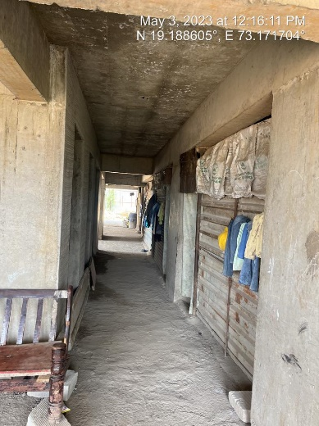
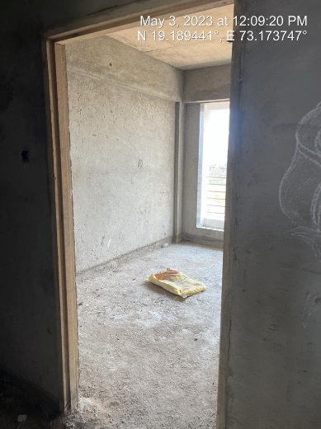
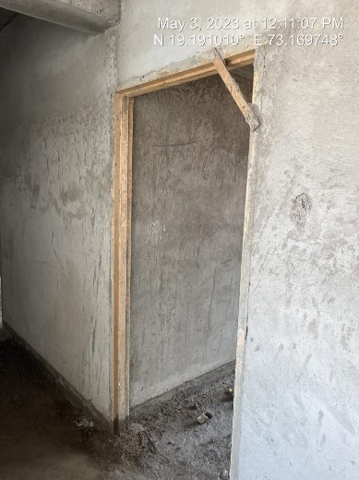

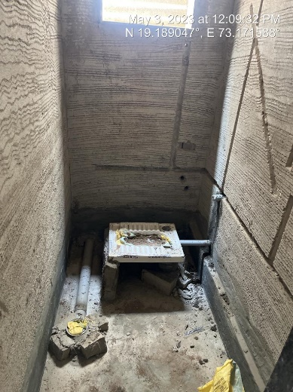
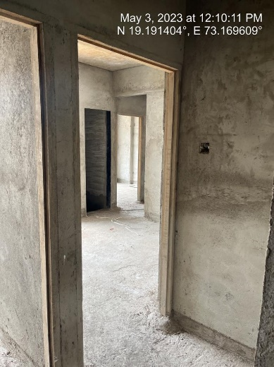
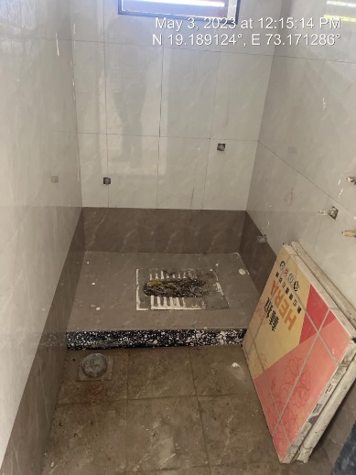

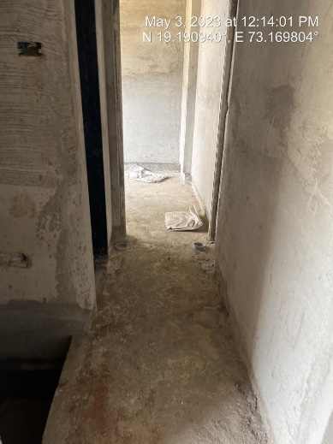
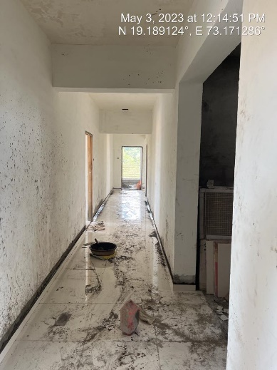
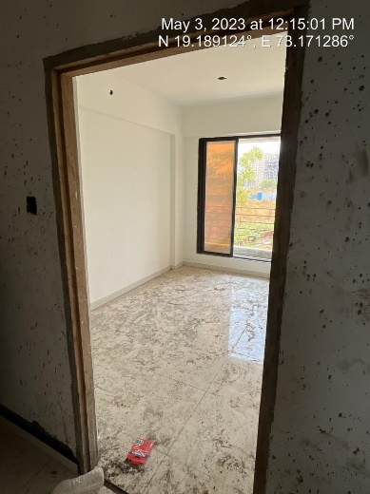

Actual Site Photographs

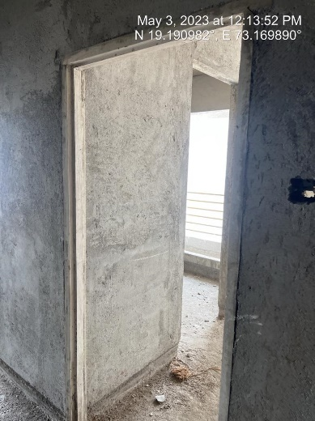
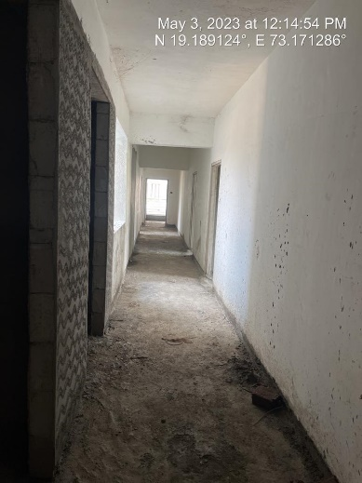
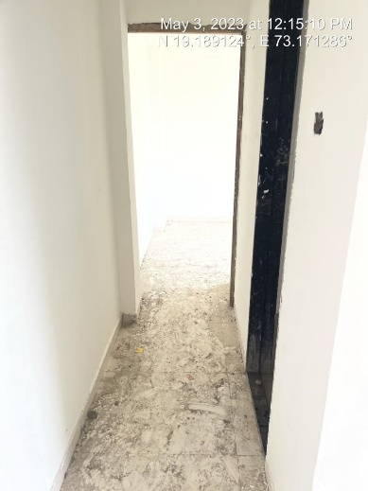
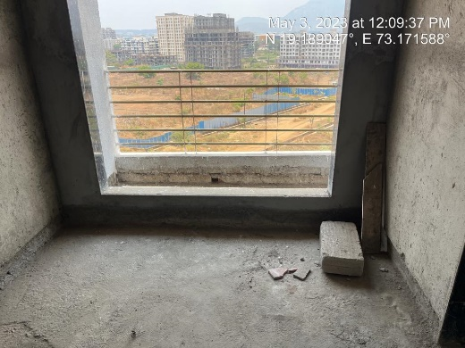
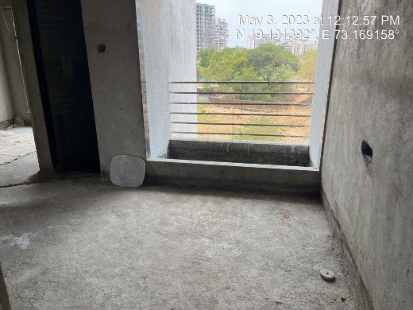
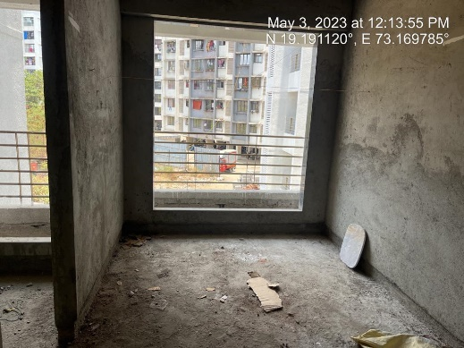
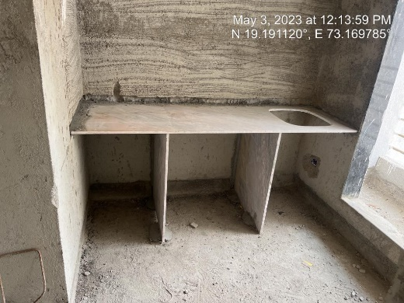
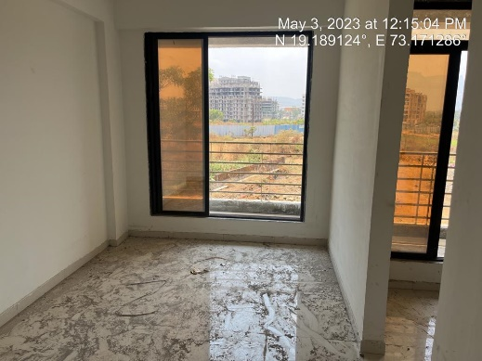
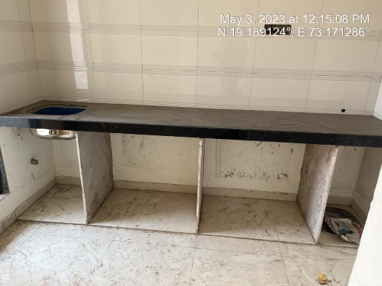
Actual Site Photographs
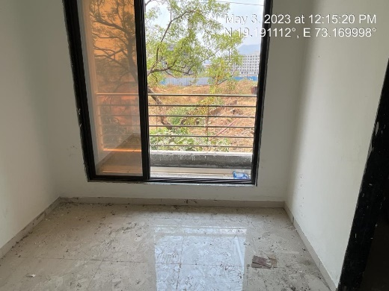
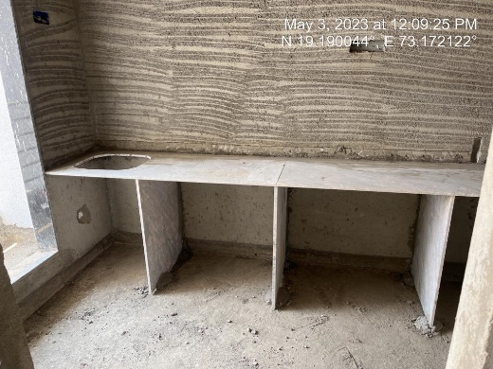
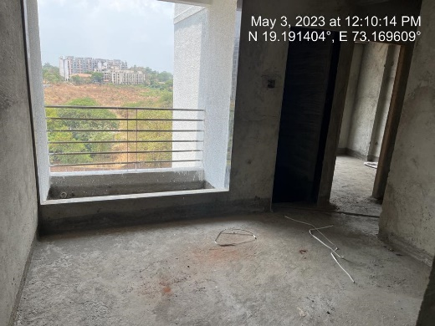
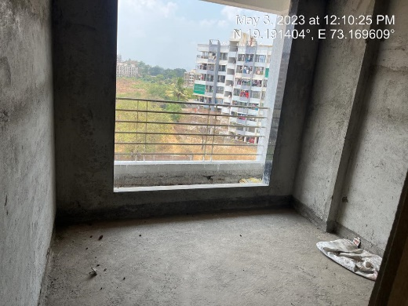
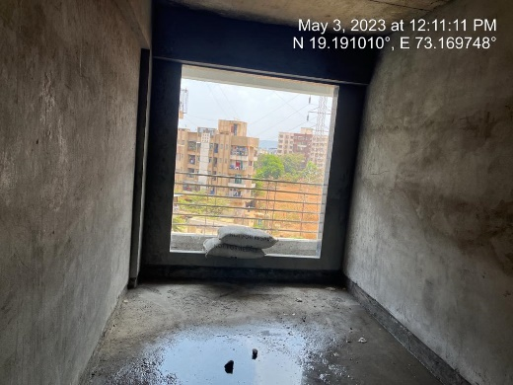
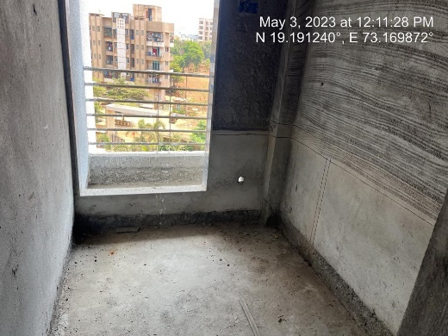
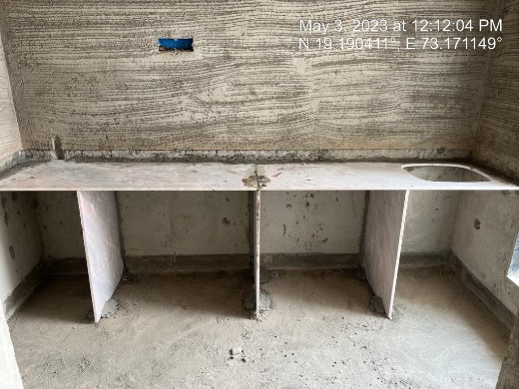
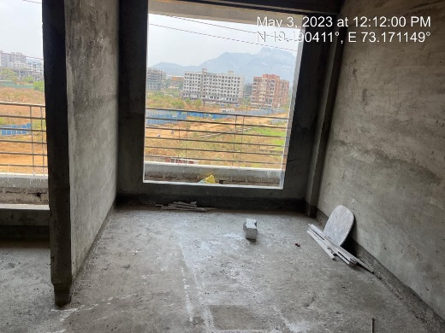
Actual Site Photographs
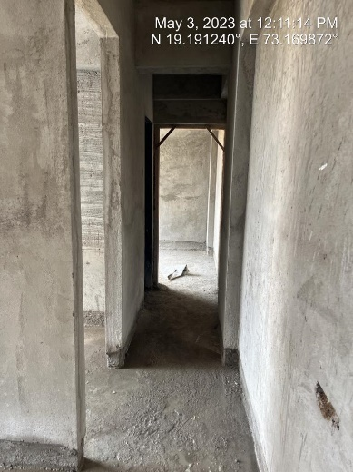
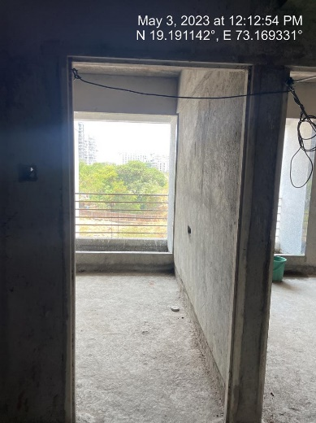
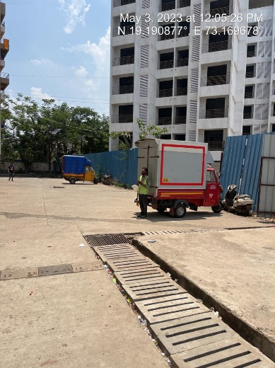
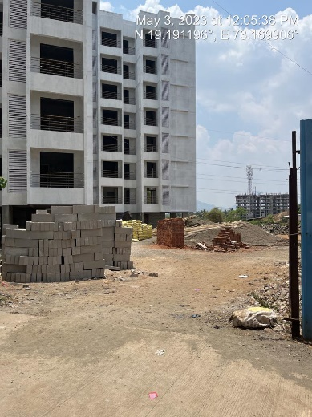
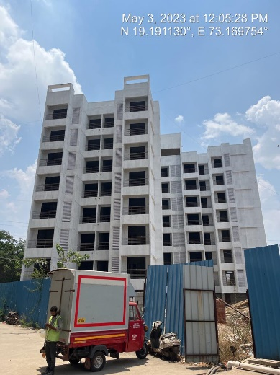
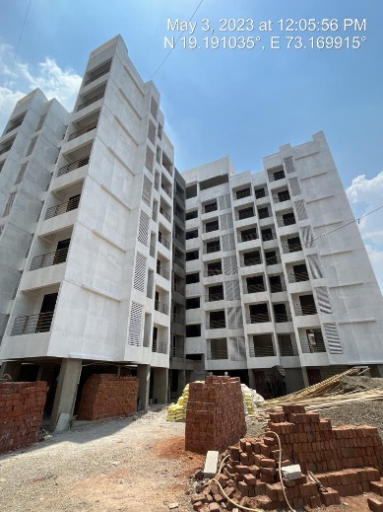
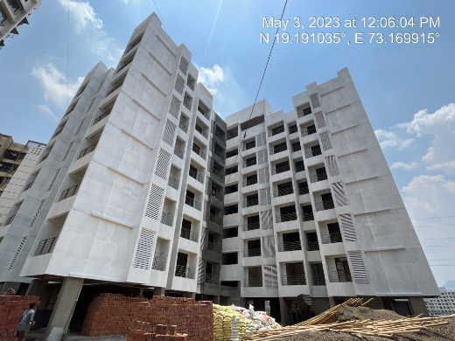
Route Map of the property
Site u/r
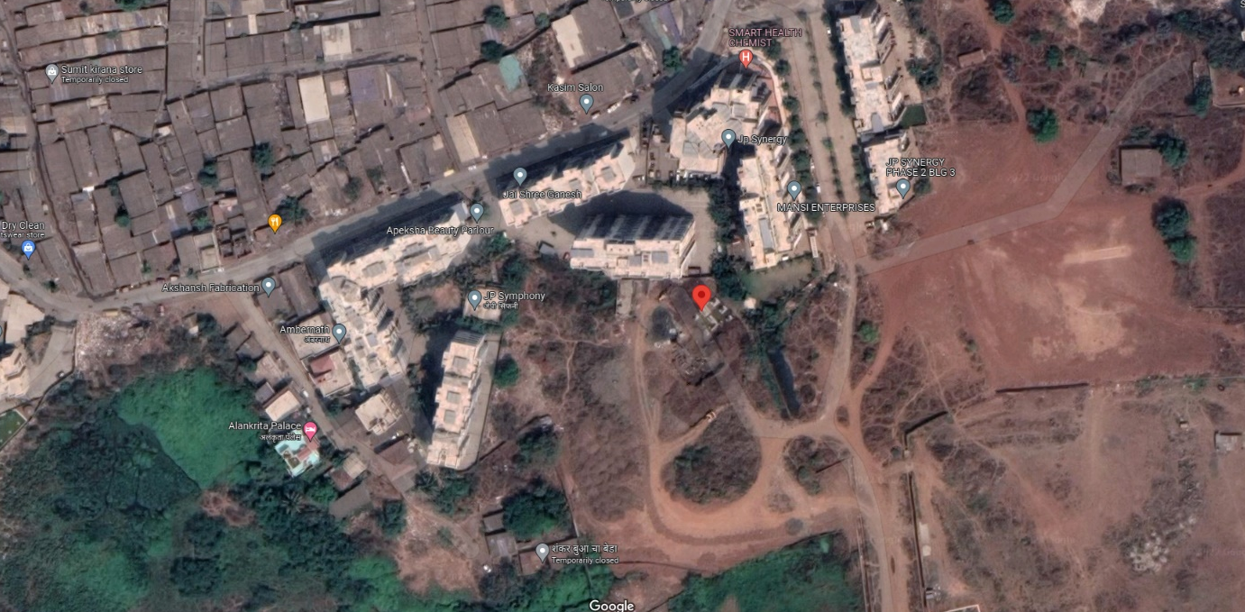

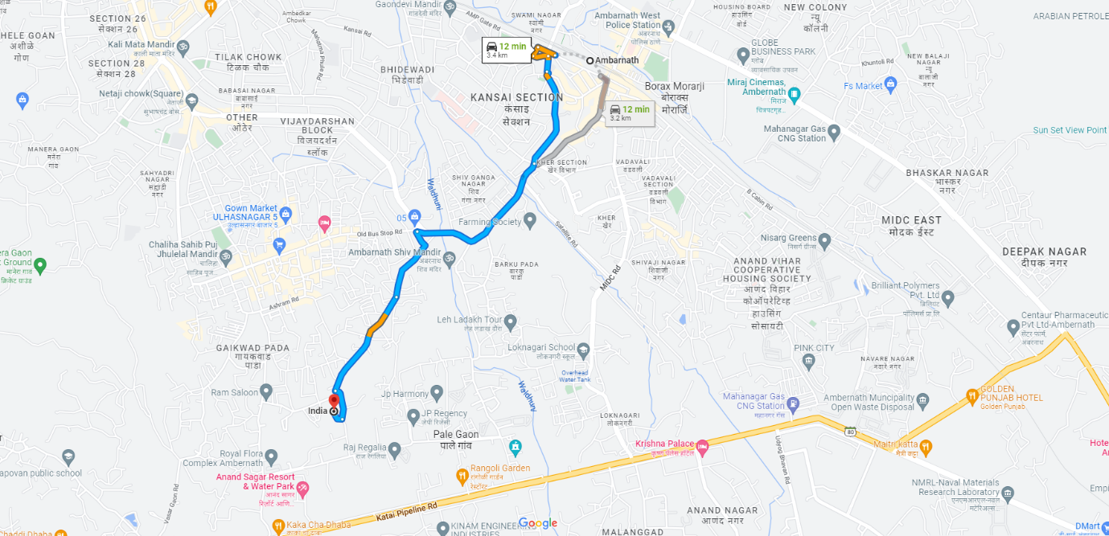

Latitude Longitude: 19°11'27.6"N 73°10'12.7"E

Note: The Blue line shows the route to site from nearest railway station (Ambernath – 3.40 Km.)

