COST VETTING REPORT

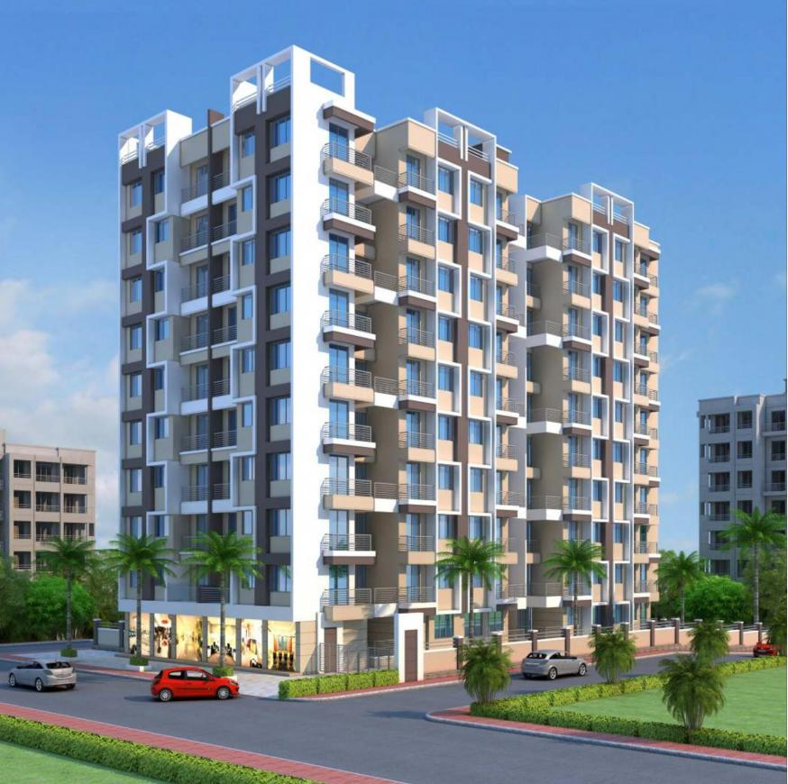

**Details of the property under consideration:**

**Name of Project: "JP Symphony Building. No. 5"**

**“JP Symphony Building. No. 5”,** Proposed Residential Buildings on Survey No. 138, Hissa No. 1,

Survey No. 139, Hissa No. 12, CTS No. 9467, 9469, Gaikwad Pada, Kailash Colony, Mouje – Ambernath,

Taluka – Ambernath, District – Thane, Pin Code – 421 501, State – Maharashtra, Country – India

**Latitude Longitude: 19°11'27.6"N 73°10'12.7"E**

**Bank of India**

**SME City Centre Branch**

Sector No. 11, Plot No. 11, Bank of India Bldg,

Ground Floor, C. B. D. Belapur, Navi Mumbai,

Pin Code – 400 614, State - Maharashtra, Country – India

|  |
| --- |
| Vastu/BOI/Mumbai/05/2023/31260/2300423 04/01-44-PY  Date: 05.05.2023  To,  **The Branch Manager,**  **Bank of India**  **SME City Centre Branch**  Sector No. 11, Plot No. 11,  Bank of India Bldg, Ground Floor,  C. B. D. Belapur, Navi Mumbai,  Pin Code – 400 614,  State - Maharashtra, Country – India  **Sub:** Cost Vetting for "**JP Symphony Building. No. 5**" at Mouje – Ambernath, Taluka – Ambernath, District – Thane, Pin Code – 421 501  **Ref:** Your mail dated 17.04.2023  Dear Sir,  In accordance with your Mail as stated above, we enclose our Report on Cost Vetting for **“JP Symphony Building. No. 5”**, Proposed Residential Buildings on Survey No. 138, Hissa No. 1, Survey No. 139, Hissa No. 12, CTS No. 9467, 9469, Gaikwad Pada, Kailash Colony, Mouje – Ambernath, Taluka – Ambernath, District – Thane, Pin Code – 421 501, State – Maharashtra, Country – India.  The project is being developed by M/s. Risali Developers is a partnership firm. They are one of the most highly recalled and respected Builders and Property Developers with an impeccable track record of ‘On Time’, ‘On Budget’ and ‘Futuristic’ credentials in the Country. They revolve around one entity – our CUSTOMERS. The Company has always strived hard to keep its commitments and thus enjoys an extremely resounding reputation in the construction industry. The Company enjoys a sound financial base, infrastructure and has requisite experienced manpower to undertake many large projects simultaneously.  Sale Building is proposed of Stilt Floor + 1st to 7th Upper Floors with total RERA carpet area of 23,824.00 Sq. Ft. which consists 1 BHK units with total 70 nos. of flats for sale along with Play Area and Society Office.  In this regard, Bank of India, Sector No. 11, Plot No. 11, Bank of India Bldg, Ground Floor, C. B. D. Belapur, Navi Mumbai, Pin Code – 400 614, has approached Vastukala Consultants (I) Pvt. Ltd. (VCIPL) to conduct a Cost vetting Report of the said project.  Our analysis of the cost vetting is enclosed in this report. This Report forms an integral whole and cannot be split in parts. The outcome of the report/ study can only lead to proper conclusions if the Report as a whole is taken into account.  The information used by Vastukala Consultants (I) Pvt. Ltd. (VCIPL) in preparing this report has been obtained from a variety of sources and other relevant documents provided by the client & bank. As agreed, we have performed our cost vetting exercise with the data available related to the business, considering the market prospects and projections. Our results are dependent on documents provided by client & bank, the underlying assumptions, which has been analyzed at a broader level by VCIPL while assessing their reasonableness.  Total Project Cost for the completion of Project will be **` 9.47 Cr.**  **For Vastukala Consultants (I) Pvt. Ltd.**  **Sharadkumar B. Chalikwar**  Govt. Reg. Valuer  Chartered Engineer (India)  Reg. No. (N) CCIT/1-14/52/2008-09  Encl: Cost Vetting report.  **About the Project:**  It is an under construction Proposed Residential Building on Survey No. 138, Hissa No. 1, Survey No. 139, Hissa No. 12, CTS No. 9467, 9469, Gaikwad Pada, Kailash Colony, Mouje – Ambernath, Taluka – Ambernath, District – Thane, Pin Code – 421 501, State – Maharashtra, Country – India. It is about 3.40 Km. travel distance from Ambernath Railway Station. Near JP Synergy. |

## Area Statement As per Approved Plan

|  | Area Statement | SQ. MT |
| --- | --- | --- |
| 1 | Area of plot (minimum area of a, b, c) + B27B8B2:BB2: B31 |  |
|  | a) As per ownership document (7/12) |  |
|  | Deduct - S. NO. 139, H. NO.12 = 14800.00 SQ. MT., Owners Area = 4900.00 SQ. MT., Area for Development = 9900.00 SQ. MT., S.NO. 138, H. No. 1 - 4480.00 SQ. MT. | 14,400.00 |
|  | b) As per site measurement |  |
|  | c) As per site |  |
| 2 | Deduction for |  |
|  | a) Proposed D.P / D.P Road widening Area/Service Road/ Highway winding 18.00 M wd Road | 61.88 |
|  | b) Any D.P Reservation Area |  |
|  | (Total a + b) | 61.83 |
| 3 | Balance area of plot (1+2) | 14,338.17 |
| 4 | Amenity Space (if applicable) |  |
|  | a) Required |  |
|  | b) Adjustment of 2 (a), if any |  |
|  | c) Balanced Proposed |  |
| 5 | Net Plot Area (3-4 c) | 14,338.17 |
| 6 | Recreational Open Space (if Applicable) |  |
|  | a) Required | 1,433.81 |
|  | b) Proposed | 1,435.00 |
| 7 | Internal Road area |  |
| 8 | Plotable area (if applicable) |  |
| 9 | Built up area with reference to Basic F.S.I as per front road width (sr. no. 5 x basic FSI) 14338.17 X 1.10 | 14,194.72 |
| 10 | Additional of FSI on payment in proposal |  |
|  | a) Maximum permissible premium FSI - based on road width / TOD Zone | 0.30 |
|  | b) Proposed FSI on payment of premium 1,44,400.00 x 0.30 % | 2,580.85 |
| 11 | In-situ FSI/TDR Loading |  |
|  | a) In-situ area against D.P. Road [2.0 x Sr. no.2 (a)], if any |  |
|  | b) In-situ area against Amenity Space if handed over 61.88 x 2.05 = 126.85  (2.00 or 1.85 x sr no. 4 (a)/ or (c) 61.88 x out of 26.85 | 61.88 |
|  | c) TDR AREA 14400.00 X 0.70% 1600.00 OUT OF 10080.00 | 1,600.00 |
|  | d) Total in situ / TDR loading proposed (11 (a) + (b) + (c) | 1,661.88 |
| 12 | Additional FSI area under Chapter No. 7 |  |
| 13 | a) (9 + 10 (a) + 11 (d) or whichever is applicable | 18,437.45 |
|  | b) Ancillary Area FSI upto 60% or 80% with payment of charges existing Built Up Area - 16832.07 (18437.45 -16832.07 = 1605.38) (1605.38 x 60% = 963.22) | 963.22 |
|  | c) Total entitlement (a + b) | 19,400.67 |
| 14 | Maximum Utilization limit of F.S.I. (building potential) Permissible as per road width [as per regulation No. 6.1 or 6.2 or 6.3 or 6.4 as applicable) x 1.6 or 1.8] |  |
| 15 | Total Built - Up area in proposal (excluding area at Sr. No. 17 b) |  |
|  | **a) Existing Built up area BLDG NO. 1 TO 4 = 15172.81 EXISTING STRUCTURE = 1659.26** | **16,832.07** |
|  | **b) Proposed Built up area (as per P-line) BLDG NO. 5** | **2,565.21** |
|  | **C) Total (a + b)** | **19,397.28** |
| 16 | F.S.I. Consumed (15/13) (should not be more then serial no. 14 above | 1.00 |
| 17 | Area for inclusive Housing if any |  |
|  | a) Required (20% of sr. no. 5) |  |
|  | b) Proposed |  |

## Construction Area

|  |  |  |  |  |  |
| --- | --- | --- | --- | --- | --- |
| Sr. No. | Floor | Built Up Area in Sq. M. | Staircase, Lift & Lobby Area in Sq. M. | Other Area in Sq. M. | Total Area in Sq. M. |
| 1 | Ground | 16.90 | 16.90 | 344.07 | 377.87 |
| 2 | 1st | 360.97 | 16.90 | - | 377.87 |
| 3 | 2nd | 360.97 | 16.90 | - | 377.87 |
| 4 | 3rd | 360.97 | 16.90 | - | 377.87 |
| 5 | 4th | 360.97 | 16.90 | - | 377.87 |
| 6 | 5th | 360.97 | 16.90 | - | 377.87 |
| 7 | 6th | 360.97 | 16.90 | - | 377.87 |
| 8 | 7th | 360.97 | 16.90 | - | 377.87 |
| 10 | Terrace | - | 16.90 | - | 16.90 |
| TOTAL | | **2,543.69** | **152.10** | **344.07** | **3,039.86** |

## Project Cost

|  |  |  |  |
| --- | --- | --- | --- |
| Sr. No. | Particulars | Total Estimated Amount in ` | Total Estimated Amount in ` Cr. |
| 1 | **Land Cost** |  |  |
|  | Acquisition Cost of Land or Development Rights, and Legal Cost. | 64,36,120.00 | 0.64 |
|  | Rent to Tenants, Lease premium, Lease Rent, interest cost incurred or payable on Land Cost | - | - |
|  | Amount of Premium payable to obtain development rights, FSI, additional FSI, fungible area, and any other incentive under DCR from Local Authority or State Government or any Statutory Authority. | 27,91,508.00 | 27.92 |
|  | Acquisition cost of TDR (if any) | 1,03,32,020.00 | 1.03 |
| 2 | **Cost of Construction** |  |  |
| 1. I | Estimated construction cost of rehab cum sale building including site development and infrastructure for the same excluding of GST amount. | 6,68,76,920.00 | 6.69 |
|  | On site expenditure for development of entire project excluding cost of construction as per(i) above, |  |  |
| a. | Architect Fees & Consultant fees | 33,43,846.00 | 0.33 |
| b. | Admin Cost includes salaries, site overheads, development works, cost of services (including water, electricity, sewerage, drainage, layout roads etc.), cost of machineries and equipment including its hire and maintenance cost, consumables etc. All costs directly incurred to complete the construction of the entire phase of the project registered. | 26,75,077.00 | 0.27 |
| c. | Marketing Cost | 22,61,108.00 | 0.23 |
| 3 | Interest during the Project | - | - |
| 4 | Contiguous Cost | - | - |
|  | **GRAND TOTAL:** | **9,47,16,599.00** | **9.47** |

**Sharadkumar B. Chalikwar**

Govt. Reg. Valuer

Chartered Engineer (India)

Reg. No. (N) CCIT/1-14/52/2008-09

**Comments on each element of Cost of Project**: -

1. **Land Cost:**

Cost of land is ` 64,36,120.00 i.e., ` 0.64 Cr. which is 6.80% of Total Project Cost.

|  |  |  |  |  |  |
| --- | --- | --- | --- | --- | --- |
| Sr. No. | Date | Document Name | Description | Total Cost in ` | Incurred Cost in ` |
| 1 | 29.07.2016 | Sale Agreement | Purchase Price | 61,00,000.00 | 61,00,000.00 |
| 2 | Stamp Duty | 3,05,000.00 | 3,05,000.00 |
| 3 | Reg. Fees | 30,000.00 | 30,000.00 |
| 4 | 1,120.00 | 1,120.00 |
| Total | | | | **64,36,120.00** | **64,36,120.00** |

1. **TDR Charges:**

The TDR charges is ` 1,03,32,020.00 i.e., ` 1.03 Cr. which is 10.91% of Total Project Cost.

|  |  |  |  |  |  |
| --- | --- | --- | --- | --- | --- |
| Sr. No. | Date | Description | Area in Sq. M. | Total Cost in ` | Incurred Cost in ` |
| 1 | 25.04.2019 | Stamp Duty | 2,488.00 | 3,00,100.00 | 3,00,100.00 |
| 2 | Purchase Price | 1,00,01,000.00 | 1,00,01,000.00 |
| 3 | Reg. Fees | 30,920.00 | 30,920.00 |
| Total | | | **2,488.00** | **1,03,32,020.00** | **1,03,32,020.00** |

1. **Building Cost of Construction:**

Construction area Building = 3,039.86 Sq. M.

Total estimated cost for construction of Building (includes cost of RCC work, manpower, lift, material, painting, finishing work, site development, etc.) is ` 6,68,76,920.00 i.e., ` 6.69 Cr. which comes ` 22,000.00 per Sq. M. on total construction area for building.

Hence, total cost of construction is ` 6,68,76,920.00 i.e., ` 6.69 Cr. which is 70.61% of total project cost.

VCIPL opinion the construction cost of 22,000/- Per Sq. M which is in line with Market-Trend.

1. **Approval Charges:**

The Total Approval Cost (Fungible Cost & Development Cess Premium) is ` 27,91,508.00 i.e., ` 0.28 Cr. which is 2.95% of Total Project Cost.

|  |  |  |
| --- | --- | --- |
| Sr. No. | Particulars | Total Amount in ` |
| 1 | Water Drainage Charges | 2,81,013.00 |
| 2 | Development Charges & CC Fees | 22,10,495.00 |
| 3 | OC Charges | 3,00,000.00 |
| TOTAL | | **27,91,508.00** |

As per details provided by the developer.

1. **Architect Cost, RCC & Other Professional Charges:**

The total Architect charges of ` 33,43,846.00 i.e., ` 0.33 Cr. is 5% of total construction cost of Building & it is line up with Market trend.

The professional charge consists of Architect & Legal which in market is in the range of 3% - 6% of Total Construction cost of the project.

1. **Administrative Expenses:**

Salaries, site overheads, development works, cost of services (including water, electricity, sewerage, drainage, layout roads etc.), cost of machineries and equipment including its hire and maintenance cost, consumables etc. All costs directly incurred to complete the construction of the entire phase of the project registered is estimated 4% of total construction cost of Building which comes to ` 26,75,077.00 i.e., ` 0.27 Cr.

The admin charges which in market is in the range of 2% - 4% of Total Project cost of the project.

1. **Marketing Expenses:**

Marketing costs directly incurred to complete the construction of the entire phase of the project registered is estimated at 2% of total Sale income from the project which comes to ` 22,61,108.00 i.e., ` 0.23 Cr.

The marketing charge consists of brokerage & commission which in market is in the range of 1% - 3% of Total Sale income of the property.

**Observation and Construction**: -

**Total estimated cost of project i.e., ` 9,47,16,599.00 (Rupees Nine Crore Forty Seven Lakh Sixteen Thousand Five Hundred Ninety Nine Only) i.e. ` 9.47 Cr. is fair & reasonable.**

The project cost is including land premium payable to concern authorities, Fungible FSI Premium, Cost of Construction of Building, on site expenses including admin & marketing expenses, premiums / charges to be paid to competent authority, etc. we have not independently verified interest cost hence not consider in cost vetting.

Total estimated cost of construction for Building for sanctioned plan up to Stlit Floor + 1st to 7th Upper Floors is ` 6,68,76,920.00 which is ` 22,000.00 per Sq. M. on construction area is 3,039.86 Sq. M., which is fair & reasonable considering the present status of project, type & quality of construction & specification of the building materials to be used, height of the structure, amenities to be provided in proposed building.

**Assumptions & Remarks-**

* The adequacy of Engineering / Structural design is beyond the scope of our assignment.
* Estimated project completion date is 31/12/2024. The cost is certified based on the assumptions that the project will be completed within time frame. Few assumptions are made regarding inflation & cost rise etc. during construction period.

Photo copy of following document is provided to us & this report should be read along with it:

* Copy of Sale Agreement Doc. No. Ulhasnagar-3/590/2013 dated 28.01.2013.
* Copy of Sale Agreement Doc. No. Ulhasnagar-3/578/2013 dated 28.01.2013.
* Copy of Sale Agreement Doc. No. Ulhasnagar-3/583/2013 dated 28.01.2013.
* Copy of Sale Agreement Doc. No. Ulhasnagar-3/588/2013 dated 28.01.2013.
* Copy of Sale Agreement Doc. No. Ulhasnagar-3/586/2013 dated 28.01.2013.
* Copy of Sale Agreement Doc. No. Ulhasnagar-3/7747/2016 dated 29.07.2016.
* Copy of TDR Purchase Agreement Doc. No. Ulhasnagar-3/4363/2019 dated 25.04.2019.
* Copy of Approved Plan No. ANP/NRV/BP/21-22/1299/1299/9259/135 dated 18.02.2022 issued by Ambernath Municipal Council.

**Approved upto: Stilt Floor + 1st to 7th Upper Floor**

* Copy of Commencement Certificate No. ANP/NRV/BP/2021-22/1299/9259/135 dated 18.02.2022 issued by Ambernath Municipal Council.

**Approved upto: Stilt Floor + 1st to 7th Upper Floor**

* Copy of RERA Certificate **No. P51900046198** dated 20.06.2022 issued by Maharashtra Real Estate Regulatory Authority (MAHRERA).
* Copy of CA Certificate issued by M/s. Pritesh Gada & Co.
* Copy of Engineer’s Certificate dated 19.05.2022 issued by M/s. Astruct.

**Actual Site Photographs**

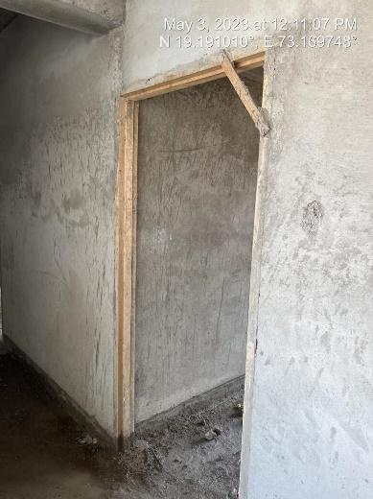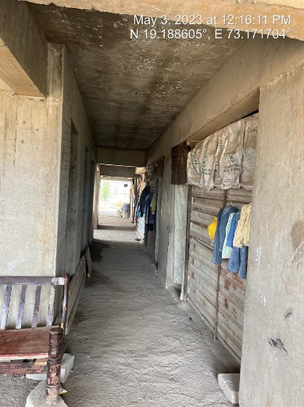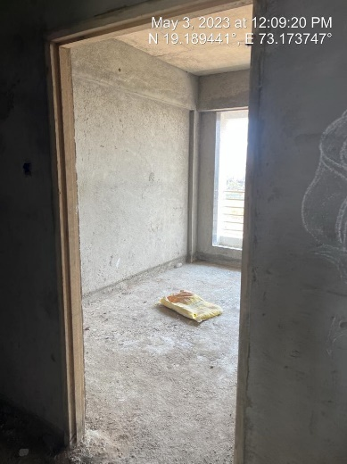

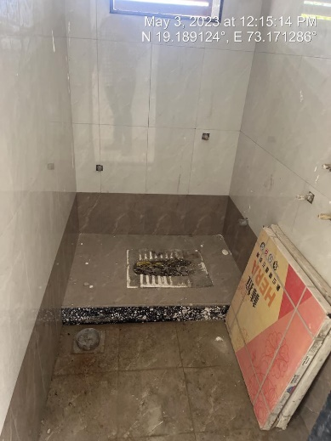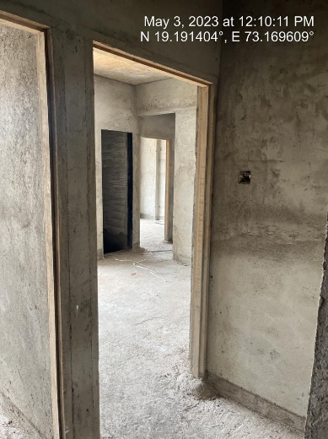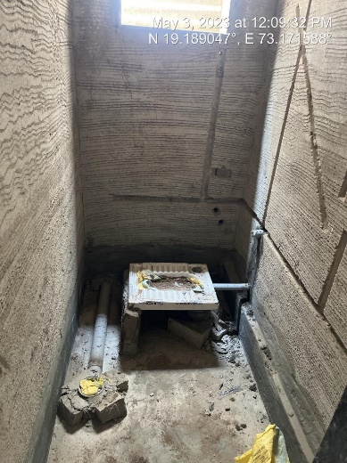

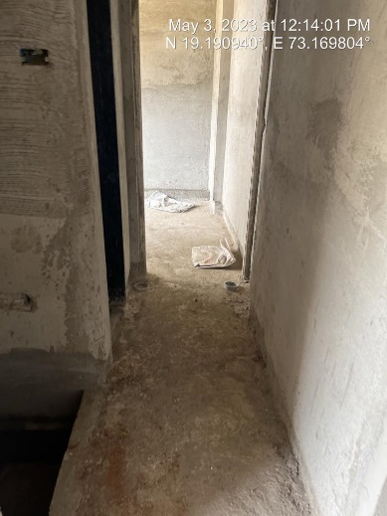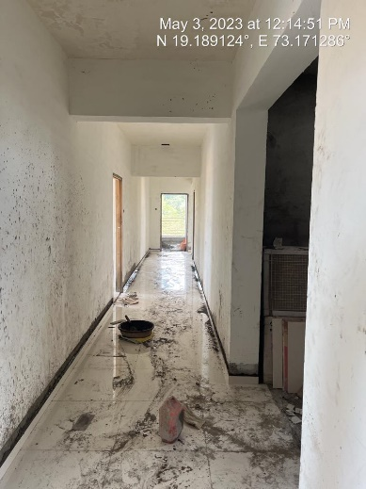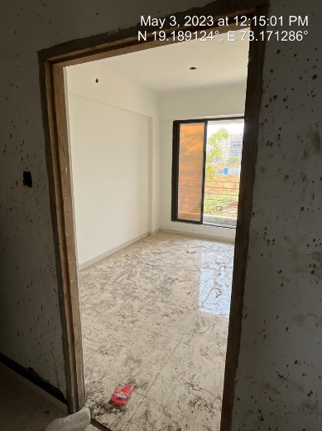

**Actual Site Photographs**

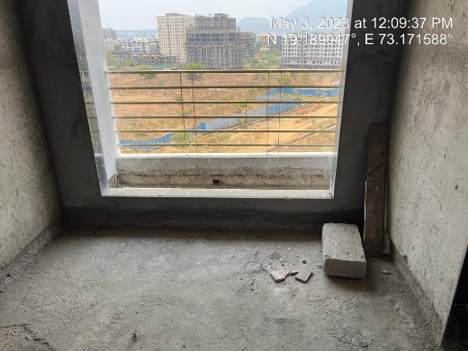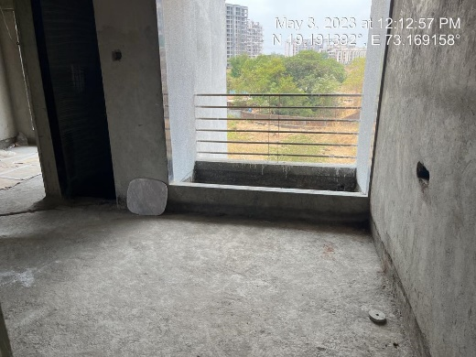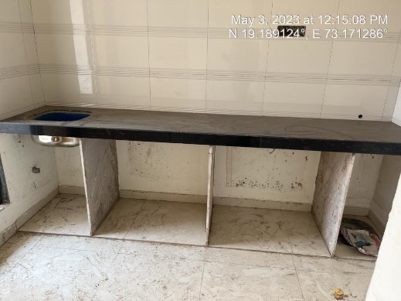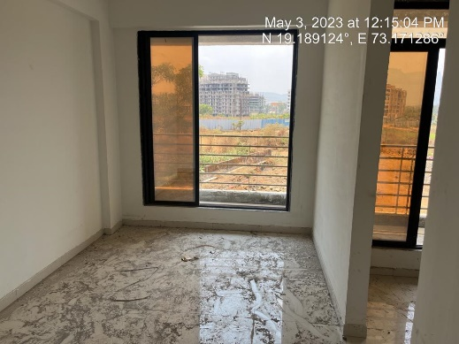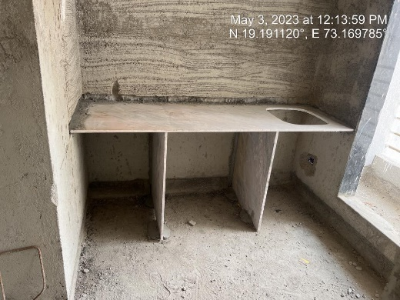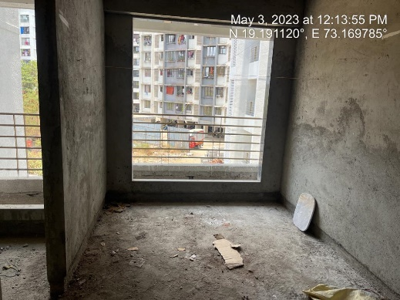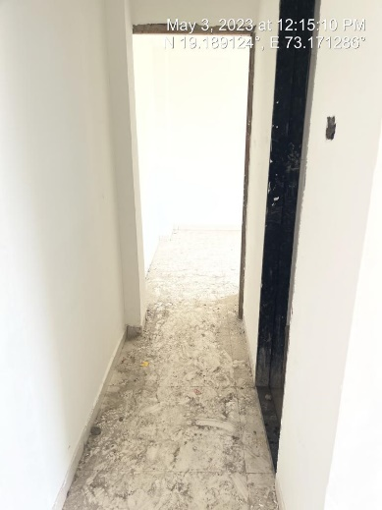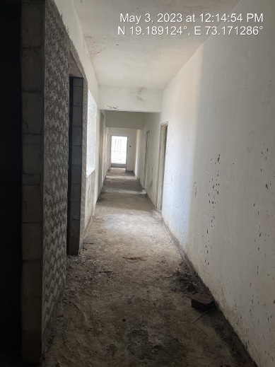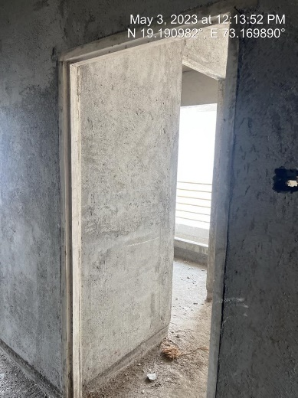

**Actual Site Photographs**

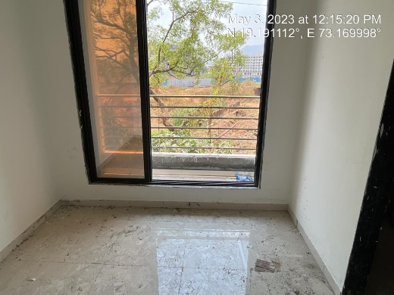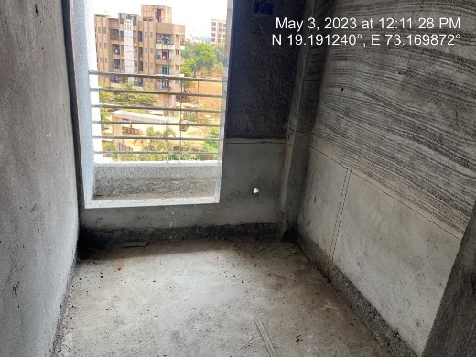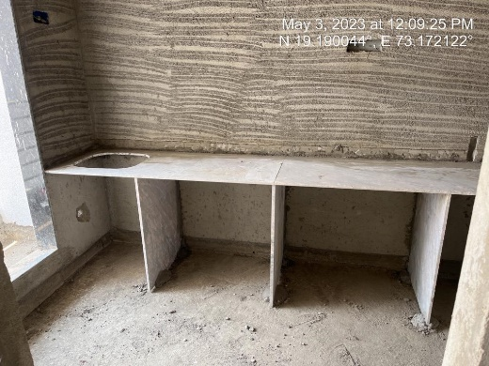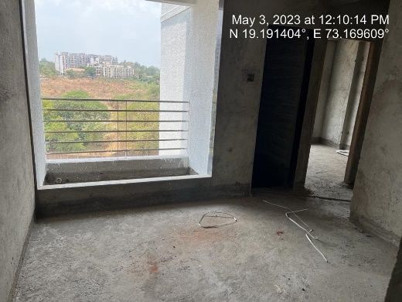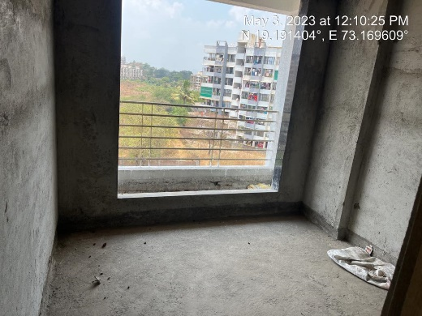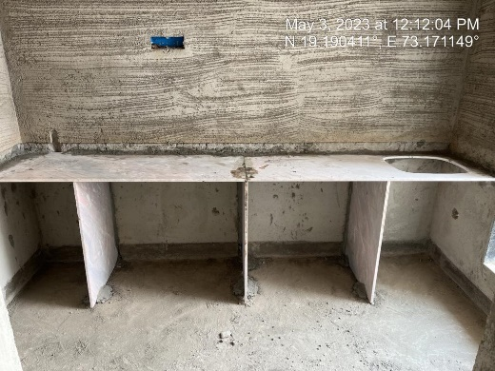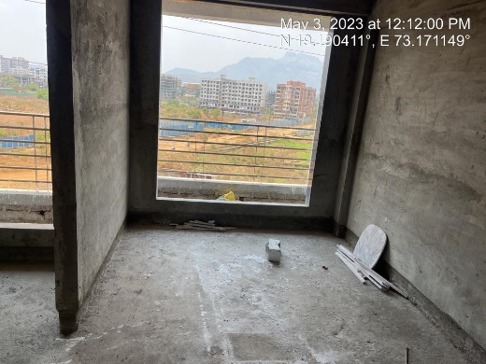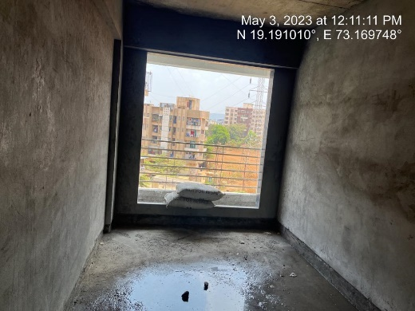

**Actual Site Photographs**

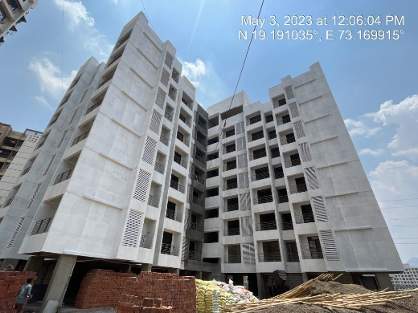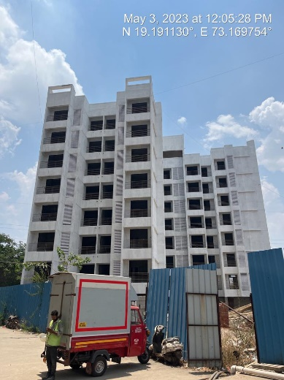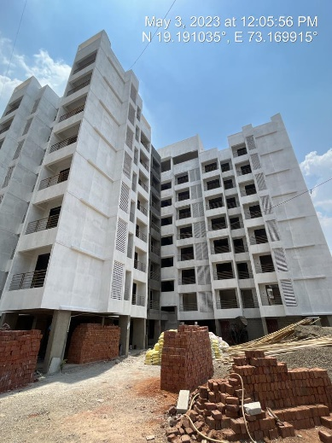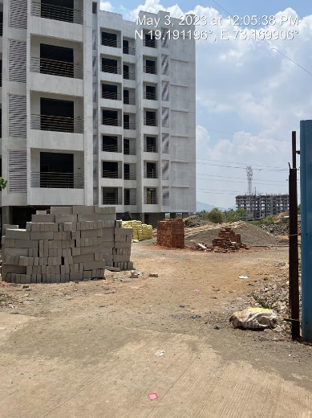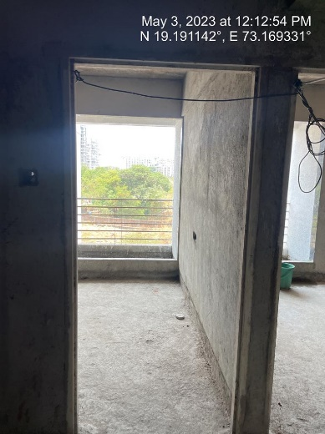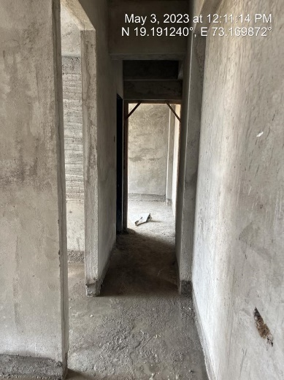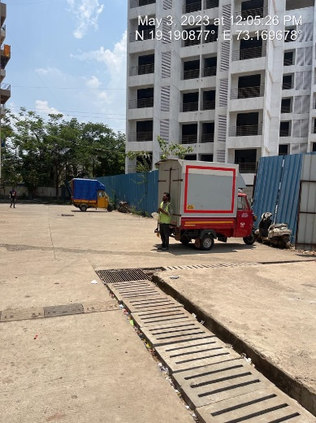

**Route Map of the property**

**Site u/r**

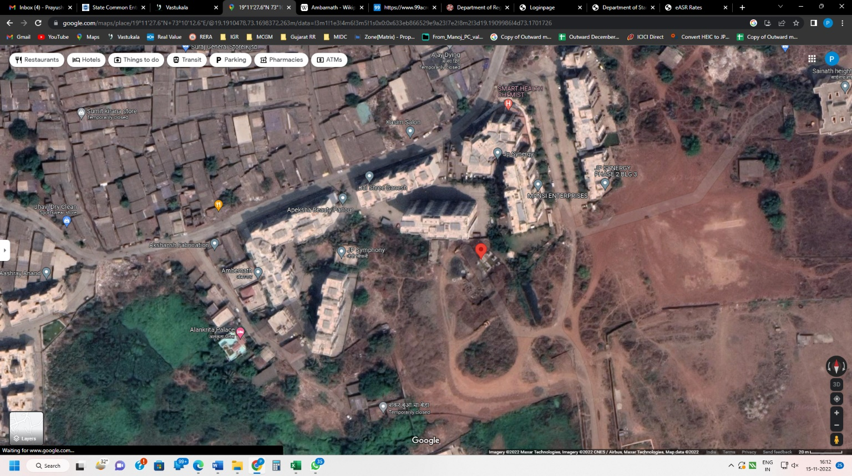

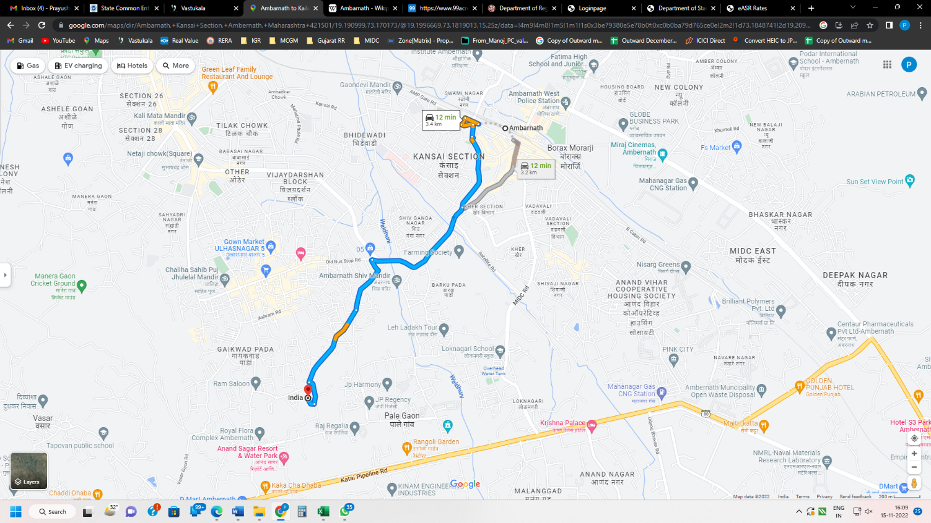

**Latitude Longitude: 19°11'27.6"N 73°10'12.7"E**

Note: The Blue line shows the route to site from nearest railway station (Ambernath – 3.40 Km.)