1st LENDERS INDEPENDENT ENGINEER REPORT

**Details of the property under consideration:**

**Name of Project: Giriraj Sparsh**

**"Giriraj Sparsh", Proposed Residential Building on plot bearing on C.T.S. No. 77, Tika No. 18,**

**Near Hari – Niwas Circle, L. B. S. Road, Village - Naupada, Thane (West), Taluka &**

**District – Thane, Pin Code – 400 602, State - Maharashtra, Country – India**

**Latitude Longitude: 19°11'28.3"N 72°58'06.5"E**

Valuation Prepared for:

State Bank of India

Industrial Finance Branch Malad (West)

Industrial Finance Branch, Near Chincholi Phatak Signal, S. V. Road,

Malad (West), Mumbai - 400 064, State - Maharashtra, Country - India.

Vastu/Mumbai/04/2023/31095/2300232

24/01-247-PY

Date: - 24.04.2023

FIRST LENDERS INDEPENDENT ENGINEER REPORT

**To,**

**State Bank of India**

Industrial Finance Branch Malad (West),

Near Chincholi Phatak Signal, S. V. Road,

Malad (West), Mumbai - 400 064,

State - Maharashtra, Country - India.

Subject: Construction of Proposed Redevelopment on Plot bearing C.T.S. No. 77, Tika No. 18, Near Hari – Niwas Circle, L. B. S. Road, Village - Naupada, Thane (West), Taluka & District – Thane, Pin Code – 400 602, State – Maharashtra, Country – India

**Ref:** You’re Request for Lenders Independent Engineer Report of under Construction Building.

**Dear Sir,**

**The Construction work as per approved plan was in progress during the site visit on 20th April 2023. Total expenditure occurred as on 31/03/2023 on this project by M/s. Dura Vida Associates is ` 16.00 Cr. & as per CA Certificate actual total expenditure occurred as on 31/03/2023 is ` 16.00 Cr. Hence, release of Balance Amount as requested by M/s. Dura Vida Associates is hereby recommended.**

**DECLARATION**

1. The information furnished in the report is based on our 1st site visit Dated 20/04/2023 & Document Provided by Client.
2. Vastukala Project Report of the project dated 09/11/2022.
3. I have no direct and indirect interest in the property examined for report.
4. I have not been found guilty of misconduct in my professional capacity.

**Sharadkumar B. Chalikwar**

Govt. Reg. Valuer

Chartered Engineer (India)

Reg. No. (N) CCIT/1-14/52/2008-09

Encl.: LIE report

# Purpose & Methodology

* State Bank of India Banks and financial institutions require monitoring & an independent review of the progress of the sanctioned projects
* **VCIPL** undertakes such study to independently review the progress of the project and put forward a comprehensive analysis

# Advantages:

* Assurance on present practices
* Identification of risk
* Analyzing the performance of third parties
* Recommendations

# The Methodology

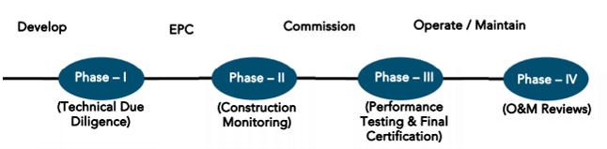

**FIRST LENDERS INDEPENDENT ENGINEER REPORT**

**OF**

**"GIRIRAJ SPARSH"**

**"Giriraj Sparsh**", Proposed Residential Building on plot bearing on C.T.S. No. 77, Tika No. 18, Near Hari – Niwas Circle, L. B. S. Road, Village - Naupada, Thane (West), Taluka & District – Thane, Pin Code – 400 602,

State - Maharashtra, Country – India

**Latitude Longitude: 19°11'28.3"N 72°58'06.5"E**

**NAME OF DEVELOPER: M/s. Dura Vida Associates**

|  |
| --- |
| Pursuant to instructions from State of India, Industrial Finance Branch, Malad (West), we have duly visited, inspected, surveyed & assessed the above said property on **20th April 2023** to determine the fair & reasonable market value of the said property/project as on Quarter ending **31st March 2023** for LIE purpose.  **1. Location Details:**  Proposed Residential Building on plot bearing on C.T.S. No. 77, Tika No. 18, Near Hari – Niwas Circle, L. B. S. Road, Village - Naupada, Thane (West), Taluka & District – Thane, Pin Code – 400 602. It is about 1.70 Km. travelling distance from Thane Railway station. Surface transport to the property is by buses, taxis & private vehicles. The property is in developed locality. All the amenities like shops, banks, hotels, markets, schools, hospitals, etc. are all available in the surrounding locality. The area is higher middle class & developed. |

**2. Developer Details:**

|  |  |
| --- | --- |
| **Name of builder** | **M/s. Dura Vida Associates** |
| **Project Rera Registration Number** | **P51700035133** |
| **Registered office address** | 105, Giri Heaven, Near Hari Niwas Circle, L. B. S. Road, Thane (West), Pin Code – 400 602, State - Maharashtra, Country – India |
| **Contact details** | **Contact Person:**  Mr. Jaynik Shah (Owner)  Mobile No. +919819270271  Mrs. Mona Mehta  Mobile No. |
| **E – mail ID and website** |  |

**3. Boundaries of the Property:**

|  |  |
| --- | --- |
| **Direction** | **Particulars** |
| **On or towards North** | Giri Heaven & L. B. S. Road |
| **On or towards South** | Giriraj Heights |
| **On or towards East** | Internal Road |
| **On or towards West** | Internal Road & Under Construction Building |

# Introduction

**As per Information on site M/s. Dura Vida Associates** has acquired land by Sale Agreement Doc. No. TNN – 2 / 2334/2021 dated 29.01.2021 admeasuring **area is 819.40 Sq. M.** bearing **C.T.S. No. 77, Tika No. 18.** For the Proposed Residential Building.

# Area Statement:

# Land:

|  |  |  |
| --- | --- | --- |
| **Date** | **Particular** | **Area in Sq. M.** |
| 29.01.2021 | C.T.S. No. 77, Tika No. 18 | 819.40 |
| TOTAL | | 819.40 |

1. Copy of Sale Agreement Doc. No. TNN – 2 / 2334/2021 dated 29.01.2021 b/w Shree Ajramar Sthanakwasi Jain Sangh – Thane (Vendors) & M/s. Dura Vida Associates (Purchasers)

# Building Area As per Approved Plan:

| **Sr. No.** | **Area Statement** | **Area in Sq. M.** |
| --- | --- | --- |
| **1** | Area of Plot (minimum area of a, b, c to be considered) | 705.40 |
| **a** | As per ownership document | 819.40 |
| **b** | As per measurement sheet | 857.84 |
| **c** | As per site (819.40 – 114.00 Not in Possession) | 705.40 |
| **2** | Deductions for |  |
| **A** | Proposed D. P. / D. P Road widening Area / Services Road / highway | - |
| **B** | Any D. P Reservations Area | - |
| **C** | Total (a + b) | - |
| **3** | Balance Area of Plot | 705.40 |
| **4** | Amenity Space (if applicable) | - |
| **a** | Required | - |
| **b** | Adjustment of 2(b) if any | - |
| **c** | Balance Proposed | - |
| **5** | Net plot Area (3 – 4(c)) | 705.40 |
| **6** | Recreational Open Space (if applicable) | - |
| **a** | Required | - |
| **b** | Proposed | - |
| **7** | Internal Road Area | - |
| **8** | Plotable Area | - |
| **9** | Built Up Area with reference to Basic FSI as per front road width (Sr. No.5 X basic FSI)  (705.40 X 1.10 = 775.94 Sq. M.) | 775.94 |
| **10** | Addition of FSI on payment of premium |  |
| **a** | Maximum permissible premium FSI – based on road width / TOD Zone.  (705.40 X 50% = 352.70 Sq. M.) | 352.70 |
| **b** | Proposed FSI on payment of premium | - |
| **11** | In – situ FSI / TDR loading | - |
| **a** | In-situ area against D. p. road (2 X Sr. No. 2 (a)), if any | - |
| **b** | In -situ area against amenity space if handed over (2.00 or 1.85 X Sr. No. 4 9b) and / or (c) | - |
| **c** | TDR area | - |
| **d** | Total in-situ / TDR loading proposed (11 (a) + (b) + (c)) | - |
| **12** | Additional entitlement of FSI in the proposal | - |
| **13** | Total entitlement of FSI in the proposal | - |
| **a** | (9 + 10(b) + 11(d)) or 12 whichever is applicable | 1128.64 |
| **b** | Ancillary area FSI upto 60% or 80% with payment of charges  (Proposed Comm. Area 100.33 / 1.8 = 55.74 X 80% = 44.59 Sq. M.)  (Proposed Resi. Area = 1699.23 / 1.6 = 1062.02 X 60% = 637.21 Sq. M.) | 44.59  637.21 |
| **c** | Total entitlement (a + b) | 1810.44 |
| **14** | Maximum utilization limit of FSI (building potential) permissible as per road width  (as per regulation No. 6.1 or 6.2 or 6.3 or 6.4 as applicable 0 X 1.6 or 1.8) | - |
| **15** | Total Built – up Area in proposal (excluding area Sr. No. 17b) | 1799.56 |
| **a** | Existing Built – up Area | - |
| **b** | Proposed Built – up Area (As per P – line) | 1799.56 |
| **c** | Total (a + b) | 1799.56 |
| **d** | Balance Area (15(c) – 13(C)) | 10.88 |
| **16** | FSI consumed (15 / 3) should not be more than serial no. 14 above) | 0.994 |
| **17** | Area for inclusive housing, if any | - |
| **a** | Required (20% of Sr. no. 5) | - |
| **b** | Proposed | - |

# List of Approvals:

1. Copy of Approved Plan No. V.P. S02/0021/08/TMC/TDD/PS/4217/22 dated 10.10.2022 issued by Thane Municipal Corporation.

**Approval Up to: Ground Floor + 1st to 5th Floors + 6th Floor (Pt)**

1. Copy of Commencement Certificate No. V. P. No. S02/0021/08 TMC/TDD/4217/22 dated 10.10.2022 issued by Thane Municipal Corporation.

**(This CC is now endorsed for the work for Ground / Stilt (Pt) + 1st to 5th Floors + 6th Floor (Pt))**

# LEVEL OF COMPLETION:

| **Sr. No.** | **Floor** | **Construction area as per plan (Sq. Ft.)** | **Completed area (Sq. Ft.)** | **Work Completion as 20.04.2023** |
| --- | --- | --- | --- | --- |
| 1 | Excavation |  |  | Excavation Work is Completed |
| 2 | 3 Level Basement Floor | 10,110.30 | 10,110.30 | Slab work is completed |
| 3 | Ground / Stilt Floor | 3,370.10 | 3,370.10 | Slab work is completed |
| 4 | 1st Floor | 3,370.10 | 3,370.10 | Slab work is completed |
| 5 | 2nd Floor | 3,370.10 | 3,370.10 | Slab work is completed |
| 6 | 3rd Floor | 3,370.10 | 3,370.10 | Slab work is completed |
| 7 | 4th Floor | 3,370.10 |  |  |
| 8 | 5th Floor | 3,370.10 |  |  |
| 9 | 6th Floor | 3,370.10 |  |  |
| 10 | 7th Floor | 3,370.10 |  |  |
| 11 | Terrace Floor | 337.01 |  |  |
| **TOTAL AREA in Sq. Ft.** | | **37,408.12** | **23,590.71** |  |
| **No. of Stack Parking** | | **33** |  |  |

# Details of the Project as Financed By SBI:

# Project Cost: (as per C.A. Certificate)

|  |  |  |
| --- | --- | --- |
| **Particulars** | **Estimated Cost (in Cr.)** | **Incurred Cost (In Cr.) till 31.03.2023 by M/s Varma & Associates** |
| Land Cost | 8.36 | 8.36 |
| Construction Cost | 17.87 | 5.28 |
| Approval Cost of Fungible Cost & Development cess premium & Stamp Duty | 3.20 | 1.43 |
| Architect Cost, RCC & other Professional fees | 0.89 | 0.27 |
| On- site expenditure for development / Advance for Project/ Administrative Cost / Fixed Assets | 0.71 | 0.63 |
| Marketing Expenses | 0.93 | - |
| Interest Cost | 2.65 | 0.03 |
| Contingency | 0.54 | - |
| **Total** | **35.15** | **16.00** |

* **The Builder has incurred about 8.36 Cr. as land cost, 5.28 Cr. as construction cost, 1.43 Cr. for approval of project, 0.27 Cr. for Professional charges, 0.63 Cr. for admin cost in last quarter till 31.03.2023 as per C.A. certificate issued by M/s. Varma & Associates dated 20.04.2023**

# Project Cost: (as per Bills):

|  |  |
| --- | --- |
| **Particulars** | **Incurred Cost (in Cr.)** |
| **31.03.2023 as per Bill (Inclusive GST)** |
| Land Cost | 8.36 |
| Construction cost of Building | 5.04 |
| Premium Cost / FSI / GOM Charges / fees / security Deposits | 1.44 |
| Architect Cost, RCC & Professional Cost | 0.29 |
| On- site expenditure for development / Advance for Project/ Administrative Cost / Fixed Assets | 0.85 |
| Marketing Cost | - |
| Interest Cost | 0.03 |
| Contingency Cost | - |
| **Total** | **16.00** |

Note:

# Land Cost:

|  |  |  |  |  |  |
| --- | --- | --- | --- | --- | --- |
| Sr. No. | Date | Document Name | Description | Total Cost in ` | Incurred Cost in ` |
| 1 | 28.03.2019 | Conveyance Deed | Purchase Price | 8,00,11,501.00 | 8,00,11,501.00 |
| 2 | Stamp Duty | 35,73,000.00 | 35,73,000.00 |
| 3 | Reg. Fees | 30,000.00 | 30,000.00 |
| 4 | 1,320.00 | 1,320.00 |
| Total | | | | **8,36,15,821.00** | **8,36,15,821.00** |

As per Sale Agreement.

|  |  |  |  |
| --- | --- | --- | --- |
| **Summary of Bills** | | | |
| **Sr. No.** | **Particulars** | **Amount in `**  **(till 31.03.2023)** | **Amount in ` (in Cr.)** |
| **1** | Construction Cost | 5,03,58,038.00 | 5.04 |
| **2** | Premium Cost / FSI / GOM Charges / fees / security Deposits | 1,43,73,647.00 | 1.44 |
| **3** | Professional Cost | 28,85,807.00 | 0.29 |
| **4** | Administrative Cost | 84,51,082.00 | 0.85 |
| **5** | Marketing Cost | - | - |
| **TOTAL** | | **7,60,68,574.00** | **7.61** |

Note: Bills were provided by the client up to 31.03.2023

# Interest Cost:

|  |  |  |  |  |
| --- | --- | --- | --- | --- |
| **Sr. No** | **Particulars** | **Estimate Amount in `** | **Incurred Amount in ` (till 31.03.2023)** | **Balance Amount in `** |
| **1** | Interest Cost | 2,65,00,000.00 | 3,03,714.00 | 2,61,96,286.00 |
| **TOTAL** | | **2,65,00,000.00** | **3,03,714.00** | **2,61,96,286.00** |

Interest Cost is based on discussion with the client.

# Cost of Construction as on 13th February 2023:

|  |  |  |  |  |  |  |  |
| --- | --- | --- | --- | --- | --- | --- | --- |
| Plinth Area Calculation | | | | | | | |
| Sr. No | **Floor Nos.** | **Construction Area in Sq. Ft.** | **Completed Area in Sq. Ft.** | **Rate per Sq. Ft.** | **Full Value after completion in `** | **Percentage of work completed** | **Actual Expenditure till date in `** |
| 1 | Excavation | | | | 1,41,25,305.00 | 100% | 1,41,25,305.00 |
| 2 | 3 Level Basement | 10,110.30 | 10,110.30 | 3,776.00 | 3,81,76,501.00 | 50% | 1,90,88,251.00 |
| 3 | 1st Floor | 3,370.10 | 3,370.10 | 3,776.00 | 1,27,25,500.00 | 50% | 63,62,750.00 |
| 4 | 2nd Floor | 3,370.10 | 3,370.10 | 3,776.00 | 1,27,25,500.00 | 50% | 63,62,750.00 |
| 5 | 3rd Floor | 3,370.10 | 3,370.10 | 3,776.00 | 1,27,25,500.00 | 40% | 50,90,200.00 |
| 6 | 4th Floor | 3,370.10 |  | 3,776.00 | 1,27,25,500.00 | 0% | - |
| 7 | 5th Floor | 3,370.10 |  | 3,776.00 | 1,27,25,500.00 | 0% | - |
| 8 | 6th Floor | 3,370.10 |  | 3,776.00 | 1,27,25,500.00 | 0% | - |
| 9 | 7th Floor | 3,370.10 |  | 3,776.00 | 1,27,25,500.00 | 0% |  |
| 10 | Terrace Floor | 337.01 |  | 3,776.00 | 12,72,550.00 |  |  |
| 11 | Stack Parking in Nos | 33 |  |  | 2,33,64,000.00 |  |  |
| Total | | **37,408.12** | **23,590.71** |  | **17,87,42,356.00** | **32%** | **5,73,92,006.00** |

##### Note: Details of work completed is as per site visit dated 20.04.2023 but report is prepared for 31st March quarter 2023.

|  |  |  |  |  |
| --- | --- | --- | --- | --- |
| **Particulars** | **Estimated Cost**  **(In Cr.)** | **Incurred Cost (in Cr.)** | | **Net** |
| **Issued dated 20.04.2023 till 31.03.2023 as per CA** | **As per Bills upto 31.03.2023** |
| Land Cost | 8.36 | 8.36 | 8.36 | - |
| Construction cost of Building | 17.87 | 5.28 | 5.04 | -0.24 |
| Premium Cost / FSI / GOM Charges / fees / security Deposits | 3.20 | 1.43 | 1.44 | 0.01 |
| Architect, RCC & Other Professional Cost | 0.89 | 0.27 | 0.29 | 0.02 |
| On- site expenditure for development / Advance for Project/ Administrative Cost/ Fixed Assets | 0.71 | 0.63 | 0.85 | 0.22 |
| Marketing Cost | 0.93 | - | - | - |
| Interest Cost | 2.65 | 0.03 | 0.03 | - |
| Contingency Cost | 0.54 | - | - | - |
| **Total** | **35.15** | **16.00** | **16.00** | **-** |

Note:

We have considered Other Expenses, Printing & Stationery, and Water Bills cost is consider in on-site expenditure cost header but CA has considered them in cost of construction header .

As per plinth area, calculation the work completed is up to 32% of total work, which comes to ` 5.74 Cr. However, company has incurred cost of ` 5.04 Cr. till 28.02.2023 as per bill .

# Comparison of Cost incurred on dated 31.03.2023 & CA Certificate

|  |  |  |  |  |
| --- | --- | --- | --- | --- |
| Particulars | 31.03.2023 as per Bill | As per CA Certiifcate | Net | % of net amount |
| Land Cost | 8.36 | 8.36 | - | 0.00% |
| Construction cost of Building | 5.04 | 5.28 | -0.24 | -1.50% |
| Premium Cost / FSI / GOM Charges / fees / security Deposits | 1.44 | 1.43 | 0.01 | 0.06% |
| Architect, RCC & Other Professional Cost | 0.29 | 0.27 | 0.02 | 0.13% |
| On- site expenditure for development / Advance for Project/ Administrative Cost/ Fixed Assets | 0.85 | 0.63 | 0.22 | 1.38% |
| Marketing Cost | - | - | - | 0.00% |
| Interest Cost | 0.03 | 0.03 | - | 0.00% |
| Contingency Cost | - | - | - | 0.00% |
| Total | **16.00** | **16.00** | **-** | **0.00%** |

# % of Fund Utilised till 31st March 2023

|  |  |  |  |  |
| --- | --- | --- | --- | --- |
| Particulars | Estimated Project Cost  (in Cr.) | Incurred cost as on 28.02.2023 | % of Incurred Cost | % of Estimated Project Cost |
| Land Cost | 8.36 | 8.36 | 100.00% | 23.79% |
| Construction cost of Building | 17.87 | 5.04 | 28.18% | 14.33% |
| Premium Cost / FSI / GOM Charges / fees / security Deposits | 3.20 | 1.44 | 44.92% | 4.09% |
| Architect, RCC & Other Professional Cost | 0.89 | 0.29 | 32.42% | 0.82% |
| On- site expenditure for development / Advance for Project/ Administrative Cost/ Fixed Assets | 0.71 | 0.85 | 119.03% | 2.40% |
| Marketing Cost | 0.93 | - | 0.00% | 0.00% |
| Interest Cost | 2.65 | 0.03 | 1.15% | 0.09% |
| Contingency Cost | 0.54 | - | 0.00% | 0.00% |
| Total | **35.15** | **16.00** | **45.52%** | **45.52%** |

Based on above Calculation it is found that total Project cost incurred is 45.52% of the Total Project Cost.

# Means of Finance:

|  |  |  |
| --- | --- | --- |
| **Sr. No.** | **Particulars** | **Exp. Cumulative (Cr.)** |
|  | Equity share capital / Quassi Loan from Promoter | 12.55 |
|  | Sales (Advance from customer) | - |
|  | Bank Laon Amount | 3.45 |
|  | **Total** | **16.00** |

The Details of the Means of Finance are provided by Client as on 31.03.2023.

# Mandatory Arrangements:

|  |  |  |
| --- | --- | --- |
| **Sr. No.** | **Particulars** | **Status** |
|  | Rainwater Harvesting | To be executed after RCC Structure |
|  | Firefighting System | To be executed after RCC Structure |
|  | Solid Waste Management | To be executed after RCC Structure |

# Quality of Construction:

|  |  |  |
| --- | --- | --- |
| **Sr. No.** | **Particulars** | **Status** |
|  | Soundness of Structures | Executing as per approved Structural Design |
|  | Look of Structures | Good |
|  | Quality of Material Used | Good |
|  | Safety Measures for Construction/labour | Taken Care by Contractor |

# Schedule V/s. Actual Progress:

| Activity | Date of Implementation | Date of Completion | Status |
| --- | --- | --- | --- |
| Land |  |  | Completed |
| Development of Land |  |  | Completed |
| Foundation Work |  |  | Completed |
| 3 level Basement |  |  | Slab work is Completed |
| Ground Floor Slab |  |  | Slab work is Completed |
| 1st Floor Slab |  |  | Slab work is Completed |
| 2nd Floor Slab |  |  | Slab work is Completed |
| 3rd Floor Slab |  |  | Slab work is Completed |
| 4th Floor Slab |  |  |  |
| 5th Floor Slab |  |  |  |
| 6th Floor Slab |  |  |  |
| 7th Floor Slab |  |  |  |
| Block work / Internal Plaster work |  |  |  |
| Terrace Parapet wall / Overhead water tank / Lift Machine room / compound wall / External Plaster work |  |  |  |
| Electric Work |  |  |  |
| Water Proofing |  |  |  |
| Plumbing Work |  |  |  |
| Tiling / Marble Flooring |  |  |  |
| Door Frames |  |  |  |
| Window Installation |  |  |  |
| Staircase Flooring |  |  |  |
| Staircase Railing |  |  |  |
| Refuge Area Flooring |  |  |  |
| Internal Painting |  |  |  |
| External Painting |  |  |  |
| Lift Work |  |  |  |
| Fire Fighting Installation |  |  |  |
| Stack Parking |  |  |  |
| CP Fitting & Sanitary Work |  |  |  |
| Final Finishing & Fitting |  |  |  |

Work progress schedule is not shared by the developer.

# Action initiated to complete the project in time:

Till 3rd Slab work is completed, on 1st floor work block work is in progress.

# Comments related to cost overrun if any:

The cost of Sales Building is ` 35.15 Cr.

# Balance investment required for completion of project:

We opinion amount of **` 19.15 Cr.** Will be required to complete the Project.

# Mandatory Approval Status:

|  |  |  |  |  |
| --- | --- | --- | --- | --- |
| **Sr. No.** | **Particulars** | **Name of Department** | **Status** | **Order Details** |
| **1** | IOD of Building | Thane Municipal Corporation | Obtained and available at site | No.V.P.S02/0021/08/TMC/TDD/PS/4217/22 dated 10.10.2022 |
| **2A** | First C.C. | Thane Municipal Corporation | Obtained and available at site | No. V.P.No.S02/0021/08 TMC/TDD/4217/22 dated 10.10.2022. This CC is endorsed for the work for Ground / Stilt (Pt) + 1st to 5th Floors + 6th Floor (Pt) |
| **3B** | Occupancy | Thane Municipal Corporation | Pending (Project is not completed) |  |

# Status Insurance Coverage:

Information not available

# Assumptions & Remarks:

* The adequacy of Engineering / Structural design is beyond the scope of our assignment.
* Estimated project completion date is 30/06/2025 for Sales Building respectively. The cost is certified based on the assumptions that the project will be completed within period. Few assumptions were made regarding inflation & cost rise etc. during construction period.

**Sharadkumar B. Chalikwar**

Govt. Reg. Valuer

Chartered Engineer (India)

Reg. No. (N) CCIT/1-14/52/2008

**About the Project:**

|  |  |  |
| --- | --- | --- |
| **1. Introduction** | |  |
| a) | Project Name  (With Address & Phone Nos.) | **"Giriraj Sparsh",** Proposed Residential Building on plot bearing on C.T.S. No. 77, Tika No. 18, Near Hari – Niwas Circle, L. B. S. Road, Village - Naupada, Thane (West), Taluka & District – Thane, Pin Code – 400 602, State - Maharashtra, Country – India  Contact Person:  Mr. Jaynik Shah (Owner)  Mobile No. +9198192 70271 |
| b) | Purpose of Valuation | As per request from State Bank of India, IFB Malad Branch to assess fair market value of the Project for LIE purpose. |
| c) | Date of Inspection of Property | 20.04.2023 |
| d) | Date of LIE Report | 24.04.2023 |
| e) | Name of the Developer of Property  (in case of developer built properties) | M/s. Dura Vida Associates  105, Giri Heaven, Near Hari Niwas Circle, L. B. S. Road, Thane (West), Pin Code – 400 602, State - Maharashtra, Country – India |
| **2. Physical Characteristics of the Property** | | |
| a) | Location of the Property | **"Giriraj Sparsh",** Proposed Residential Building on plot bearing on C.T.S. No. 77, Tika No. 18, Near Hari – Niwas Circle, L. B. S. Road, Village - Naupada, Thane (West), Taluka & District – Thane, Pin Code – 400 602, State - Maharashtra, Country – India |
| Brief description of the property |  |
|  | About "Giriraj Sparsh" Project:  Dura Giri Sparsh is a project by Dura Vida Associates in Thane. It is a Under Construction project. Dura Giriraj Sparsh offers some of the most conveniently designed Apartment. Located in Thane West, it is a residential project. The project is spread over 0.2 Acres. It has 7 units of shops and 12 units of flats. There is 1 building in this project. Dura Giriraj Sparsh offers some of the most exclusive 3 BHK & 5 BHK. As per the area plan, units are in the size range of 1375 - 2827 sq. ft. Launched in May 2022, Dura Giriraj Sparsh is slated for possession in Jun, 2025. The address of Dura Giriraj Sparsh is Naupada.  Dura Giriraj Sparsh ensures a coveted lifestyle and offers a convenient living. Some other provisions include access to Landscaping & Tree Planting, Storm Water Drains. There is provision for Closed Car Parking.  The project is RERA compliant and fulfils all necessities as required by the authorities.  TYPE OF THE BUILDING   |  |  | | --- | --- | | **Project Name** | **Number of Floors** | | **"Giriraj Sparsh"** | Proposed building of Ground Floor + 1st to 6th (pt.) Upper Floor as per approved plan. As per information from builder & architect drawing building proposed of Ground Floor + 1st to 7th Upper Floors. |   Building work is given on contract based for RCC contract. Developer has grant to the contractor do the work of construction and completion includes Concrete work, Reinforcement work, Masonry, Internal Plaster, External Plaster and other miscellaneous work such as repairing, joints b/w concrete and masonry surface, etc. Bill must be paid on measurement of construction area exclusive of Steel, Cement & other construction material.  Lift & lift installation contract is not finalized till now.  Firefighting work contract is not finalized.  **PROPOSED DATE OF COMPLETION & FUTURE LIFE:**  Expected completion date as per RERA is 30th June 2025 | |
|  | Nearby landmark | Hira Niwas Circle |
| Postal Address of the Property | **"Giriraj Sparsh",** Proposed Residential Building on plot bearing on C.T.S. No. 77, Tika No. 18, Near Hari – Niwas Circle, L. B. S. Road, Village - Naupada, Thane (West), Taluka & District – Thane, Pin Code – 400 602, State - Maharashtra, Country – India |
|  | Area of the plot/land  (Supported by a plan) | Plot Area: 705.40 Sq. M. |
| Type of Land: Solid, Rocky, Marsh land, reclaimed land, Water-logged, Land locked. | Solid land |
|  | Independent access/approach to the property etc. | Yes |
| Google Map Location of the Property with a neighborhood layout map | Provided |
|  | Details of roads abutting the property | 30.00 Mt. wide Road |
| Description of adjoining property | Located in Higher Middle-class locality |
| Plot No. Survey No. | C.T.S. No. 77, Tika No. 18 |
| Ward/Village/Taluka | Village – Naupada, Taluka – Thane |
| Sub-Registry/Block | Thane |
| District | District – Thane |
| b) | **Boundaries of the Plot** |  |
|  | |  |  |  |  | | --- | --- | --- | --- | |  | **As per Agreement** | **As per RERA Certificate** | **Actual** | | **North** | Information not available | Giri Heven CHS Ltd. | Giri Heaven & L. B. S. Road | | **South** | Information not available | Giriraj CHS | Giriraj Heights | | **East** | Information not available | Giriraj Gate | Internal Road | | **West** | Information not available | JVM Corner Stone Building | Internal Road & Under Construction Building | | |

|  |  |
| --- | --- |
| **4. Document Details and Legal Aspects of Property:** | |
| a) | Ownership Documents (**Building Permission, Commencement Certificate & Status of Plan)** |
|  | Sale Deed, Gift Deed, Lease Deed |
| 1. Copy of Sale Agreement Doc. No. TNN – 2 / 2334/2021 dated 29.01.2021 b/w Shree Ajramar Sthanakwasi Jain Sangh – Thane (Vendors) & M/s. Dura Vida Associates (Purchasers) |
| 1. Copy of Approved Plan No. V.P. S02/0021/08/TMC/TDD/PS/4217/22 dated 10.10.2022 issued by Thane Municipal Corporation. 2. **Approval Up to: Ground Floor + 1st to 5th Floors + 6th Floor (Pt)** |
| 1. Copy of Commencement Certificate No. V. P. No. S02/0021/08 TMC/TDD/4217/22 dated 10.10.2022 issued by Thane Municipal Corporation. 2. **(This CC is now endorsed for the work for Ground / Stilt (Pt) + 1st to 5th Floors + 6th Floor (Pt))** |
| 1. Copy of CA Certificate dated 02.11.2022 issued by M/s. Varma & Associates. |
| 1. Copy of Legal Title Report No. DAP/2022/16 dated 18.04.2022 issued by Mr. Damodar A. Patil |
| 1. Copy of Approval Cost Breakup dated 04.11.2022 issued by M/s. Dura Vida Associates |
| 1. Copy of Fire NOC Receipt dated 03.02.2022 issued by Thane Municipal Corporation |
| 1. Copy of RERA Certificate No. P51700035133 dated 10.05.2022 issued by Maharashtra Real Estate Regulatory Authority (MAHRERA). |
| 1. Copy of Architect Certificate dated 27.10.2022 issued by M/s. 10 Folds Architects & Consultants |
| 1. Copy of Engineer Certificate dated 04.02.2022 issued by Mr. Ajay Mahale |
| 1. Copy of Architect Drawing Plan |
| 1. Copy of CA Certificate dated 28.03.2023 issued by M/s. Varma & Associates. |
| 1. Copy of CA Certificate dated 20.04.2023 issued by M/s. Varma & Associates. |
| 1. Copy of Bill till 31.03.2023 |

**Actual Site Photographs As on 20.04.2023**

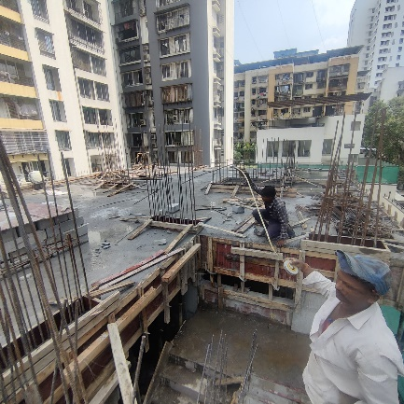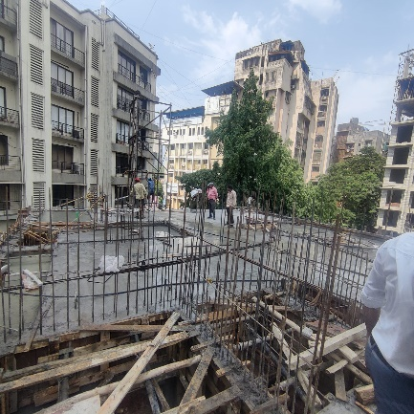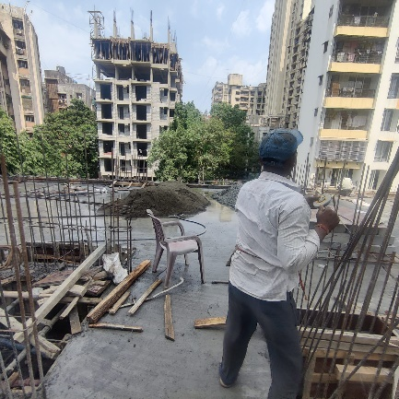

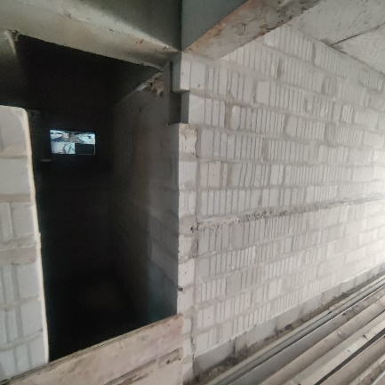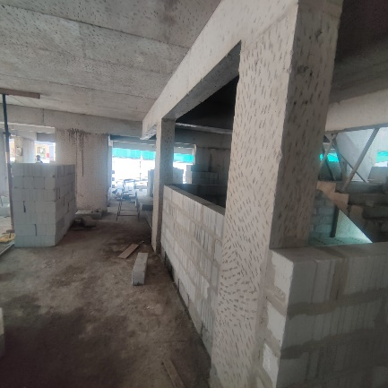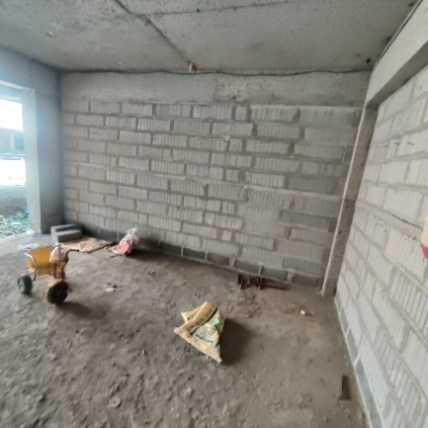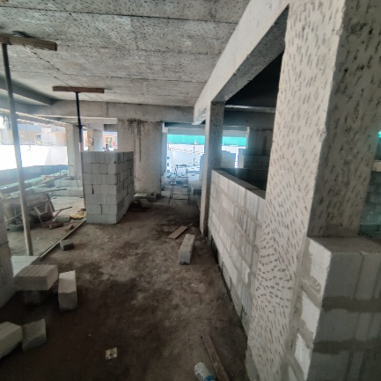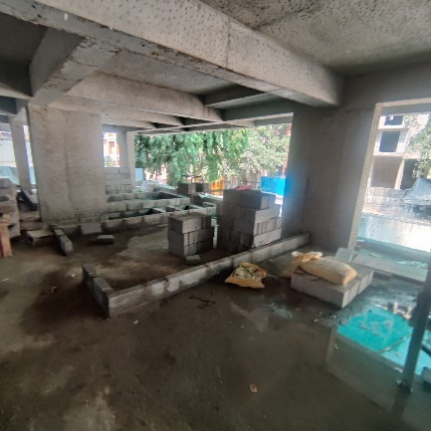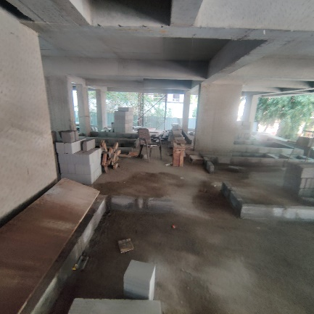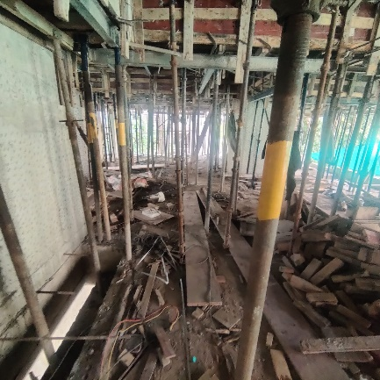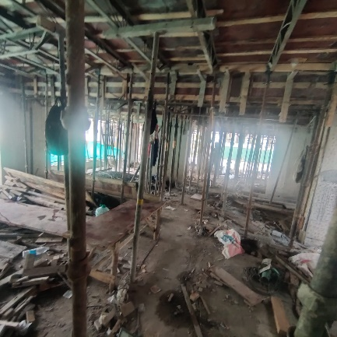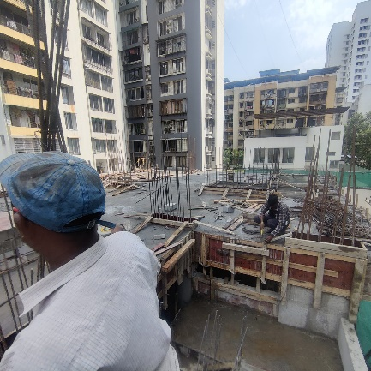

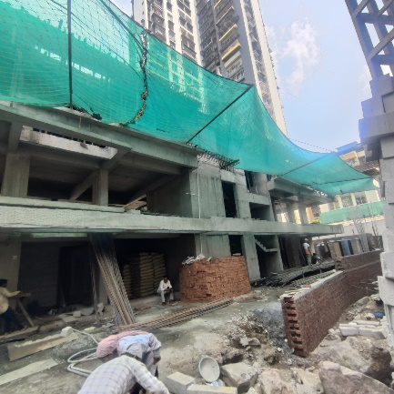**Actual Site Photographs As on 20.04.2023**

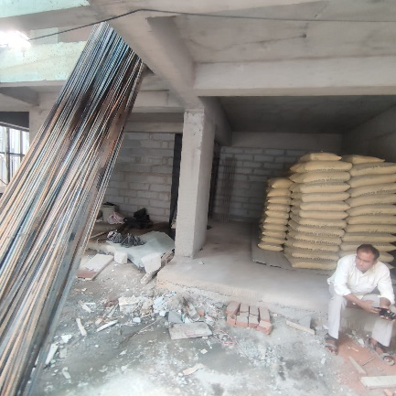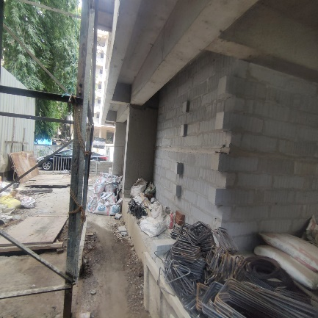

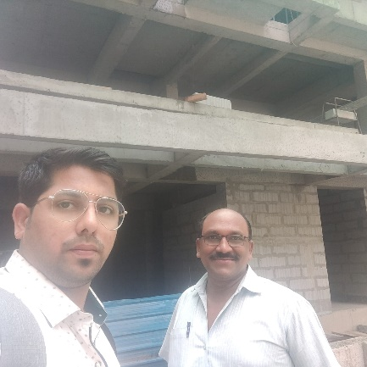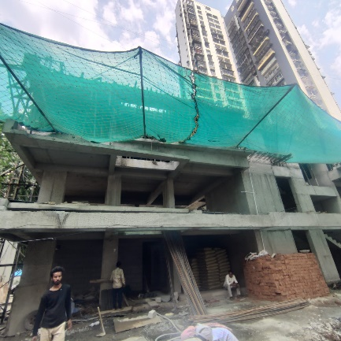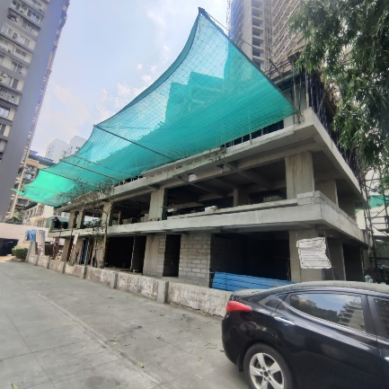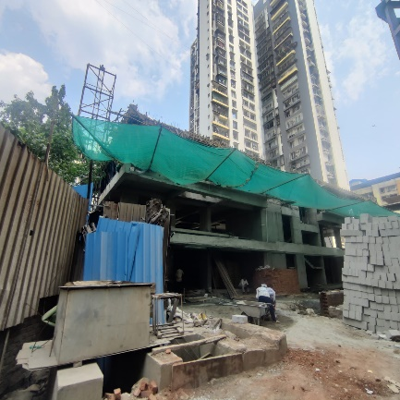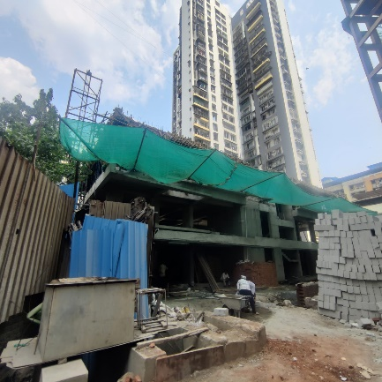

**Route Map of the property**

**Site u/r**

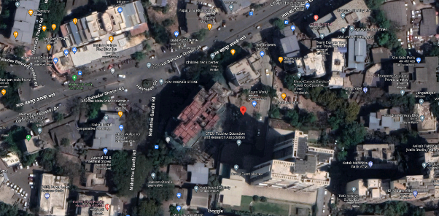

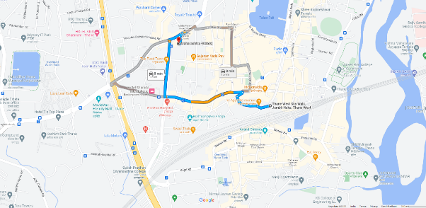

## Latitude Longitude: 19°11'28.3"N 72°58'06.5"E

Note: The Blue line shows the route to site from nearest railway station (Thane – 1.70 Km.)

**CA Certificate Dated 20.04.2023 till 31.03.2023**

