COST VETTING REPORT

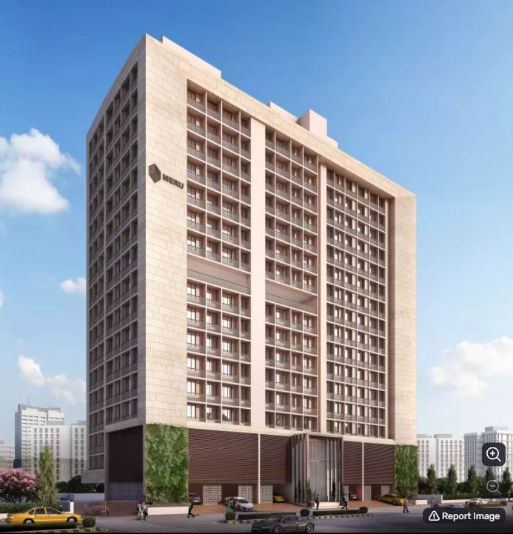

**Details of the property under consideration:**

**Name of Project: "Yojan One"**

**"Yojan One",** Proposed Slum Rehabilitation Scheme Residential Building on plot bearing on

C.T.S. No.131 (pt),131/1 to 131/50, 131/52 to 131/84, Match Factory Lane, H.P.K Marg,

Village – Kurla (IV), Kurla (West), Mumbai, Pin Code – 400 070, State - Maharashtra, Country - India

**Latitude Longitude: 19°04'08.2"N 72°52'33.2"E**

**Valuation Done for:**

**State Bank of India**

**Diamond Garden Chembur Branch**

Unit No. 11, Building No. 11, Ground Floor, Corporate Park, Sion Trombay Road,

Chembur, Mumbai, Pin Code – 400 071, State - Maharashtra, Country – India.

|  |
| --- |
| Vastu/SBI/Mumbai/04/2023/31036/2300162 19/13-159-PY  Date: 19.04.2023 To, **The Branch Manager,**  **State Bank of India**  **Diamond Garden Chembur Branch**  Unit No. 11, Building No. 11,  Ground Floor, Corporate Park,  Sion Trombay Road, Chembur,  Mumbai, Pin Code – 400 071,  State - Maharashtra, Country – India  **Sub:** Cost Vetting for "**Yojan One**" at Kurla (West), Mumbai, Pin Code – 400 070  **Ref:** Your office mail dated 20.03.2023  Dear Sir,  In accordance with your mail as stated above, we enclose our Report on Cost Vetting for "**Yojan One**", Proposed Slum Rehabilitation Scheme - Residential Building on plot bearing on C.T.S. No.131,131/1 to 131/50, 131/52 to 131/84 Match Factory Lane, H.P.K Marg, Village – Kurla (IV), Kurla (West), Mumbai, Pin Code – 400 070, State - Maharashtra, Country – India.  The project is being developed by M/s. Meru Realty LLP which is established in year 2017. Meru Realty is founded by Mr. Arvind M. Shah backed by professionals who have a strong background in real estate industry. The board comprises entrepreneurs who have the needed expertise and real-time experience across fields including finance, marketing, construction etc.  M/s. Meru Realty LLP is developing a Slum Rehabilitation Scheme - Residential Building Project on plot bearing on C.T.S. No.131,131/1 to 131/50, 131/52 to 131/84 having land area of 3,248.10 Sq. M. at Match Factory Lane, H.P.K Marg, Village – Kurla (IV). Project is comprising of one Rehab Building & one Sale Building.  Rehab Building is proposed of Basement (Pt.) + Ground Floor + 1st to 15th Upper Floors having total 150 flats along with religious store, Yogalay, Balwadi, Welfare Centre, Library and Society Office.  Sale Building is proposed of Ground Floor + 1st to 16th Upper Floors with total RERA carpet area of 81,638 Sq. Ft. which consists 1 BHK, 2 BHK units with total 171 nos. of flats along with Fitness Centre and Society Office.  In this regard, State Bank of India, Diamond Garden Chembur Branch, Unit No. 11, Building No. 11, Ground Floor, Corporate Park, Sion Trombay Road, Chembur, Mumbai – 400 071 has approached Vastukala Consultants (I) Pvt. Ltd. (VCIPL) to conduct a Cost Vetting of the said project.  Our analysis of the cost vetting is enclosed in this report. This Report forms an integral whole and cannot be split in parts. The outcome of the report/ study can only lead to proper conclusions if the Report as a whole is taken into account.  The information used by Vastukala Consultants (I) Pvt. Ltd. (VCIPL) in preparing this report has been obtained from a variety of sources and other relevant documents provided by the client & bank. As agreed, we have performed our project valuation exercise with the data available related to the business, considering the market prospects and projections. Our results are dependent on documents provided by client & bank, the underlying assumptions, which has been analyzed at a broader level by VCIPL while assessing their reasonableness.  Total Project Cost for the completion of Project will be **` 114.54 Cr.**  For Vastukala Consultants (I) Pvt. Ltd. Manoj B. Chalikwar Registered Valuer  Chartered Engineer (India)  Reg. No. IBBI / RV / 07/2018/10366  Reg. No. CAT-I-F-1763  SBI Empanelment No.: SME/TCC/2021-22/86/3  **About the Project:**  It is an under construction Proposed Residential Building on plot bearing on C.T.S. No.131,131/1 to 131/50, 131/52 to 131/84 Match Factory Lane, H.P.K Marg, Village – Kurla (IV), Kurla (West), Mumbai, Pin Code – 400 070 It is about 850 M. travelling distance from Kurla Railway station. Near BMC. |

**AREA STATEMENT AS PER APPROVED PLAN:**

| **Sr. No.** | **Area Statement** | **Area in Sq. M.** |
| --- | --- | --- |
| **1** | Area of Plot | 3,248.10 |
| **a** | Area of Reservation in Plot |  |
| **b** | Area of Road Set Back | 261.19 |
| **c** | Area of DP Road | - |
| **2** | Ductions For |  |
| **A** | For Reservation / Road Area | - |
| **a** | Road Set Back Area to Be Handed Over (100%) (Regulation No. (16) | 261.19 |
| **b** | Proposed DP Road to Be Handed Over (100%)  (Regulation No. (16) | - |
| **c** | i) Reservation Area to Be Handed Over (100%) (Regulation No. (17) |  |
|  | ii) Reservation Area to Be Handed Over as Per AR (Regulation No. (17) | - |
| **B** | For Amenity Area | - |
| **a** | Area of Amenity Plots / Plots to Be Handed Over as Per DSR 14 A | - |
| **b** | Area of Amenity Plots / Plots to Be Handed Over as Per DSR 14 B | - |
| **c** | Area of Amenity Plots / Plots to Be Handed Over as Per DSR 35 (Abeyance) | - |
| **C** | Deduction For Existing BUA to Be Retained If Any / Land Component of Existing BUA/ Existing BUA as Per Regulation Under which the Development Was Allowed | - |
| **3** | Total Deduction [(2(A) +2(B)+2(C)] and when Applicable | 2,986.91 |
| **4** | Balance Area of Plot (1 Minus 3) | - |
| **5** | Plot Area Under Development After Area to Be Handed Over to MCGM / Applicable Authority as Per SR No. 4 Above | - |
| **6** | Zonal (Basic FSI (0.50 or 0.75 or 0.33) | - |
| **SR 1.1** | Minimum FSI to Be Attained as Per Clouse Use 3.8 of 33 (10) of DCPR 2034 | - |
| **SR 1.2** | Permissible FSI as Per 33(11)A | - |
| **7** | Built Up Area as Per Zonal (Basic) FSI (5X6) (In Case of Mill Land Permissible BUA / Keep in Abeyance |  |
| **8** | Built Up Equal to Area of Land Handed Over as Per Regulation 30 (A) |  |
|  | i) As Per 2(A) And 2 (B) Except 2(A) (C) ii) Above with In Cap of Permissible TDR as Column 6 of Table-12 On Remaining/ Balance Plot |  |
|  | ii) In Case of 2 (A)(C) ii) Permissible Over and Above Permissible BUA on Remaining/ Balance Plot. |  |
| **9** | Built Up Area In Lieu of Cost of Construction of Built-Up Amenity to Be Handed Over (Within the Limit of Premises BUA On Remaining Plot) |  |
| **10** | Built Up Area Due to Additional FSI on Payment of Premium as per Table No. 12 of Regulation No. 30 (A) On Remaining / Balance Plot |  |
| **11** | Built Up Area Due to Admissible TDR as Per Table No. 12 of Regulation NC 30 (A) And 32 On remaining / Balance Plot |  |
| **12** | Permissible Built-Up Area (As the Case May Be with / without BUA as Per 2 (C) |  |
| **SR 2.1** | Proposed Built Up Area of Rehab | 4,903.76 |
|  | Rehab Component | 5,945.47 |
|  | Permissible Sale Component (Incentive x Rehab Component) 5945.64 X 1.10 | 5945.64 X 1.10 |
| **SR 2.2** | Permissible Built-Up Transit Tenements for SRA / of Total Additional BUA |  |
|  | Permissible BUA for Sale Components of Total Additional BUA | 6,540.02 |
| **SR 3** | Total BUA Sanctioned for The Project | 11,443.78 |
| **13** | Proposed BUA (As the Case May Be with / Without BUA as Per 2C |  |
| **SR 4.1** | Total BUA Proposed to Be Consumed In Situ |  |
| **SR 4.1** | Proposed BUA for Transit Tenements For SRA/Of Total Additional BUA |  |
|  | Proposed BUA for Sale Component of Total Additional BUA | 6,540.02 |
| **14** | TDR Generate If Any as Per Regulation No. 30 (A) And 32 |  |
| **SR 5** | TDR Generate in Schedule |  |
| **15** | Fungible Compensatory Area as Per Regulation No. 31(3) |  |
| **a** | i) Permissible Fungible Compensatory Area for Rehab Component Without Charging Premium | 1,716.52 |
|  | ii) Fungible Compensatory Area Availed for Rehab Component Without Charging Premium | 155.52 |
| **b** | i) Permissible Fungible Compensatory Area by Charging Premium for Sale | 2,289.00 |
|  | ii) Fungible Compensatory Area Availed on Payment of Premium for Sale | 2,283.29 |
| **16** | i) Total BUA Including Fungible for Rehab Component |  |
| **SR 6** | ii) Total BUA Including Fungible for Sale Component | 8,823.31 |
|  | Total Built Up Area Proposed Including Fungible Compensatory Area [13 + 15 (a) (ii) + 15 (b)(ii)] |  |
| **17** | FSI Consumed on Net Plot 13 SR 4.1 / 4 |  |

**CONSTRUCTION AREA FOR REHAB BUILDING**

|  |  |  |  |  |  |  |  |  |  |  |
| --- | --- | --- | --- | --- | --- | --- | --- | --- | --- | --- |
| **Sr. No** | **Floor Nos.** | **Built Up Area in Sq. M.** | **Balcony/ FB / Terrace Area in Sq. M.** | **Staircase & Lift Area in Sq. M.** | **Refuge Area in Sq. M.** | **Stilt Area in Sq. M.** | **Meter Room/ Electric room / DG Room area in Sq. M.** | **Lobby Area in Sq. M.** | **Other Area in Sq. M.** | **Total Area in Sq. M.** |
| **1** | Basement | - | - | - | - | 508.14 | - | - | - | 508.14 |
| **2** | Ground Floor | 52.78 | 20.25 | 27.20 | - | 92.76 | 89.59 | 37.94 | 138.02 | 458.54 |
| **3** | 1st Floor | 192.75 | 70.20 | 40.83 | - | 102.10 | - | 58.33 | - | 464.21 |
| **4** | 2nd Floor | 323.42 | 4.37 | 38.40 | - | - | - | 58.07 | 32.88 | 457.14 |
| **5** | 3rd Floor | 355.80 | 4.37 | 38.40 | - | - | - | 55.07 | - | 453.64 |
| **6** | 4th Floor | 355.80 | 4.37 | 38.40 | - | - | - | 55.07 | - | 453.64 |
| **7** | 5th Floor | 355.80 | 4.37 | 38.40 | - | - | - | 55.07 | - | 453.64 |
| **8** | 6th Floor | 355.80 | 4.37 | 38.40 | - | - | - | 55.07 | - | 453.64 |
| **9** | 7th Floor | 355.80 | 4.37 | 38.40 | - | - | - | 55.07 | - | 453.64 |
| **10** | 8th Floor | 258.08 | 4.37 | 38.40 | 97.72 | - | - | 58.07 | - | 456.64 |
| **11** | 9th Floor | 355.80 | 4.37 | 38.40 | - | - | - | 55.07 | - | 453.64 |
| **12** | 10th Floor | 355.80 | 4.37 | 38.40 | - | - | - | 55.07 | - | 453.64 |
| **13** | 11th Floor | 355.80 | 4.37 | 38.40 | - | - | - | 55.07 | - | 453.64 |
| **14** | 12th Floor | 355.80 | 4.37 | 38.40 | - | - | - | 55.07 | - | 453.64 |
| **15** | 13th Floor | 355.80 | 4.37 | 38.40 | - | - | - | 55.07 | - | 453.64 |
| **16** | 14th Floor | 355.80 | 4.37 | 38.40 | - | - | - | 55.07 | - | 453.64 |
| **17** | 15th Floor | 162.93 | 8.26 | 39.15 | - | - | - | 58.07 | 38.13 | 306.54 |
| **18** | Terrace | - | - | 39.15 | - | - | - | - | - | 39.15 |
|  | **Total** | **4,903.76** | **155.52** | **645.53** | **97.72** | **703.00** | **89.59** | **876.25** | **209.03** | **7,680.40** |
|  | **No. of Stack Car Parking** | | | | | | | | **24.00 Nos** | |

**CONSTRUCTION AREA FOR SALE BUILDING**

|  |  |  |  |  |  |  |  |  |  |  |  |
| --- | --- | --- | --- | --- | --- | --- | --- | --- | --- | --- | --- |
| **Sr. No** | **Floor Nos.** | **Built Up Area in Sq. M.** | **Balcony / FB / Terrace Area in Sq. M.** | **Staircase & Lift Area in Sq. M.** | **Refuge Area in Sq. M.** | **Stilt Area in Sq. M.** | **Meter Room area in Sq. M.** | **Society Office Area in Sq. M.** | **Servant Toilet Area in Sq. M.** | **Fitness Area in Sq. M.** | **Total Area in Sq. M.** |
| **1** | Ground Floor | - | - | 137.84 | - | 595.91 | 34.99 | 24.10 | - | 156.09 | 948.93 |
| **2** | 1st Floor | 330.33 | 128.04 | 137.84 | - | 321.16 | - | - | 5.36 | 20.49 | 943.22 |
| **3** | 2nd Floor | 377.03 | 72.18 | 137.84 | - | 321.16 | - | - | 6.83 | - | 915.04 |
| **4** | 3rd Floor | 618.28 | 63.47 | 126.65 | - | - | - | - | 5.36 | - | 813.76 |
| **5** | 4th Floor | 618.28 | 63.47 | 126.65 | - | - | - | - | 5.36 | - | 813.76 |
| **6** | 5th Floor | 618.28 | 63.47 | 126.65 | - | - | - | - | 5.36 | - | 813.76 |
| **7** | 6th Floor | 618.28 | 63.47 | 126.65 | - | - | - | - | 5.36 | - | 813.76 |
| **8** | 7th Floor | 618.28 | 63.47 | 126.65 | - | - | - | - | 5.36 | - | 813.76 |
| **9** | 8th Floor | 441.77 | 63.47 | 126.65 | 176.51 | - | - | - | 5.36 | - | 813.76 |
| **10** | 9th Floor | 618.28 | 63.47 | 126.65 | - | - | - | - | 5.36 | - | 813.76 |
| **11** | 10th Floor | 618.28 | 63.47 | 126.65 | - | - | - | - | 5.36 | - | 813.76 |
| **12** | 11th Floor | 618.28 | 63.47 | 126.65 | - | - | - | - | 5.36 | - | 813.76 |
| **13** | 12th Floor | 618.28 | 63.47 | 126.65 | - | - | - | - | 5.36 | - | 813.76 |
| **14** | 13th Floor | 618.28 | 63.47 | 126.65 | - | - | - | - | 5.36 | - | 813.76 |
| **15** | 14th Floor | 618.28 | 63.47 | 126.65 | - | - | - | - | 5.36 | - | 813.76 |
| **16** | 15th Floor | 618.28 | 63.47 | 126.65 | - | - | - |  | 5.36 | - | 813.76 |
| **17** | 16th floor | 254.82 | 439.13 | 137.84 | - | - | - | - | - | - | 831.79 |
| **18** | Terrace | - | - | 137.84 | - | - | - | **-** | - | - | 137.84 |
|  | **Total** | **8,823.31** | **1,464.45** | **2,335.65** | **176.51** | **1,238.23** | **34.99** | **24.10** | **81.87** | **176.58** | **14,355.69** |
|  | **No. of Stack Car Parking** | | | | | | | | | **92.00 Nos** | |

## Project Cost

|  |  |  |  |
| --- | --- | --- | --- |
| Sr. No. | Particulars | Total Estimated Amount in ` | Total Estimated Amount  in ` Cr. |
| 1 | **Land Cost** |  |  |
|  | Acquisition Cost of Land or Development Rights, and Legal Cost. | 8,07,30,100.00 | 8.07 |
|  | Rent to Tenants, Lease premium, Lease Rent, interest cost incurred or payable on Land Cost | 6,77,22,640.00 | 6.77 |
|  | Amount of Premium payable to obtain development rights, FSI, additional FSI, fungible area, and any other incentive under DCR from Local Authority or State Government or any Statutory Authority. | 9,32,90,405.00 | 9.33 |
|  | Acquisition cost of TDR (if any) | - | - |
| 2 | **Cost of Construction** |  |  |
| 1. I | Estimated construction cost of rehab building including site development and infrastructure for the same. | 22,44,11,000.00 | 22.44 |
|  | Estimated construction cost of sale building including site development and infrastructure for the same. | 47,69,64,112.00 | 47.70 |
|  | On site expenditure for development of entire project excluding cost of construction as per(i) above, |  |  |
| a. | Architect Fees & Consultant fees | 3,50,68,756.00 | 3.51 |
| b. | Admin Cost includes salaries, site overheads, development works, cost of services (including water, electricity, sewerage, drainage, layout roads etc.), cost of machineries and equipment including its hire and maintenance cost, consumables etc. All costs directly incurred to complete the construction of the entire phase of the project registered. | 2,80,55,004.00 | 2.81 |
| c. | Marketing Cost | 3,88,72,485.00 | 3.89 |
| 3 | Interest during the Project | 8,00,00,000.00 | 8.00 |
| 4. | Contingency Charges | 2,10,41,253.00 | 2.10 |
|  | **GRAND TOTAL:** | **114,54,06,936.00** | **114.54** |

## Manoj B. Chalikwar

Registered Valuer

Chartered Engineer (India)

Reg. No. IBBI / RV / 07/2018/10366

Reg. No. CAT-I-F-1763

SBI Empanelment No.: SME/TCC/2021-22/86/3

**Comments on each element of Cost of Project**: -

1. **Land Cost:**

As per Present Ready Reckoner rate the Land Value is ` 16.33 Cr. considering Land Rate @ ` 54,680.00 per Sq. M. & Net Plot Area of 2,986.91 Sq. M.

Cost of land is ` 8,07,30,100.00 i.e., ` 8.07 Cr. which is 7.05% of Total Project Cost.

|  |  |  |  |  |
| --- | --- | --- | --- | --- |
| **Sr. No.** | **Date** | **Description** | **Total Cost in `** | **Incurred Cost in `** |
| **1** | 06.10.2017 | Land Cost | 7,40,71,573.00 | 7,40,71,573.00 |
| **2** | Stamp Duty | 66,28,427.00 | 66,28,427.00 |
| **3** | Reg. Fees | 30,000.00 | 30,000.00 |
| **5** | 100.00 | 100.00 |
| **Total** | | | **8,07,30,100.00** | **8,07,30,100.00** |

1. **Building Cost of Construction for Rehab Building:**

Construction area Building = 7,680.40 Sq. M.

No. of total Puzzle Pit Car Parking = 24 Nos.

Total estimated cost for construction of Building (includes cost of RCC work, manpower, lift, material, painting, finishing work, site development, etc.) is ` 19,20,10,000.00 i.e., ` 19.20 Cr. which comes ` 25,000.00 per Sq. M. on construction area for building and cost for construction of stack car parking is ` 1,20,00,000.00 i.e., ` 2.58 Cr. which comes ` 5,00,000.00 per car parking and cost for construction for deep excavation & piling work is ` 2,04,01,000.00 i.e., ` 2.04 Cr. which is 10% of (Cost of Construction + Cost of Construction of Puzzle Pit Car Parking.

Hence, total cost of construction (Cost of Construction of Building + Cost of Construction of Puzzle Pit Car Parking + Cost of Deep Excavation & Piling Work) is ` 22,44,11,000.00 i.e., ` 22.44 Cr.

The total construction area is 7,680.40 Sq. M., projected cost of ` 22.44 Cr is 19.59 % of total project cost

VCIPL opinion the construction cost of 25,000/- Per Sq. M. which is in line with Market-Trend for Rehab Building.

|  |  |
| --- | --- |
| **Particulars** | **Rate per Sq. M.** |
| **Excavation Work** | **2,500.00** |
| **Total RCC Work** | **13,000.00** |
| **Final Finishing Work** | **5,500.00** |
| **Other Work** | **4,000.00** |
| **Total Cost of Construction** | **25,000.00** |
| **Stack Car Parking** | **5,00,000.00 per car parking** |
| **Deep Excavation & Piling Work** | **10% of total Cost of construction + Cost of Parking** |

1. **Building Cost of Construction for Sale Building:**

Construction area Building = 14,355.69 Sq. M.

No. of total Puzzle Pit Car Parking = 92 Nos.

Total estimated cost for construction of Building (includes cost of RCC work, manpower, lift, material, painting, finishing work, site development, etc.) is ` 38,76,03,738.00 i.e., ` 38.76 Cr. which comes ` 27,000.00 per Sq. M. on construction area for building and cost for construction of stack car parking is ` 4,60,00,000.00 i.e., ` 4.60 Cr. which comes ` 5,00,000.00 per car parking and cost for construction for deep excavation & piling work is ` 4,33,60,374.00 i.e., ` 4.34 Cr. which is 10% of (Cost of Construction + Cost of Construction of Puzzle Pit Car Parking.

Hence, total cost of construction (Cost of Construction of Building + Cost of Construction of Puzzle Pit Car Parking + Cost of Deep Excavation & Piling Work) is ` 47,69,64,112.00 i.e., ` 47.70 Cr.

The total construction area is 14,355.69 Sq. M., projected cost of ` 47.70 Cr is 41.64 % of total project cost

VCIPL opinion the construction cost of 27,000/- Per Sq. M. which is in line with Market-Trend for Sale Building.

|  |  |
| --- | --- |
| **Particulars** | **Rate per Sq. M.** |
| **Excavation Work** | **2,500.00** |
| **Total RCC Work** | **14,000.00** |
| **Final Finishing Work** | **6,500.00** |
| **Other Work** | **4,000.00** |
| **Total Cost of Construction** | **27,000.00** |
| **Stack Car Parking** | **5,00,000.00 per car parking** |
| **Deep Excavation & Piling Work** | **10% of total Cost of construction + Cost of Parking** |

1. **Rent Cost to Tenants:**

Since it is a Redevelopment project under Sec (33)7 from the date of shifting of 144 Tenants the compensation for rent and shifting charges is to be paid till handing over their respective new flats as per the Tenant Agreement. Further the rent keeps on increasing by 10% per annum. The existing Tenants has to be given total rental of ` 6,77,22,640.00 i.e., ` 6.77 Cr. Builder has paid ` 2.18 Cr. which is 5.91% of Total Project Cost.

Existing Tenants Carpet Area & Rent per month for Flat are as follows:

| **Sr. No.** | **Particulars** | **Unit** |
| --- | --- | --- |
| **1** | No. of tenants | 142.00 |
| **2** | Rate / month / tenant (Jan 2021 to Nov 2021) | 12,000.00 |
| **3** | Rent / month (Jan 2021 to Nov 2021) | 17,04,000.00 |
| **4** | Rent / Year (Jan 2021 to Nov 2021) | 1,87,44,000.00 |
| **5** | Rate / month / tenant (Dec 2021 to Oct 2022) | 13,200.00 |
| **6** | Rent / month (Dec 2021 to Oct 2022) | 18,74,000.00 |
| **7** | Rent / Year (Dec 2021 to Oct 2022) | 2,06,18,400.00 |
| **8** | Rate / month / tenant (Nov 2022 to Sept 2023) | 14,520.00 |
| **9** | Rent / month (Nov 2022 to Sept 2023) | 20,61,840.00 |
| **10** | Rent / Year (Nov 2022 to Sept 2023) | 2,26,80,240.00 |
| **11** | Corpus fund per tenant | 40,000.00 |
| **12** | Total Corpus fund | 57,60,000.00 |
|  | **Total Rent Cost (4 + 7 + 10 + 12)** | **6,77,22,640.00** |

1. **Approval Charges:**

The Total Approval Cost (Fungible Cost & Development Cess Premium) is ` 9,32,90,405.00 i.e., ` 9.33 Cr. which is 8.14% of Total Project Cost.

|  |  |  |
| --- | --- | --- |
| **Sr. No.** | **Particulars** | **Amount in `** |
| **1** | Infrastructure Charges | 85,02,000.00 |
| **2** | MRTP Charges |  |
|  | Land Component | 16,84,800.00 |
|  | Construction Component | 1,83,18,500.00 |
| **3** | Staircase Premium | 26,71,300.00 |
| **4** | Open Space Deficiency | 58,33,700.00 |
| **5** | Labour Charges |  |
|  | Rehab Building | 19,86,500.00 |
|  | Sale Building | 36,37,000.00 |
| **6** | Legal Charges | 5,00,000.00 |
| **7** | Sale Fungible FSI | 2,18,71,395.00 |
| **8** | Payment of Cess & Taxes | 2,82,85,210.00 |
|  | **Total** | **9,32,90,405.00** |

1. **Architect Cost, RCC & Other Professional Charges:**

The total Architect charges of ` 3,50,68,756.00 i.e., ` 3.51 Cr. is 5% of total construction cost of Rehab Building & Sale Building & it is line up with Market trend.

The professional charge consists of Architect & Legal which in market is in the range of 3% - 6% of Total Construction cost of the project.

1. **Administrative Expenses:**

Salaries, site overheads, development works, cost of services (including water, electricity, sewerage, drainage, layout roads etc.), cost of machineries and equipment including its hire and maintenance cost, consumables etc. All costs directly incurred to complete the construction of the entire phase of the project registered is estimated 4% of total construction cost of Rehab Building & Sale Building which comes to ` 2,80,55,004.00 i.e., ` 2.81 Cr.

The admin charges which in market is in the range of 2% - 4% of Total Project cost of the project.

1. **Marketing Expenses:**

Marketing costs directly incurred to complete the construction of the entire phase of the project registered is estimated at 2% of total Sale income from the project which comes to ` 3,81,23,666.00 i.e., ` 3.81 Cr.

The marketing charge consists of brokerage & commission which in market is in the range of 1% - 3% of Total Sale income of the property.

1. **Interest Costs:**

The Interest cost for the term loan is ` 8,00,00,000.00 i.e., ` 8.00 Cr., which is 6.99 % of total project cost.

As per information provided by the client.

1. **Contingency Costs:**

The contingency charges estimated at 2% of cost of construction cost of Rehab Building & Sale Building which comes to ` 2,10,41,253.00 i.e., ` 2.10 Cr.

**Observation and Construction**: -

**Total estimated cost of project i.e., ` 114,54,06,936.00 (Rupees One Hundred Fourteen Crore Fifty Four Lakh Six Thousand Nine Hundred Thirty Six Only) i.e. ` 114.54 Cr. is fair & reasonable.**

The project cost is including land premium payable to concern authorities, Fungible FSI Premium, Cost of Construction of rehab & Sale Building, on site expenses including admin & marketing expenses, premiums / charges to be paid to competent authority and Bank interest, etc. we have not independently verified interest cost hence not consider in cost vetting.

Total estimated cost of construction for Rehab Building for sanctioned plan up to Basement + Ground Floor + 1st to 15th Upper Floor is ` 22,44,11,000.00 which is ` 25,000.00 per Sq. M. on gross construction area is 7,680.40 Sq. M. & ` 5,00,000.00 per stack car parking & 10% for deep excavation & piling (cost of construction + cost of stack parking) which is fair & reasonable considering the present status of project, type & quality of construction & specification of the building materials to be used, height of the structure, amenities to be provided in proposed building.

Total estimated cost of construction for Sale Building for sanctioned plan up to Ground Floor + 1st to 16th Upper Floor is ` 47,69,64,112.00 which is ` 27,000.00 per Sq. M. on gross construction area is 14,355.69 Sq. M. & ` 5,00,000.00 per stack car parking & 10% for deep excavation & piling (cost of construction + cost of stack parking) which is fair & reasonable considering the present status of project, type & quality of construction & specification of the building materials to be used, height of the structure, amenities to be provided in proposed building.

**Assumptions & Remarks-**

* The adequacy of Engineering / Structural design is beyond the scope of our assignment.
* Estimated project completion date is 30/09/2026. The cost is certified based on the assumptions that the project will be completed within time frame. Few assumptions are made regarding inflation & cost rise etc. during construction period.

Photo copy of following document is provided to us & this report should be read along with it:

|  |
| --- |
| * Copy of Conveyance Deed dated 10.10.2017 b/w M/s. A. H. Wadia Trust (The Vendors) & M/s. Meru Realty LLP (The Purchasers) |
| * Copy of Limited Liability Partnership Agreement dated 06.07.2019. |
| * Copy of Amended Approved Plan for Sale Building No. SRA/ENG/L/PVT/0076/2018/0604/AP/S dated 23.01.2023 issued by Slum Rehabilitation Authority (SRA). * **Approval Up to: Ground Floor + 1st to 16th Upper Floors** |
| * Copy of Amended Approved Plan for Sale Building No. L/PVT/0076/20180604/AP/S dated 14.10.2021 issued by Slum Rehabilitation Authority (SRA). * **Approval Up to: Ground Floor + 1st to 16th Upper Floors** |
| * Copy of Approved Plan for Sale Building No. L/PVT/0076/20180604/AP/LAY dated 24.11.2020 issued by Slum Rehabilitation Authority (SRA).   **Approval Up to: Ground Floor + 1st to 11th Upper Floors** |
| * Copy of Approved Plan for Rehab Building No. L/PVT/0076/20180604/AP/R dated 15.09.2020 issued by Slum Rehabilitation Authority (SRA).   **Approval Up to: Basement + Ground Floor + 1st to 15th Upper Floors** |
| * Copy of IOD Plan for Sale Building No. L/PVT/0076/20180604/AP/S dated 15.09.2020 issued by Slum Rehabilitation Authority (SRA). |
| * Copy of IOD Plan for Rehab Building No. L/PVT/0076/20180604/LOI dated 28.08.2020 issued by Slum Rehabilitation Authority (SRA). |
| * Copy of Commencement Certificate for Rehab Building No. L/PVT/0076/20180604/AP/R dated 29.06.2021 issued by Slum Rehabilitation Authority (SRA).   **(This CC is now endorsed for the work of Basement + Ground Floor + 1st to 15th Upper Floors including OHT& LMR)** |
| * Copy of Commencement Certificate for Sale Building No. L/PVT/0076/20180604/AP/S dated 23.01.2023 issued by Slum Rehabilitation Authority (SRA). * **(This CC is now endorsed for the work of Ground Floor + 1st to 6th Upper Floors)** |
| * Copy of Commencement Certificate for Sale Building No. L/PVT/0076/20180604/AP/S dated 10.02.2021 issued by Slum Rehabilitation Authority (SRA).   **(This CC is now endorsed for the work of Plinth level)** |
| * Copy of No Objection Certificate for Height Clearance No. SNCR/WEST/B/031919/378819 dated 05.04.2019 valid upto 04.04.2027 issued by Airports Authority of India.   **(Permissible Top Elevation of the building above Mean Sea Level (AMSL) should be 57.13 M)** |
| * Copy of CA Certificate dated 18.04.2023 issued by M/s. H. L. Jain & Associates. |
| * Copy of CA Certificate (Form 3) dated 14.04.2023 issued by M/s. H. L. Jain & Associates. |
| * Copy of CA Certificate dated 15.12.2021 issued by M/s. H. L. Jain & Associates. |
| * Copy of Title Report dated 25.03.2021 issued by Mr. G.S. Bhat |
| * Copy of Title Report dated 18.06.2021 issued by M/s. R. K. Consultant |
| * Copy of Search Report dated 21.02.2017 issued by R.K Consultant |
| * Copy of RERA Certificate No. **P51800028864** dated 08.09.2021 issued by Maharashtra Real Estate Regulatory Authority (MAHRERA). |
| * Copy of Architect Certificate dated 31.12.2022 issued by Consultants Combined Architects |
| * Copy of Architect Certificate dated 11.02.2021 issued by Consultants Combined Architects |
| * Copy of Architect Certificate dated 08.12.2021 issued by Consultants Combined Architects |
| * Copy of Engineer Certificate dated 30.01.2023 issued by Mr. Sailesh R. Mahimtura. |
| * Copy of Engineer Certificate dated 03.03.2021 issued by M/s. Mahimtura Consultants Pvt. Ltd. |
| * Copy of Engineer Certificate dated 30.09.2021 issued by Mr. Sailesh R. Mahimtura. |

**Actual Site Photographs**

**Rehab Building**

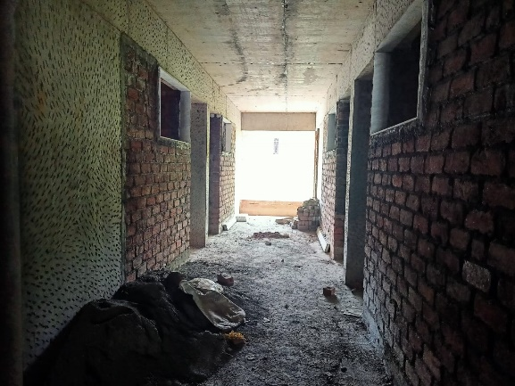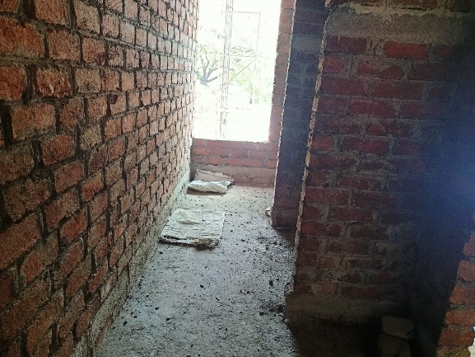

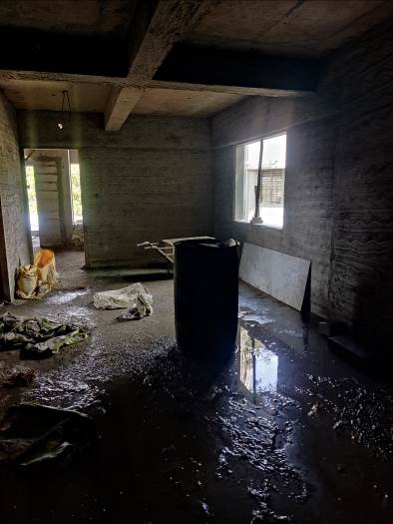

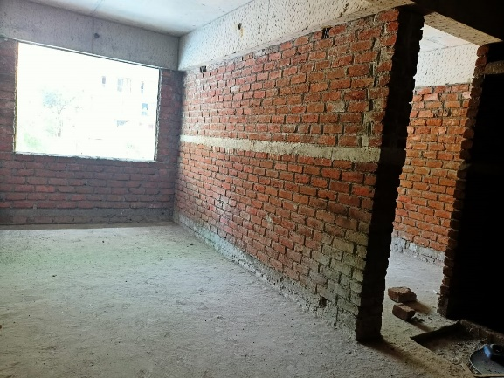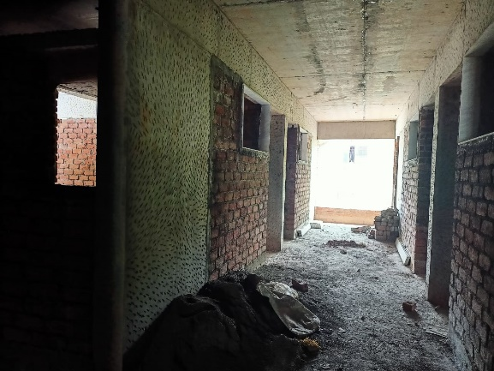

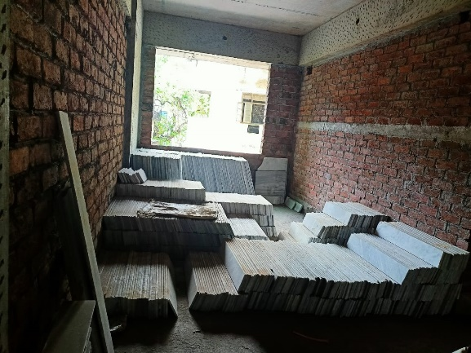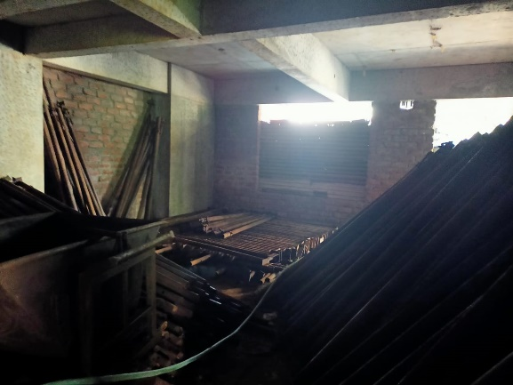

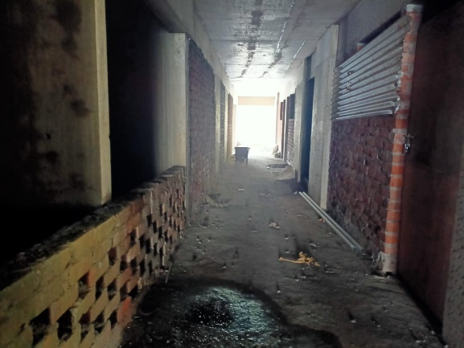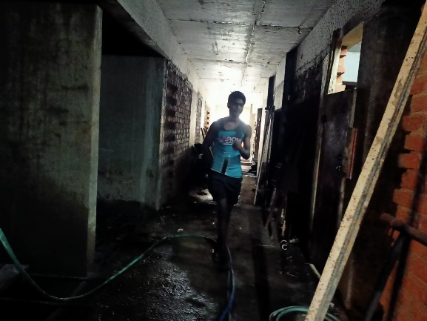**Actual Site Photographs**

**Rehab Building**

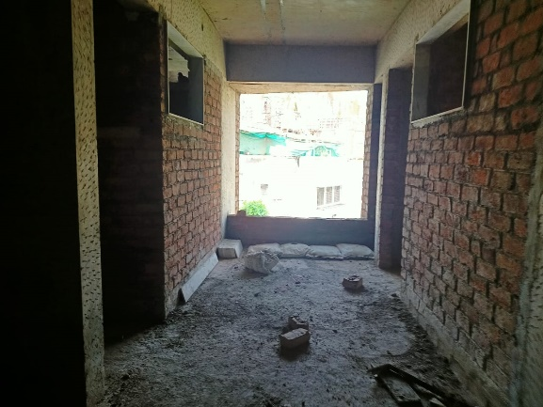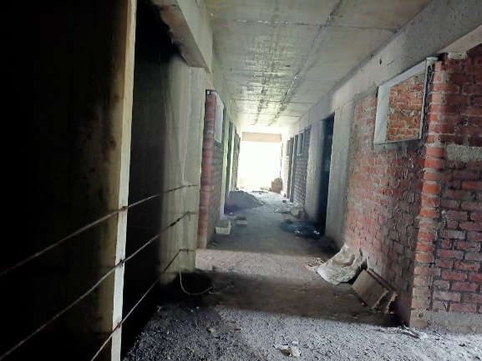

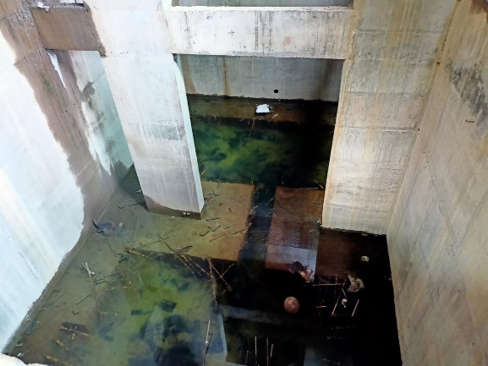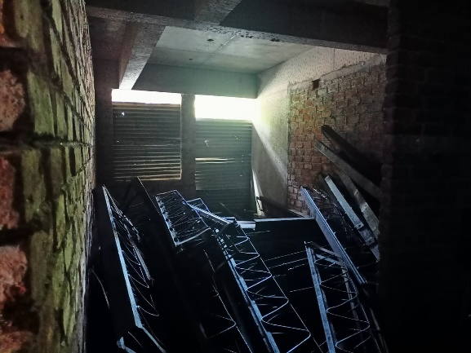**Actual Site Photographs**

**Rehab Building**

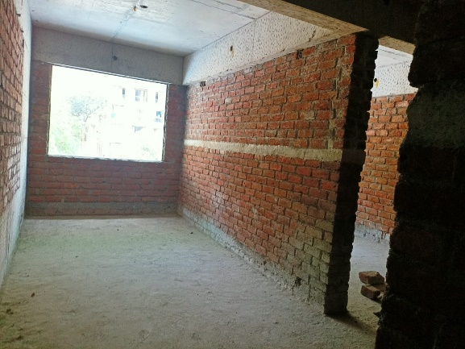

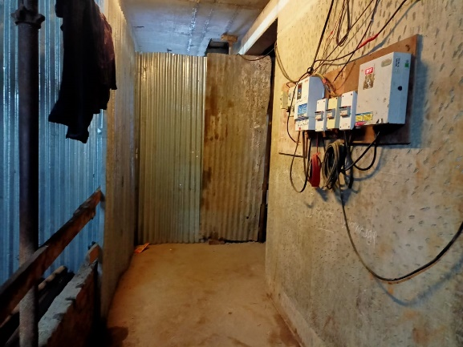

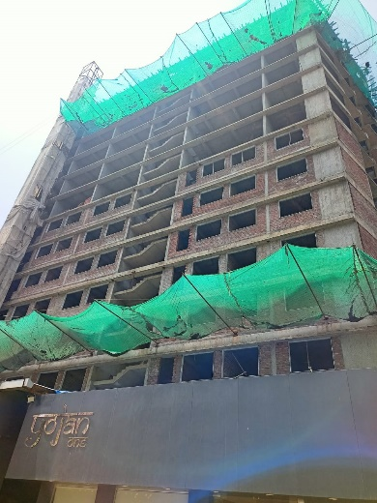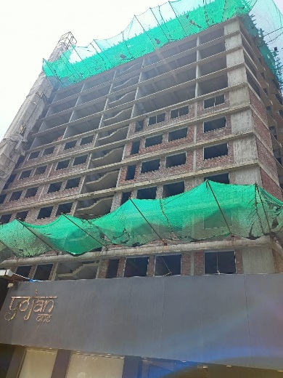

**Actual Site Photographs**

**Sale Building**

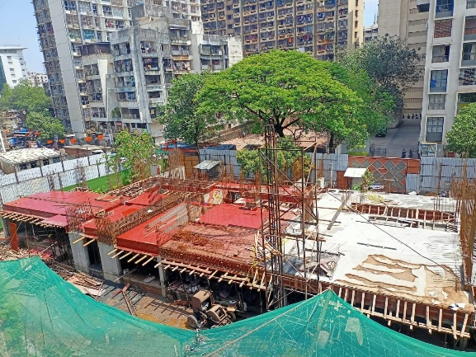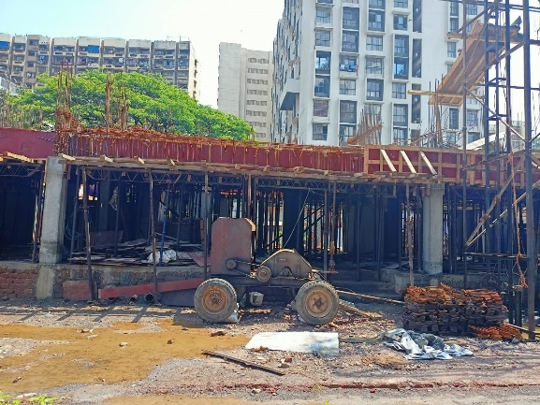

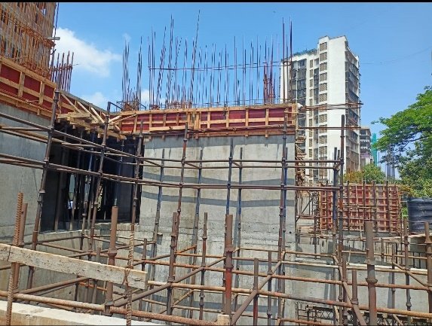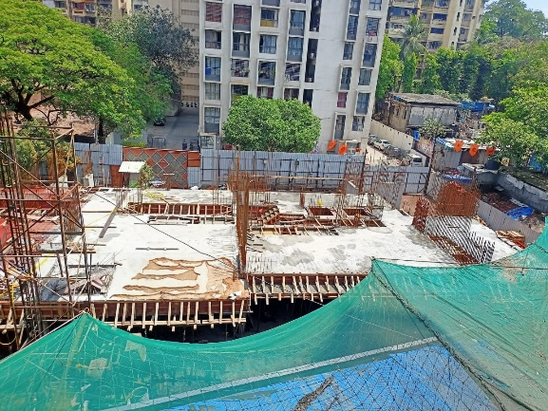

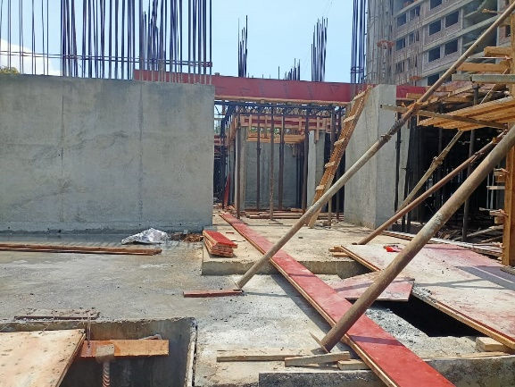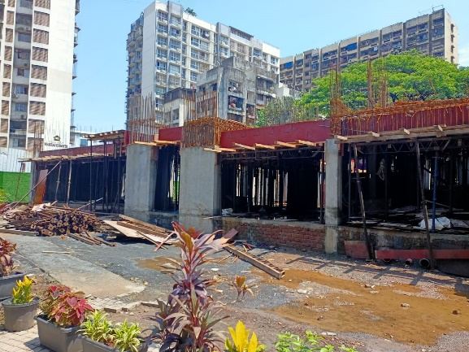

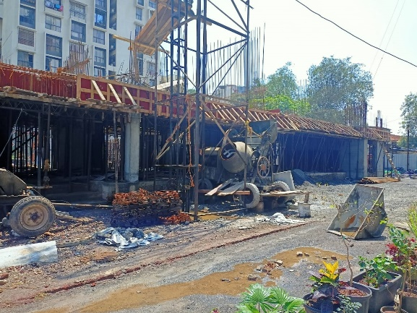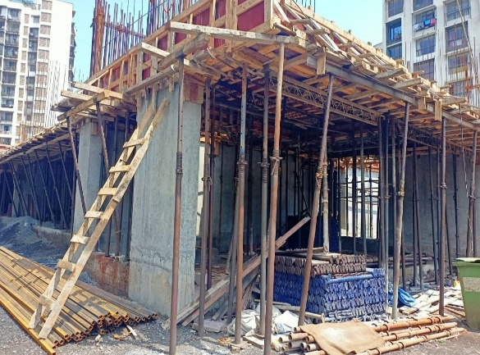

**Actual Site Photographs**

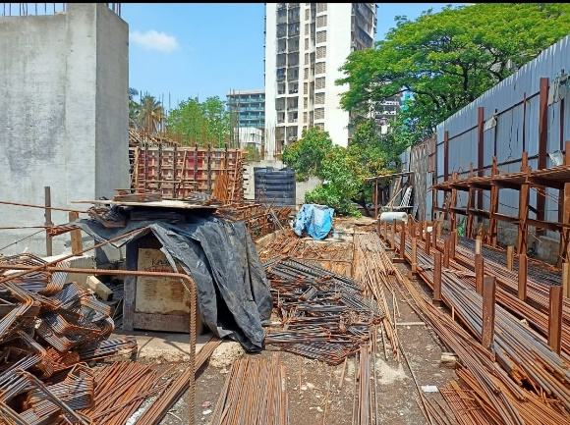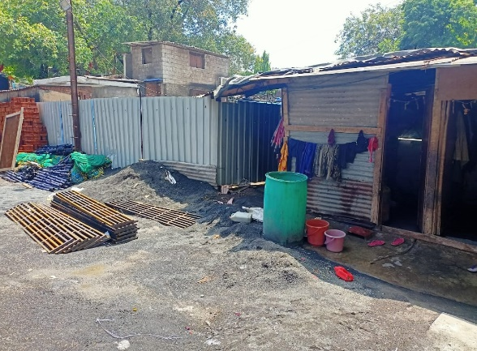

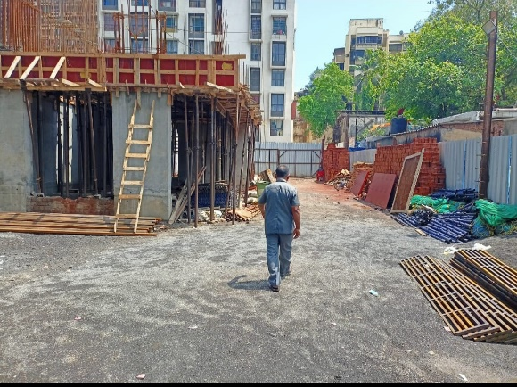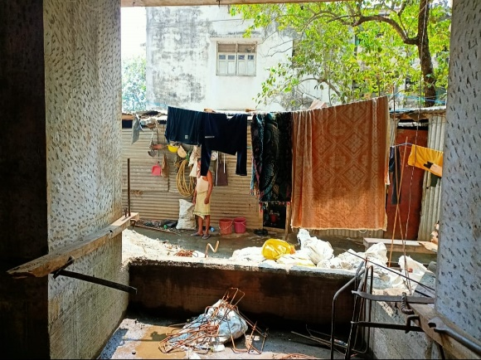

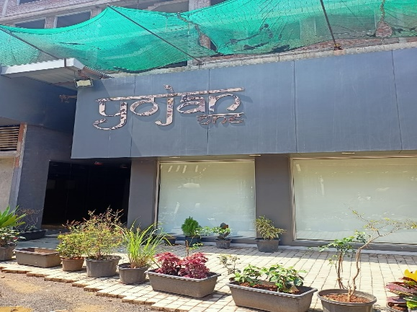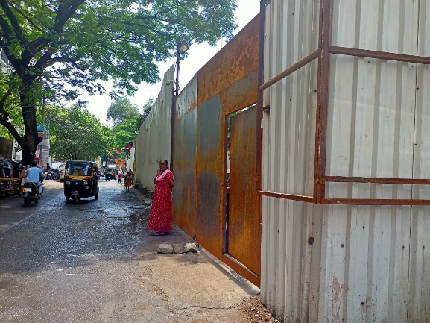

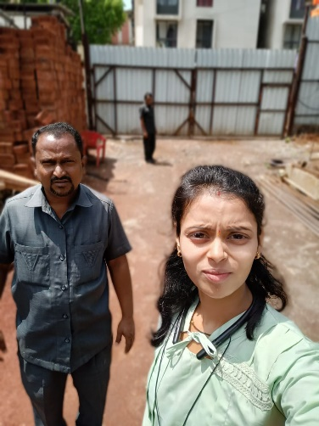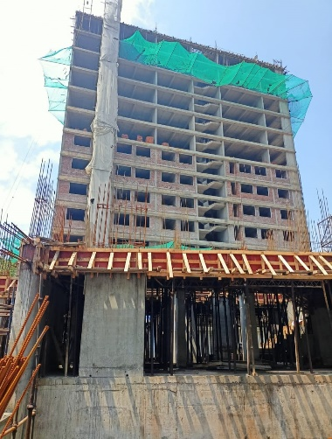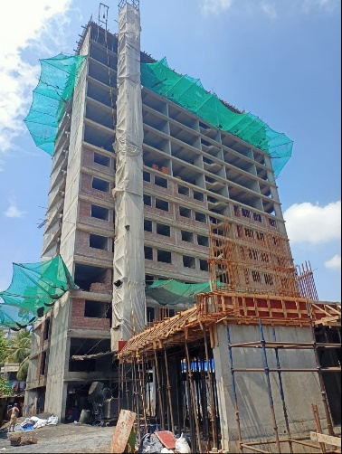

**Route Map of the property**

**Site u/r**

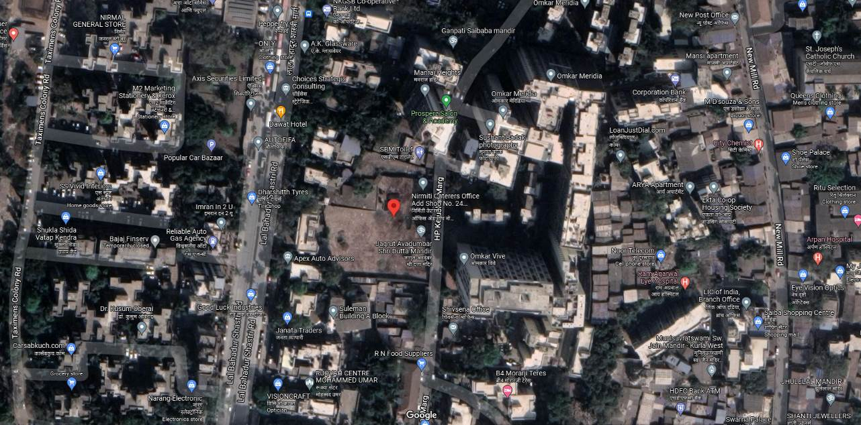

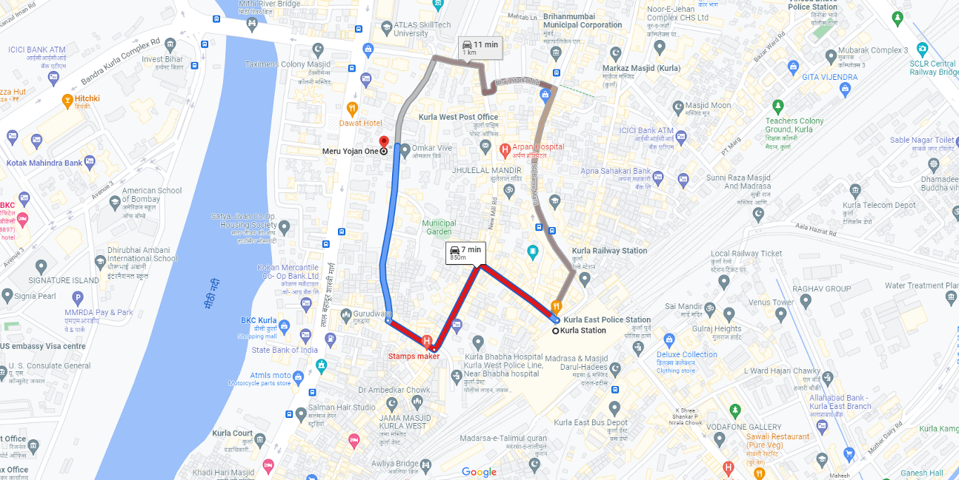

# **Latitude Longitude: 19°04'08.2"N 72°52'33.2"E**

**Note:** The Blue line shows the route to site from nearest railway station (Kurla – 850.00 Km.)