Valuation Report of the Immovable Property
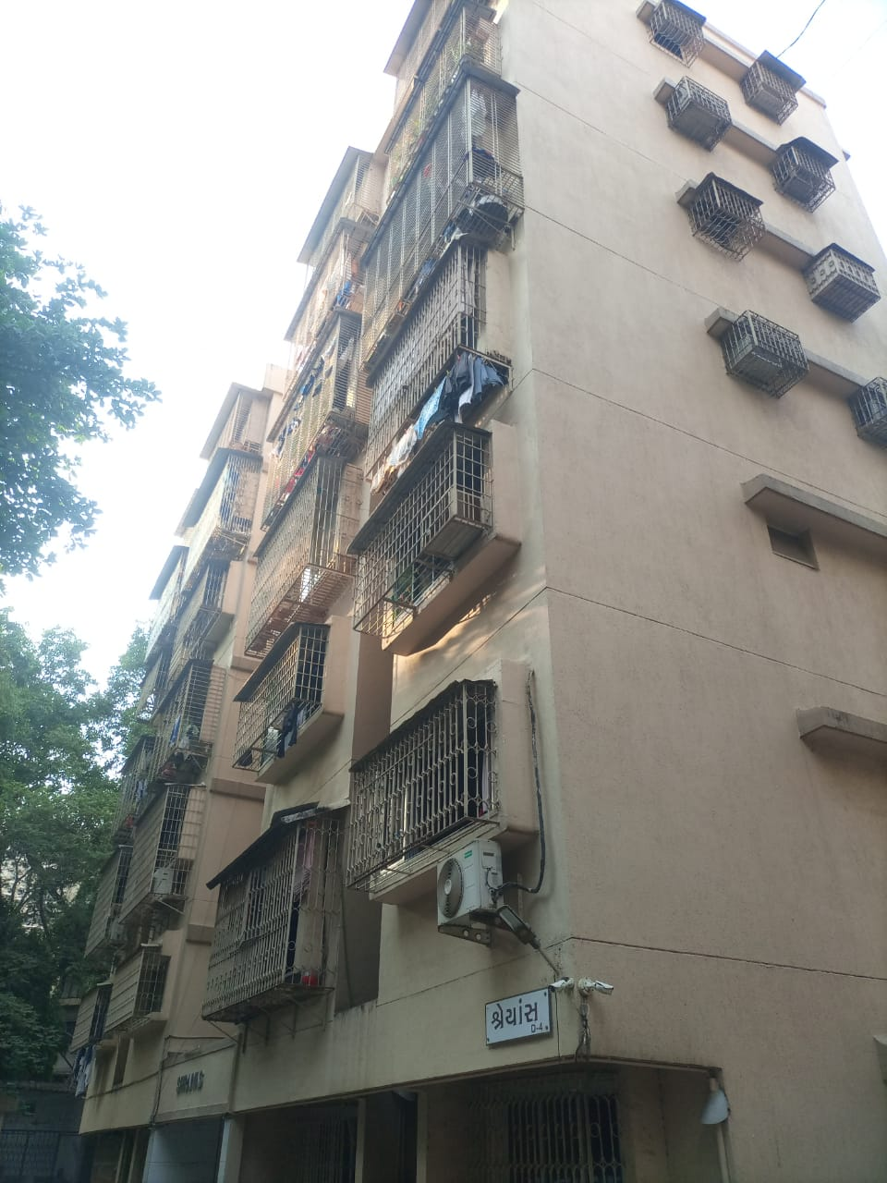

Details of the property under consideration:

Name of Owner: Mr. Mehul Chandrakant Doshi &
Dhara Mehul Doshi (Before marriage Dhara Yogesh Diora)

Residential Flat No. 105, 1st Floor, Building No. D-4, "Shraiyas Apartment", Suvadhi Shraiyas Co-Op. Hsg. Soc. Ltd.", Sarvodaya Parshwanath Nagar, Nahur Road, Village – Nahur, Mulund (West),
Mumbai – 400 080, State – Maharashtra, Country – India.

Latitude Longitude: 19°09'50.1"N 72°56'43.4"E

Valuation Done for:
Punjab National Bank

Mulund West Branch
Aroto House, P. K. Road, Near Pooja Blood Bank, Mulund (West), Mumbai – 400 080,
State – Maharashtra, Country – India.

Vastu/Thane/04/2023/30749/2300071
12/09-69-PSVS
Date: 12.04.2023

VALUATION OPINION REPORT

This is to certify that the property bearing Residential Flat No. 105, 1st Floor, Building No. D-4, "Shraiyas Apartment", Suvadhi Shraiyas Co-Op. Hsg. Soc. Ltd.", Sarvodaya Parshwanath Nagar, Nahur Road, Village – Nahur, Mulund (West), Mumbai – 400 080, State – Maharashtra, Country – India belongs to Mr. Mehul Chandrakant Doshi & Dhara Mehul Doshi (before marriage Dhara Yogesh Diora).
Boundaries of the property.

North | : | Jain Mandir Marg
South | : | Raj Darshan Tower
East | : | Vasupujya Apartment
West | : | Sursha apartment
Considering various parameters recorded, existing economic scenario, and the information that is available with reference to the development of neighborhood and method selected for valuation, we are of the opinion that, the property premises can be assessed and this particular purpose at ` 1,61,75,700.00 (Rupees One Crore Sixty One Lakh Seventy Five Thousand Seven Hundred Only).

The valuation of the property is based on the documents produced by the concern. Legal aspects have not been taken into considerations while preparing this valuation report.

Hence certified

Sharadkumar B. Chalikwar
Govt. Reg. Valuer
Chartered Engineer (India)
Reg. No. (N) CCIT/1-14/52/2008-09
Encl: Valuation report.

Valuation Report of Immovable Property

I | General
1. | Name and Address of the Valuer |  |  | : | Vastukala Consultants (I) Pvt. Ltd.  121, 1st Floor, Ackruti Star, Central Road, MIDC, Andheri (E), Mumbai – 400 093.
2. | Purpose for which the valuation is made |  |  | : | To assess Fair Market value of the property for Banking Loan Purpose.
3. | a) | Date of inspection |  | : | 11.04.2023
 | b) | Date of valuation |  | : | 12.04.2023
 | C) | Title Deed Number & Date |  | : | 2738 / 2015 Dated 24.03.2015
4. | List of documents produced for perusal:  - Copy of Agreement for sale dated 24.03.2015 (18 pages from Documents).  - Copy of Occupancy Certificate No. CE / 3370 / BPES / AT dated 28.02.1989 issued by Brihanmumbai Mahanagarpalika.  - Copy of No Objection Certificate dated 21.03.2015 issued by Suvadhi Shraiyas CHSL.  - Copy of Previous Valuation Report dated 16.03.2018 issued by Basavaraj Masanagi & Co.
5. | Name of the owner(s) and his / their address (es) with Phone no. (details of share of each owner in case of joint ownership) |  |  | : | Mr. Mehul Chandrakant Doshi &  Dhara Mehul Doshi (Before marriage Dhara Yogesh Diora).  Address: Residential Flat No. 105, 1st Floor, Building No. D-4, "Shraiyas Apartment", Suvadhi Shraiyas Co-Op. Hsg. Soc. Ltd.", Sarvodaya Parshwanath Nagar, Nahur Road, Village – Nahur, Mulund (West), Mumbai – 400 080, State – Maharashtra, Country – India.  Contact Person:  Mrs. Dhara Doshi (Owner)  Contact No. 9820440633  Joint Ownership  Details of Ownership shares not available
6. | Brief description of the property |  |  | : | The property is a Residential Flat No. 105 is located on 1st Floor. The composition of flat is 2 Bedrooms + Living Room + Kitchen + 2 Toilet (i.e. 2 BHK With 2 Toilets). The property is at 2.4 KM. travelling distance from nearest railway station Mulund west.
7. | Location of property |  |  | :
 | a) |  | Plot No. / Survey No. | : | -
 | b) |  | Door No. | : | Residential Flat No. 105
 | c) |  | C.T.S. No. / Village | : | C.T.S. No. 663 & 665 of Village - Nahur
 | d) |  | Ward / Taluka | : | T – Ward, Taluka – Kurla
 | e) |  | Mandal / District | : | District – Mumbai Suburban
 | f) |  | Date of issue and validity of layout of approved map / plan | : | As Occupancy Certificate is received may be assumed that the construction is as per sanctioned plan.
 | g) |  | Approved map / plan issuing authority | :
 | h) |  | Whether genuineness or authenticity of approved map/ plan is verified | : | N.A.
 | i) |  | Any other comments by our empanelled valuers on authentic of approved plan |  | N.A.
8. | Postal address of the property |  |  | : | Residential Flat No. 105, 1st Floor, Building No. D-4, "Shraiyas Apartment", Suvadhi Shraiyas Co-Op. Hsg. Soc. Ltd.", Sarvodaya Parshwanath Nagar, Nahur Road, Village – Nahur, Mulund (West), Mumbai – 400080, State – Maharashtra, Country – India.
9. | City / Town |  |  | : | Mulund (West), Mumbai
 | Residential area |  |  | : | Yes
 | Commercial area |  |  | : | No
 | Industrial area |  |  | : | No
10. | Classification of the area |  |  | :
 | i) High / Middle / Poor |  |  | : | Middle Class
 | ii) Urban / Semi Urban / Rural |  |  | : | Urban
11. | Coming under Corporation limit / Village Panchayat / Municipality |  |  | : | Village – Nahur  Municipal Corporation of Greater Mumbai
12. | Whether covered under any State / Central Govt. enactments (e.g., Urban Land Ceiling Act) or notified under agency area/ scheduled area / cantonment area |  |  | : | No
13. | Boundaries of the property |  |  |  | As per Site | As per Document
 | North |  |  | : | Jain Mandir Marg | Details not available
 | South |  |  | : | Raj Darshan Tower | Details not available
 | East |  |  | : | Vasupujya Apartment | Details not available
 | West |  |  | : | Sursha apartment | Details not available
14. | Dimensions of the site |  |  |  | N. A. as property under consideration is a Residential Flat in the residential building.
 |  |  |  |  | A  As per the Deed | B Actuals
 | North |  |  | : | - | Lift
 | South |  |  | : | - | Walls
 | East |  |  | : | - | Walls
 | West |  |  | : | - | Flat No. 106
15. | Extent of the site |  |  | : | Carpet Area in Sq. Ft. = 652.00  Flowerbed Area in Sq. Ft. = 14.00  Total Carpet Area in Sq. Ft = 666.00  (Area as per actual site measurement)  Built Up Area in Sq. Ft. = 810.00  (Area as per Agreement for sale)
15.1 | Latitude, Longitude & Co-ordinates of Residential Flat |  |  | : | 19°09'50.1"N 72°56'43.4"E
16. | Extent of the site considered for Valuation (least of 13A& 13B) |  |  | : | Built Up Area in Sq. Ft. = 810.00  (Area as per Agreement for sale)
17. | Whether occupied by the owner / tenant? If occupied by tenant since how long? Rent received per month. |  |  | : | Owner Occupied
II | APARTMENT BUILDING
 | Name of the Apartment |  |  | : | "Suvadhi Shraiyas Co-Op. Hsg. Soc. Ltd.",
 | Description of the locality Residential / Commercial / Mixed |  |  | : | Residential
3 | Year of Construction |  |  | : | 1989 (As per Occupancy Certificate)
4 | Number of Floors |  |  | : | Ground + 6 Upper Floors
5 | Type of Structure |  |  | : | R.C.C. framed structure
6 | Number of Dwelling units in the building |  |  | : | 3 Flats on 1st Floor
7 | Quality of Construction |  |  | : | Good
8 | Appearance of the Building |  |  | : | Good
9 | Maintenance of the Building |  |  | : | Good
10 | Facilities Available |  |  | :
 | Lift |  |  | : | 1 Lift
 | Protected Water Supply |  |  | : | Municipal Water supply
 | Underground Sewerage |  |  | : | Connected to Municipal Sewerage System
 | Car parking - Open / Covered |  |  | : | Open / Covered Parking
 | Is Compound wall existing? |  |  | : | Yes
 | Is pavement laid around the building |  |  | : | Yes

III | Residential Flat
1 | The floor in which the Flat is situated | : | 1st Floor
2 | Door No. of the Flat | : | Residential Flat No. 105
3 | Specifications of the Flat | :
 | Roof | : | R.C.C. Slab
 | Flooring | : | Italian Marble Flooring
 | Doors | : | Wooden frame with Solid flush Shutter with safety door
 | Windows | : | Aluminum sliding windows
 | Fittings | : | Concealed plumbing with C.P. fittings.  Concealed Electrical wiring
 | Finishing | : | Cement Plastering with POP false ceiling
4 | House Tax | :
 | Assessment No. | : | Details not available
 | Tax paid in the name of: | : | Details not available
 | Tax amount: | : | Details not available
5 | Electricity Service connection No. | : | Details not available
 | Meter Card is in the name of | : | Details not available
6 | How is the maintenance of the Flat? | : | Normal
7 | Sale Deed executed in the name of | : | Mr. Mehul Chandrakant Doshi &  Dhara Mehul Doshi (Before marriage Dhara Yogesh Diora).
8 | What is the undivided area of land as per Sale Deed? | : | Not applicable
9 | What is the plinth area of the Flat? | : | Built Up Area in Sq. Ft. = 810.00  (Area as per Agreement for sale)
10 | What is the floor space index (app.) | : | As per MCGM norms
11 | What is the Carpet Area of the Flat? | : | Carpet Area in Sq. Ft. = 652.00  Flowerbed Area in Sq. Ft. = 14.00  Total Carpet Area in Sq. Ft = 666.00  (Area as per actual site measurement)
12 | Is it Posh / I Class / Medium / Ordinary? | : | Middle Class
13 | Is it being used for Residential or Commercial purpose? | : | Residential purpose
14 | Is it Owner-occupied or let out? | : | Owner Occupied
15 | If rented, what is the monthly rent? | : | ` 34,000.00 Expected rental income per month
IV | MARKETABILITY | :
1 | How is the marketability? | : | Good
2 | What are the factors favouring for an extra Potential Value? | : | Located in developed area
3 | Any negative factors are observed which affect the market value in general? | : | No
V | Rate | :
1 | After analyzing the comparable sale instances, what is the composite rate for a similar Residential flat with same specifications in the adjoining locality? - (Along with details / reference of at - least two latest deals / transactions with respect to adjacent properties in the areas) | : | ` 19,000.00 to ` 22,000.00 on Built up Area
2 | Assuming it is a new construction, what is the adopted basic composite rate of the residential flat under valuation after comparing with the specifications and other factors with the residential flat under comparison (give details). | : | ` 21,500.00 per Sq. Ft.
3 | Break – up for the rate | :
 | I. Building + Services | : | ` 3,000.00 per Sq. Ft.
 | II. Land + others | : | ` 18,500.00 per Sq. Ft.
4 | Guideline rate obtained from the Registrar's Residential flat (evidence thereof to be enclosed) | : | ` 1,32,680.00 Per Sq. M.  i.e. ` 12,326.00 Per Sq. Ft.
 | Guideline rate (after deprecation) | : | ` 1,09,410.00 Per Sq. M.  i.e. ` 10,164.00 Per Sq. Ft.
5 | In case of variation of 20% or more in the valuation proposed by the Valuer and the Guideline value provided in the State Govt. notification or Income Tax Gazette justification on variation has to be given | : | It is a foregone conclusion that market value is always more than the RR price. As the RR Rates area Fixed by respective State Government for computing Stamp Duty / Rgstn. Fees. Thus the differs from place to place and Location, Amenities per se as evident from the fact than even RR Rates Decided by Government Differs.
VI | COMPOSITE RATE ADOPTED AFTER DEPRECIATION
a | Depreciated building rate | :
 | Replacement cost of residential flat | : | ` 3,000.00 per Sq. Ft.
 | Age of the building | : | 34 years
 | Life of the building estimated | : | 26 years Subject to proper, preventive periodic maintenance & structural repairs.
 | Depreciation percentage assuming the salvage value as 10% | : | 51.00%
 | Depreciated Ratio of the building | : | -
b | Total composite rate arrived for Valuation | :
 | Depreciated building rate VI (a) | : | ` 1470.00 per Sq. Ft.
 | Rate for Land & other V (3) ii | : | ` 18,500.00 per Sq. Ft.
 | Total Composite Rate | : | ` 19,970.00 per Sq. Ft.
 | Remark:

Details of Valuation:

Sr. No. | Description | Qty. | Rate per  unit (`) | Estimated  Value (`)
1 | Present value of the Residential flat | 810.00 Sq. Ft. | 19,970.00 | 1,61,75,700.00

Justification for price / rate
The Market Value of the property is based on facts of markets discovered by us during our enquiries, however the government rate value in this case is less than the market value arrived by us. We are of the opinion that the value arrive by us will prove to be correct if an Auction of the subject property is carried out. As far as Market Value in Index II is concerned, it is not possible to comment on same, may be government rates are fixed by sampling during same point of time in part and whereas, Market values change every month.
In most of the cases the actual deal amount or Transaction value is not reflected in Index II because of various Market practices. As Valuer, we always try to give a value which is correct reflection of actual transaction value irrespective of any factors in market.

Method of Valuation / Approach
The sales comparison approach uses the market data of sale prices to estimate the value of a real estate property. Property valuation in this method is done by comparing a property to other similar properties that have been recently sold. Comparable properties, also known as comparables, or comps, must share certain features with the property in question. Some of these include physical features such as square footage, number of rooms, condition, and age of the building; however, the most important factor is no doubt the location of the property. Adjustments are usually needed to account for differences as no two properties are exactly the same. To make proper adjustments when comparing properties, real estate appraisers must know the differences between the comparable properties and how to value these differences. The sales comparison approach is commonly used for Residential flat, where there are typically many comparables available to analyze. As the property is a Residential flat, we have adopted Sale Comparison Approach Method for the purpose of valuation. The Price for similar type of property in the nearby vicinity is in the range of i.e. ` 19,000.00 to ` 22,000.00 on Built up Area. Considering the rate with attached report, current market conditions, demand and supply position, Residential flat size, location, upswing in real estate prices, sustained demand for Residential flat, all round development of residential and commercial application in the locality etc. We estimate ` 19,970.00 per Sq. Ft. (After depreciation) on Built up Area for valuation.

As a result of my appraisal and analysis, it is my considered opinion that the of the above property in the prevailing condition with aforesaid specifications is ` 1,61,75,700.00 (Rupees One Crore Sixty One Lakh Seventy Five Thousand Seven Hundred Only).

I | Date of Purchase of Immovable Property | : | 24.03.2015
II | Purchase Price of immovable property | : | ` 60,00,000.00
III | Book value of immovable property: | : | ` 63,30,000.00
IV | Fair Market Value of immovable property: |  | ` 1,61,75,700.00
V | Realizable Value of immovable property: | : | ` 1,45,58,130.00
VI | Distress Sale Value of immovable property: | : | ` 1,29,40,560.00
VII | Insurable value of the property (810.00 X 3,000.00) | : | ` 24,30,000.00
VIII | Guideline Value of immovable property (810.00X10,164.00) |  | ` 82,32,840.00
IX | Value of property of similar nature in the same locality drawn from any one of the popular property websites such as Magic bricks, 99 Acres, Housing NHB Residex etc. | : | Please Refer Page No. 12 - 15

Place: Thane
Date: 12.04.2023

Sharadkumar B. Chalikwar
Govt. Reg. Valuer
Chartered Engineer (India)
Reg. No. (N) CCIT/1-14/52/2008-09

Enclosures
1. | Declaration from the valuer
2. | Model code of conduct for valuer
3. | Photograph of owner with the property in the background
4. | Screen shot (in hard copy) of Global Positioning System (GPS)/Various Applications (Apps)/Internet sites (eg. Google earth)/etc
5. | Any other relevant documents/extracts

Actual Site Photographs
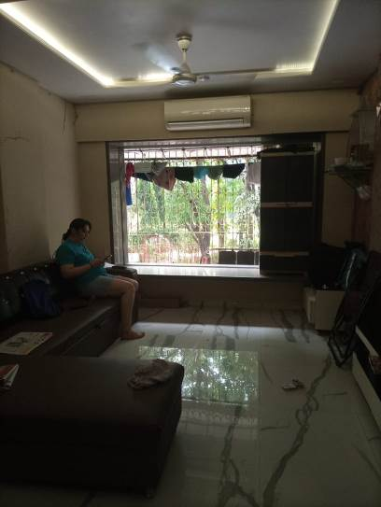
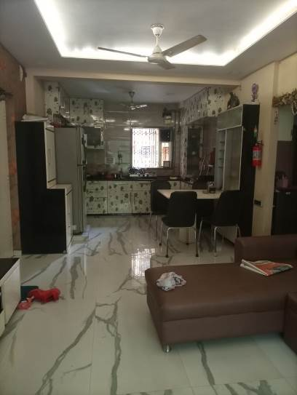
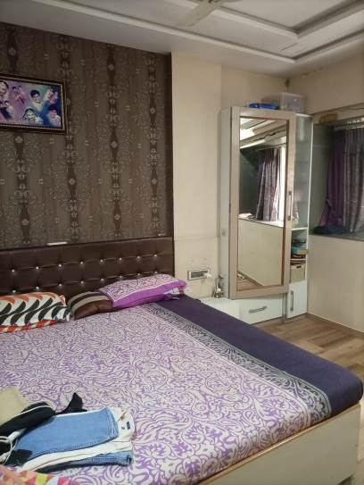

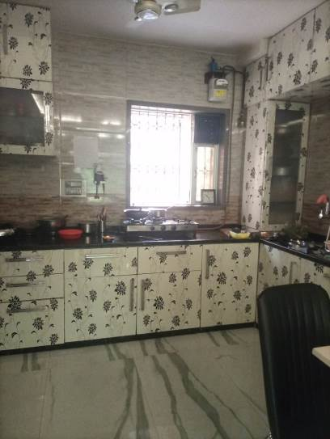
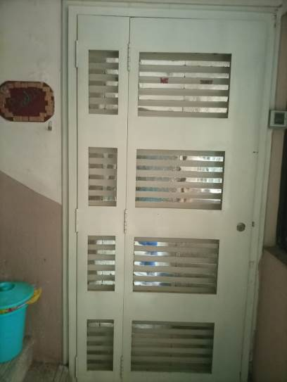
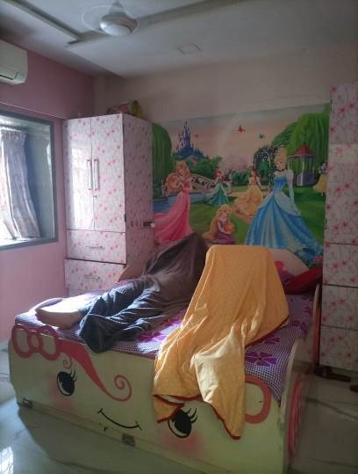

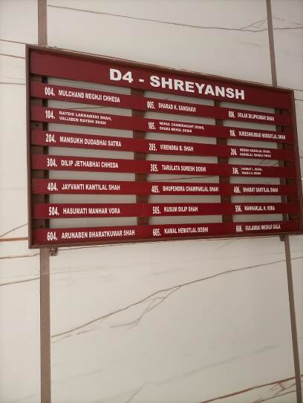
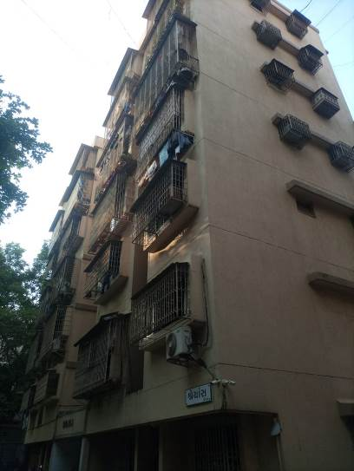

Route Map of the property

Site u/r
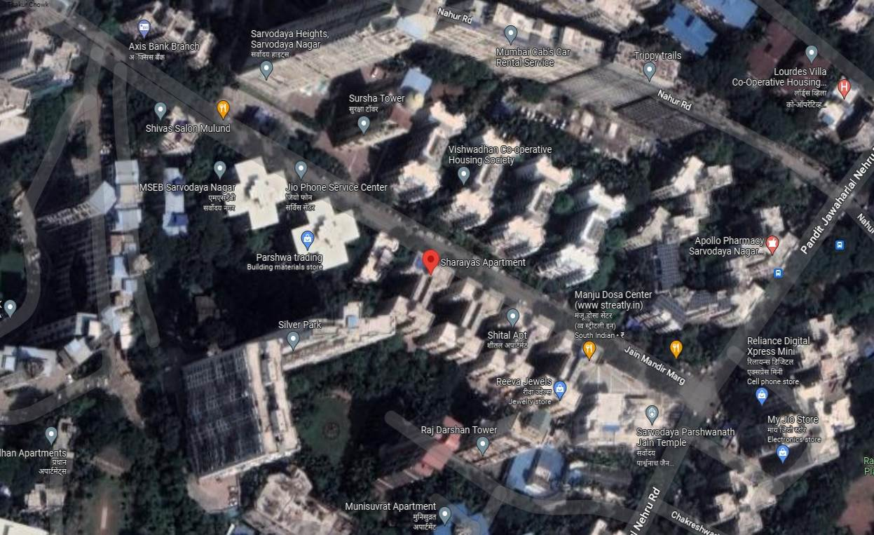

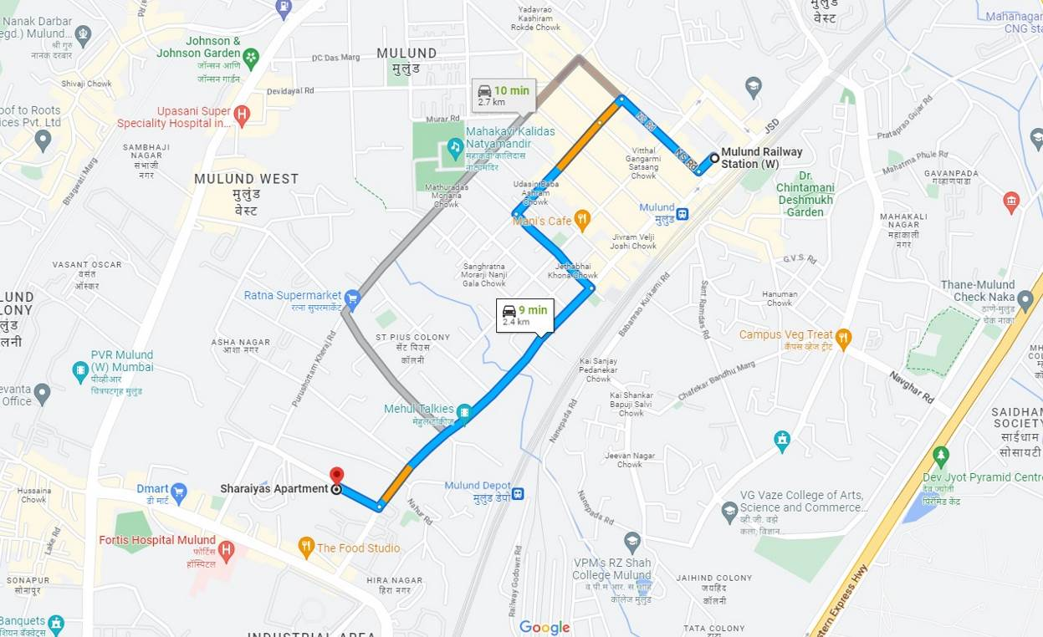

Longitude Latitude - 19°09'50.1"N 72°56'43.4"E

Note: The Blue line shows the walkable route to site from nearest metro station (Mulund – 2.4 KM.)

Ready Reckoner Rate
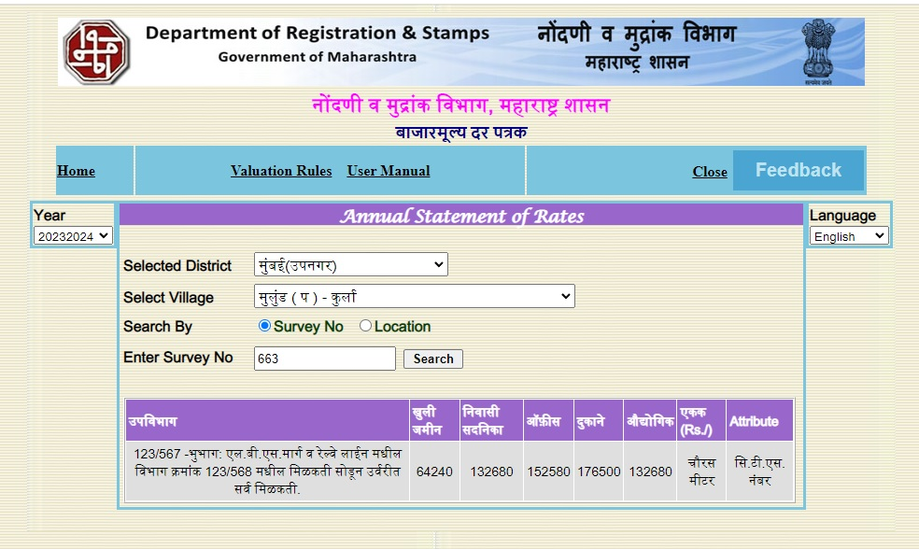

Stamp Duty Ready Reckoner Market Value Rate for Flat | 1,32,680.00
No increase as Flat Located on 1st Floor | 00.00
Stamp Duty Ready Reckoner Market Value Rate (After Reduced) (A) | 1,32,680.00 | Sq. Mtr. | 12,326.00 | Sq. Ft.
Stamp Duty Ready Reckoner Market Value Rate for Land (B) | 64,240.00
The difference between land rate and building rate (A – B = C) | 68,440.00
Depreciation Percentage as per table (D) | 34%
Rate to be adopted after considering depreciation [B + (C x D)] | 1,09,410.00 | Sq. Mtr. | 10,164.00 | Sq. Ft.

Building not having lift
The following table gives the valuation of residential building / flat / commercial unit / office in such building on above floor where there is no lift. Depending upon the floor, ready reckoner rates will be reduced.

 | Floor on which flat is Located | Rate to be adopted
a) | Ground Floor / Stilt / Floor | 100%
b) | First Floor | 95%
c) | Second Floor | 90%
d) | Third Floor | 85%
e) | Fourth Floor and above | 80%
Table – D: Depreciation Percentage Table

Completed Age of Building in Years | Value in percent after depreciation
 | R.C.C. Structure / other Pukka Structure | Cessed Building, Half or Semi – Pukka Structure & Kaccha Structure.
0 to 2 Years | 100% | 100%
Above 2 & up to 5 Years | 95% | 95%
Above 5 Years | After initial 5 year for every year 1% depreciation is to be considered. However maximum deduction available as per this shall be 70% of Market Value rate | After initial 5 year for every year 1.5% depreciation is to be considered. However maximum deduction available as per this shall be 85% of Market Value rate
Price Indicators

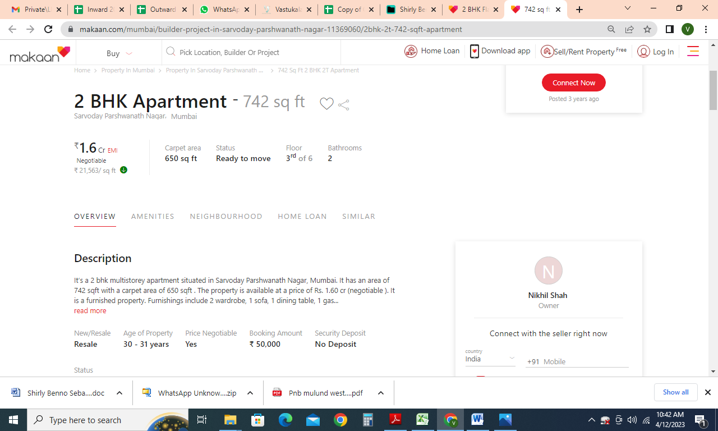

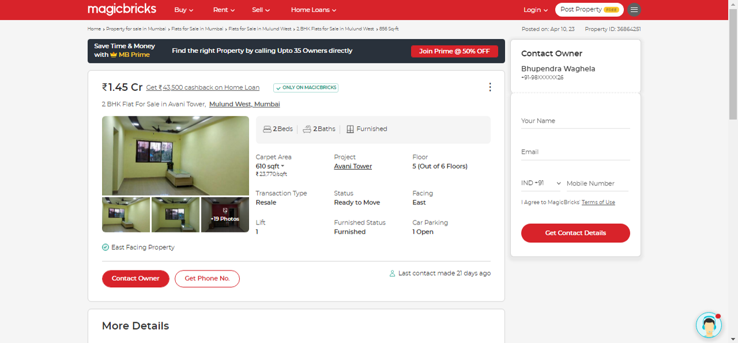
Price Indicators
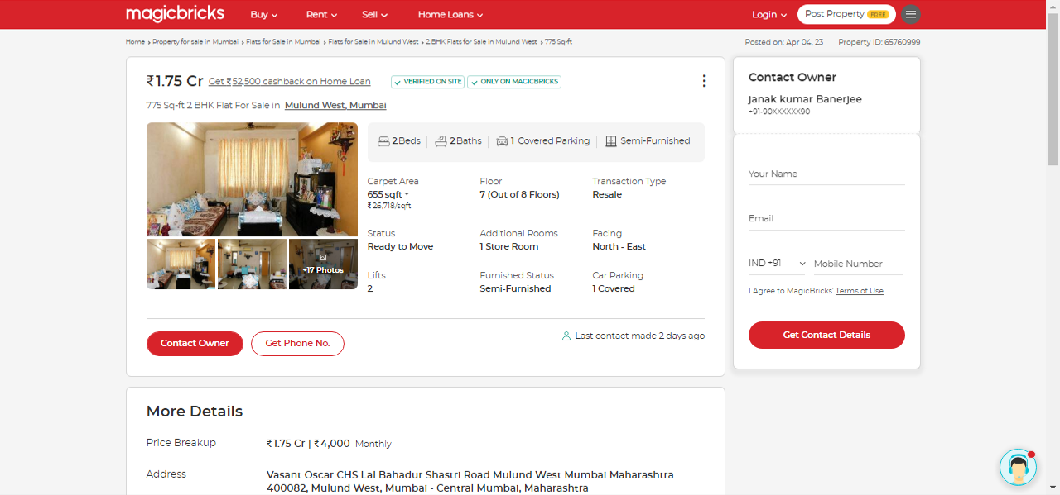

Sales Instance
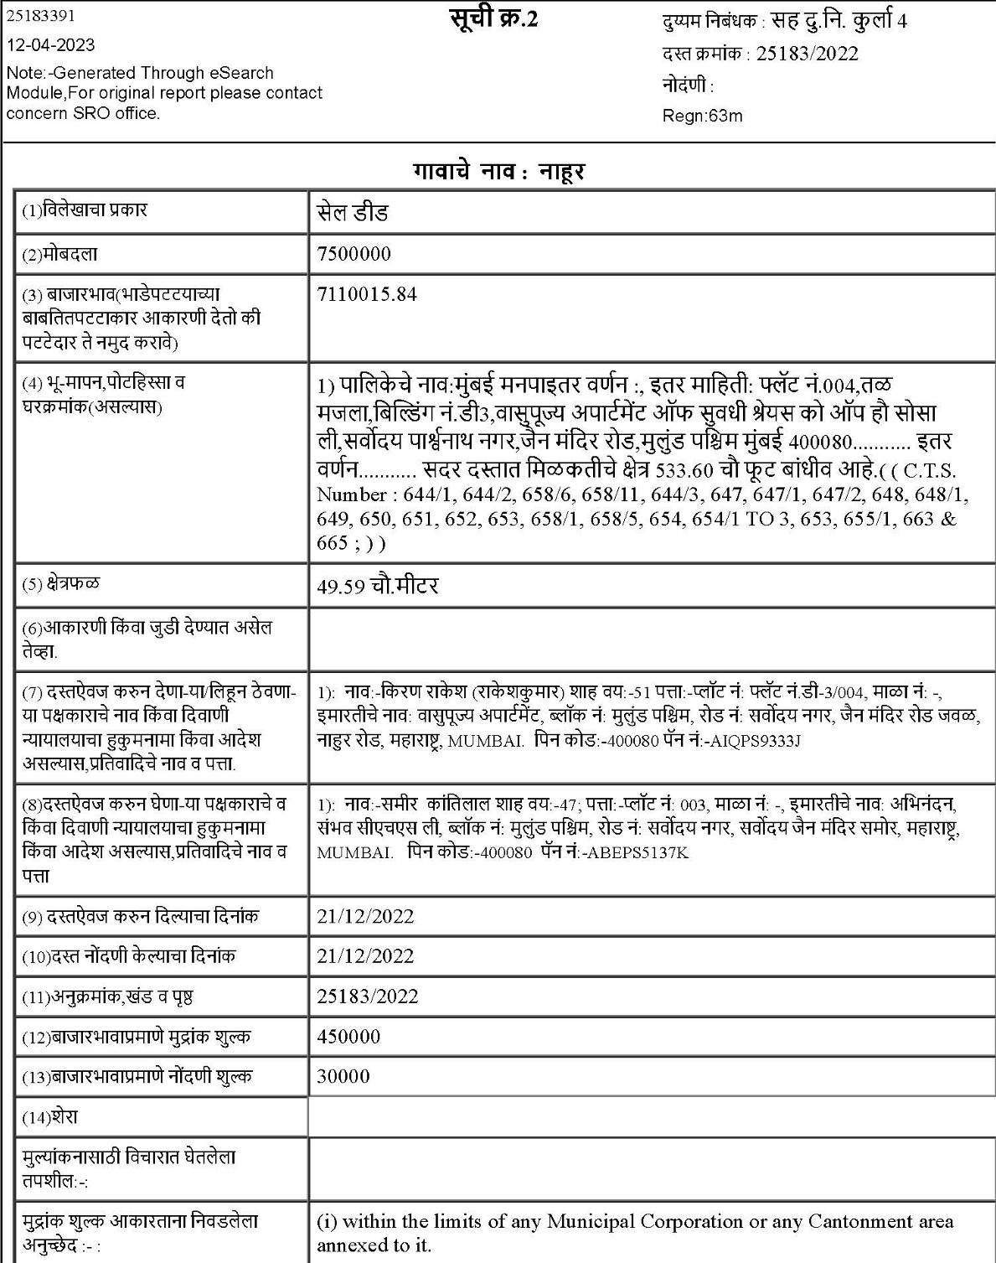

Sales Instance
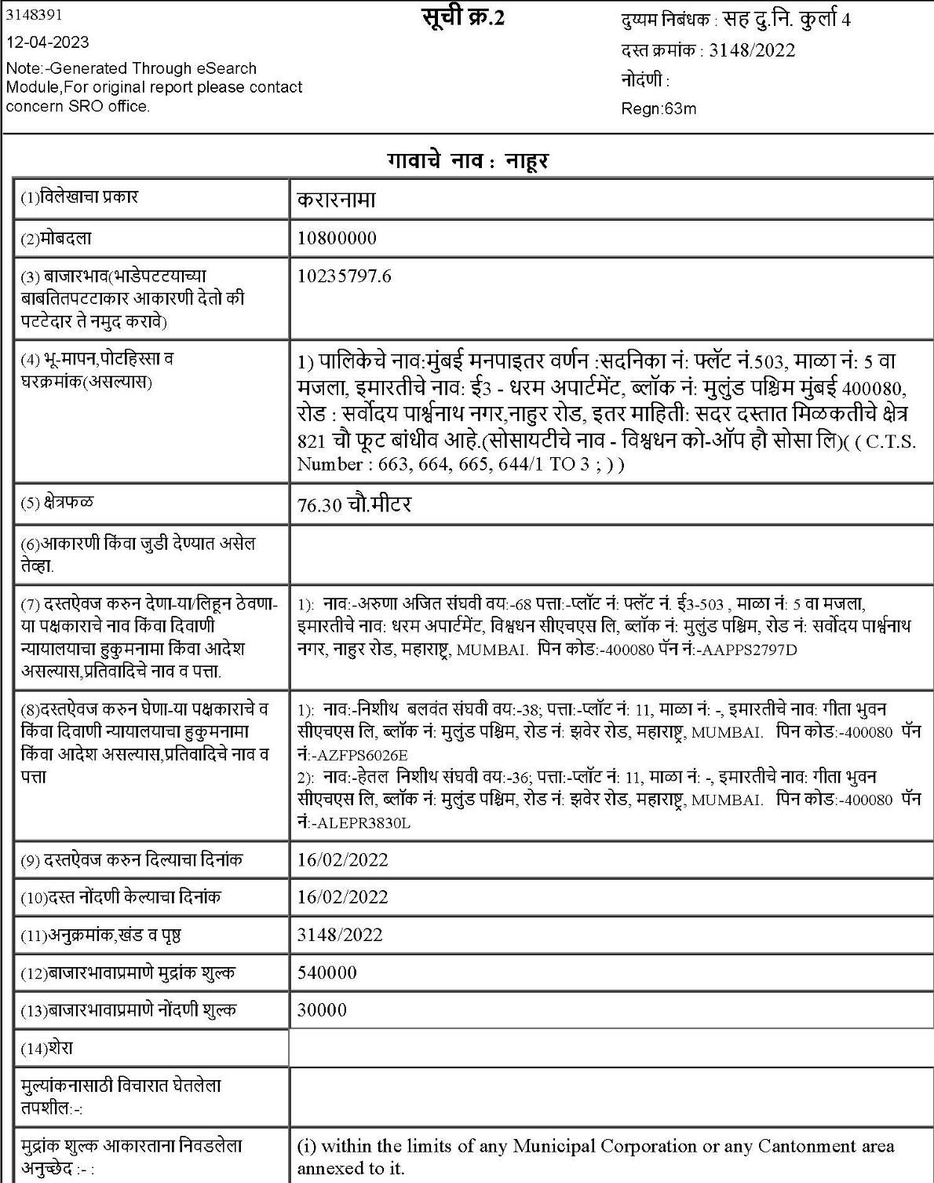

(Annexure-I)
DECLARATION-CUM-UNDERTAKING

I, Sharadkumar B. Chalikwar son of Shri. Baburao Chalikwar do hereby solemnly affirm and state that:

- The information furnished in my valuation report dated 12.04.2023 is true and correct to the best of my knowledge and belief and I have made an impartial and true valuation of the property.

- I have no direct or indirect interest in the property valued;

- I/ my authorized representative have personally inspected the property on 11.04.2023. The work is not sub - contracted to any other valuer and carried out by myself.

- I have not been convicted of any offence and sentenced to a term of imprisonment.

- I have not been found guilty of misconduct in my professional capacity.
- I have read the Handbook on Policy, Standards and procedure for Real Estate Valuation, 2011 of the IBA and this report is in conformity to the "Standards" enshrined for valuation in the Part - B of the above handbook to the best of my ability.
- I have read the International Valuation Standards (IVS) and the report submitted to the Bank for the respective asset class is in conformity to the "Standards" as enshrined for valuation in the IVS in "General Standards" and "Asset Standards" as applicable.
- I abide by the Model Code of Conduct for empanelment of valuer in the Bank. (Annexure III - A signed copy of same to be taken and kept along with this declaration).
- I am registered under Section 34 AB of the Wealth Tax Act, 1957

- I am Chairman & Managing Director of the company, who is competent to sign this valuation report.

- Further, I hereby provide the following information.

- Valuer/authorized representative have visited & valued the right property.

Sl No. | Particulars | Valuer comment
 | Background information of the asset being valued; | The property under consideration was purchased by Mr. Mehul Chandrakant Doshi & Dhara Mehul Doshi (before marriage Dhara Yogesh Diora) from Mr. Jayesh Anantrai Doshi vide Agreement for sale dated 24.03.2015.
 | Purpose of valuation and appointing authority | As per the request from Punjab National Bank, Mulund West Branch, Thane to assess Fair Market value of the property for Banking purpose
 | Identity of the valuer and any other experts involved in the valuation; | Manoj B. Chalikwar – Regd. Valuer  Suraj Zore – Valuation Engineer  Vaishali Sarmalkar – Technical Manager  Pratibha Shilvanta – Technical Officer
 | Disclosure of valuer interest or conflict, if any; | We have no interest, either direct or indirect, in the property valued. Further to state that we do not have relation or any connection with property owner / applicant directly or indirectly. Further to state that we are an independent Valuer and in no way related to property owner / applicant
 | Date of appointment, valuation date and date of report; | Date of Appointment – 11.04.2023  Valuation Date – 12.04.2023  Date of Report – 12.04.2023
 | Inspections and/or investigations undertaken; | Physical Inspection done on 11.04.2023
 | Nature and sources of the information used or relied upon; | - Market Survey at the time of site visit  - Ready Reckoner rates / Circle rates  - Online search for Registered Transactions  - Online Price Indicators on real estate portals  - Enquiries with Real estate consultants  Existing data of Valuation assignments carried out by us
 | Procedures adopted in carrying out the valuation and valuation standards followed; | Sales Comparison Method
 | Restrictions on use of the report, if any; | This valuation is for the use of the party to whom it is addressed and for no other purpose. No responsibility is accepted to any third party who may use or rely on the whole or any part of this valuation. The valuer has no pecuniary interest that would conflict with the proper valuation of the property.
 | Major factors that were taken into account during the valuation; | current market conditions, demand and supply position, Residential flat size, location, upswing in real estate prices, sustained demand for Commercial Godown, all round development of commercial and residential application in the locality etc.
 | Caveats, limitations and disclaimers to the extent they explain or elucidate the limitations faced by valuer, which shall not be for the purpose of limiting his responsibility for the valuation report. | Attached

(Annexure - II)

MODEL CODE OF CONDUCT FOR VALUERS

Integrity and Fairness
- A valuer shall, in the conduct of his/its business, follow high standards of integrity and fairness in all his/its dealings with his/its clients and other valuers.
- A valuer shall maintain integrity by being honest, straightforward, and forthright in all professional relationships.
- A valuer shall endeavour to ensure that he/it provides true and adequate information and shall not misrepresent any facts or situations.
- A valuer shall refrain from being involved in any action that would bring disrepute to the profession.
- A valuer shall keep public interest foremost while delivering his services.

Professional Competence and Due Care
- A valuer shall render at all times high standards of service, exercise due diligence, ensure proper care and exercise independent professional judgment.
- A valuer shall carry out professional services in accordance with the relevant technical and professional standards that may be specified from time to time.
- A valuer shall continuously maintain professional knowledge and skill to provide competent professional service based on up-to-date developments in practice, prevailing regulations / guidelines and techniques.
- In the preparation of a valuation report, the valuer shall not disclaim liability for his/its expertise or deny his/its duty of care, except to the extent that the assumptions are based on statements of fact provided by the company or its auditors or consultants or information available in public domain and not generated by the valuer.
- A valuer shall not carry out any instruction of the client insofar as they are incompatible with the requirements of integrity, objectivity and independence.
- A valuer shall clearly state to his client the services that he would be competent to provide and the services for which he would be relying on other valuers or professionals or for which the client can have a separate arrangement with other valuers.

Independence and Disclosure of Interest
- A valuer shall act with objectivity in his/its professional dealings by ensuring that his/its decisions are made without the presence of any bias, conflict of interest, coercion, or undue influence of any party, whether directly connected to the valuation assignment or not.
- A valuer shall not take up an assignment if he/it or any of his/its relatives or associates is not independent in terms of association to the company.
- A valuer shall maintain complete independence in his/its professional relationships and shall conduct the valuation independent of external influences.
- A valuer shall wherever necessary disclose to the clients, possible sources of conflicts of duties and interests, while providing unbiased services.
- A valuer shall not deal in securities of any subject company after any time when he/it first becomes aware of the possibility of his / its association with the valuation, and in accordance with the Securities and Exchange Board of India (Prohibition of Insider Trading)Regulations,2015 or till the time the valuation report becomes public, whichever is earlier.
- A valuer shall not indulge in "mandate snatching" or offering "convenience valuations" in order to cater to a company or client's needs.
- As an independent valuer, the valuer shall not charge success fee.
- In any fairness opinion or independent expert opinion submitted by a valuer, if there has been a prior engagement in an unconnected transaction, the valuer shall declare the association with the company during the last five years.
Confidentiality
- A valuer shall not use or divulge to other clients or any other party any confidential information about the subject company, which has come to his / its knowledge without proper and specific authority or unless there is a legal or professional right or duty to disclose.

Information Management
- A valuer shall ensure that he/ it maintains written contemporaneous records for any decision taken, the reasons for taking the decision, and the information and evidence in support of such decision. This shall be maintained so as to sufficiently enable a reasonable person to take a view on the appropriateness of his /its decisions and actions.
- A valuer shall appear, co-operate and be available for inspections and investigations carried out by the authority, any person authorised by the authority, the registered valuers organisation with which he/it is registered or any other statutory regulatory body.
- A valuer shall provide all information and records as may be required by the authority, the Tribunal, Appellate Tribunal, the registered valuers organisation with which he/it is registered, or any other statutory regulatory body.
- A valuer while respecting the confidentiality of information acquired during the course of performing professional services, shall maintain proper working papers for a period of three years or such longer period as required in its contract for a specific valuation, for production before a regulatory authority or for a peer review. In the event of a pending case before the Tribunal or Appellate Tribunal, the record shall be maintained till the disposal of the case.

Gifts and hospitality:
- A valuer or his / its relative shall not accept gifts or hospitality which undermines or affects his independence as a valuer.
Explanation: For the purposes of this code the term 'relative' shall have the same meaning as defined in clause (77) of Section 2 of the Companies Act, 2013 (18 of 2013).
- A valuer shall not offer gifts or hospitality or a financial or any other advantage to a public servant or any other person with a view to obtain or retain work for himself / itself, or to obtain or retain an advantage in the conduct of profession for himself / itself.

Remuneration and Costs.
- A valuer shall provide services for remuneration which is charged in a transparent manner, is a reasonable reflection of the work necessarily and properly undertaken, and is not inconsistent with the applicable rules.
- A valuer shall not accept any fees or charges other than those which are disclosed in a written contract with the person to whom he would be rendering service.

Occupation, employability and restrictions.
- A valuer shall refrain from accepting too many assignments, if he/it is unlikely to be able to devote adequate time to each of his/ its assignments.
- A valuer shall not conduct business which in the opinion of the authority or the registered valuer organisation discredits the profession.
Miscellaneous
- A valuer shall refrain from undertaking to review the work of another valuer of the same client except under written orders from the bank or housing finance institutions and with knowledge of the concerned valuer.
- A valuer shall follow this code as amended or revised from time to time.

ASSUMPTIONS, CAVEATS, LIMITATION AND DISCLAIMERS
1. We assume no responsibility for matters of legal nature affecting the property appraised or the title thereto, nor do we render our opinion as to the title, which is assumed to be good and marketable.
2. The property is valued as though under responsible ownership.
3. It is assumed that the property is free of liens and encumbrances.
4. It is assumed that there are no hidden or unapparent conditions of the subsoil or structure that would render it more or less valuable. No responsibility is assumed for such conditions or for engineering that might be required to discover such factors.
5. There is no direct/ indirect interest in the property valued.
6. The rates for valuation of the property are in accordance with the Govt. approved rates and prevailing market rates.

DEFINITION OF VALUE FOR THIS SPECIFIC PURPOSE

This exercise is to assess Fair Market Value of the property under reference as on 12th April 2023.

The term Fair Market Value is defined as

“The most probable price, as of a specified date, in cash, terms equivalent to cash, or in other precisely revealed terms for which the specified property rights would sell after reasonable exposure in a competitive market under all conditions requisite to a fair sale, with the buyer and seller each acting prudently knowledgeably and for self interest assuming that neither is under undue duress”.

Fundamental assumptions and conditions presumed in this definition are:

1. Buyer and seller are motivated by self-interest.
2. Buyer and seller are well informed and are acting prudently.
3. The property is exposed for a reasonable time on the open market.
4. Payment is made in cash or equivalent or in specified financing terms.
DECLARATION OF PROFESSIONAL FEES CHARGED

We hereby declare that, our professional fees are not contingent upon the valuation findings. However, if the statute AND/OR clients demands that, the fees should be charged on the percentage of assessed value then, with the full knowledge of the AND/OR end user, it is being charged accordingly.

VALUATION OF THE PROPERTY PREMISES

Considering various parameters recorded herein above, existing economic scenario, and the information that is available with reference to the development of neighborhood and method selected for valuation, we are of the opinion that, the property premises can be assessed and for this particular purpose at ` 1,61,75,700.00 (Rupees One Crore Sixty One Lakh Seventy Five Thousand Seven Hundred Only).

Sharadkumar B. Chalikwar
Govt. Reg. Valuer
Chartered Engineer (India)
Reg. No. (N) CCIT/1-14/52/2008-09

