**Valuation Report of the Immovable Property**

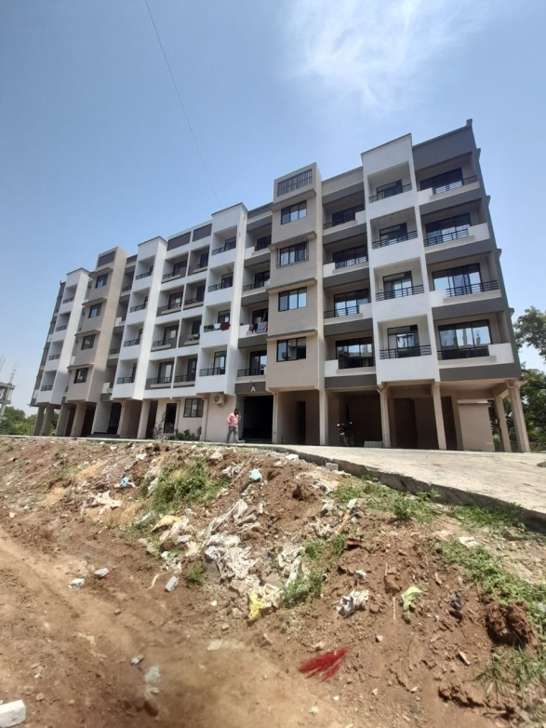

**Details of the property under consideration:**

Name of Owner : **Mr. Nagnath Maroti Panchaal & Mrs. Jayshri Nagnath Panchaal**

Residential Flat No. 103, 1st Floor, B- Wing, Building No. 1, **"Golden Paradise"** Central Park Ext – II Project, Makane Pandit Pada, Saphale (W), Taluka & District Palghar Pin Code – 401 404,

State - Maharashtra, Country - India

# Latitude Longitude - 19°34'33.6"N 72°48'13.4"E

**Valuation Done for:**

**The Zoroastrian Co-operative Bank Ltd**

**Bandra (West) Branch**

Darvesh Royal, Master Vinayak Road (Perry Road), Bandra (West), Mumbia - 400050,

State - Maharashtra, Country - India

Vastu/Mumbai/04/2023/30842/2300049

10/08-49-AHVS

Date: 10.04.2023

**VALUATION OPINION REPORT**

This is to certify that the property bearing Residential Flat No. 103, 1st Floor, B- Wing, Building No. 1, **"Golden Paradise"** Central Park Ext – II Project, Makane Pandit Pada, Saphale (W), Taluka & District Palghar Pin Code – 401 404, State - Maharashtra, Country - India belongs to **Mr. Nagnath Maroti Panchaal & Mrs. Jayshri Nagnath Panchaal.**

|  |  |
| --- | --- |
| Boundaries of the property. | |
| North | Under Construction Building |
| South | Under Construction Building |
| East | Open Plot |
| West | Under Construction Building |

Considering various parameters recorded, existing economic scenario, and the information that is available with reference to the development of neighbourhood and method selected for valuation, we are of the opinion that, the property premises can be assessed and **Fair Market Value** for this particular purpose at **` 27,55,000.00 (Rupees Twenty Seven Lakh Fifty Five Thousand Only).** As per site inspection / site information 96% construction work is completed as on date.

The valuation of the property is based on the documents produced by the concern. Legal aspects have not been taken into considerations while preparing this report.

Hence certified

**Sharadkumar B. Chalikwar**

Govt. Reg. Valuer

Chartered Engineer (India)

Reg. No. (N) CCIT/1-14/52/2008-09

Encl.: Valuation report

**VALUATION REPORT IN RESPECT OF IMMOVABLE PROPERTY**

|  |  |  |  |  |  |  |  |  |
| --- | --- | --- | --- | --- | --- | --- | --- | --- |
| 1 | Date of Inspection | | | : | 07.04.2023 | | | |
| 2 | Purpose of valuation | | | : | As per request from The Zoroastrian Co-operative Bank Ltd, Bandra (West) Branch Fair Market Value of the property under reference for Banking purpose | | | |
| 3 | Name and address of the Valuer | | | : | **Sharadkumar B. Chalikwar**  **Vastukala Consultants (I) Pvt. Ltd.**  121, 1st Floor, Ackruti Star, Central Road, MIDC, Andheri (E), Mumbai - 400 093 | | | |
| 4 | List Of Documents Handed Over To The Valuer By The Bank | | | : | 1. Copy of Agreement for Sale dated 29.03.2023 2. Copy of Approved Plan No. 218/1/Residential/423 dated 18.02.2021, approved by Town Planning Palghar (From RERA Site) | | | |
| 5 | Details of enquiries made/ visited to government Flats for arriving fair market value. | | | : | Market analysis and as per sub-registrar value. | | | |
| 6 | Factors for determining its market value. | | | : | Location, development of surrounding area, type of construction, construction specifications, age of building, condition of the premises & building, facilities provided and its prevailing market rate. | | | |
| 7 | ANY CRITICAL ASPECTS ASSOCIATED WITH PROPERTY | | | : | No | | | |
| 8 | Present/Expected Income from the property | | | : | ` 5,000.00 Expected rental income per month after completion | | | |
|  | **Property Details** | | | : |  | | | |
| 9 | Name(s) of the Owner | | | : | **Mr. Nagnath Maroti Panchaal &**  **Mrs. Jayshri Nagnath Panchaal** | | | |
|  | Address | | | : | Residential Flat No. 103, 1st Floor, B- Wing, Building No. 1, **"Golden Paradise"** Central Park Ext – II Project, Makane Pandit Pada, Saphale (W), Taluka & District Palghar Pin Code – 401 404, State - Maharashtra, Country - India  Contact Person: Mr. Faruk Nagori (Mobile No. 91378 46590) | | | |
| 10 | If the property is under joint ownership/ co-ownership share of each such owner/ are the share is undivided. | | | : | Joint Ownership  Details of share of each owner not available. | | | |
| 11 | Brief description of the property. | | | : | Residential Flat  The property is a Residential Flat located on 1st Floor. The composition of Residential Flat is 1 Living Room + 2 Bedroom + Kitchen + 2 Toilet + Balcony. The property is at 2.4 Kms. travelling distance from nearest railway station Saphale. The building’s final finishing work is pending.  **At the time of inspection, the property was under construction. Extent of completion are as under:** | | | |
|  | If under construction, extent of completion | | | : |  | | | |
|  | Foundation | **Completed** | RCC Plinth | | | | **Completed** | |
|  | Ground | **Completed** | RCC work for Floors | | | | **Completed** | |
|  | Internal Brick Work | **Completed** | External Brick Work | | | | **Completed** | |
|  | Internal Plastering | **Completed** | External Plastering | | | | **Completed** | |
|  | **Total** | | | | | | **96% Work Completed** | |
| 12 | Location of the property (C.T.S. No., Survey No., Hissa No., Plot No., etc.). | | | : | Gat No. 218, Hissa No. 2/1 of Village Makane | | | |
|  |  | | | : |  | | | |
| 13 | **Boundaries** | | | : | **As on site** | | | **As per documents** |
|  | North | | | : | Under Construction Building | | | Details not provided |
|  | South | | | : | Under Construction Building | | | Details not provided |
|  | East | | | : | Open Plot | | | Details not provided |
|  | West | | | : | Under Construction Building | | | Details not provided |
| 14 | Matching of Boundaries | | | : | N.A. | | | |
| 15 | Route map | | | : | Enclosed | | | |
| 16 | Any specific identification marks | | | : | Near Zeneth International School | | | |
| 17 | Whether covered under Corporation/ Panchayat/ Municipality. | | | : | Palghar Municipal Council | | | |
| 18 | Whether covered under any land ceiling of State/ Central Government. | | | : | No | | | |
| 19 | Is the land freehold/ leasehold. | | | : | Free Hold | | | |
| 20 | Are there any restrictive covenants in regard to use of Land? If so attach a copy of the covenant. | | | : | As Per Agreement | | | |
| 21 | Type of the property | | | : | Residential | | | |
| 22 | Year of acquisition/ purchase. | | | : | 29.03.2023 | | | |
| 23 | Purchase value as per document | | | : | ` 25,00,000.00 | | | |
| 24 | Whether the property is occupied by owner or tenant. If occupied by tenant since how long he is staying and the amount of rent being paid. | | | : | Building Under Construction | | | |
| 25 | Classification of the site | | | : |  | | | |
|  | 1. Population group | | | : | Semi Urban | | | |
|  | 1. High/ Middle/ Poor class | | | : | Middle Class | | | |
|  | 1. Residential/ Non-Residential | | | : | Residential | | | |
|  | 1. Development of surrounding area | | | : | Developing | | | |
|  | 1. Possibility of any threat to the property (Floods, calamities etc.). | | | : | No | | | |
| 26 | Proximity of civic amenities (like school, hospital, bus stop, market etc.). | | | : | All Available nearby. | | | |
| 27 | Level of the land (Plain, rock etc.) | | | : | Plain | | | |
| 28 | Terrain of the Land. | | | : | Levelled | | | |
| 29 | Shape of the land (Square/ rectangle etc.). | | | : | Irregular | | | |
| 30 | Type of use to which it can be put (for construction of house, factory etc.). | | | : | Residential purpose | | | |
| 31 | Whether the plot is under town planning approved layout? | | | : | Information not available | | | |
| 32 | Whether the building is intermittent or corner? | | | : | Intermittent | | | |
| 33 | Whether any road facility is available? | | | : | Yes | | | |
| 34 | Type of road available (B.T/Cement Road etc.). | | | : | B.T. Road | | | |
| 35 | Front Width of the Road? | | | : | 09.00 Mtr. | | | |
| 36 | Source of water & water potentiality. | | | : | Municipal Water Supply | | | |
| 37 | Type of Sewerage System. | | | : | Connected to Municipal Sewerage System | | | |
| 38 | Availability of power supply. | | | : | Yes | | | |
| 39 | Advantages of the site. | | | : | Located in developing area | | | |
| 40 | Disadvantages of the site. | | | : | No | | | |
| 41 | Give instances of sales of immovable property in the locality on a separate sheet, indicating the name & address of the property, registration No. sale price and area of land sold. | | | : | As per Sub-Registrar of Assurance records | | | |
|  | **Valuation of the property :** | | | | | | | |
| 42 | Total area of the Residential Flat | | | : | Carpet area = 454.00 Sq. Ft.  Balcony area = 58 sq. ft.  Total Carpet area = 603.00 Sq. Ft.  (Area as per actual site measurement)  **Carpet area = 497.00 Sq. Ft.**  **Balcony area = 54.00 Sq. Ft.**  **Total Carpet area = 551.00 Sq. Ft.**  **(Area as per Agreement for sale)**  Built up area = 661.00 Sq. Ft.  (Carpet area as per agreement + 20%) | | | |
| 43 | Prevailing market rate. | | | : | ` 5,000.00 per Sq. Ft. Rate on Carpet area | | | |
| 44 | Floor Rise Rate per Sq. Ft. | | | : | ` 0.00 | | | |
| 45 | PLC Rate per Sq. Ft. | | | : | ` 0.00 | | | |
| 46 | Total Rate per Sq. Ft. | | | : | ` 5,000.00 per Sq. Ft. | | | |
| 47 | Guideline rate obtained from the Stamp Duty Ready Reckoner. | | | : | ` 35,100.00 per Sq. M. i.e.  ` 3,261.00 per Sq. Ft. | | | |
|  | Guideline rate obtained after depreciation. | | | : | N.A. being building is under construction | | | |
| 48 | Value of the property | | | : | **` 27,55,000.00** | | | |
| 49 | The realizable value of the property | | | : | **` 24,79,500.00** | | | |
| 50 | Distress value of the property | | | : | **` 22,04,000.00** | | | |
| 51 | Insurable value of the property | | | : | **` 16,52,500.00** | | | |
|  | **Technical details of the building :** | | | | | | | |
| 52 | Type of building (Residential/ Residential/ Industrial). | | | : | | Residential | | |
| 53 | Year of construction. | | | : | | 2023 (As per site information) | | |
| 54 | Future life of the property. | | | : | | 60 years (After completion) Subject to proper, preventive periodic maintenance and structural repairs. | | |
| 55 | No. of floors and height of each floor including basement. | | | : | | Part Stilt + Part Ground + 4 Upper Floors. 1st Floor is having 4 Residential Flats. Building is having 1 Lift Proposed | | |
|  | **Type of construction** | | | | | | | |
| 56 | (Load bearing/ R.C.C./ Steel framed) | | | : | | R.C.C. Framed Structure | | |
|  | **Condition of the building.** | | | | | | | |
| 57 | External (excellent/ good/ normal/ poor) | | | : | | Building Under Construction | | |
| 58 | Internal (excellent/ good/ normal/ poor). | | | : | | Building Under Construction | | |
| 59 | Whether the Residential Flat is constructed strictly according to the sanctioned plan, details of variations noticed if any and effect of the same on the valuation | | | : | | Yes, Approved Plan No. 218/1/Residential/423 dated 18.02.2021, approved by Town Planning Palghar (From RERA Site) | | |
|  | Remarks | | | : | |  | | |
|  |  | | | | | | | |
| 60 | **Specifications of Construction :** | | | | | | | |
| **sr.** | **Description** | | | : | | **1st Floor** | | |
| a | Foundation | | | : | | R.C.C. Foundation | | |
| b | Basement | | | : | | No | | |
| c | Superstructure | | | : | | R.C.C. frame work with 9 inch thick B. B. Masonry for external walls.6 inch thick B.B. Masonry for internal walls | | |
| d | Joinery/Doors/Windows | | | : | | Teak Wood door with wooden door frame, Powder coated aluminium sliding windows | | |
| e | RCC Work | | | : | | R.C.C. Framed Structure | | |
| f | Plastering | | | : | | Cement Plastering + POP finish | | |
| g | Flooring, Skirting | | | : | | Vitrified tiles Flooring | | |
| h | Kitchen Platform | | | : | | Granite Kitchen Platform with service floor | | |
| i | Whether any proof course is provided? | | | : | | Yes | | |
| j | Drainage | | | : | | Connected to Municipal Sewerage System | | |
| k | Compound Wall(Height, length and type of construction) | | | : | | 5.6" Height | | |
| l | Electric Installation (Type of wire, Class of construction) | | | : | | Concealed | | |
| m | Plumbing Installation (No. of closets and wash basins etc.) | | | : | | Concealed | | |
| n | Bore Well | | | : | | Not Provided | | |
| o | Wardrobes, if any | | | : | | No. | | |
| p | Development of open area | | | : | | Stilt and open | | |
|  |  | | | | |  | | |
|  | **Valuation of proposed construction/ additions/ renovation if any :** | | | | | | | |
| 61 | **SUMMARY OF VALUATION :** | | | : | |  | | |
|  | Part I Land | | | : | | ` 0.00 | | |
|  | Part II Building | | | : | | **` 27,55,000.00** | | |
|  | Part III Other amenities/ Miscellaneous | | | : | | ` 0.00 | | |
|  | Part IV Proposed construction | | | : | | ` 0.00 | | |
|  | **TOTAL.** | | | : | | **` 27,55,000.00** | | |
|  |  | | | | | | | |
|  | **Calculation:** | | | | | | | |
| **1** | **Construction** | | | : | |  | | |
| 1.01 | Built up area of Residential Flat | | | : | | 661.00 Sq. Ft. | | |
| 1.02 | Rate per Sq. Ft. | | | : | | ` 2,500.00 | | |
| 1.03 | Cost of Construction = (1.01x1.02) | | | : | | ` 16,52,500.00 | | |
| **2** | **Value of property** | | | : | |  | | |
| 2.01 | Total Carpet area of Residential Flat | | | : | | 551.00 Sq. Ft. | | |
| 2.02 | Rate per Sq. Ft. | | | : | | ` 5,000.00 | | |
| 2.03 | Floor Rise Rate per Sq. Ft. | | | : | | ` 0.00 | | |
| 2.04 | PLC Rate per Sq. Ft. | | | : | | ` 0.00 | | |
| 2.05 | Total Rate per Sq. Ft. | | | : | | ` 5,000.00 | | |
| 2.06 | Value of Residential Flat = (2.01x2.05) | | | : | | ` **27,55,000.00** | | |
| **3** | **The value of the property.** | | | : | | **` 27,55,000.00** | | |

I certify that,

I/ my authorized representative, has inspected the subject property on 07.04.2023. Mr. Faruk Nagori (Mobile No. 91378 46590) has shown the property.

The rates for valuation of the property are in accordance with the Govt. approved rates and prevailing market rates.

There is no direct/ indirect interest in the property valued.

As per site inspection / site information 96% construction work is completed as on date.

**Actual site photographs**

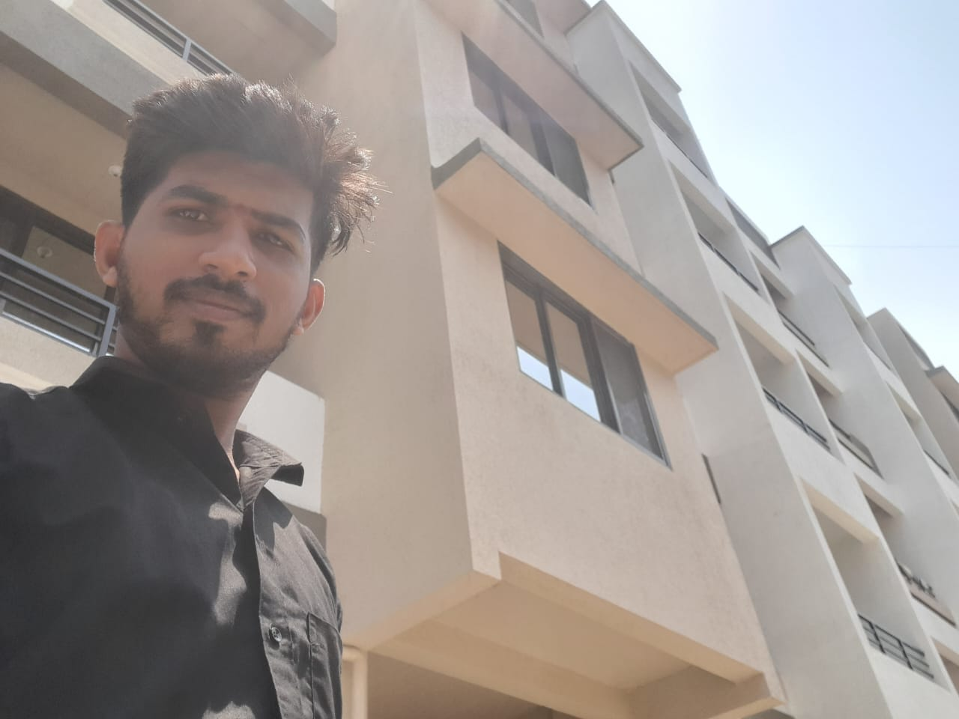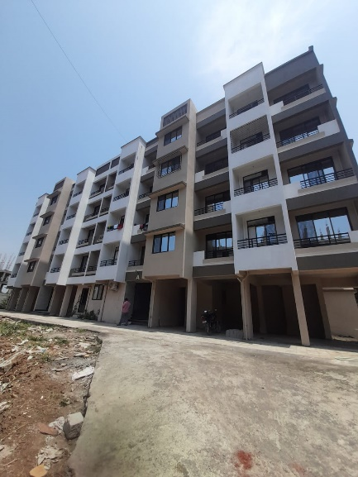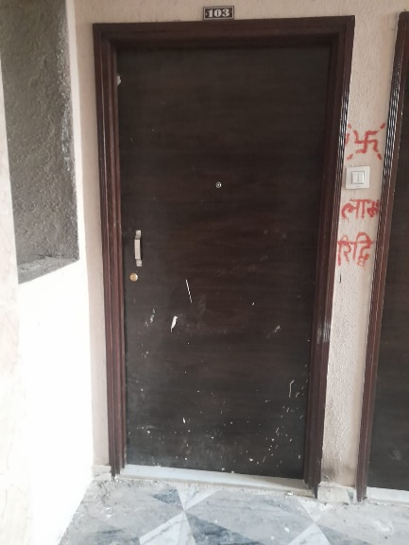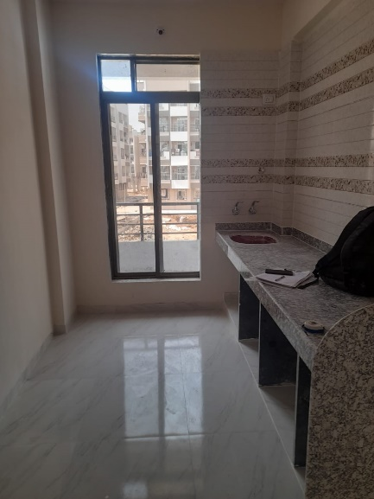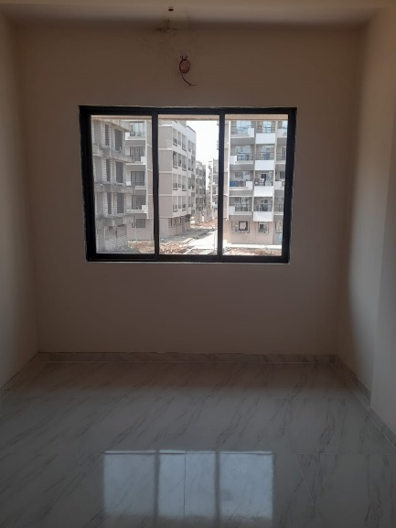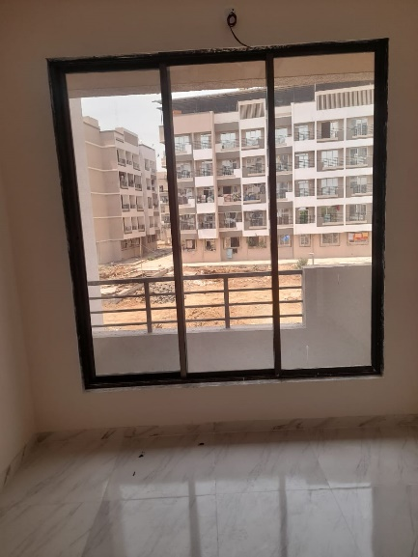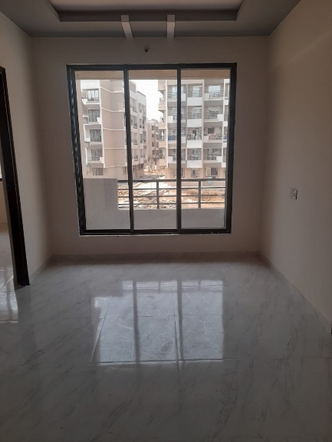 **Route Map of the property**

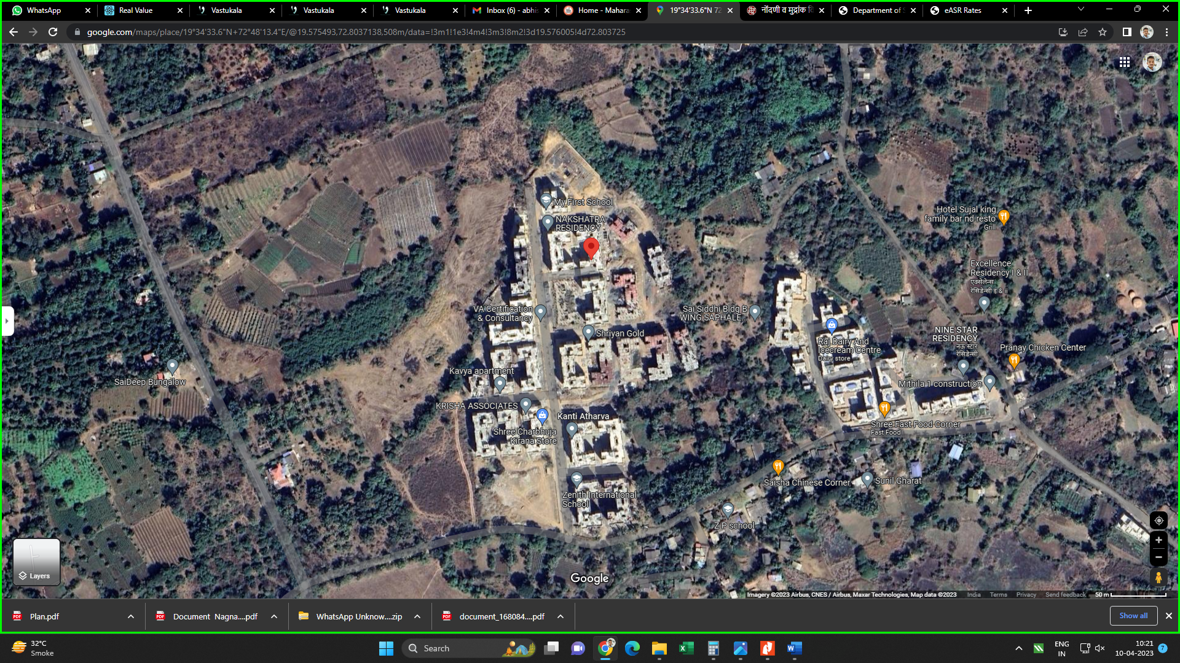**Site u/r**

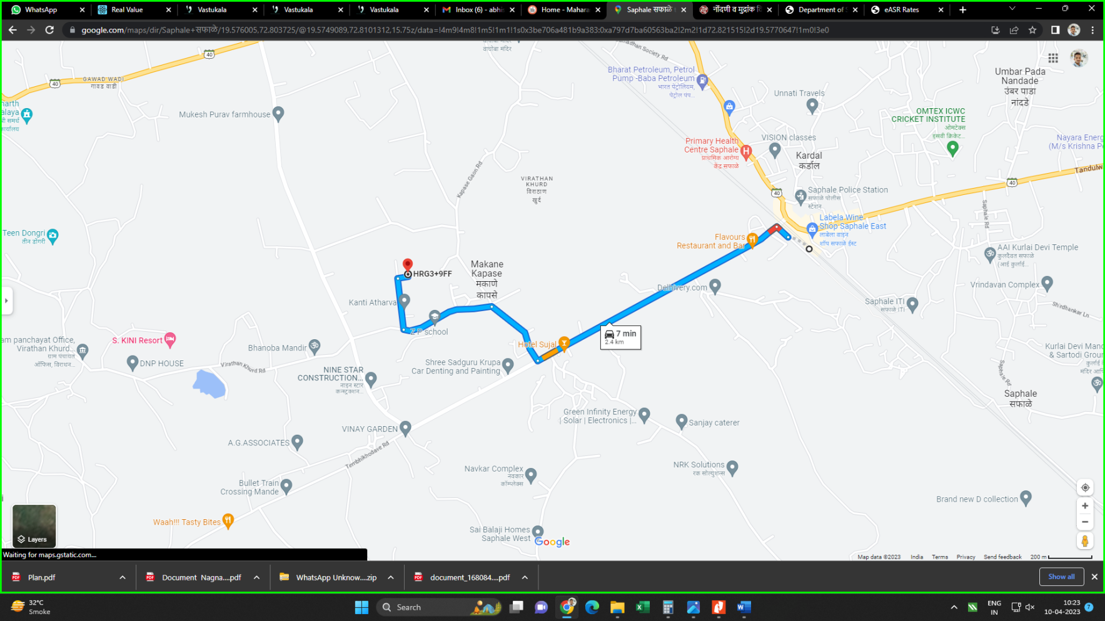

**Latitude Longitude - 19°34'33.6"N 72°48'13.4"E**

**Note**: The Blue line shows the route to site from nearest railway station (Saphale –2.4 Kms.)

**Ready Reckoner Rate**

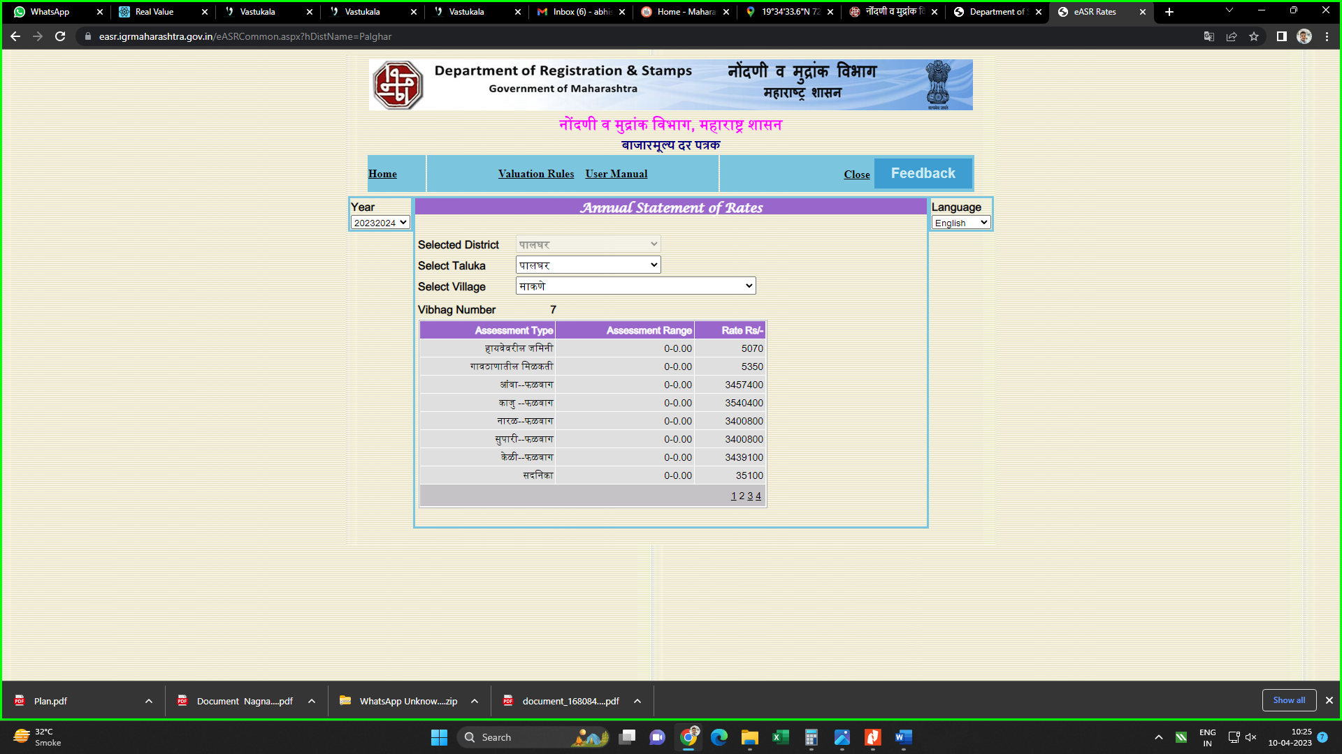

|  |  |  |  |  |
| --- | --- | --- | --- | --- |
| Stamp Duty Ready Reckoner Market Value Rate for **Flat** | **35,100.00** |  |  |  |
| No increase for all floors from ground to 4 floors | **-** |  |  |  |
| **Stamp Duty Ready Reckoner Market Value Rate (After Increase) (A)** | **35,100.00** | **Sq. Mtr.** | **3,261.00** | **Sq. Ft.** |

**Multi-Storied building with Lift**

For residential premises / commercial unit / office on above floor in multistoried building, the rate mentioned in the ready reckoner will be increased as under:

|  |  |  |
| --- | --- | --- |
|  | **Location of Flat / Commercial Unit in the building** | **Rate** |
| a) | On Ground to 4 Floors | No increase for all floors from ground to 4 floors |
| b) | 5 Floors to 10 Floors | Increase by 5% on units located between 5 to 10 floors |
| c) | 11 Floors to 20 Floors | Increase by 10% on units located between 11 to 20 floors |
| d) | 21 Floors to 30 Floors | Increase by 15% on units located between 21 to 30 floors |
| e) | 31 Floors and above | Increase by 20% on units located on 31 and above floors |

**Table – D: Depreciation Percentage Table**

|  |  |  |
| --- | --- | --- |
| **Completed Age of Building in Years** | **Value in percent after depreciation** | |
|  | **R.C.C. Structure / other Pukka Structure** | **Cessed Building, Half or Semi – Pukka Structure & Kaccha Structure.** |
| 0 to 2 Years | 100% | 100% |
| Above 2 & up to 5 Years | 95% | 95% |
| Above 5 Years | After initial 5 year for every year 1% depreciation is to be considered. However maximum deduction available as per this shall be 70% of Market Value rate | After initial 5 year for every year 1.5% depreciation is to be considered. However maximum deduction available as per this shall be 85% of Market Value rate |

**Sale Instance**

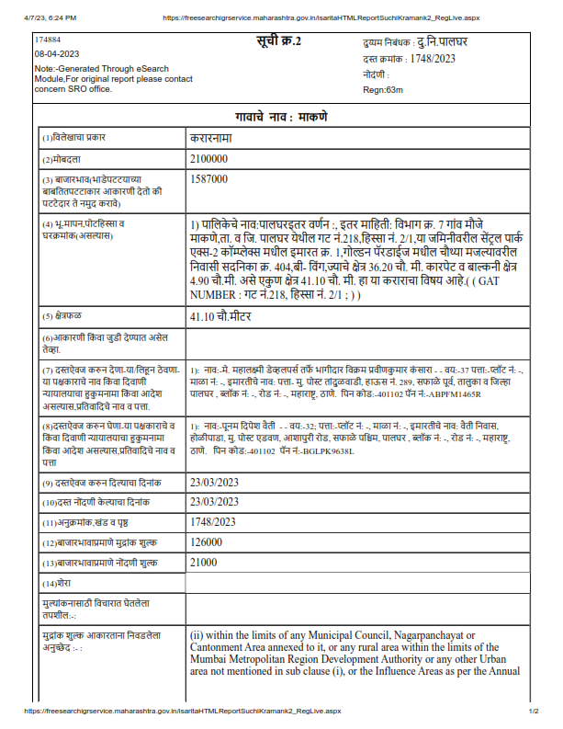

**Price Indicator**

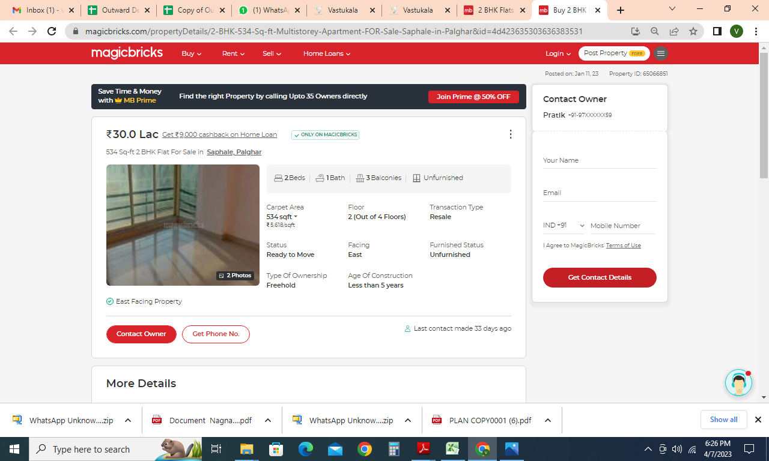

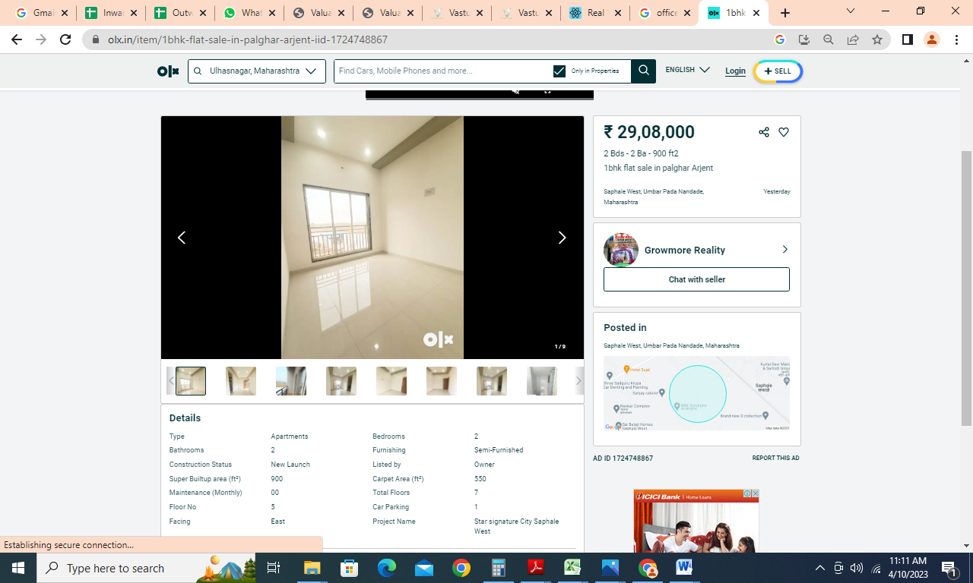**DEFINITION OF VALUE FOR THIS SPECIFIC PURPOSE**

This exercise is to assess **Fair Market Value** of the property under reference for **Fair Market Value** purpose as on dated **10th April 2023.**

The term **Fair Market Value** is defined as

*"The most probable price, as of a specified date, in cash, terms equivalent to cash, or in other precisely revealed terms for which the specified property rights would sell after reasonable exposure in a competitive market under all conditions requisite to a fair sale, with the buyer and seller each acting prudently knowledgeably and for self-interest assuming that neither is under undue duress"*

Fundamental assumptions and conditions presumed in this definition are:

1. Buyer and seller are motivated by self-interest.
2. Buyer and seller are well informed and are acting prudently.
3. The property is exposed for a reasonable time on the open market.
4. Payment is made in cash or equivalent or in specified financing terms.

**ASSUMPTIONS, CAVEATS, LIMITATION AND DISCLAIMERS**

1. We assume no responsibility for matters of legal nature affecting the property appraised or the title thereto, nor do we render our opinion as to the title, which is assumed to be good and marketable.
2. The property is valued as though under responsible ownership.
3. It is assumed that there are no hidden or unapparent conditions of the subsoil or structure that would render it more or less valuable. No responsibility is assumed for such conditions or for engineering that might be required to discover such factors.
4. There is no direct/ indirect interest in the property valued.
5. The rates for valuation of the property are in accordance with the Govt. approved rates and prevailing market rates.

**DECLARATION OF PROFESSIONAL FEES CHARGED**

We hereby declare that, our professional fees are not contingent upon the valuation findings. However, if the statute AND/OR clients demands that, the fees should be charged on the percentage of assessed value then, with the full knowledge of the AND/OR end user, it is being charged accordingly.

**VALUATION OF THE PROPERTY PREMISES**

Considering various parameters recorded herein above, existing economic scenario, and the information that is available with reference to the development of neighbourhood and method selected for valuation, we are of the opinion that, the property premises can be assessed and valued for Fair Market Value Purpose as on day for  
**` 27,55,000.00 (Rupees Twenty Seven Lakh Fifty Five Thousand Only).** As per site inspection / site information 96% construction work is completed as on date.

**Sharadkumar B. Chalikwar**

Govt. Reg. Valuer

Chartered Engineer (India)

Reg. No. (N) CCIT/1-14/52/2008-09