# Valuation Report of the Immovable Property

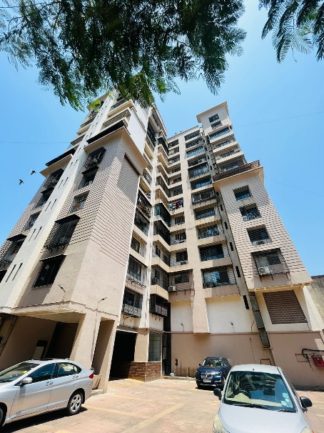

**Details of the property under consideration:**

Name of Proposed Buyer:**Mr. Subramaniam Mahalingam Iyer**

Name of Owner:**Mr. Abhishek Laxman Dube & Mrs. Jyoti Laxman Dube**

Residential Flat No. C1, 1st Floor, **“Shubham Co-op. Hsg. Soc. Ltd.”,**Juhu Versova Link Road, Versova, Andheri (West), Mumbai – 400 053, State - Maharashtra, Country – India.

# Latitude Longitude - 19°07’30.8”N 72°49’20.1”E

**Valuation Done for:**

**The Zoroastrian Co-operative Bank Ltd.**

**Lokhandwala Branch**

S41, RNA Shopping Arcade, Lokhandwala Complex Market, Main Road, Swami Samarth Nagar Lokhandwala, Lokhandwala Complex, Andheri West, Mumbai – 400053, State – Maharashtra, Country – India.

Vastu/Mumbai/04/2023/30798/2300012

05/06-12-NIPA

Date: 05.04.2023

**VALUATION OPINION REPORT**

This is to certify that the property bearingResidential Flat No. C1, 1stFloor, **“Shubham Co-op. Hsg. Soc. Ltd.”**, Juhu Versova Link Road, Versova, Andheri (West), Mumbai – 400 053, State - Maharashtra, Country – Indiabelongs to **Mr. Abhishek Laxman Dube & Mrs. Jyoti Laxman Dube.** Name of Proposed Buyer: **Mr. Subramaniam Mahalingam Iyer.**

|  |  |
| --- | --- |
| **Boundaries of the property.** | |
| North | Internal Road |
| South | Jeevan Sapna CHSL |
| East | Juhu Versova Link Road |
| West | Vanashree Apartment |

Considering various parameters recorded, existing economic scenario, and the information that is available with reference to the development of neighbourhood and method selected for valuation, we are of the opinion that, the property premises can be assessed and **Fair Market Value** for this particular purpose at **`3,04,80,000.00 (Rupees Three Crore Four Lakh Eighty Thousand Only).**

The valuation of the property is based on the documents produced by the concern. Legal aspects have not been taken into considerations while preparing this report.

Hence certified

Sharadkumar B. Chalikwar

Govt. Reg. Valuer

Chartered Engineer (India)

Reg. No. IBBI/RV/07/2019/11744

Reg. No. (N) CCIT/1-14/52/2008-09

**VALUATION REPORT IN RESPECT OF IMMOVABLE PROPERTY**

|  |  |  |  |  |  |  |  |  |  |
| --- | --- | --- | --- | --- | --- | --- | --- | --- | --- |
| 1 | Date of Inspection | : | 04.04.2023 | | | | | | |
| 2 | Purpose of valuation | : | As per request from The Zoroastrian Co-operative Bank Ltd, Lokhandwala Branch, Fair Market Value of the property under reference for Bank Loan Purpose | | | | | | |
| 3 | Name and address of the Valuer | : | **Manoj B. Chalikwar**  **Vastukala Consultants (I) Pvt. Ltd.**  121, 1st Floor, Ackruti Star, Central Road, MIDC, Andheri (East), Mumbai – 400 093. | | | | | | |
| 4 | **List of Documents Handed Over to The Valuer by The Bank**   1. Copy of Draft Agreement for Sale dated 2023 2. Copy of Occupancy Certificate No. CE / 7170 / WS/ AK dated 07.03.2008 issued by Municipal Corporation Greater Mumbai. | | | | | | | | |
| 5 | Details of enquiries made/ visited to government Office for arriving fair market value. | : | Market analysis and as per sub-registrar value. | | | | | | |
| 6 | Factors for determining its market value. | : | Location, development of surrounding area, type of construction, construction specifications, age of building, condition of the premises & building, facilities provided and its prevailing market rate. | | | | | | |
| 7 | ANY CRITICAL ASPECTS ASSOCIATED WITH PROPERTY | : | No | | | | | | |
| 8 | Present/Expected Income from the property | : | ` 60,000.00 Expected rental income per month | | | | | | |
|  | **Property Details** | : |  | | | | | | |
| 9 | Name(s) of the Owner and Postal address of the property under consideration. | : | Name of Proposed Buyer: **Mr. Subramaniam Mahalingam Iyer**.  Name of Owner:  **Mr. Abhishek Laxman Dube &**  **Mrs. Jyoti Laxman Dube.** | | | | | | |
|  |  | : | **Address:**Residential Flat No. C1, 1st Floor, **“Shubham Co-op. Hsg. Soc. Ltd.”**, Juhu Versova Link Road, Versova, Andheri (West), Mumbai – 400 053, State - Maharashtra, Country – India.  **Contact Person:**  Mr. Hemant(Broker)  Contact No. 98200 28191 | | | | | | |
| 10 | If the property is under joint ownership/ co-ownership share of each such owner/ are the share is undivided. | : | Sole Ownership (Proposed) | | | | | | |
| 11 | Brief description of the property. | : | The property is a residential flat located on 1st Floor.The composition of flat is 3 Bedrooms + Living Room + Kitchen + 3 Toilets. **(i.e.,3BHK + 3 Toilets).**The property is at 650 Mts. travelling distance from nearest Metro station Versova. | | | | | | |
| 12 | Location of the property (C.T.S. No., Survey No., Hissa No., Plot No., etc.). | : | C.T.S. No. 1376/1/82 of Village -Versova | | | | | | |
| 13 | **Boundaries** | : | **As per Site** | | | | **As per Documents** | | |
|  | North | : | Internal Road | | | | Details not available | | |
|  | South | : | Jeevan Sapna CHSL | | | | Details not available | | |
|  | East | : | Juhu Versova Link Road | | | | Details not available | | |
|  | West | : | Vanashree Apartment | | | | Details not available | | |
| 14 | Matching of Boundaries | : | N.A. | | | | | | |
| 15 | Route map | : | Enclosed | | | | | | |
| 16 | Any specific identification marks | : | Near Mahanagar Gas CNG Station | | | | | | |
| 17 | Whether covered under Corporation/ Panchayat/ Municipality. | : | Municipal Corporation of Greater Mumbai | | | | | | |
| 18 | Whether covered under any land ceiling of State/ Central Government. | : | No | | | | | | |
| 19 | Is the land freehold/ leasehold? | : | Free Hold | | | | | | |
| 20 | Are there any restrictive covenants in regard to use of Land? If so, attach a copy of the covenant. | : | As Per Draft Agreement | | | | | | |
| 21 | Type of the property | : | Residential | | | | | | |
| 22 | Year of acquisition/ purchase. | : | 2023 (As per Draft Agreement for Sale) | | | | | | |
| 23 | Purchase value as per document | : | `2,66,00,000.00 (Draft Agreement for Sale) | | | | | | |
| 24 | Whether the property is occupied by owner or tenant. If occupied by tenant since how long he is staying and the amount of rent being paid. | : | Seller Occupied - Mr. Abhishek Laxman Dube | | | | | | |
| 25 | Classification of the site | : |  | | | | | | |
|  | 1. Population group | : | Urban | | | | | | |
|  | 1. High/ Middle/ Poor class | : | Higher Middle Class | | | | | | |
|  | 1. Residential/ Non-Residential | : | Residential | | | | | | |
|  | 1. Development of surrounding area | : | Developed Area | | | | | | |
|  | 1. Possibility of any threat to the property (Floods, calamities etc.). | : | No | | | | | | |
| 26 | Proximity of civic amenities (like school, hospital, bus stop, market etc.). | : | All Available near by | | | | | | |
| 27 | Level of the land (Plain, rock etc.) | : | Plain | | | | | | |
| 28 | Terrain of the Land. | : | Levelled | | | | | | |
| 29 | Shape of the land (Square/ rectangle etc.). | : | Irregular | | | | | | |
| 30 | Type of use to which it can be put (for construction of house, factory etc.). | : | Residential purpose | | | | | | |
| 31 | Whether the plot is under town planning approved layout? | : | Information not Available | | | | | | |
| 32 | Whether the building is intermittent or corner? | : | Intermittent | | | | | | |
| 33 | Whether any road facility is available? | : | Yes | | | | | | |
| 34 | Type of road available (B.T/Cement Road etc.). | : | B.T. Road | | | | | | |
| 35 | Front Width of the Road? | : | 06.00 M. Wide Road | | | | | | |
| 36 | Source of water & water potentiality. | : | Municipal Water supply | | | | | | |
| 37 | Type of Sewerage System. | : | Connected to Municipal Sewerage System | | | | | | |
| 38 | Availability of power supply. | : | Yes | | | | | | |
| 39 | Advantages of the site. | : | Located in developed area | | | | | | |
| 40 | Disadvantages of the site. | : | No | | | | | | |
| 41 | Give instances of sales of immovable property in the locality on a separate sheet, indicating the name & address of the property, registration No. sale price and area of land sold. | : | As per Sub-Registrar of Assurance records | | | | | | |
|  | **Valuation of the property:** | | | | | | | | |
| 42 | Total area of the Residential Flat | : | Carpet Area in Sq. Ft. = 962.00  (Area as per actual site measurement)  **Built up Area in Sq. Ft. = 1,270.00**  **(Area as per Draft Agreement for Sale)** | | | | | | |
| 43 | Prevailing market rate. | : | ` 24,000.00 per Sq. Ft. Rate on Built up Area | | | | | | |
| 44 | Floor Rise Rate per Sq. Ft. | : | ` 0.00 | | | | | | |
| 45 | PLC Rate per Sq. Ft. | : | ` 0.00 | | | | | | |
| 46 | Total Rate per Sq. Ft. | : | ` 24,000.00 per Sq. Ft. | | | | | | |
| 47 | Guideline rate obtained from the Stamp Duty Ready Reckoner. | : | ` 2,33,060.00 per Sq. M. i.e.  ` 21,652.00 per Sq. Ft. | | | | | | |
|  | Guideline rate (after deprecation) | : | ` 2,15,468.00 per Sq. M. i.e.  ` 20,017.00 per Sq. Ft. | | | | | | |
| 48 | Government Value | : |  | | | | | | |
|  |  |  | **Area in**  **Sq. Ft.** | | **Rate** | | | **Value** | |
|  | Built up area | : | 1,270.00 | | `20,017.00 | | | **` 2,54,21,590.00** | |
| 49 | Value of the property |  |  | | | | | | |
|  |  |  | **Area in Sq. Ft.** | | | **Rate** | | | **Value** |
|  | Carpet Area | : | 1,270.00 | | | `24,000.00 | | | **`3,04,80,000.00** |
|  | Total Value of the Property |  |  | | | | | | **`3,04,80,000.00** |
| 50 | The realizable value of the property | : | **`2,74,32,000.00** | | | | | | |
| 51 | Distress value of the property | : | **`2,43,84,000.00** | | | | | | |
| 52 | Insurable value of the property | : | **`38,10,000.00** | | | | | | |
|  | **Technical details of the building:** | | | | | | | | |
| 53 | Type of building (Residential / Commercial / Industrial). | : | | Residential | | | | | |
| 54 | Year of construction. | : | | 2008(As per Occupancy Certificate) | | | | | |
| 55 | Future life of the property. | : | | 45 years Subject to proper, preventive periodic maintenance & structural repairs. | | | | | |
| 56 | No. of floors and height of each floor including basement. | : | | Part Ground + Part Stilt + 1st (Part) for Bank + (Part) Residential + 2nd to 13th Upper Floors.  1st Floor is having 1 Flat. | | | | | |
|  | **Type of construction** | | | | | | | | |
| 57 | (Load bearing/ R.C.C./ Steel framed) | : | | R.C.C. Framed Structure | | | | | |
|  | **Condition of the building.** | | | | | | | | |
| 58 | External (excellent/ good/ normal/ poor) | : | | Good | | | | | |
| 59 | Internal (excellent/ good/ normal/ poor). | : | | Good | | | | | |
| 60 | Whether the Residential Flat is constructed strictly according to the sanctioned plan, details of variations noticed if any and effect of the same on the valuation | : | | Occupancy Certificate No. CE / 7170 / WS/ AK dated 07.03.2008 issued by Municipal Corporation Greater Mumbai. | | | | | |
|  | **Remarks:** | | | | | | | | |
| 61 | **Specifications of Construction:** | | | | | | | | |
| **sr.** | **Description** | : | | **1st Floor** | | | | | |
| a | Foundation | : | | R.C.C. Foundation | | | | | |
| b | Basement | : | | No | | | | | |
| c | Superstructure | : | | R.C.C. frame work with 9-inch-thick B. B. Masonry for external walls 6-inch thick B.B. Masonry for internal walls | | | | | |
| d | Joinery/Doors/Windows | : | | Teak Wood door framed with flush door,  Powder coated aluminium sliding windows | | | | | |
| e | RCC Work | : | | R.C.C. Framed Structure | | | | | |
| f | Plastering | : | | Cement Plastering + POP false ceiling | | | | | |
| g | Flooring, Skirting | : | | All rooms are finished with Vitrified tiles flooring. Toilets are finished with ceramic tiles flooring & full height glazed tiles dado. | | | | | |
| h | Pantry Platform | : | | Granit kitchen platform | | | | | |
| i | Whether any proof course is provided? | : | | Yes | | | | | |
| j | Drainage | : | | Connected to Municipal Sewerage System | | | | | |
| k | Compound Wall (Height, length and type of construction) | : | | 5'6" High, R.C.C. columns with B. B. Masonry wall | | | | | |
| l | Electric Installation (Type of wire, Class of construction) | : | | Concealed Electrification | | | | | |
| m | Plumbing Installation (No. of closets and wash basins etc.) | : | | Concealed Plumbing | | | | | |
| n | Bore Well | : | | Not found | | | | | |
| o | Wardrobes, if any | : | | No | | | | | |
| p | Development of open area | : | | Cemented road in open spaces, etc. | | | | | |
|  | **Valuation of proposed construction/ additions/ renovation if any:** | | | | | | | | |
| 62 | **SUMMARY OF VALUATION:** | : | |  | | | | | |
|  | Part I Land | : | | ` 0.00 | | | | | |
|  | Part II Building | : | | **`3,04,80,000.00** | | | | | |
|  | Part III Other amenities/ Miscellaneous | : | | ` 0.00 | | | | | |
|  | Part IV Proposed construction | : | | ` 0.00 | | | | | |
|  | **TOTAL.** | : | | **`3,04,80,000.00** | | | | | |
|  | **Calculation:** | | | | | | | | |
| **1** | **Construction** | : | |  | | | | | |
| 1.01 | Built up Area of Residential Flat | : | | 1,270.00 Sq. Ft. | | | | | |
| 1.02 | Rate per Sq. Ft. | : | | ` 3,000.00 | | | | | |
| 1.03 | Cost of Construction = (1.01x1.02) | : | | **`38,10,000.00** | | | | | |
| **2** | **Value of property** | : | |  | | | | | |
| 2.01 | Carpet Area of Residential Flat | : | | 1,270.00 Sq. Ft. | | | | | |
| 2.02 | Rate per Sq. Ft. | : | | ` 24,000.00 | | | | | |
| 2.03 | Floor Rise Rate per Sq. Ft. | : | | ` 0.00 | | | | | |
| 2.04 | PLC Rate per Sq. Ft. | : | | ` 0.00 | | | | | |
| 2.05 | Total Rate per Sq. Ft. | : | | ` 24,000.00 | | | | | |
| 2.06 | Value of Residential Flat = (2.01x2.05) | : | | **`3,04,80,000.00** | | | | | |
| **3** | **The value of the property.** | : | | **`3,04,80,000.00** | | | | | |

I certify that,

I/ my authorized representative, has inspected the subject property on 04.04.2023. Mr. Hemant (Broker) has shown the property.

The rates for valuation of the property are in accordance with the Govt. approved rates and prevailing market rates.

There is no direct/ indirect interest in the property valued.

The fair value of the property as on 05.04.2023 is **`3,04,80,000.00 (Rupees Three Crore Four Lakh Eighty Thousand Only).**

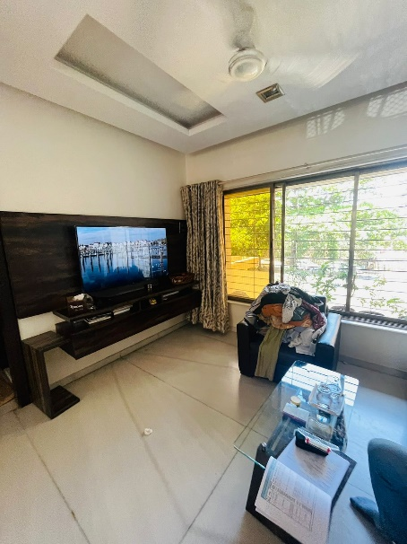**Actual site photographs**

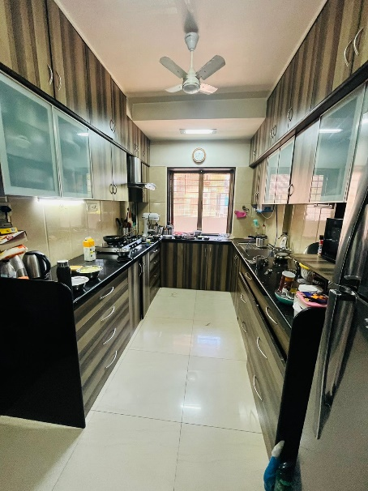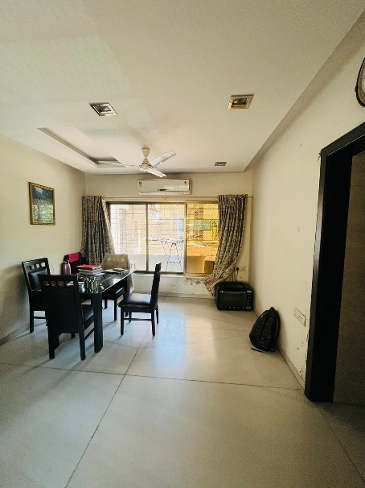

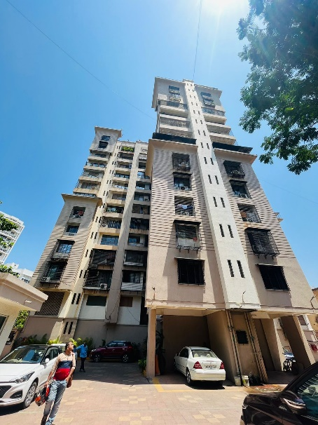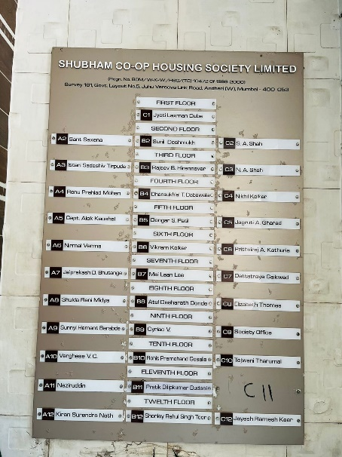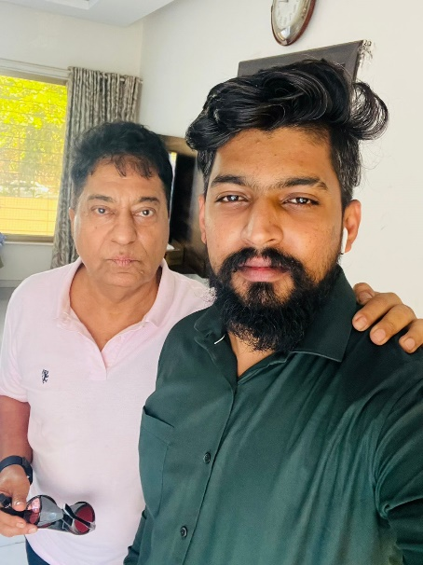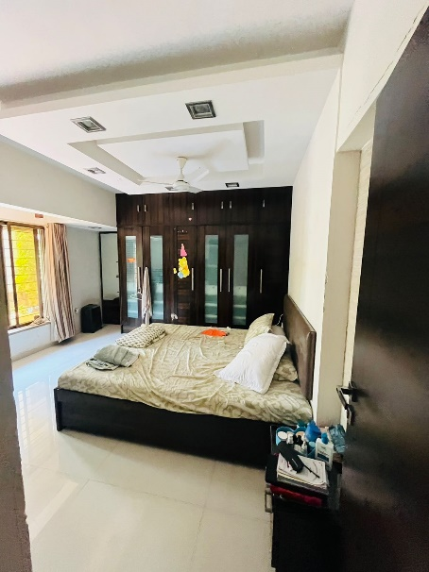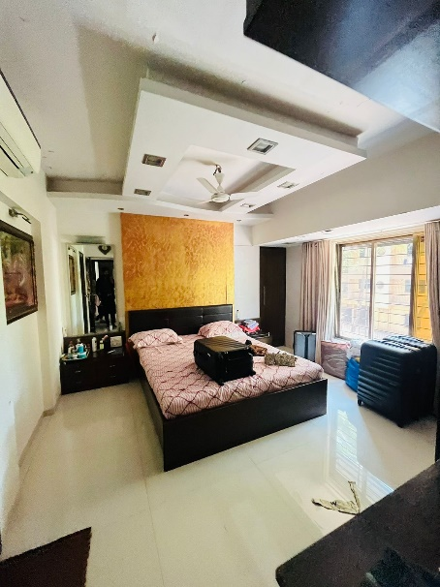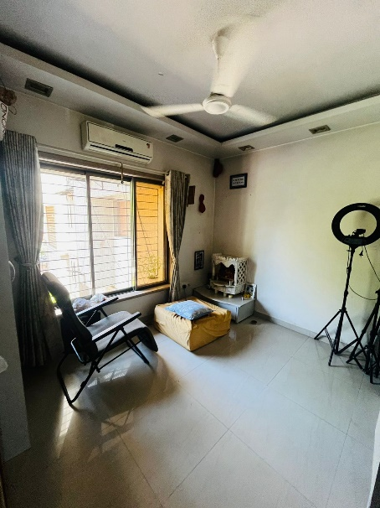

**Route Map of the property**

**Site u/r**

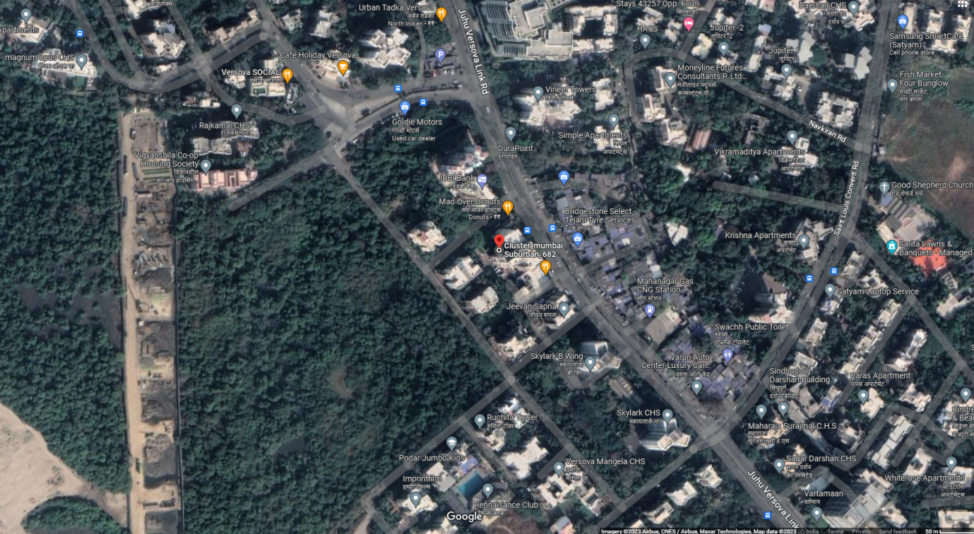

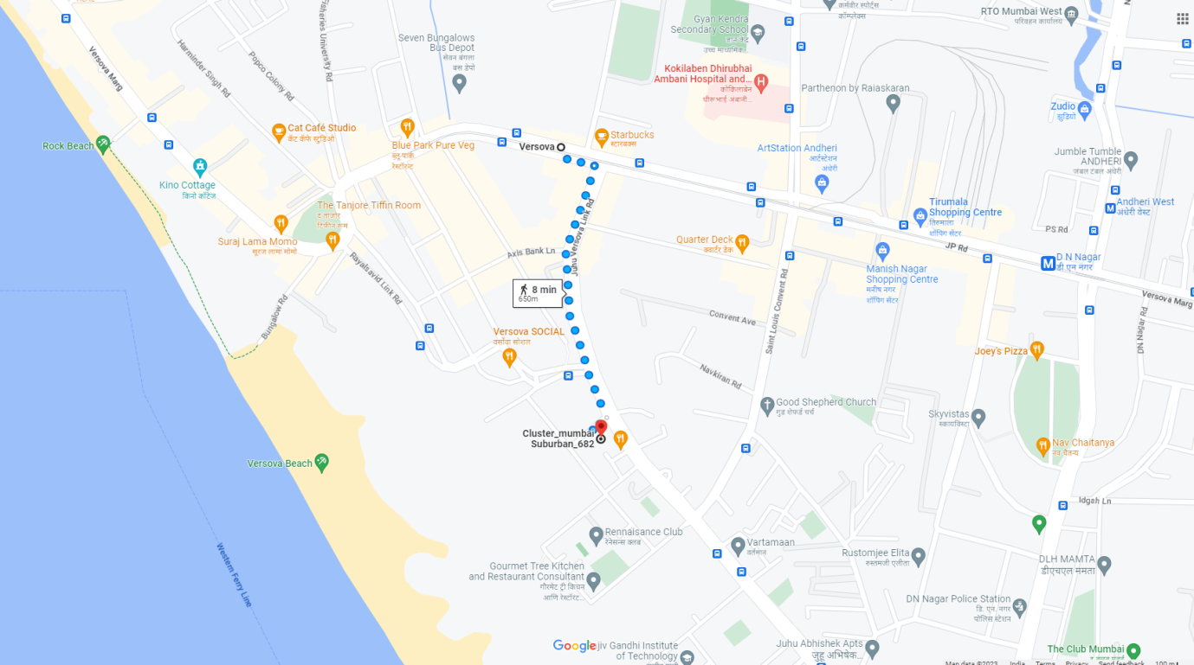

# Latitude Longitude - 19°07’30.8”N 72°49’20.1”E

**Note**: The Blue line shows the route to site from nearest railway station (Versova– 650 Mts.)

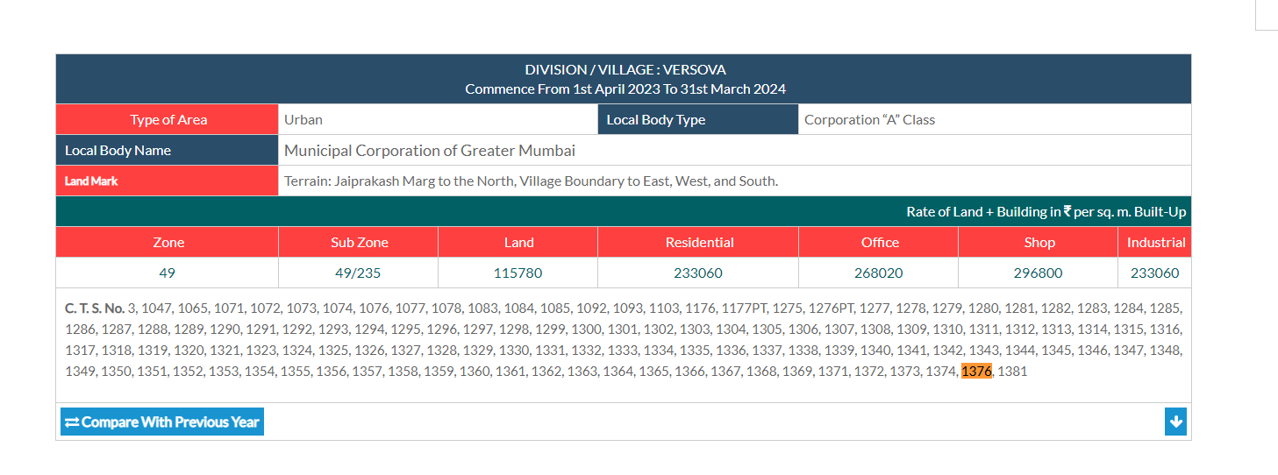**Ready Reckoner Rate**

**Price Indicators**

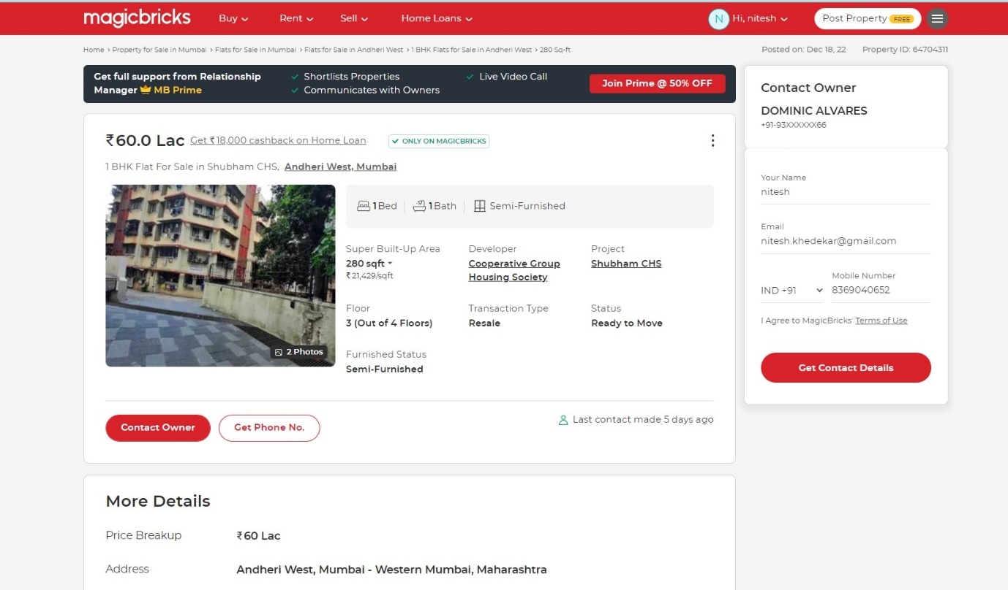

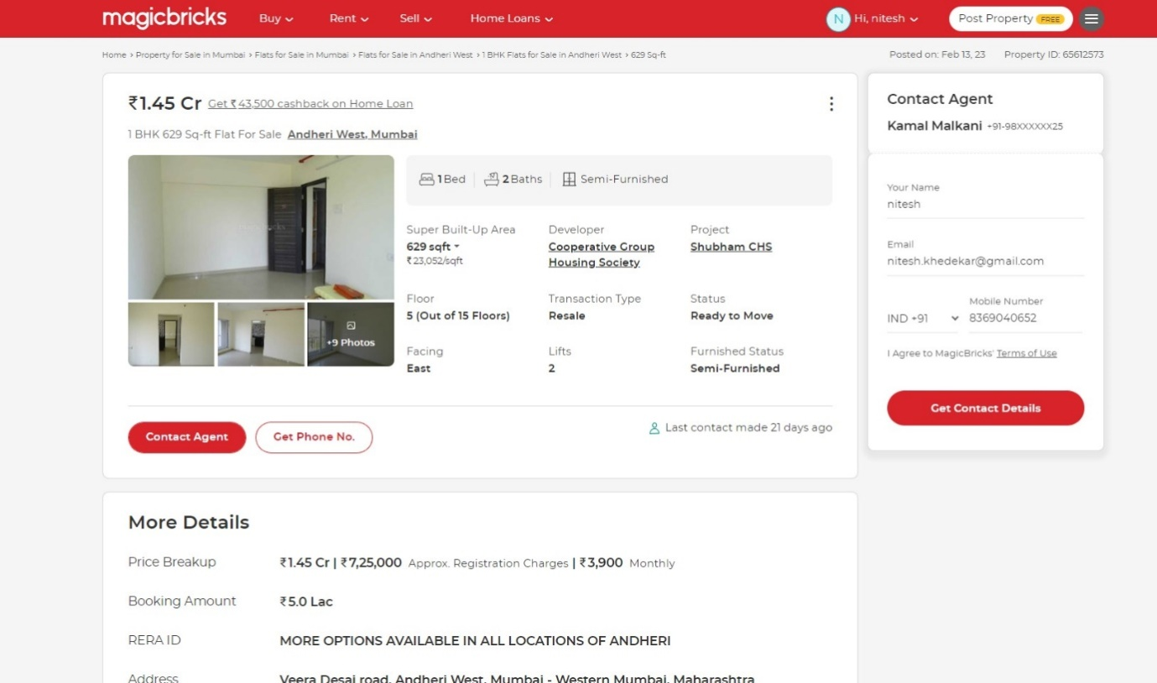**Price Indicators**

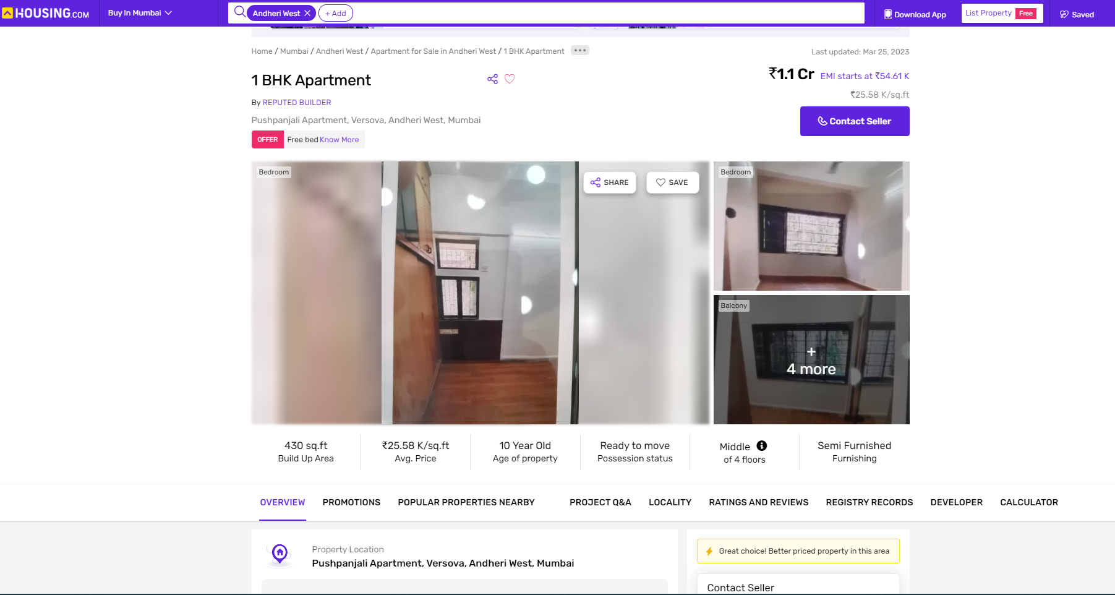

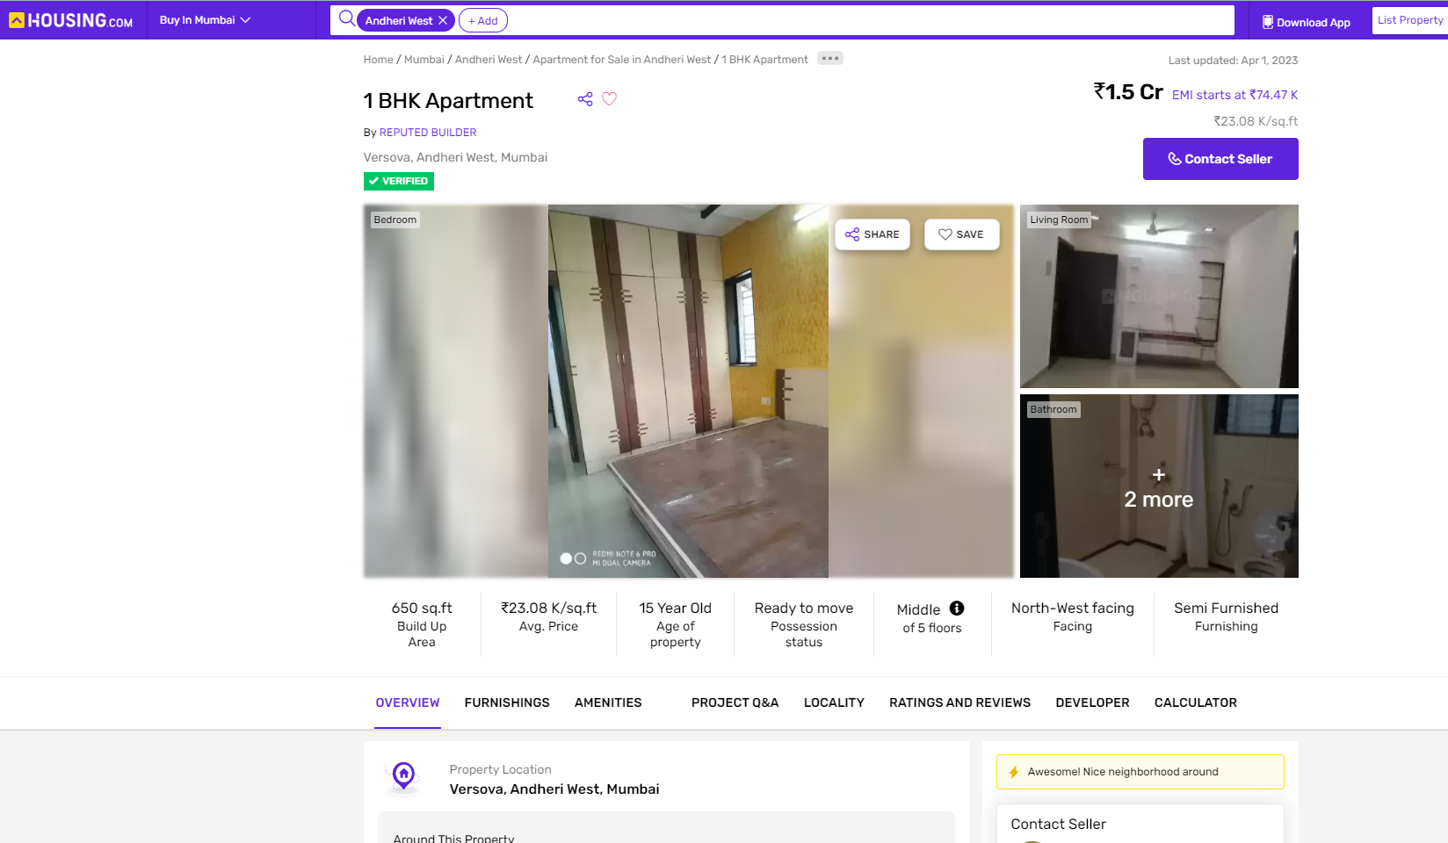

**DEFINITION OF VALUE FOR THIS SPECIFIC PURPOSE**

This exercise is to assess **Fair Market Value** of the property under reference for **Fair Market Value** purpose ason dated **05th April 2023.**

The term **Fair Market Value** is defined as

*"The most probable price, as of a specified date, in cash, terms equivalent to cash, or in other precisely revealed terms for which the specified property rights would sell after reasonable exposure in a competitive market under all conditions requisite to a fair sale, with the buyer and seller each acting prudently knowledgeably and for self-interest assuming that neither is under undue duress"*

Fundamental assumptions and conditions presumed in this definition are:

1. Buyer and seller are motivated by self-interest.
2. Buyer and seller are well informed and are acting prudently.
3. The property is exposed for a reasonable time on the open market.
4. Payment is made in cash or equivalent or in specified financing terms.

**ASSUMPTIONS, CAVEATS, LIMITATION AND DISCLAIMERS**

1. We assume no responsibility for matters of legal nature affecting the property appraised or the title thereto, nor do we render our opinion as to the title, which is assumed to be good and marketable.
2. The property is valued as though under responsible ownership.
3. It is assumed that there are no hidden or unapparent conditions of the subsoil or structure that would render it more or less valuable. No responsibility is assumed for such conditions or for engineering that might be required to discover such factors.
4. There is no direct/ indirect interest in the property valued.
5. The rates for valuation of the property are in accordance with the Govt. approved rates and prevailing market rates.

**DECLARATION OF PROFESSIONAL FEES CHARGED**

We hereby declare that, our professional fees are not contingent upon the valuation findings. However, if the statute AND/OR clients demands that, the fees should be charged on the percentage of assessed value then, with the full knowledge of the AND/OR end user, it is being charged accordingly.

**VALUATION OF THE PROPERTY PREMISES**

Considering various parameters recorded herein above, existing economic scenario, and the information that is available with reference to the development of neighbourhood and method selected for valuation, we are of the opinion that, the property premises can be assessed and valued for this particular purpose at **`3,04,80,000.00 (Rupees Three Crore Four Lakh Eighty Thousand Only).**

Sharadkumar B. Chalikwar

Govt. Reg. Valuer

Chartered Engineer (India)

Reg. No. IBBI/RV/07/2019/11744

Reg. No. (N) CCIT/1-14/52/2008-09