Valuation Report of the Immovable Property
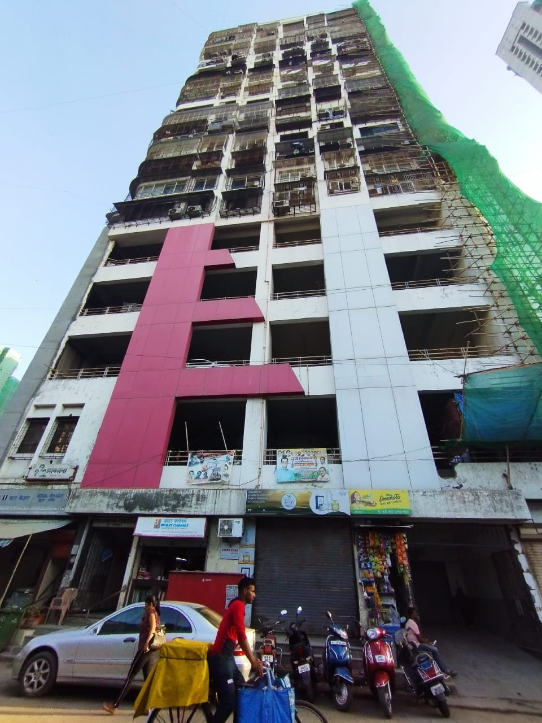

Details of the property under consideration:

Name of Owner: Rajesh Ravjibhai Khokhariya, Shobhna Rajesh Khokhariya &
Prakash Ravjibhai Khokhariya

Residential Flat (Pent House) No. 1901, 19th & 20th Floor, C Wing, “Valencia Tower C Wing Co-op. Hsg. Soc. Ltd.,” Tukaram Jivaji Marg, Chikalwadi Lane, C. S. No. 293, Tardeo Division, Near Bhatia Hospital, Tardeo,
Grant Road (West), Mumbai – 400007, State – Maharashtra, Country – India.

Longitude Latitude: 18°57’54.2”N 72°48’53.5”E

Valuation Done for:
Central Bank of India
Corporate Finance Branch BKC
Mumbai Suburban Regional Office, 2rd Floor, NCl Building, Plot No. 6, E-Block, Bandra Kurla Complex, Bandra (East), Mumbai, State - Maharashtra, Country - India.

Vastu/Mumbai/06/2023/30777/2301175
20/08-277-SKVSUM
Date: 20.06.2023

VALUATION OPINION REPORT

This is to certify that the property bearing Residential Flat (Pent House) No. 1901, 19th & 20th Floor, C Wing, “Valencia Tower C Wing Co-op. Hsg. Soc. Ltd.,” Tukaram Jivaji Marg, Chikalwadi Lane, C. S. No. 293, Tardeo Division, Near Bhatia Hospital, Tardeo, Grant Road (West), Mumbai – 400007, State – Maharashtra, Country – India belongs to Rajesh Ravjibhai Khokhariya, Shobhna Rajesh Khokhariya & Prakash Ravjibhai Khokhariya.

Boundaries of the property.

North | : | Tukaram Jivaji Marg
South | : | Clothia Building
East | : | Solitaire Building
West | : | Residential Building

Considering various parameters recorded, existing economic scenario, and the information that is available with reference to the development of neighborhood and method selected for valuation, we are of the opinion that, the property premises can be assessed for this particular purpose at ` 10,34,92,060.00 (Rupees Ten Crore Thirty Four Lakh Ninety Two Thousand Sixty Only).

The valuation of the property is based on the documents produced by the concern. Legal aspects have not been taken into considerations while preparing this valuation report.

Hence certified

Manoj B. Chalikwar
Registered Valuer
Chartered Engineer (India)
Reg. No. CAT-I-F-1763
CBI Emp. No. SMRO/CREDIT/2017-18/1311
Encl: Valuation report.

Vastukala Consultants (I) Pvt. Ltd.
121, 1st Floor, Ackruti Star, Central Road, MIDC, Andheri (E), Mumbai – 400 093.

To,
The Branch Manager,
Central Bank of India
Corporate Finance Branch BKC
Mumbai Suburban Regional Office, 2nd Floor,
NCl Building, Plot No. 6, E-Block,
Bandra Kurla Complex, Bandra (East),
Mumbai, State - Maharashtra, Country - India.

VALUATION REPORT (IN RESPECT OF FLAT (PENT HOUSE))
I | General
1. | Purpose for which the valuation is made |  |  | : | To assess fair market value of the property for the purpose of release of the property
2. | a) |  | Date of inspection | : | 29.03.2023
 | b) |  | Date on which the valuation is made | : | 20.06.2023
3. | List of documents produced for perusal:  - Copy of Agreement for Sale dated 23.06.2011.  - Copy of Occupancy Certificate No. EB / 9020 / D / A dated 05.10.2011 issued by Municipal Corporation of Greater Mumbai.  - Copy of NOC dated 16.09.2019 Rajesh Ravjibhai Khokhariya, Shobhna Rajesh Khokhariya & Prakash Ravjibhai Khokhariya issued by Valencia Tower C Wing Co-op. Hsg. Soc. Ltd.  - Copy of NOC dated 25.06.2011 Rajesh Ravjibhai Khokhariya, Shobhna Rajesh Khokhariya & Prakash Ravjibhai Khokhariya issued by M/s. ABU Enterprises.  - Copy of Share Certificate No. 33 bearing nos. 321 to 330 having 10 Shares of ` 50/- each dated 30.06.2012 in the name of Rajesh Ravjibhai Khokhariya, Shobhna Rajesh Khokhariya & Prakash Ravjibhai Khokhariya issued by Valencia Tower C Wing Co-op. Hsg. Soc. Ltd. for Flat No. 1901.  - Copy of Car Parking Allotment Letter dated 19.11.2011 in the name of Rajesh Ravjibhai Khokhariya, Shobhna Rajesh Khokhariya & Prakash Ravjibhai Khokhariya issued by M/s. ABU Enterprises.  - Copy of Car Parking Allotment Letter dated 16.12.2011 in the name of Rajesh Ravjibhai Khokhariya, Shobhna Rajesh Khokhariya & Prakash Ravjibhai Khokhariya issued by M/s. ABU Enterprises.  - Copy of Electricity Bill Consumer No. 874-492-080*1 dated 02.02.2023 in the name of Rajesh Ravjibhai Khokhariya, Shobhna Rajesh Khokhariya & Prakash Ravjibhai Khokhariya issued by BEST.  - Copy of Maintenance Bill No. 895 dated 01.10.2022 in the name of Rajesh Ravjibhai Khokhariya, Shobhna Rajesh Khokhariya & Prakash Ravjibhai Khokhariya issued by Valencia Tower C Wing Co-op. Hsg. Soc. Ltd.
4. | Name of the owner(s) and his / their address (es) with Phone no. (details of share of each owner in case of joint ownership) |  |  | : | Rajesh Ravjibhai Khokhariya,  Shobhna Rajesh Khokhariya &  Prakash Ravjibhai Khokhariya  Address: Residential Flat (Pent House) No. 1901, 19th & 20th Floor, C Wing, “Valencia Tower C Wing Co-op. Hsg. Soc. Ltd.,” Tukaram Jivaji Marg, Chikalwadi Lane, C. S. No. 293, Tardeo Division, Near Bhatia Hospital, Tardeo, Grant Road (West), Mumbai – 400007, State – Maharashtra, Country – India.  Contact Person:  Shobhna Rajesh Khokhariya (Owner)  Contact No. 9820080970  Joint Ownership  (Details of ownership share not available)
5. | Brief description of the property (Including Leasehold / freehold etc.) |  |  | : | The property is a Residential Flat (Pent House) located on 19th & 20th Floor. The property is at 350 M. walkable distance from nearest railway station Grant Road.  The composition of Flat (Pent House) are as under:
  Floor | Composition
  19th Floor | 2 Bedrooms + Living Room + Dining + Kitchen + 2 Toilets + Internal Staircase to the upper floor
  20th Floor | 2 Bedrooms + Living Room + Dining + Kitchen + 2 Toilets + Internal Staircase to the lower floor
6. | Location of property |  |  | :
 | a) | Plot No. / Survey No. |  | : | C.S. No. 293 of Tardeo Division
 | b) | Door No. |  | : | Residential Flat (Pent House) No. 1901
 | c) | C.T.S. No. / Village |  | : | Tardeo Division
 | d) | Ward / Taluka |  | : | D Ward
 | e) | Mandal / District |  | : | Mumbai
 | f) | Date of issue and validity of layout of approved map / plan |  | : | Copy of Occupancy Certificate No. EB / 9020 / D / A dated 05.10.2011 issued by Municipal Corporation of Greater Mumbai.
 | g) | Approved map / plan issuing authority |  | :
 | h) | Whether genuineness or authenticity of approved map/ plan is verified |  | :
 | i) | Any other comments by our empanelled valuers on authentic of approved plan |  | : | No
7. | Postal address of the property |  |  | : | Residential Flat (Pent House) No. 1901, 19th & 20th Floor, C Wing, “Valencia Tower C Wing Co-op. Hsg. Soc. Ltd.,” Tukaram Jivaji Marg, Chikalwadi Lane, C. S. No. 293, Tardeo Division, Near Bhatia Hospital, Tardeo, Grant Road (West), Mumbai – 400007, State – Maharashtra, Country – India.
8. | City / Town |  |  | : | Grant Road (West), Mumbai
 | Residential area |  |  | : | Yes
 | Commercial area |  |  | : | No
 | Industrial area |  |  | : | No
9. | Classification of the area |  |  | :
 | i) High / Middle / Poor |  |  | : | High Class
 | ii) Urban / Semi Urban / Rural |  |  | : | Urban
10. | Coming under Corporation limit / Village Panchayat / Municipality |  |  | : | Tardeo Division  Municipal Corporation of Greater Mumbai
11. | Whether covered under any State / Central Govt. enactments (e.g., Urban Land Ceiling Act) or notified under agency area/ scheduled area / cantonment area |  |  | : | No
12. | Boundaries of the property
 |  |  |  |  | As per Site |  | As per Documents
 | North |  |  | : | Tukaram Jivaji Marg |  | Details not available
 | South |  |  | : | Clothia Building |  | Details not available
 | East |  |  | : | Solitaire Building |  | Details not available
 | West |  |  | : | Residential Building |  | Details not available
13 | Dimensions of the site |  |  |  | N. A. as property under consideration is a Residential Flat (Pent House) in a building.
 |  |  |  |  | A  As per the Deed | B Actuals
 | North |  |  | : | - | -
 | South |  |  | : | - | -
 | East |  |  | : | - | -
 | West |  |  | : | - | -
14. | Extent of the site |  |  | : | Area as per actual site measurement are as under:  Carpet Area in Sq. Ft. = 1,211.00  (Area as per Agreement for Sale of Flat No. 1901 only)  Built Up Area in Sq. Ft. = 1,454.00  (Area as per Index II)
  Floor | Carpet Area in Sq. Ft.
  19th Floor | 1,172.00
  20th Floor | 1,120.00
  Total Carpet Area | 2,292.00
14.1 | Latitude, Longitude & Co-ordinates of Flat (Pent House) |  |  | : | 18°57’54.2”N 72°48’53.5”E
15. | Extent of the site considered for Valuation (least of 13A& 13B) |  |  | : | Built Up Area in Sq. Ft. = 1,454.00  (Area as per Index II)
16 | Whether occupied by the owner / tenant? If occupied by tenant since how long? Rent received per month. |  |  | : | Owner Occupied
II | APARTMENT BUILDING
 | Nature of the Apartment |  |  | : | Residential
 | Location |  |  | :
 | C.T.S. No. |  |  | : | C.S. No. 293 of Tardeo Division
 | Block No. |  |  | : | -
 | Ward No. |  |  | : | D Ward
 | Village / Municipality / Corporation |  |  | : | Tardeo Division  Municipal Corporation of Greater Mumbai
 | Door No., Street or Road (Pin Code) |  |  | : | Residential Flat (Pent House) No. 1901, 19th & 20th Floor, C Wing, “Valencia Tower C Wing Co-op. Hsg. Soc. Ltd.,” Tukaram Jivaji Marg, Chikalwadi Lane, C. S. No. 293, Tardeo Division, Near Bhatia Hospital, Tardeo, Grant Road (West), Mumbai – 400007, State – Maharashtra, Country – India.
 | Description of the locality Residential / Commercial / Mixed |  |  | : | Residential
 | Year of Construction |  |  | : | 2011 (As per Occupancy Certificate)
 | Number of Floors |  |  | : | Ground + 1st (Pt) to 2nd (Pt) School + 1st (Pt) to 2nd (Pt) Parking + 3rd to 4th Parking + 5th to 20th Upper Floors (As per Occupancy Certificate)
 | Type of Structure |  |  | : | R.C.C. Framed Structure
 | Number of Dwelling units in the building |  |  | : | 2 Flats (Pent Houses) on 19th & 20th Floor
 | Quality of Construction |  |  | : | Good
 | Appearance of the Building |  |  | : | Good
 | Maintenance of the Building |  |  | : | Good
 | Facilities Available |  |  | :
 | Lift |  |  | : | 2 Lifts
 | Protected Water Supply |  |  | : | Municipal Water supply
 | Underground Sewerage |  |  | : | Connected to Municipal sewer
 | Car parking - Open / Covered |  |  | : | 3 Car Parking Nos. 40, 17, 17A
 | Is Compound wall existing? |  |  | : | Yes
 | Is pavement laid around the building |  |  | : | Yes

III | Residential Flat (Pent House)
1 | The floor in which the Flat (Pent House) is situated | : | 19th & 20th Floor
2 | Door No. of the Flat (Pent House) | : | Residential Flat (Pent House) No. 1901
3 | Specifications of the Flat (Pent House) | :
 | Roof | : | R.C.C. Slab
 | Flooring | : | Wooden + Italian marble tiles flooring
 | Doors | : | Teak Wood door frame with flush doors
 | Windows | : | Powder Coated Aluminum Sliding windows
 | Fittings | : | Concealed plumbing with C.P. fittings.  Electrical wiring with Concealed
 | Finishing | : | Cement Plastering with POP false ceiling
4 | House Tax | :
 | Assessment No. | : | Details not available
 | Tax paid in the name of: | : | Details not available
 | Tax amount: | : | Details not available
5 | Electricity Service connection No.: | : | Details not available
 | Meter Card is in the name of: | : | Details not available
6 | How is the maintenance of the Flat (Pent House)? | : | Good
7 | Sale Deed executed in the name of | : | Rajesh Ravjibhai Khokhariya,  Shobhna Rajesh Khokhariya &  Prakash Ravjibhai Khokhariya
8 | What is the undivided area of land as per Sale Deed? | : | Details not available
9 | What is the plinth area of the Flat (Pent House)? | : | Built Up Area in Sq. Ft. = 1,454.00  (Area as per Index II)
10 | What is the floor space index (app.) | : | As per MCGM norms
11 | What is the Carpet Area of the Flat (Pent House)? | : | Area as per actual site measurement are as under:  Carpet Area in Sq. Ft. = 1,211.00  (Area as per Agreement for Sale of Flat No. 1901 only)
  Floor | Carpet Area in Sq. Ft.
  19th Floor | 1,172.00
  20th Floor | 1,120.00
  Total Carpet Area | 2,292.00
12 | Is it Posh / I Class / Medium / Ordinary? | : | Medium
13 | Is it being used for Residential or Commercial purpose? | : | Residential Purpose
14 | Is it Owner-occupied or let out? | : | Owner Occupied
15 | If rented, what is the monthly rent? | : | ` 2,60,000.00 Expected rental income per month
IV | MARKETABILITY | :
1 | How is the marketability? | : | Good
2 | What are the factors favoring for an extra Potential Value? | : | Located in developed area
3 | Any negative factors are observed which affect the market value in general? | : | No
V | Rate | :
1 | After analyzing the comparable sale instances, what is the composite rate for a similar Flat (Pent House) with same specifications in the adjoining locality? - (Along with details / reference of at - least two latest deals / transactions with respect to adjacent properties in the areas) | : | Market Rate vicinity around ` 45,000.00 to ` 47,000.00 per Sq. Ft. on Carpet Area  Higher rate i.e., ` 85,000.00 to ` 87,000.00 per Sq. Ft. on Carpet Area
2 | Assuming it is a new construction, what is the adopted basic composite rate of the Flat (Pent House) under valuation after comparing with the specifications and other factors with the Flat (Pent House) under comparison (give details). | : | ` 86,000.00 per Sq. Ft. on Carpet Area
3 | Break – up for the rate | :
 | I. Building + Services | : | ` 3,000.00 per Sq. Ft.
 | II. Land + others | : | ` 83,000.00 per Sq. Ft.
4 | Guideline rate obtained from the Registrar's Office | : | ` 3,27,921.00 per Sq. M. i.e.  ` 30,465.00 per Sq. Ft.
 | Guideline rate (after deprecation) | : | ` 3,05,508.00 per Sq. M. i.e.  ` 28,382.00 per Sq. Ft.
VI | COMPOSITE RATE ADOPTED AFTER DEPRECIATION
a | Depreciated building rate | :
 | Replacement cost of Flat (Pent House) with Services (v(3)i) | : | ` 3,000.00 per Sq. Ft.
 | Age of the building | : | 12 Years
 | Life of the building estimated | : | 48 years Subject to proper, preventive periodic maintenance & structural repairs.
 | Depreciation percentage assuming the salvage value as 10% | : | 18.00%
 | Depreciated Ratio of the building | :
b | Total composite rate arrived for Valuation | :
 | Depreciated building rate VI (a) | : | ` 2,460.00 per Sq. Ft.
 | Rate for Land & other V (3) ii | : | ` 83,000.00 per Sq. Ft.
 | Total Composite Rate | : | ` 85,460.00 per Sq. Ft. (Including Car Parking)
Remarks:
- To assess fair market value of the property for the purpose of release of the property.
- As per Site Inspection, Actual Total Carpet Area 2,292.00 Sq. Ft. (19th & 20th Floor) is more than Carpet Area 1,211.00 Sq. Ft. mentioned in Agreement for Sale of Flat No. 1901 only. Hence, to give proper weightage to the value of the property, higher rate i.e., ` 85,460.00 per Sq. Ft. is considered.
- Legal documents of 20th Floor Area and Terrace Area not provided; hence we have not considered for valuation. For the purpose of valuation, we have considered the Carpet Area as per Agreement for Sale.

Details of Valuation:

Sr. No. | Description | Qty. | Rate per  unit (`) | Estimated  Value (`)
1 | Present value of the Flat (Pent House) | 1,211.00 Sq. Ft. | 85,460.00 | 10,34,92,060.00
2 | Wardrobes
3 | Showcases /
4 | Kitchen arrangements
5 | Superfine finish
6 | Interior Decorations
7 | Electricity deposits / electrical fittings, etc.
8 | Extra collapsible gates / grill works etc.
9 | Potential value, if any
10 | Others
 | Total value of the property |  |  | 10,34,92,060.00
 | Realizable value of the property |  |  | 9,31,42,854.00
 | Distress Value of the property |  |  | 8,27,93,648.00
 | Insurable value of the property (1,454.00 X 3,000.00) |  |  | 43,62,000.00
 | Guideline value of the property (1,454.00 X 28,382.00) |  |  | 4,12,67,428.00

Justification for price / rate
The Market Value of the property is based on facts of markets discovered by us during our enquiries, however the government rate value in this case is less than the market value arrived by us. We are of the opinion that the value arrive by us will prove to be correct if an Auction of the subject property is carried out. As far as Market Value in Index II is concerned, it is not possible to comment on same, may be government rates are fixed by sampling during same point of time in part and whereas, Market values change every month.

In most of the cases the actual deal amount or Transaction value is not reflected in Index II because of various Market practices. As Valuer, we always try to give a value which is correct reflection of actual transaction value irrespective of any factors in market.
Method of Valuation / Approach
The sales comparison approach uses the market data of sale prices to estimate the value of a real estate property. Property valuation in this method is done by comparing a property to other similar properties that have been recently sold. Comparable properties, also known as comparables, or comps, must share certain features with the property in question. Some of these include physical features such as square footage, number of rooms, condition, and age of the building; however, the most important factor is no doubt the location of the property. Adjustments are usually needed to account for differences as no two properties are exactly the same. To make proper adjustments when comparing properties, real estate appraisers must know the differences between the comparable properties and how to value these differences. The sales comparison approach is commonly used for Residential Flat (Pent House), where there are typically many comparables available to analyze. As the property is a residential Flat (Pent House), we have adopted Sale Comparison Approach Method for the purpose of valuation. The Price for similar type of property in the nearby vicinity is in the range of Market Rate vicinity around ` 45,000.00 to ` 47,000.00 per Sq. Ft. on Carpet Area, Higher rate i.e., ` 85,000.00 to ` 87,000.00 per Sq. Ft. on Carpet Area Considering the rate with attached report, current market conditions, demand and supply position, Flat (Pent House) size, location, upswing in real estate prices, sustained demand for Residential Flat (Pent House), all round development of commercial and residential application in the locality etc. We estimate ` 85,460.00 per Sq. Ft. on Carpet Area (after deprecation) for valuation.
Impending threat of acquisition by government for road widening / publics service purposes, sub merging & applicability of CRZ provisions (Distance from sea-cost / tidal level must be incorporated) and their effect on | -
- Saleability | Good
- Likely rental values in future in | ` 2,60,000.00 Expected rental income per month
- Any likely income it may generate | Rental Income

Actual Site Photographs – 19th Floor
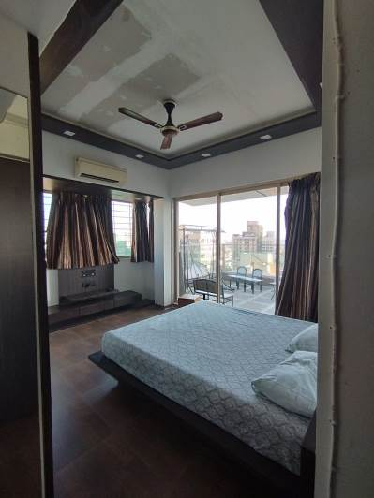
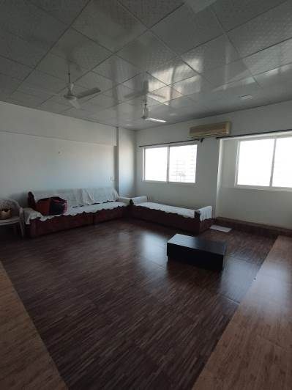
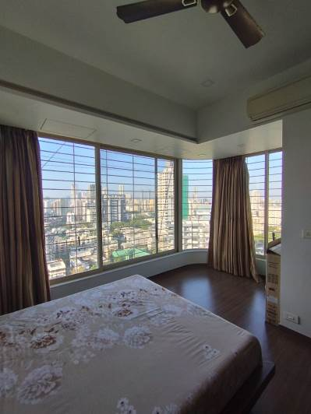

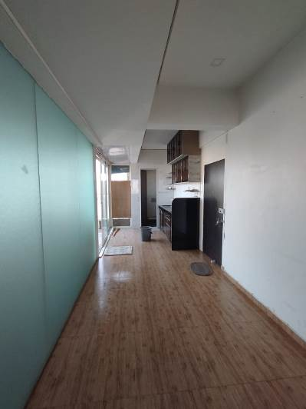
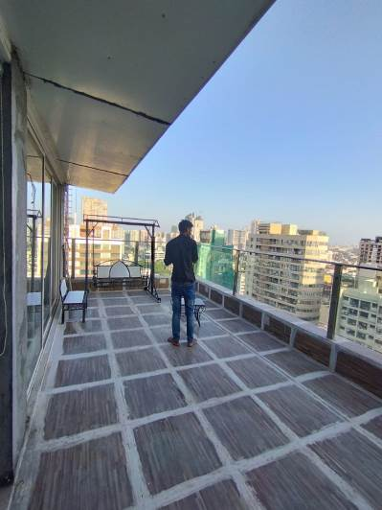
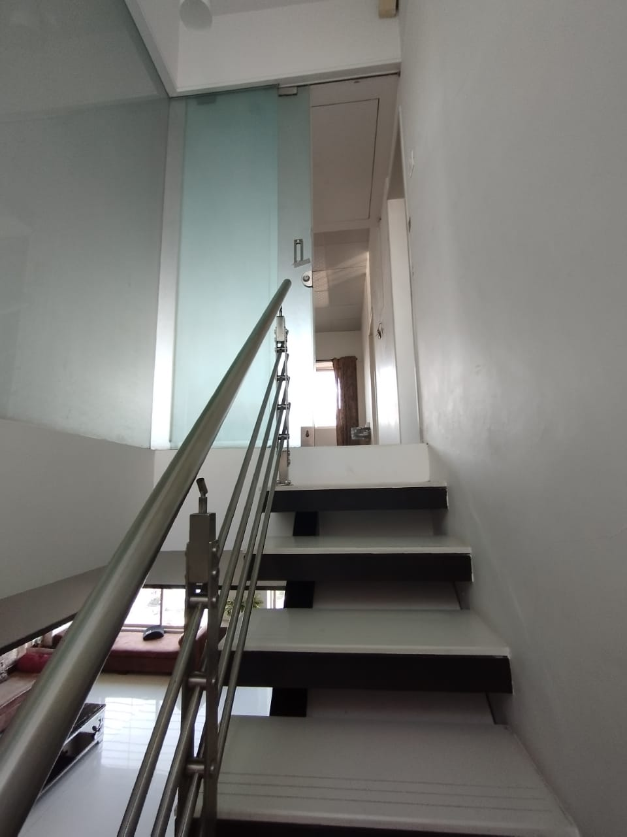

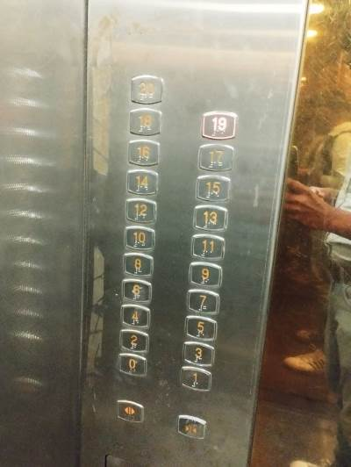

Actual Site Photographs – 20th Floor
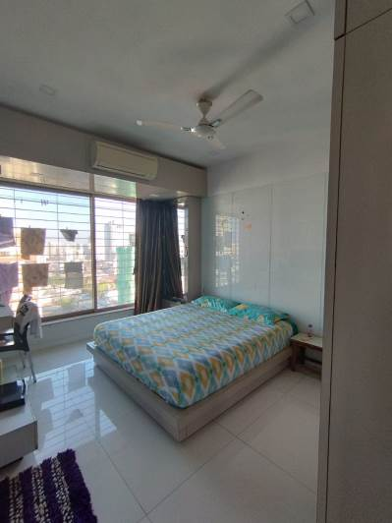
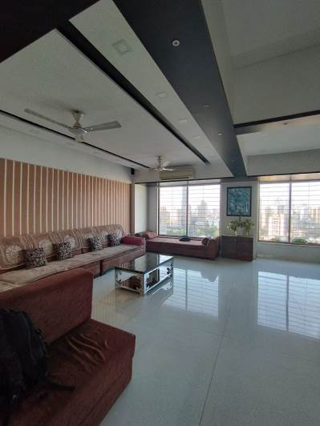
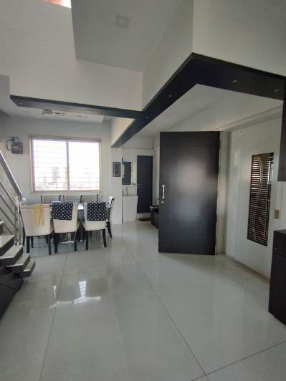


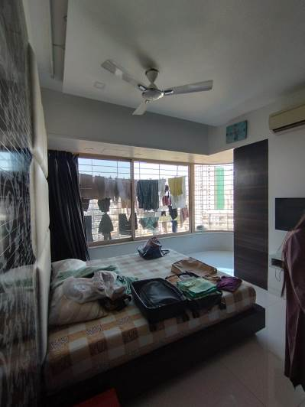
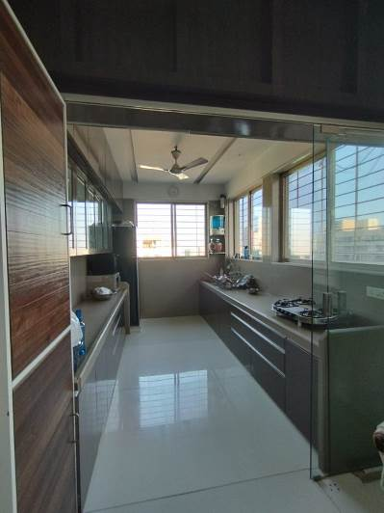
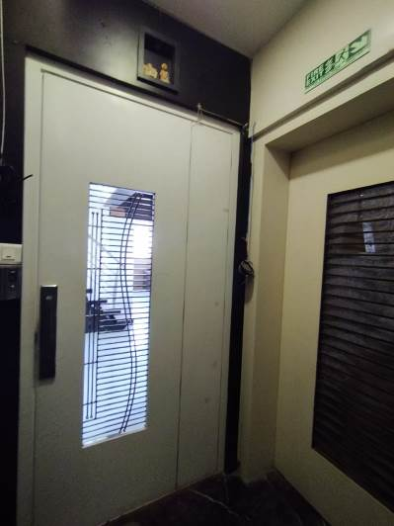
Route Map of the property
(Site ur)
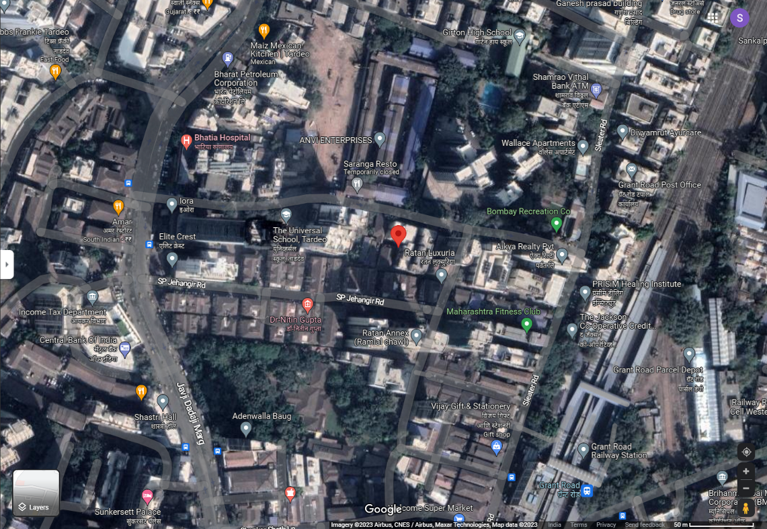

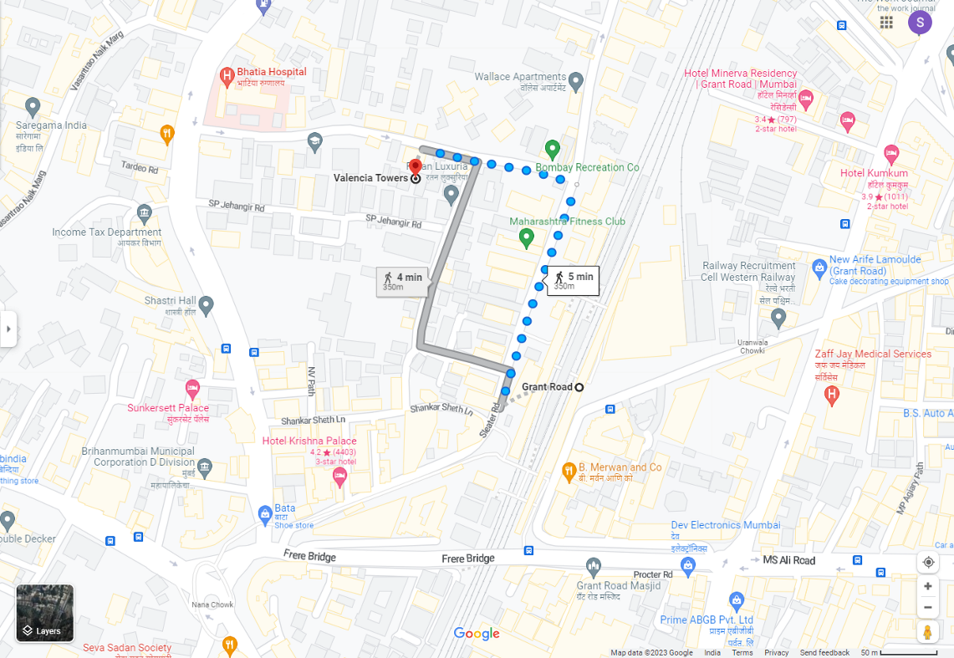

Longitude Latitude: 18°57’54.2”N 72°48’53.5”E
Note: The Blue line shows the route to site from nearest railway station (Grant Road – 350 M.)

Ready Reckoner Rate

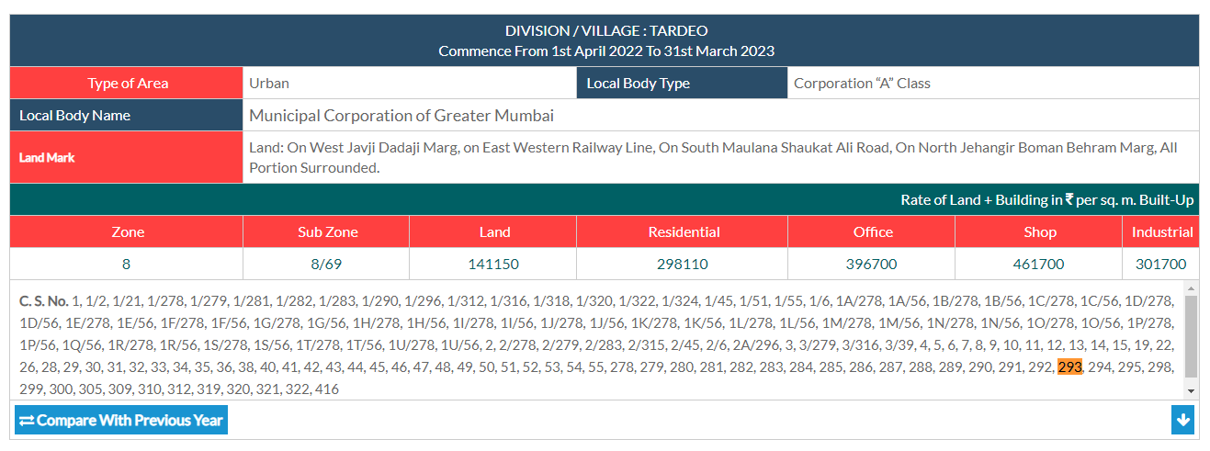

Stamp Duty Ready Reckoner Market Value Rate for Flat | 2,98,110.00
Increase by 10% on units located between 11 to 20 floors | 29,811.00
Stamp Duty Ready Reckoner Market Value Rate (After Increase) (A) | 3,27,921.00 | Sq. Mtr. | 30,465.00 | Sq. Ft.
Stamp Duty Ready Reckoner Market Value Rate for Land (B) | 1,41,150.00
The difference between land rate and building rate (A – B = C) | 1,86,771.00
Depreciation Percentage as per table (D) [100% - 12%]  (Age of the Building – 12 Years) | 88%
Rate to be adopted after considering depreciation [B + (C x D)] | 3,05,508.00 | Sq. Mtr. | 28,382.00 | Sq. Ft.

Multi-Storied building with Lift
For residential premises / commercial unit / office on above floor in multistoried building, the rate mentioned in the ready reckoner will be increased as under:

 | Location of Flat / Commercial Unit in the building | Rate
a) | On Ground to 4 Floors | No increase for all floors from ground to 4 floors
b) | 5 Floors to 10 Floors | Increase by 5% on units located between 5 to 10 floors
c) | 11 Floors to 20 Floors | Increase by 10% on units located between 11 to 20 floors
d) | 21 Floors to 30 Floors | Increase by 15% on units located between 21 to 30 floors
e) | 31 Floors and above | Increase by 20% on units located on 31 and above floors

Table – D: Depreciation Percentage Table

Completed Age of Building in Years | Value in percent after depreciation
 | R.C.C. Structure / other Pukka Structure | Cessed Building, Half or Semi – Pukka Structure & Kaccha Structure.
0 to 2 Years | 100% | 100%
Above 2 & up to 5 Years | 95% | 95%
Above 5 Years | After initial 5 year for every year 1% depreciation is to be considered. However maximum deduction available as per this shall be 70% of Market Value rate | After initial 5 year for every year 1.5% depreciation is to be considered. However maximum deduction available as per this shall be 85% of Market Value rate

Sale Instance
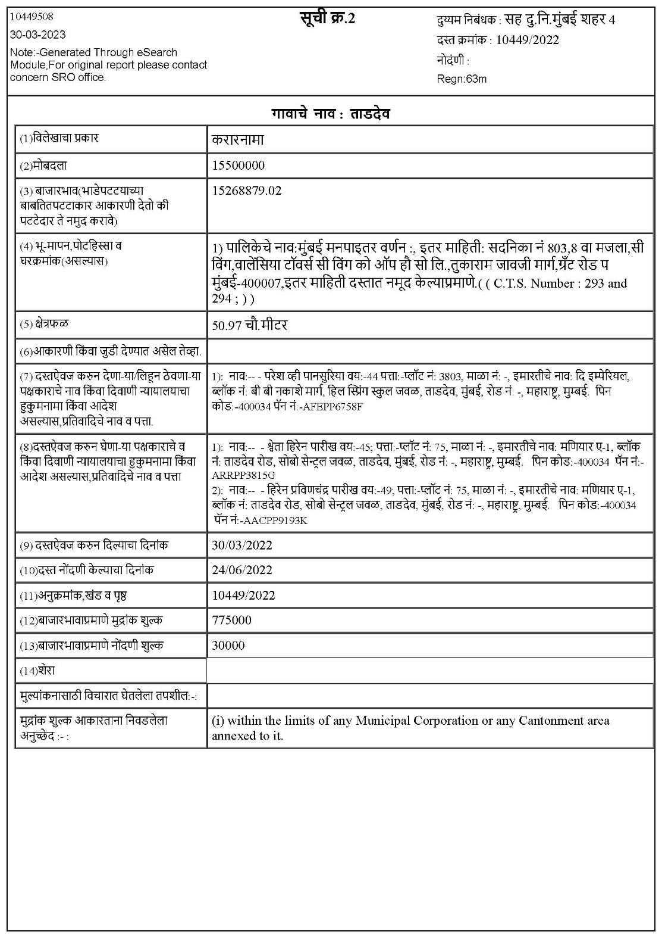

Price Indicators
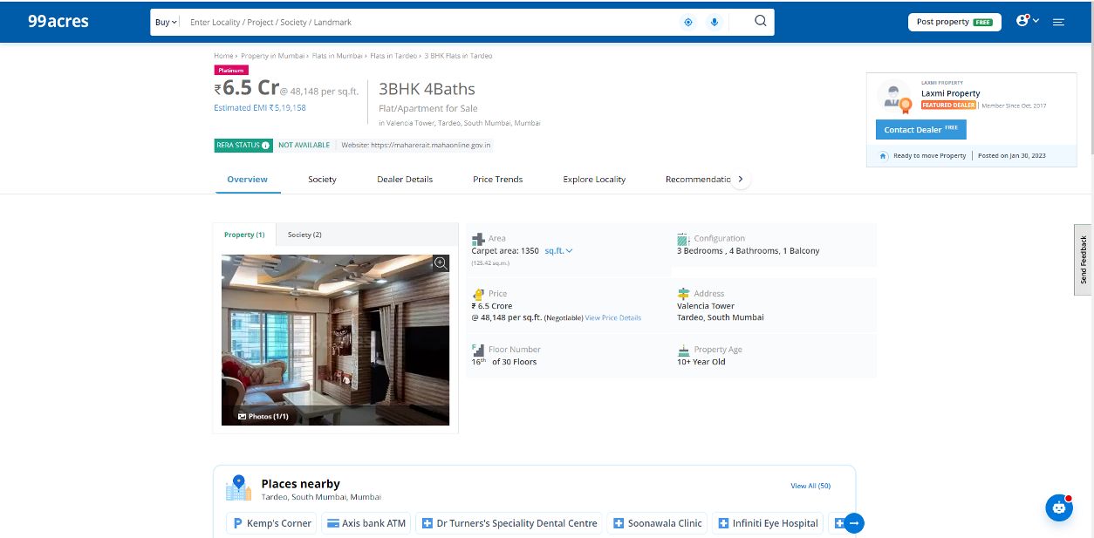

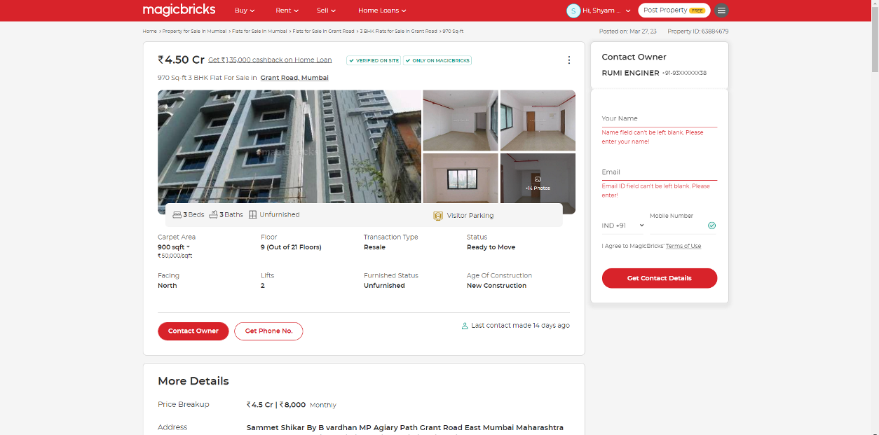

Index II
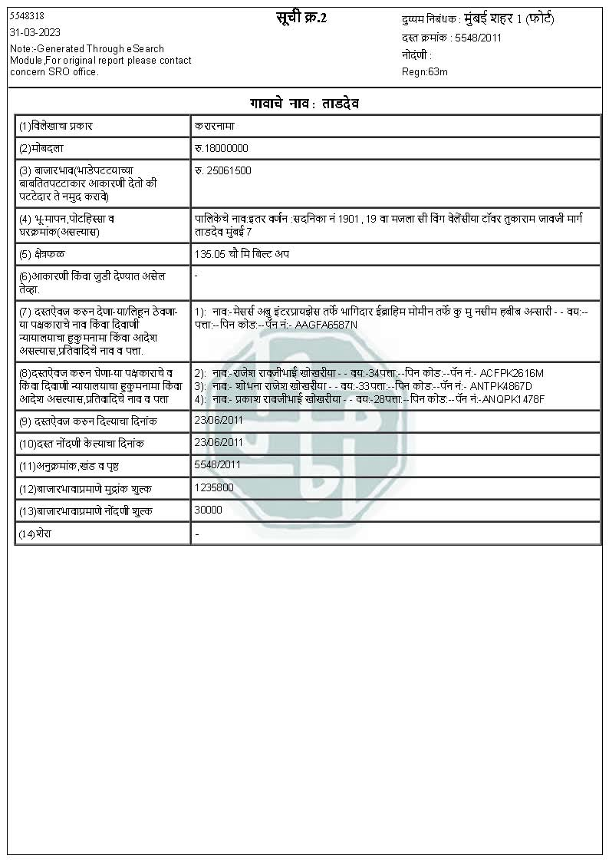

Society NOC
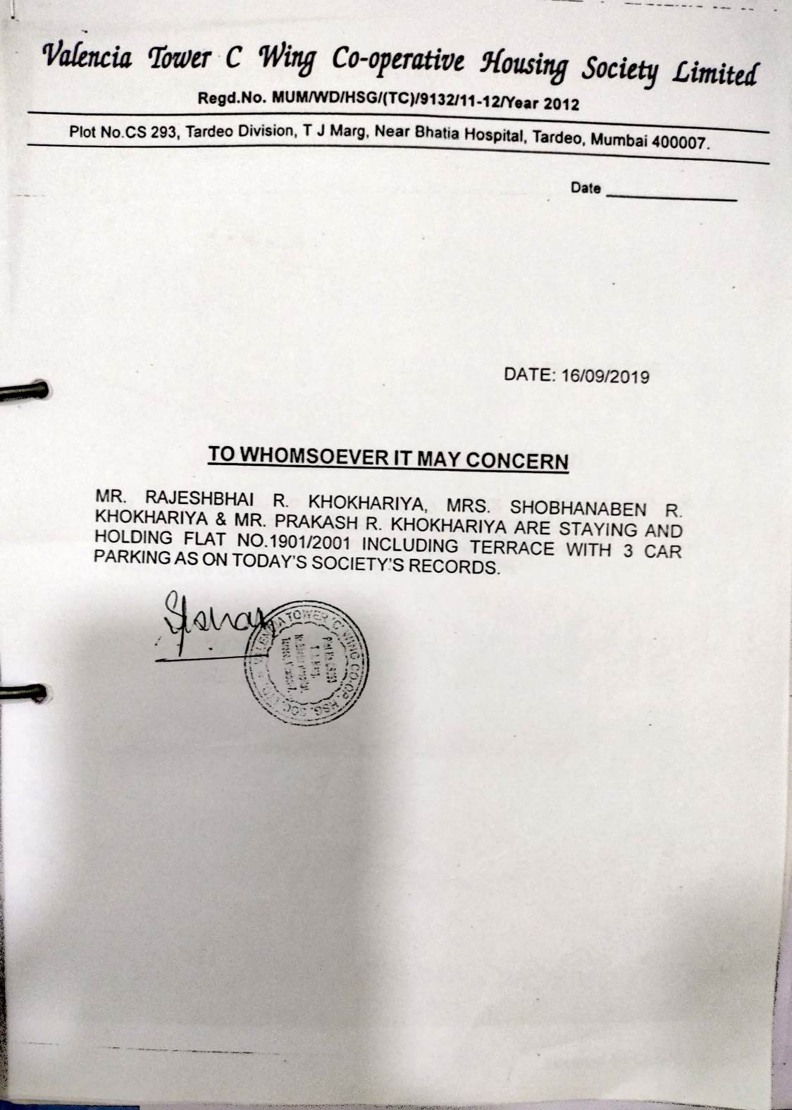

Builders NOC
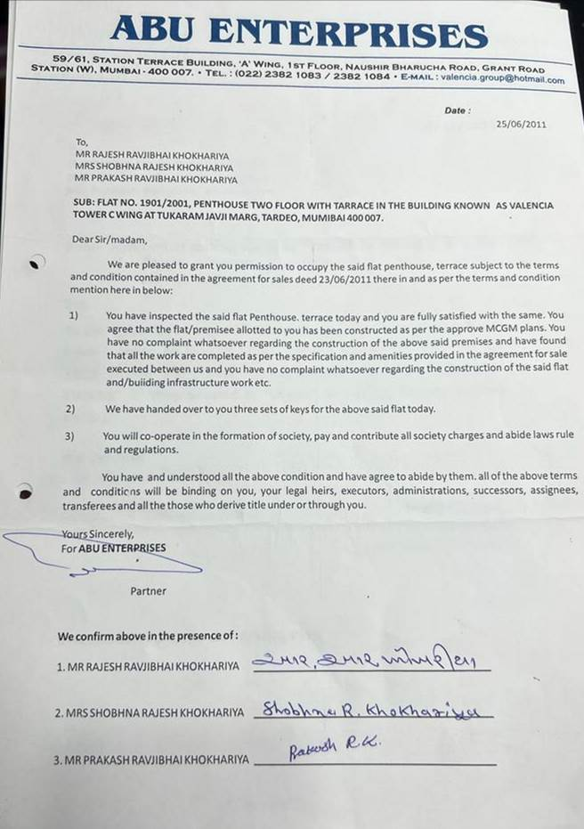

Car Parking Letter
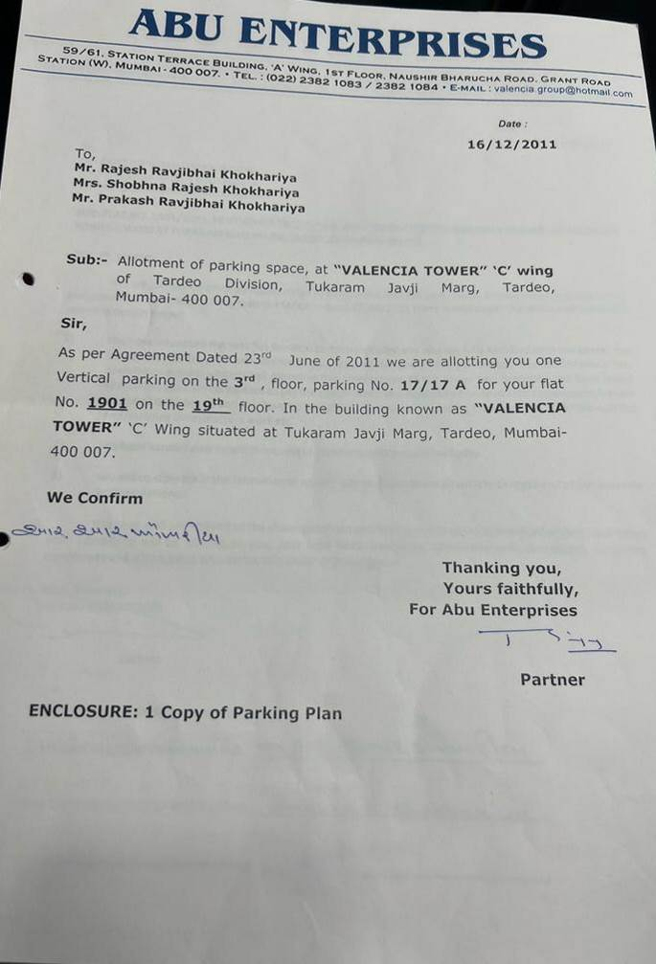

Car Parking Letter
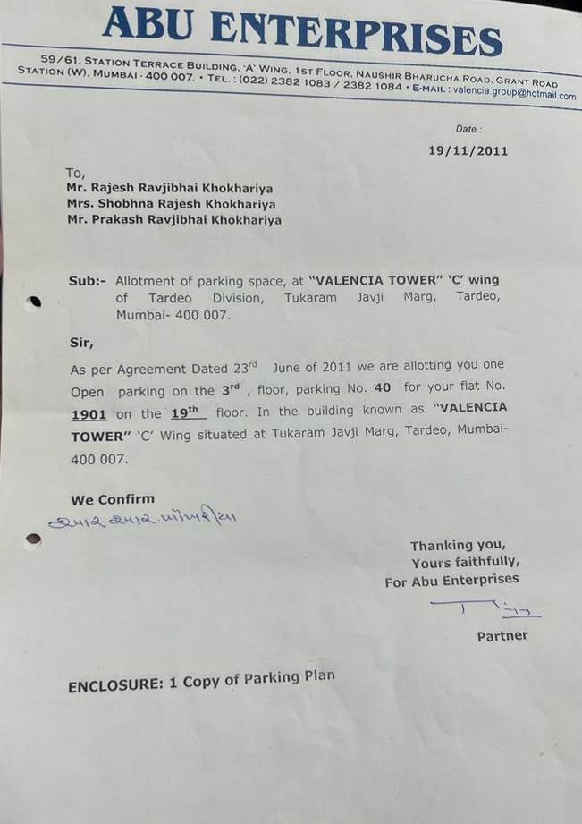

Occupancy Certificate
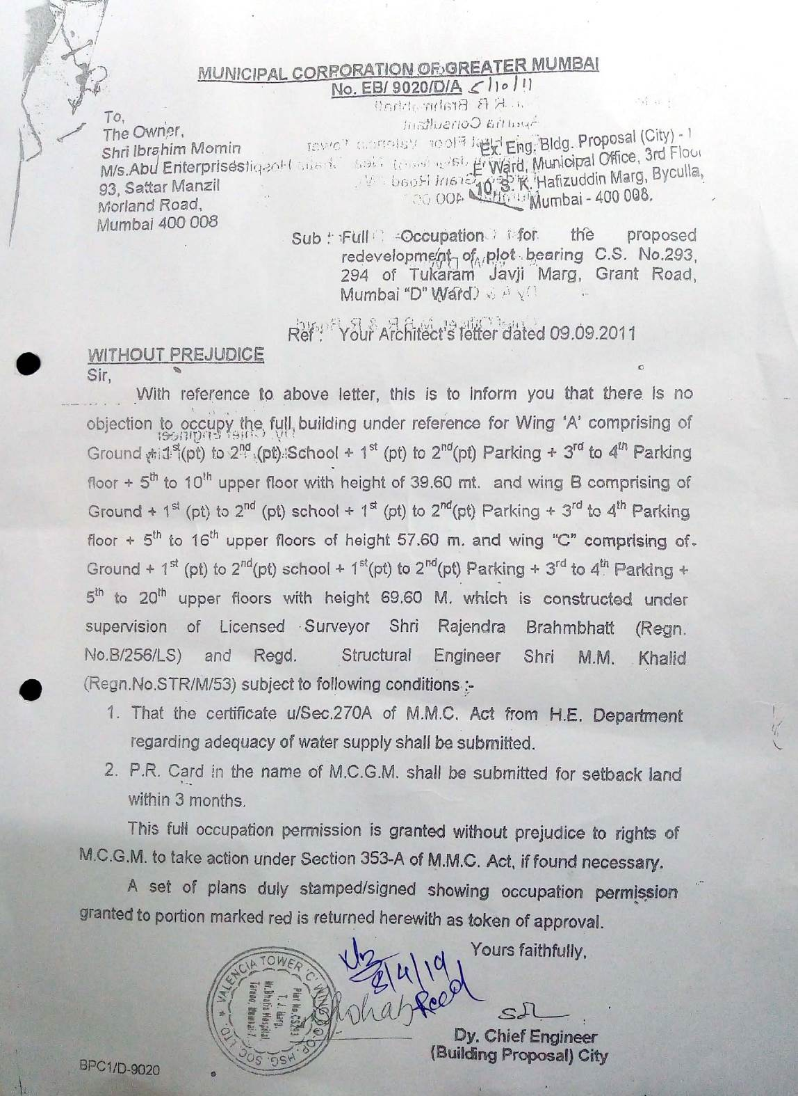

As a result of my appraisal and analysis, it is my considered opinion that of the above property in the prevailing condition with aforesaid specifications is ` 10,34,92,060.00 (Rupees Ten Crore Thirty Four Lakh Ninety Two Thousand Sixty Only). The Realizable Value of the above property is ` 9,31,42,854.00 (Rupees Nine Crore Thirty One Lakh Forty Two Thousand Eight Hundred Fifty Four Only). The Distress Value is ` 8,27,93,648.00 (Rupees Eight Crore Twenty Seven Lakh Ninety Three Thousand Six Hundred Forty Eight Only).

Place: Mumbai
Date: 20.06.2023

Manoj B. Chalikwar
Registered Valuer
Chartered Engineer (India)
Reg. No. CAT-I-F-1763
CBI Emp. No. SMRO/CREDIT/2017-18/1311

The undersigned has inspected the property detailed in the Valuation Report dated _______________________

on ____________________. We are satisfied that the fair and reasonable market value of the property is `_________________________ (Rupees ________________________________________________________

________________________________________only).

Date
Signature
(Name & Designation of the Inspecting Official/s)

Countersigned
(BRANCH MANAGER)

Enclosures
 | Declaration-cum-undertaking from the valuer (Annexure – I) | Attached
 | Model code of conduct for valuer (Annexure – II) | Attached

(Annexure – I)

DECLARATION-CUM-UNDERTAKING

I, Manoj Chalikwar son of Shri. Baburao Chalikwar do hereby solemnly affirm and state that:

- I am a citizen of India.

- I will not undertake valuation of any assets in which I have a direct or indirect interest or become so interested at any time during a period of three years prior to my appointment as valuer or three years after the valuation of assets was conducted by me.

- The information furnished in my valuation report dated 20.06.2023 is true and correct to the best of my knowledge and belief and I have made an impartial and true valuation of the property.

- I/ my authorized representative have personally inspected the property on 29.03.2023. The work is not sub - contracted to any other valuer and carried out by myself.

- Valuation report is submitted in the format as prescribed by the bank.

- I have not been depanelled / delisted by any other bank and in case any such depanelment by other banks during my empanelment with you, I will inform you within 3 days of such depanelment.

- I have not been removed / dismissed from service / employment earlier.

- I have not been convicted of any offence and sentenced to a term of imprisonment

- I have not been found guilty of misconduct in my professional capacity.

- I have not been declared to be unsound mind

- I am not an undischarged bankrupt, or has not applied to be adjudicated as a bankrupt;

- I am not an undischarged insolvent.

- I have not been levied a penalty under section 271J of Income-tax Act, 1961 (43 of 1961) and time limit for filing appeal before Commissioner of Income-tax (Appeals) or Income-tax Appellate Tribunal, as the case may be has expired, or such penalty has been confirmed by Income-tax Appellate Tribunal, and five years have not elapsed after levy of such penalty

- I have not been convicted of an offence connected with any proceeding under the Income Tax Act 1961, Wealth Tax Act 1957 or Gift Tax Act 1958 and

- My PAN Card number as applicable is AERPC9086P

- I undertake to keep you informed of any events or happenings which would make me ineligible for empanelment as a valuer

- I have not concealed or suppressed any material information, facts and records and I have made a complete and full disclosure

- I have read the Handbook on Policy, Standards and procedure for Real Estate Valuation, 2011 of the IBA and this report is in conformity to the "Standards" enshrined for valuation in the Part - B of the above handbook to the best of my ability.

- I have read the International Valuation Standards (IVS) and the report submitted to the Bank for the respective asset class is in conformity to the "Standards" as enshrined for valuation in the IVS in "General Standards" and "Asset Standards" as applicable. The valuation report is submitted in the prescribed format of the bank.

- I abide by the Model Code of Conduct for empanelment of valuer in the Bank. (Annexure V - A signed copy of same to be taken and kept along with this declaration)

- I am valuer registered with Insolvency & Bankruptcy Board of India (IBBI)

- My CIBIL Score and credit worthiness is as per Bank's guidelines.

- I am Director of the company, who is competent to sign this valuation report.

- I will undertake the valuation work on receipt of Letter of Engagement generated from the system (i.e. LLMS / LOS) only.

- Further, I hereby provide the following information.

Sr.  No. | Particulars | Valuer comment
 | background information of the asset being valued; | The property under consideration was owned by Rajesh Ravjibhai Khokhariya, Shobhna Rajesh Khokhariya & Prakash Ravjibhai Khokhariya.
 | purpose of valuation and appointing authority | As per the request from Central Bank of India, Corporate Finance Branch BKC to assess value of the property for the purpose of release of the property.
 | identity of the valuer and any other experts involved in the valuation; | Manoj B. Chalikwar – Regd. Valuer  Chandan Singh –Valuation Engineer  Vaishali Sarmalkar – Technical Manager  Shyam Kajvilkar – Technical Officer
 | disclosure of valuer interest or conflict, if any; | We have no interest, either direct or indirect, in the property valued. Further to state that we do not have relation or any connection with property owner / applicant directly or indirectly. Further to state that we are an independent Valuer and in no way related to property owner / applicant
 | date of appointment, valuation date and date of  report; | Date of Appointment – 29.03.2023  Valuation Date – 20.06.2023  Date of Report – 20.06.2023
 | inspections and/or investigations undertaken; | Physical Inspection done on 29.03.2023
 | nature and sources of the information used or relied upon; | - Market Survey at the time of site visit  - Ready Reckoner rates / Circle rates  - Online search for Registered Transactions  - Online Price Indicators on real estate portals  - Enquiries with Real estate consultants  - Existing data of Valuation assignments carried out by us
 | Procedures adopted in carrying out the valuation and valuation standards followed; | Sales Comparison Method
 | restrictions on use of the report, if any; | This valuation is for the use of the party to whom it is addressed and for no other purpose. No responsibility is accepted to any third party who may use or rely on the whole or any part of this valuation. The valuer has no pecuniary interest that would conflict with the proper valuation of the property.
 | major factors that were taken into account during the valuation; | current market conditions, demand and supply position, Residential Flat (Pent House) size, location, upswing in real estate prices, sustained demand for Residential Flat (Pent House), all round development of commercial and Commercial application in the locality etc.
 | Caveats, limitations and disclaimers to the extent they explain or elucidate the limitations faced by valuer, which shall not be for the purpose of limiting his responsibility for the valuation report. | Attached

Assumptions, Disclaimers, Limitations & Qualifications
Value Subject to Change
The subject appraisal exercise is based on prevailing market dynamics as on 20th June 2023 and does not take into account any unforeseeable developments which could impact the same in the future.
Our Investigations
We are not engaged to carry out all possible investigations in relation to the subject property. Where in our report we identify certain limitations to our investigations, this is to enable the reliant party to instruct further investigations where considered appropriate or where we recommend as necessary prior to reliance. Vastukala Consultants India Pvt. Ltd. (VCIPL) is not liable for any loss occasioned by a decision not to conduct further investigations
Assumptions
Assumptions are a necessary part of undertaking valuations. VCIPL adopts assumptions for the purpose of providing valuation advice because some matters are not capable of accurate calculations or fall outside the scope of our expertise, or out instructions. The reliant party accepts that the valuation contains certain specific assumptions and acknowledge and accept the risk of that if any of the assumptions adopted in the valuation are incorrect, then this may have an effect on the valuation.
Information Supplied by Others
The appraisal is based on the information provided by the client. The same has been assumed to be correct and has been used for appraisal exercise. Where it is stated in the report that another party has supplied information to VCIPL, this information is believed to be reliable but VCIPL can accept no responsibility if this should prove not to be so.
Future Matters
To the extent that the valuation includes any statement as to a future matter, that statement is provided as an estimate and/or opinion based on the information known to VCIPL at the date of this document. VCIPL does not warrant that such statements are accurate or correct.
Map and Plans
Any sketch, plan or map in this report is included to assist the reader while visualising the property and assume no responsibility in connection with such matters.
Site Details
Based on inputs received from Client's representative and site visit conducted, we understand that the subject property is Residential Flat (Pent House), admeasuring Carpet Area in Sq. Ft. = 1,211.00 in the name of Rajesh Ravjibhai Khokhariya, Shobhna Rajesh Khokhariya & Prakash Ravjibhai Khokhariya. Further, VCIPL has assumed that the subject property is free from any encroachment and is available as on the date of the appraisal.
Property Title
Based on our discussion with the Client, we understand that the subject property is owned by Rajesh Ravjibhai Khokhariya, Shobhna Rajesh Khokhariya & Prakash Ravjibhai Khokhariya. For the purpose of this appraisal exercise, we have assumed that the subject property has a clear title and is free from any encumbrances, disputes and claims. VCIPL has made no further enquiries with the relevant local authorities in this regard and does not certify the property as having a clear and marketable title. Further, no legal advice regarding the title and ownership of the subject property has been obtained for the purpose of this appraisal exercise. It has been assumed that the title deeds are clear and marketable.
Environmental Conditions
We have assumed that the subject property is not contaminated and is not adversely affected by any existing or proposed environmental law and any processes which are carried out on the property are regulated by environmental legislation and are properly licensed by the appropriate authorities.
Area
Based on the information provided by the Client's representative, we understand that the Residential Flat (Pent House), admeasuring Carpet Area in Sq. Ft. = 1,211.00. Condition & Repair
In the absence of any information to the contrary, we have assumed that there are no abnormal ground conditions, nor archaeological remains present which might adversely affect the current or future occupation, development or value of the property. The property is free from rat, infestation, structural or latent defect. No currently known deleterious or hazardous materials or suspect techniques will be used in the construction of or subsequent alteration or additions to the property and comments made in the property details do not purport to express an opinion about, or advise upon, the condition of uninspected parts and should not be taken as making an implied representation or statement about such parts
Valuation Methodology
For the purpose of this valuation exercise, the valuation methodology used is Direct Comparison Approach Method and proposed Current use / Exiting use premise is considered for this assignment.
The Direct Comparison Approach involves a comparison of the property being valued to similar properties that have actually been sold in arms - length transactions or are offered for sale. This approach demonstrates what buyers have historically been willing to pay (and sellers willing to accept) for similar properties in an open and competitive market and is particularly useful in estimating the value of the Flat (Pent House) and properties that are typically traded on a unit basis.
In case of inadequate recent transaction activity in the subject micro-market, the appraiser would collate details of older transactions. Subsequently, the appraiser would analyse rental / capital value trends in the subject micro-market in order to calculate the percentage increase / decrease in values since the date of the identified transactions. This percentage would then be adopted to project the current value of the same.
Where reliance has been placed upon external sources of information in applying the valuation methodologies, unless otherwise specifically instructed by Client and/or stated in the valuation, VCIPL has not independently verified that information and VCIPL does not advise nor accept it as reliable. The person or entity to whom the report is addressed acknowledges and accepts the risk that if any of the unverified information in the valuation is incorrect, then this may have an effect on the valuation.
Not a Structural Survey
We state that this is a valuation report and not a structural survey
Other
All measurements, areas and ages quoted in our report are approximate
Legal
We have not made any allowances with respect to any existing or proposed local legislation relating to taxation on realization of the sale value of the subject property. VCIPL is not required to give testimony or to appear in court by reason of this appraisal report, with reference to the property in question, unless arrangement has been made thereof. Further, no legal advice on any aspects has been obtained for the purpose of this appraisal exercise

Property specific assumptions

Based on inputs received from the client and site visit conducted, we understand that the subject property is Residential Flat (Pent House), admeasuring Carpet Area in Sq. Ft. = 1,211.00.

ASSUMPTIONS, CAVEATS, LIMITATION AND DISCLAIMERS
- We assume no responsibility for matters of legal nature affecting the property appraised or the title thereto, nor do we render our opinion as to the title, which is assumed to be good and marketable.
- The property is valued as though under responsible ownership.
- It is assumed that the property is free of liens and encumbrances.
- It is assumed that there are no hidden or unapparent conditions of the subsoil or structure that would render it more or less valuable. No responsibility is assumed for such conditions or for engineering that might be required to discover such factors.
- There is no direct/ indirect interest in the property valued.
- The rates for valuation of the property are in accordance with the Govt. approved rates and prevailing market rates.

(Annexure – II)

MODEL CODE OF CONDUCT FOR VALUERS

Integrity and Fairness
- A valuer shall, in the conduct of his/its business, follow high standards of integrity and fairness in all his/its dealings with his/its clients and other valuers.
- A valuer shall maintain integrity by being honest, straightforward, and forthright in all professional relationships.
- A valuer shall endeavour to ensure that he/it provides true and adequate information and shall not misrepresent any facts or situations.
- A valuer shall refrain from being involved in any action that would bring disrepute to the profession.
- A valuer shall keep public interest foremost while delivering his services.

Professional Competence and Due Care
- A valuer shall render at all times high standards of service, exercise due diligence, ensure proper care and exercise independent professional judgment.
- A valuer shall carry out professional services in accordance with the relevant technical and professional standards that may be specified from time to time.
- A valuer shall continuously maintain professional knowledge and skill to provide competent professional service based on up-to-date developments in practice, prevailing regulations / guidelines and techniques.
- In the preparation of a valuation report, the valuer shall not disclaim liability for his/its expertise or deny his/its duty of care, except to the extent that the assumptions are based on statements of fact provided by the company or its auditors or consultants or information available in public domain and not generated by the valuer.
- A valuer shall not carry out any instruction of the client insofar as they are incompatible with the requirements of integrity, objectivity and independence.
- A valuer shall clearly state to his client the services that he would be competent to provide and the services for which he would be relying on other valuers or professionals or for which the client can have a separate arrangement with other valuers.

Independence and Disclosure of Interest

- A valuer shall act with objectivity in his/its professional dealings by ensuring that his/its decisions are made without the presence of any bias, conflict of interest, coercion, or undue influence of any party, whether directly connected to the valuation assignment or not.
- A valuer shall not take up an assignment if he/it or any of his/its relatives or associates is not independent in terms of association to the company.
- A valuer shall maintain complete independence in his/its professional relationships and shall conduct the valuation independent of external influences.
- A valuer shall wherever necessary disclose to the clients, possible sources of conflicts of duties and interests, while providing unbiased services.
- A valuer shall not deal in securities of any subject company after any time when he/it first becomes aware of the possibility of his / its association with the valuation, and in accordance with the Securities and Exchange Board of India (Prohibition of Insider Trading)Regulations,2015 or till the time the valuation report becomes public, whichever is earlier.
- A valuer shall not indulge in "mandate snatching" or offering "convenience valuations" in order to cater to a company or client's needs.
- As an independent valuer, the valuer shall not charge success fee.
- In any fairness opinion or independent expert opinion submitted by a valuer, if there has been a prior engagement in an unconnected transaction, the valuer shall declare the association with the company during the last five years.

Confidentiality
- A valuer shall not use or divulge to other clients or any other party any confidential information about the subject company, which has come to his / its knowledge without proper and specific authority or unless there is a legal or professional right or duty to disclose.

Information Management
- A valuer shall ensure that he/ it maintains written contemporaneous records for any decision taken, the reasons for taking the decision, and the information and evidence in support of such decision. This shall be maintained so as to sufficiently enable a reasonable person to take a view on the appropriateness of his /its decisions and actions.
- A valuer shall appear, co-operate and be available for inspections and investigations carried out by the authority, any person authorised by the authority, the registered valuers organisation with which he/it is registered or any other statutory regulatory body.
- A valuer shall provide all information and records as may be required by the authority, the Tribunal, Appellate Tribunal, the registered valuers organisation with which he/it is registered, or any other statutory regulatory body.
- A valuer while respecting the confidentiality of information acquired during the course of performing professional services, shall maintain proper working papers for a period of three years or such longer period as required in its contract for a specific valuation, for production before a regulatory authority or for a peer review. In the event of a pending case before the Tribunal or Appellate Tribunal, the record shall be maintained till the disposal of the case.

Gifts and hospitality:
- A valuer or his / its relative shall not accept gifts or hospitality which undermines or affects his independence as a valuer.
Explanation: For the purposes of this code the term 'relative' shall have the same meaning as defined in clause (77) of Section 2 of the Companies Act, 2013 (18 of 2013).
- A valuer shall not offer gifts or hospitality or a financial or any other advantage to a public servant or any other person with a view to obtain or retain work for himself / itself, or to obtain or retain an advantage in the conduct of profession for himself / itself.

Remuneration and Costs.
- A valuer shall provide services for remuneration which is charged in a transparent manner, is a reasonable reflection of the work necessarily and properly undertaken, and is not inconsistent with the applicable rules.
- A valuer shall not accept any fees or charges other than those which are disclosed in a written contract with the person to whom he would be rendering service.

Occupation, employability and restrictions.
- A valuer shall refrain from accepting too many assignments, if he/it is unlikely to be able to devote adequate time to each of his/ its assignments.
- A valuer shall not conduct business which in the opinion of the authority or the registered valuer organisation discredits the profession.
Miscellaneous
- A valuer shall refrain from undertaking to review the work of another valuer of the same client except under written orders from the bank or housing finance institutions and with knowledge of the concerned valuer.
- A valuer shall follow this code as amended or revised from time to time.

Manoj B. Chalikwar
Registered Valuer
Chartered Engineer (India)
Reg. No. CAT-I-F-1763
CBI Emp. No. SMRO/CREDIT/2017-18/1311

