Vastu/Nashik/03/2023833/30490/46262
22/24-455-CCV
Date: 22.03.2023

To,
The Branch Manager
Union Bank of India
Gangapur Road Branch
Shree Ganesh Avenue, Gangapur Road,
Nashik - 422 013, State – Maharashtra, Country – India...

Sub: Vetting of Estimate

Sir,

With reference to above subject, we have evaluated the Estimate for Residential Land and Proposed Residential Land and Proposed Building on Plot No.10, Ground + Second Floor, Survey No. 45/2+3+4/1/2, Near Shri Ram Fruit Market, Samarth Nagar, Village – Makhamalabad, Taluka & District - Nashik, PIN Code – 422 004, State – Maharashtra, Country – India belongs to Shri. Manoj Rangnath Sanap & Shri. Sunil Rangnath Sanap.

We have verified the rates quoted as per current market rates. Details of work and Estimate considered as per copy of Estimate issued by Shardul Singh Design’s received on dated 20.03.2023. The estimated amount is Rs.41,00,000/- (Rupees Forty One Lakh Only)

The said Cost Vetting Certificate is valid upto next 6 months Only.

Thanking you

Sincerely yours

Sharadkumar B. Chalikwar
Govt. Reg. Valuer
Chartered Engineer (India)
Reg. No. (N) CCIT/1-14/52/2008-09

Estimate
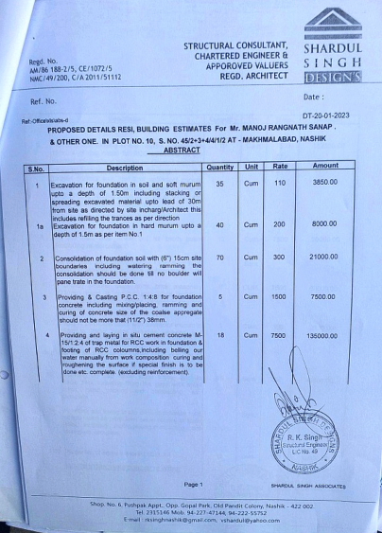
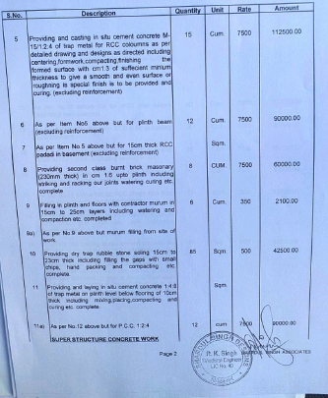

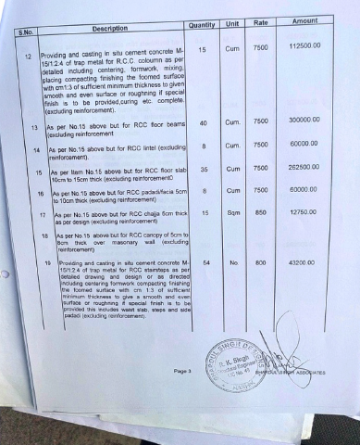
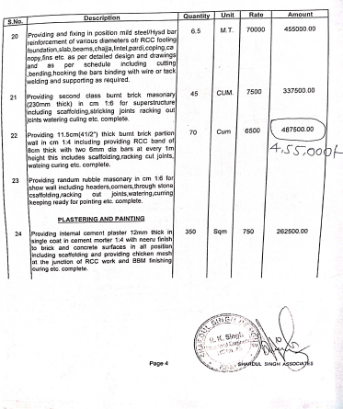

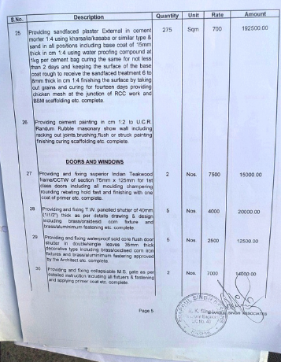
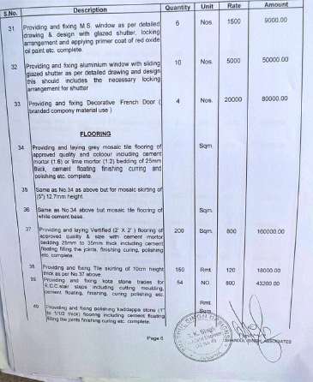

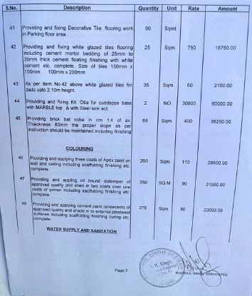
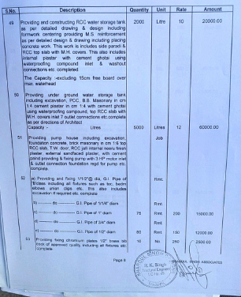

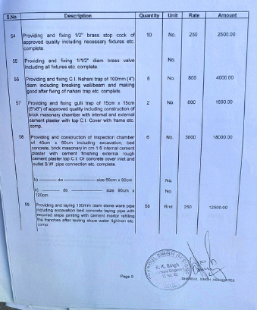
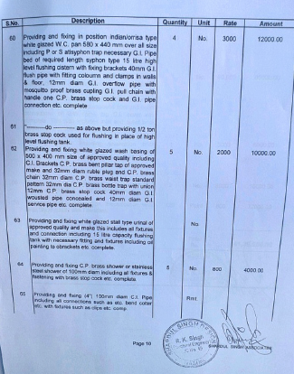

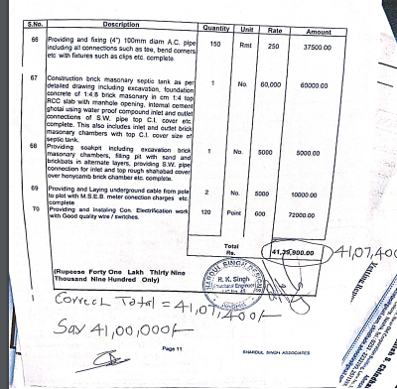

The Estimate amount is Rs.41,00,000/- (Rupees Forty One Lakh Only )

