Valuation Report of the Immovable Property
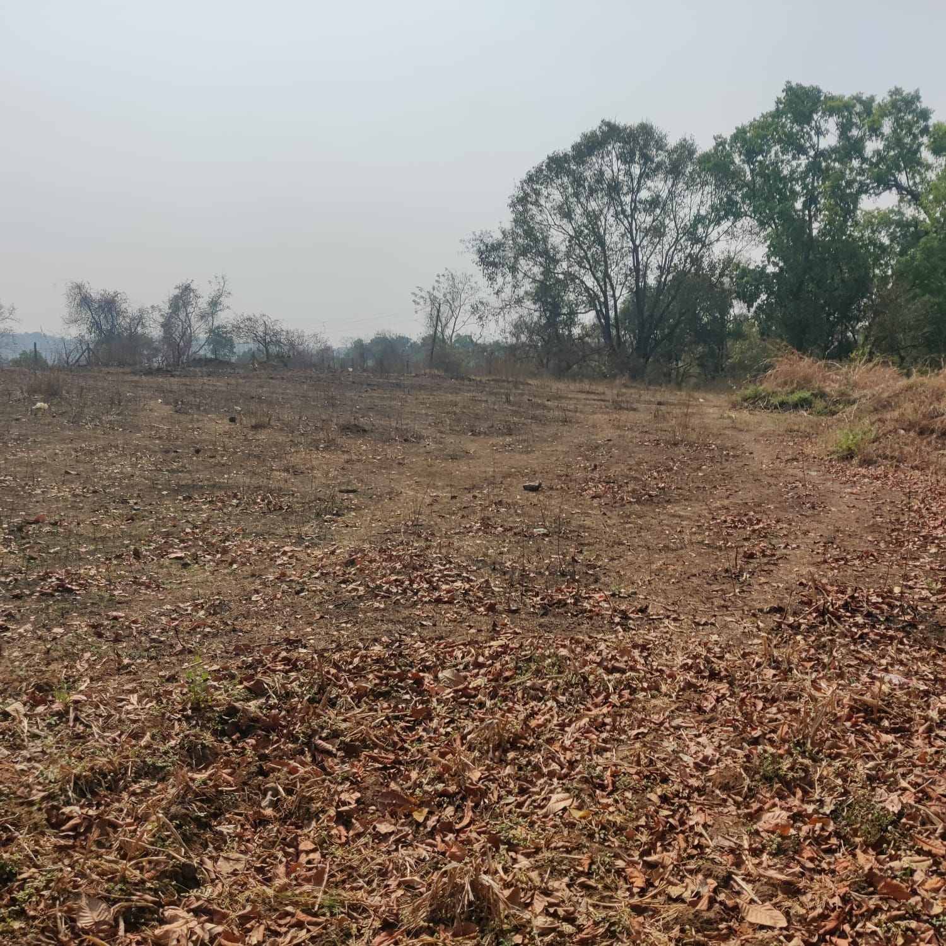

Details of the property under consideration:

Name of Owner: Poddar Housing and Development Ltd.

N.A Plot bearing Survey No.78, Hissa No. 2,4, Survey No. 9, Hissa No. 2 of Village Chamtoli, &
Survey No. 29, Hissa No. 11 A of Village Dahivali, Badlapur, Taluka – Ambernath, District – Thane,
Pin Code – 421503, State – Maharashtra, Country – India

Longitude Latitude: 19°08’06.8”N 73°15’10.3”E (For Survey No. 78, Hissa No. 2,4)

Longitude Latitude: 19°08'10.6"N 73°15'09.8"E (For Survey No. 9, Hissa No. 2)

Longitude Latitude: 19°07'56.1"N 73°14'40.2"E ( For Survey No. 29, Hissa No. 11A)

Valuation Done for:

STCI FINANCE LIMITED
A/B 1-802, A Wing, 8th Floor, Marathon Innova, Marathon Nextgen Compound,
Off. Ganpatrao Kadam Marg, Lower Parel (West), Mumbai – 400 013,
State – Maharashtra, Country – India

INDEX
1. VALUATION OPINION REPORT 3
2. VALUATION REPORT (IN RESPECT OF LAND) 4
3. TOTAL ABSTRACT OF THE ENTIRE PROPERTY 10
4. ACTUAL SITE PHOTOGRAPHS 11
5. ROUTE MAP OF THE PROPERTY 14
(Land Bearing Survey No. 78 & Hissa No. 2,4) 14
6. ROUTE MAP OF THE PROPERTY 15
(Land Bearing Survey No. 9 & Hissa No. 2) 15
7. ROUTE MAP OF THE PROPERTY 16
(Land Bearing Survey No. 29 & Hissa No. 11A) 16
8. READY RECKONER RATE 17
9. JUSTIFICATION FOR PRICE /RATE 18
10. PRICE INDICATORS 19
11. DECLARATION-CUM-UNDERTAKING 21
12. ASSUMPTIONS, DISCLAIMERS, LIMITATIONS & QUALIFICATIONS 23
13. ASSUMPTIONS, CAVEATS, LIMITATION AND DISCLAIMERS 25
14. DEFINITION OF VALUE FOR THIS SPECIFIC PURPOSE 26

This report contains total 26 pages

Vastu/Mumbai/03/2023/30369/46113
16/25-307-PY
Date: 16.03.2023

VALUATION OPINION REPORT

This is to certify that the property bearing N.A Plot bearing Survey No.78, Hissa No. 2,4, Survey No. 9, Hissa No. 2 of Village Chamtoli, & Survey No. 29, Hissa No. 11 A of Village Dahivali, Badlapur, Taluka – Ambernath, District – Thane, Pin Code – 421503, State – Maharashtra, Country – India belongs to M/s. Poddar Housing and Development Ltd.

Boundaries of the property.

Particulars | Survey No.78, Hissa No. 2,4, | Survey No. 9, Hissa No. 2 | Survey No. 29, Hissa No. 11 A
North | River | Road / Poddar Samruddhi Complex | Chawls
South | Open Plot | Open Plot | Open Plot
East | Open Plot | Open Plot | Open Plot
West | River | Open Plot | Open Plot / Road

Considering various parameters recorded, existing economic scenario, and the information that is available with reference to the development of neighborhood and method selected for valuation, we are of the opinion that, the property premises can be assessed and Fair Market Value for this particular purpose at ` 14,18,40,000.00 (Rupees Fourteen Crore Eighteen Lakh Forty Thousand Only).

The valuation of the property is based on the documents produced by the concern. Legal aspects have not been taken into considerations while preparing this valuation report.

Hence certified

Manoj B. Chalikwar
Registered Valuer
Chartered Engineer (India)
Reg. No. IBBI/RV/07/2018/10366
Valuation Report: Enclosed

Vastukala Consultants (I) Pvt. Ltd.
121, 1st Floor, Ackruti Star, Central Road, MIDC, Andheri (E), Mumbai - 400 093

To,
The Branch Manager,
STCI FINANCE LIMITED
A/B 1-802, A Wing,
8th Floor, Marathon Innova,
Marathon Nextgen Compound,
Off. Ganpatrao Kadam Marg,
Lower Parel (West), Mumbai – 400 013,
State – Maharashtra, Country – India

VALUATION REPORT (IN RESPECT OF LAND)

I | General
1. | Purpose for which the valuation is made |  |  |  | : | As per the request from STCI Finance Limited, Lower Parel (West) to assess Fair market value of the property for banking purpose.
2. | a) | Date of inspection |  |  | : | 10.03.2023
 | b) | Date on which the valuation is made |  |  | : | 16.03.2023
3. | List of documents produced for perusal
- Copy of Deed of Sale dated 11.04.2018 of Survey No. 78, Hissa No. 2 of Village Chamtoli in the name of Poddar Housing and Development Ltd.
- Copy of Deed of Sale dated 10.04.2018 of Survey No. 78, Hissa No. 4 of Village Chamtoli in the name of Poddar Housing and Development Ltd.
- Copy of Deed of Sale dated 28.04.2014 of Survey No. 9, Hissa No. 2 of Village Chamtoli in the name of Poddar Housing and Development Ltd.
- Copy of Deed of Sale dated 09.09.2020 of Survey No. 29, Hissa No. 11A in of Village Dahivali the name of Poddar Housing and Development Ltd.
- Copy of Previous Valuation Report dated 11.01.2018 issued by G. H. Jagtap for Survey No. 78, Hissa No. 2 of Village Chamtoli.
- Copy of Previous Valuation Report dated 08.02.2018 issued by G. H. Jagtap Survey No. 78, Hissa No. 4 of Village Chamtoli.
- Copy of N.A. Order No. MH / MR / South – 344 / 2014 -16 dated 22.12.1936
- Copy of Work Order Ref. No. CL / PHDL / Valuation / 2021-22 / 456 dated 16.11.2021
4. | Name of the owner(s) and his / their address (es) with Phone no. (details of share of each owner in case of joint ownership) |  |  |  | : | M/s. Poddar Housing and Development Ltd  Address: N.A Plot bearing Survey No.78, Hissa No. 2,4, Survey No. 9, Hissa No. 2 of Village Chamtoli, & Survey No. 29, Hissa No. 11 A of Village Dahivali, Badlapur, Taluka – Ambernath, District – Thane, Pin Code – 421503, State – Maharashtra, Country – India.  Contact Person –  Mr. Savan Patil – Project Manager  Contact No. +91 – 9324730796  Company Ownership
5. | Brief description of the property (Including Leasehold / freehold etc.):
Land 1:
For Land Bearing Survey No.78, Hissa No. 2,4 of Village Chamtoli. It is located at about 5.3 KM. travelling distance from Badlapur Railway Station.
Land 2:
For Survey No. 9, Hissa No. 2 of Village Chamtoli It is located at about 5.3 KM. travelling distance from Badlapur Railway Station.
Land 3:
For Survey No. 29, Hissa No. 11 A of Village Dahivali is located at about 6.5 KM. travelling distance from Badlapur Railway Station.

The properties are located in a developing area. The immovable property comprises of freehold non - agricultural land. The lands are non – contiguous and having individual road access.

LAND AREA: -
As per Sale Deeds, the Land area is as below and considered for the purpose of Valuation
Particulars | Area in Sq. M. | Handover area in Sq. M. | Net Area in Sq. M.
Survey No. 78, Hissa No. 2 of Village Chamtoli | 2,930.00 | 2,023.00 | 907.00
Survey No. 78, Hissa No. 4 of Village Chamtoli | 4,970.00 | 1,993.00 | 2,977.00
Survey No. 9, Hissa No. 2 of Village Chamtoli | 6,300.00 | - | 4,000.00
Survey No. 29, Hissa No. 11 A of Village Dahivali | 4,000.00 | - | 6,300.00
Total Land Area | 18,200.00 | 4,016.00 | 14,184.00
Hence, for the valuation purpose we have taken land net area as 14,184.00 Sq. M. as per Sale Deed.

Remarks: - At the time of site inspection, vegetation was grown on plot.
6. | Location of property |  |  |  | :
 | a) | Plot No. / Survey No. |  |  | : | Survey No.78, Hissa No. 2,4, Survey No. 9, Hissa No. 2 of Village Chamtoli, & Survey No. 29, Hissa No. 11 A of Village Dahivali.
 | b) | Door No. |  |  | : | Not applicable
 | c) | C.T.S. No. / Village |  |  | : | Village Chamtoli & Dahivali
 | d) | Ward / Taluka |  |  | : | Taluka Ambernath
 | e) | Mandal / District |  |  | : | District Thane
7. | Postal address of the property |  |  |  | : | N.A Plot bearing Survey No.78, Hissa No. 2,4, Survey No. 9, Hissa No. 2 of Village Chamtoli, & Survey No. 29, Hissa No. 11 A of Village Dahivali, Badlapur, Taluka – Ambernath, District – Thane, Pin Code – 421503, State – Maharashtra, Country – India, State – Maharashtra, Country – India
8. | City / Town |  |  |  | : | Town
 | Residential area |  |  |  | : | Yes
 | Commercial area |  |  |  | : | No
 | Industrial area |  |  |  | : | No
9. | Classification of the area |  |  |  | :
 | i) High / Middle / Poor |  |  |  | : | Middle Class
 | ii) Urban / Semi Urban / Rural |  |  |  | : | Semi – Urban
10. | Coming under Corporation limit / Village Panchayat / Municipality |  |  |  | : | Chamtoli Gram Panchayat  Dahivali Gram Panchayat
11. | Whether covered under any State / Central Govt. enactments (e.g., Urban Land Ceiling Act) or notified under agency area/ scheduled area / cantonment area |  |  |  | : | No
12. | In Case it is Agricultural land, any conversion to house site plots is contemplated |  |  |  | : | N.A.
13. | Boundaries of the property
 | Particulars |  | North | South |  |  | East |  | West
 | As per Sale Deeds
 | Survey No. 78/2 |  | Survey No.78/1 | Survey No. 78/2 |  |  | Nallah |  | Nallah
 | Survey No. 78/4 |  | Survey No.78/2 | Survey No. 78/5 |  |  | Survey No. 79/0 |  | Nallah
 | Survey No. 9/2 |  | Survey No. 78/5 | Survey No. 2/1 & 2 |  |  | Survey No. 81/1 |  | Nallah and Village Boundary
 | Survey No. 29/11A |  | Survey No. 29/20 | Survey No. 2/1 & 2 |  |  | Survey No. 29/10 |  | Survey No. 29/16
 | As per Site Visit
 | Particulars |  | North | South |  |  | East |  | West
 | Survey No. 78/2 |  | River | Open Plot |  |  | Open Plot |  | River
 | Survey No. 78/4 |  | River | Open Plot |  |  | Open Plot |  | River
 | Survey No. 9/2 |  | Road / Poddar Samruddhi Complex | Open Plot |  |  | Open Plot |  | Open Plot
 | Survey No. 29/11A |  | Chawls | Open Plot |  |  | Open Plot |  | Open Plot / Road
14.1 | Dimensions of the site |  |  |  |  | N. A. as the plot under consideration is irregular in shape.
 |  |  |  |  |  | A As per the Deed |  | B Actuals
 | North |  |  |  | : | - |  | -
 | South |  |  |  | : | - |  | -
 | East |  |  |  | : | - |  | -
 | West |  |  |  | : | - |  | -
14.2 | Latitude, Longitude & Co-ordinates of property |  |  |  | : | Longitude Latitude: 19°08’06.8”N 73°15’10.3”E  (For Survey No. 78, Hissa No. 2,4)  Longitude Latitude: 19°08'10.6"N 73°15'09.8"E  (For Survey No. 9, Hissa No. 2)  Longitude Latitude: 19°07'56.1"N 73°14'40.2"E  (For Survey No. 29, Hissa No. 11A)
14. | Extent of the site |  |  |  | : | Total Plot area = 14,184.00 Sq. M.  (Area as per Sale Deed)
15. | Extent of the site considered for Valuation (least of 14A& 14B) |  |  |  | :
16 | Whether occupied by the owner / tenant? If occupied by tenant since how long? Rent received per month. |  |  |  | : | Owner Occupied
II | CHARACTERSTICS OF THE SITE
 | Classification of locality |  |  |  | : | Middle class
 | Development of surrounding areas |  |  |  | : | Good
 | Possibility of frequent flooding/ sub-merging |  |  |  | : | No
 | Feasibility to the Civic amenities like School, Hospital, Bus Stop, Market etc. |  |  |  | : | All available near by
 | Level of land with topographical conditions |  |  |  | : | Plain
 | Shape of land |  |  |  | : | Irregular Shape
 | Type of use to which it can be put |  |  |  | : | Non-Agricultural Land
 | Any usage restriction |  |  |  | : | N.A.
 | Is plot in town planning approved layout? |  |  |  | : | N.A.
 | Corner plot or intermittent plot? |  |  |  | : | Intermittent
 | Road facilities |  |  |  | : | Yes
 | Type of road available at present |  |  |  | : | Water Bound Macadam Road
 | Width of road – is it below 20 ft. or more than 20 ft. |  |  |  | : | Water Bound Macadam Road
 | Is it a Land – Locked land? |  |  |  | : | No
 | Water potentiality |  |  |  | : | Connected to Municipal Supply Line
 | Underground sewerage system |  |  |  | : | Connected to Municipal Supply Line
 | Is Power supply is available in the site |  |  |  | : | Yes
 | Advantages of the site |  |  |  | : | Located in developing area
 | Special remarks, if any like threat of acquisition of land for publics service purposes, road widening or applicability of CRZ provisions etc. (Distance from sea-cost / tidal level must be incorporated) |  |  |  | : | No
Part – A (Valuation of land)
1 | Size of plot |  |  |  | : | Total Plot area = 14,184.00 Sq. M.  (Area as per Sale Deed)
 | North & South |  |  |  | : | -
 | East & West |  |  |  | : | -
2 | Total extent of the plot |  |  |  | : | Total Plot area = 14,184.00 Sq. M.  (Area as per Sale Deed)
3 | Prevailing market rate (Along With details / reference of at least two latest deals / transactions with respect to adjacent properties in the areas) |  |  |  | : | ` 9,000.00 to ` 11,000.00 per Sq. M.  Details of recent transactions/online listings are attached with the report.
4 | Guideline rate obtained from the Circle Rate for Land |  |  |  | : | For Chamtoli Village - ` 1100.00 Sq. M.  For Dahivali. Village - ` 850.00 Sq. M.
 | In case of variation of 20% or more in the valuation proposed by the valuer and the Guideline value provided in the State Govt. notification or Income Tax Gazette justification on variation has to be given. |  |  |  | : | It is a foregone conclusion that market value is always more than RR prices. As the RR rates are fixed by respective state governments for computing stamp duty / regn. Fees. Thus, the rates differ from place to place and location. Amenities per se as evident from the fact that even RR rates decided by Govt. differ.
5 | Assessed / adopted rate of valuation |  |  |  | : | ` 10,000.00 per Sq. M.
6 | Estimated value of land |  |  |  | : | ` 14,18,40,000.00
Part – B (Valuation of Building)
1 | Technical details of the building |  |  |  | :
 | - Type of Building (Residential / Commercial / Industrial) |  |  |  | : | N.A. Plot
 | - Type of construction (Load bearing / RCC / Steel Framed) |  |  |  | : | N.A.
 | - Year of construction |  |  |  | : | N.A.
 | - Number of floors and height of each floor including basement, if any |  |  |  | : | N.A.
 | - Plinth area floor-wise |  |  |  | :
 | - Condition of the building |  |  |  | :
 | - Exterior – Excellent, Good, Normal, Poor |  |  |  | : | N.A.
 | - Interior – Excellent, Good, Normal, Poor |  |  |  | : | N.A.
 | - Date of issue and validity of layout of approved map |  |  |  | :
 | - Approved map / plan issuing authority |  |  |  | :
 | - Whether genuineness or authenticity of approved map / plan is verified |  |  |  | : | N.A.
 | - Any other comments by our empanelled valuers on authentic of approved plan |  |  |  | : | No

Specifications of construction (floor-wise) in respect of

Sr.  No. | Description
 | Foundation | : | N.A.
 | Basement | : | No
 | Superstructure | : | N.A.
 | Joinery / Doors & Windows (Please furnish details about size of frames, shutters, glazing, fitting etc. and specify the species of timber | : | N.A.
 | RCC Works | : | N.A.
 | Plastering | : | N.A.
 | Flooring, Skirting, dado | : | N.A.
 | Special finish as marble, granite, wooden paneling, grills etc. | : | No
 | Roofing including weatherproof course | : | N.A.
 | Drainage | : | N.A.

2. | Compound Wall | :
 | Height | : | N.A.
 | Length | : | N.A.
 | Type of construction | : | N.A.

3. | Electrical installation | :
 | Type of wiring | : | N.A.
 | Class of fittings (superior / ordinary / poor) | : | N.A.
 | Number of light points | : | N.A.
 | Fan points | : | N.A.
 | Spare plug points | : | N.A.
 | Any other item | : | -

4. | Plumbing installation
 | - No. of water closets and their type | : | N.A.
 | - No. of wash basins | : | N.A.
 | - No. of urinals | : | N.A.
 | - No. of bath tubs | : | N.A.
 | - Water meters, taps etc. | : | N.A.
 | - Any other fixtures | : | N.A.

Part – C (Extra Items) |  | : | Amount in `
 | Portico | : | N.A.
 | Ornamental front door | :
 | Sit out / Verandah with steel grills | :
 | Overhead water tank | :
 | Extra steel / collapsible gates | :
 | Total
Part – D (Amenities) |  | : | Amount in `
 | Wardrobes | : | N.A.
 | Glazed tiles | :
 | Extra sinks and bath tub | :
 | Marble / ceramic tiles flooring | :
 | Interior decorations | :
 | Architectural elevation works
 | Paneling works
 | Aluminum works
 | Aluminum handrails
 | False ceiling
 | Total
Part – E (Miscellaneous) |  | : | Amount in `
 | Separate toilet room | : | N.A.
 | Separate lumber room | :
 | Separate water tank / sump | :
 | Trees, gardening | :
 | Total
Part – F (Services) |  | : | Amount in `
 | Water supply arrangements | :
 | Drainage arrangements | :
 | Compound wall | :
 | C.B. deposits, fittings etc. | :
 | Pavement
 | Total

Government Value

Particulars | Area in Sq. M. | Rate in ` | Value in `
Survey No. 78, Hissa No. 2 | 907.00 | 1100.00 | 9,97,700.00
Survey No. 78, Hissa No. 4 | 2,977.00 | 1100.00 | 32,74,700.00
Survey No. 9, Hissa No. 2 | 4,000.00 | 1100.00 | 44,00,000.00
Survey No. 29, Hissa No. 11A | 6,300.00 | 850.00 | 53,55,000.00
Total Land Area | 14,184.00 |  | 1,40,27,400.00

Market Value

Particulars | Area in Sq. M. | Rate in ` | Value in `
Survey No. 78, Hissa No. 2 | 907.00 | 10,000.00 | 90,70,000.00
Survey No. 78, Hissa No. 4 | 2,977.00 | 10,000.00 | 2,97,70,000.00
Survey No. 9, Hissa No. 2 | 4,000.00 | 10,000.00 | 4,00,00,000.00
Survey No. 29, Hissa No. 11A | 6,300.00 | 10,000.00 | 6,30,00,000.00
Total Land Area | 14,184.00 |  | 14,18,40,000.00

TOTAL ABSTRACT OF THE ENTIRE PROPERTY

Part – A | Land | : | ` 14,18,40,000.00
Part – B | Building | :
Part – C | Compound wall | :
Part – D | Amenities | :
Part – E | Pavement | :
Part – F | Services | :
 | Total Fair Market Value | : | ` 14,18,40,000.00
 | Total Realizable value | : | ` 12,76,56,000.00
 | Total Distress value | : | ` 11,34,72,000.00
Remarks | - For the purpose of valuation, we have considered the land area as per Sale Deed.  - At the time of site inspection, vegetation was grown on land.

The cost approach is a Real Property Valuation method which considers the value of a property as the cost of the land plus the replacement cost of the building (construction costs) minus the physical and functional depreciation.
This approach is most commonly used for real estate properties that are not easily sold like schools, hospitals, government buildings and above type of property.
Land cost can be estimated using the Sales Comparison Approach by studying recent sales of land close to the subject property, and these sales should be comparable in size and location with subject property.
As the property is a Non-Agricultural land, we have adopted Cost approach for the purpose of valuation. The Price for similar type of property in the nearby vicinity is in the range of ` 9,000.00 to ` 11,000.00 per Sq. M. for land Considering the rate with attached report, current market conditions, demand and supply position, Land size, location, sustained demand for Non-Agricultural / Plot, all round development of commercial and industrial application in the locality etc. We estimate ` 10,000.00 per Sq. M. for Land with appropriate cost of construction for valuation.

The saleability of the property is: Normal
Likely rental values in future in: N.A.
Any likely income it may generate: N.A.

ACTUAL SITE PHOTOGRAPHS
(Land Beraing Survey No. 78 & Hissa No. 2,4)
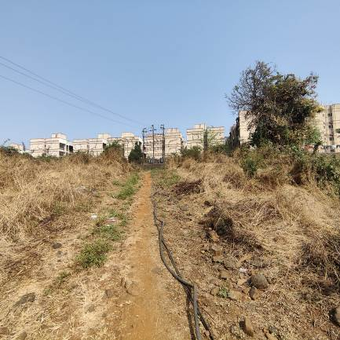
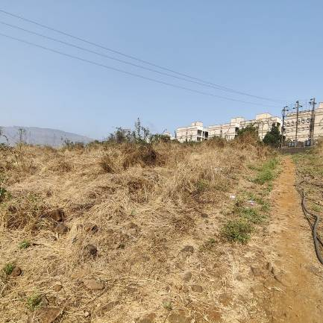

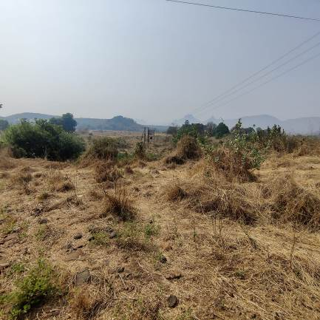
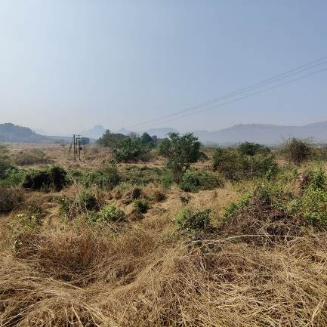
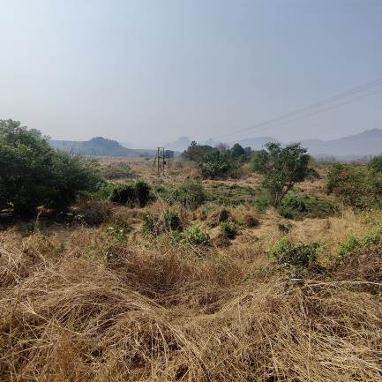
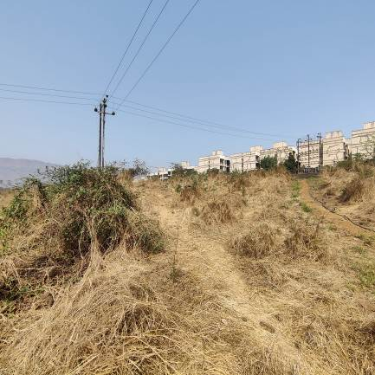

ACTUAL SITE PHOTOGRAPHS
(Land Beraing Survey No. 9 & Hissa No. 2)
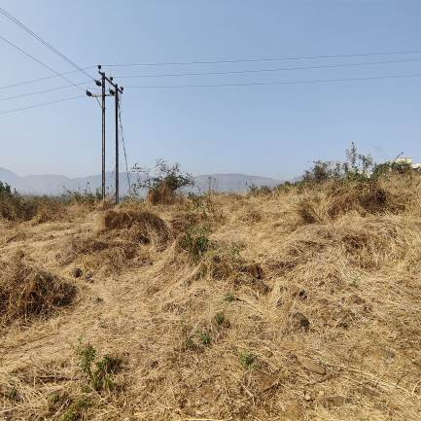
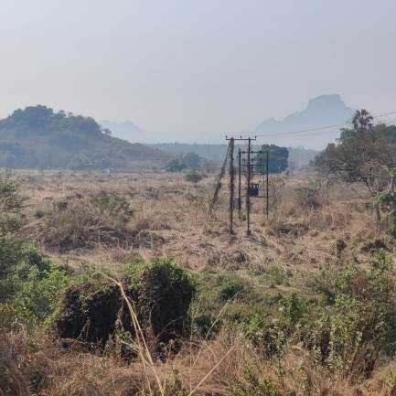
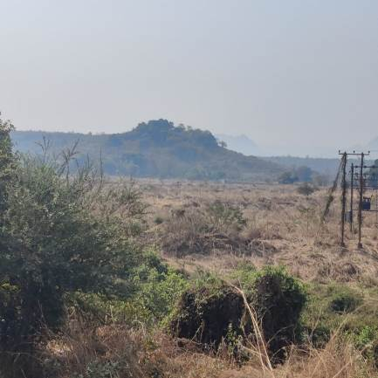
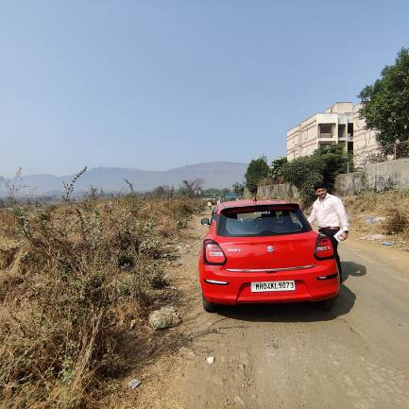

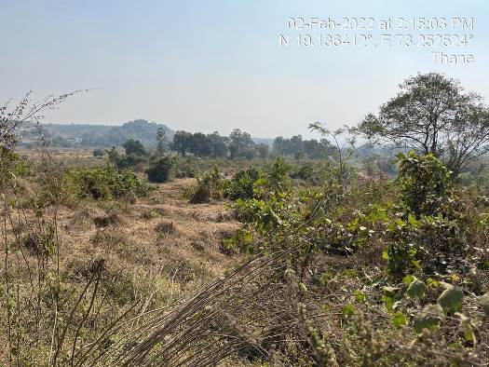

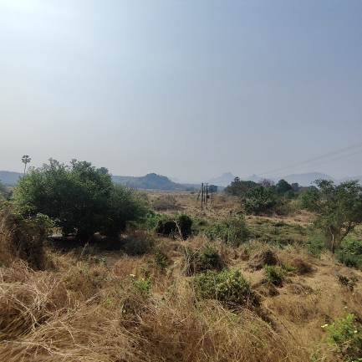



ACTUAL SITE PHOTOGRAPHS
(Land Beraing Survey No. 29 & Hissa No. 11A)
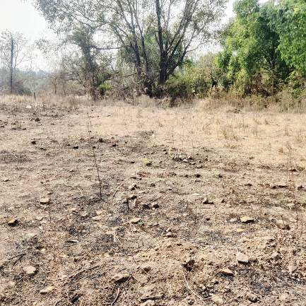
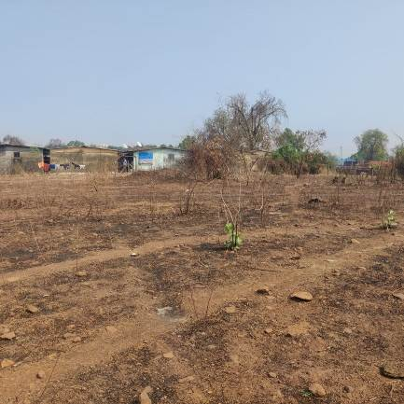
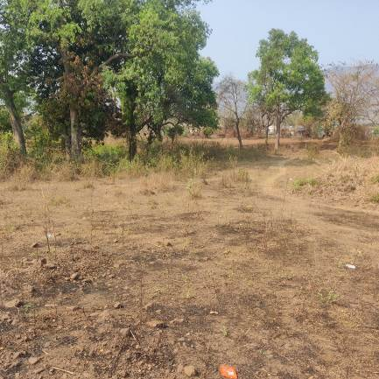
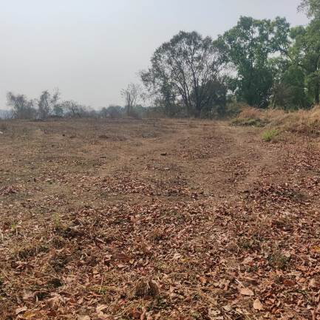

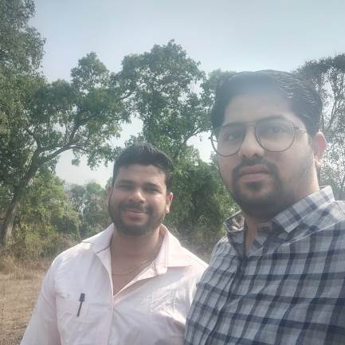

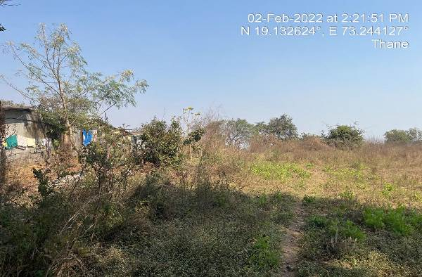

ROUTE MAP OF THE PROPERTY

(Land Bearing Survey No. 78 & Hissa No. 2,4)
Site u/r
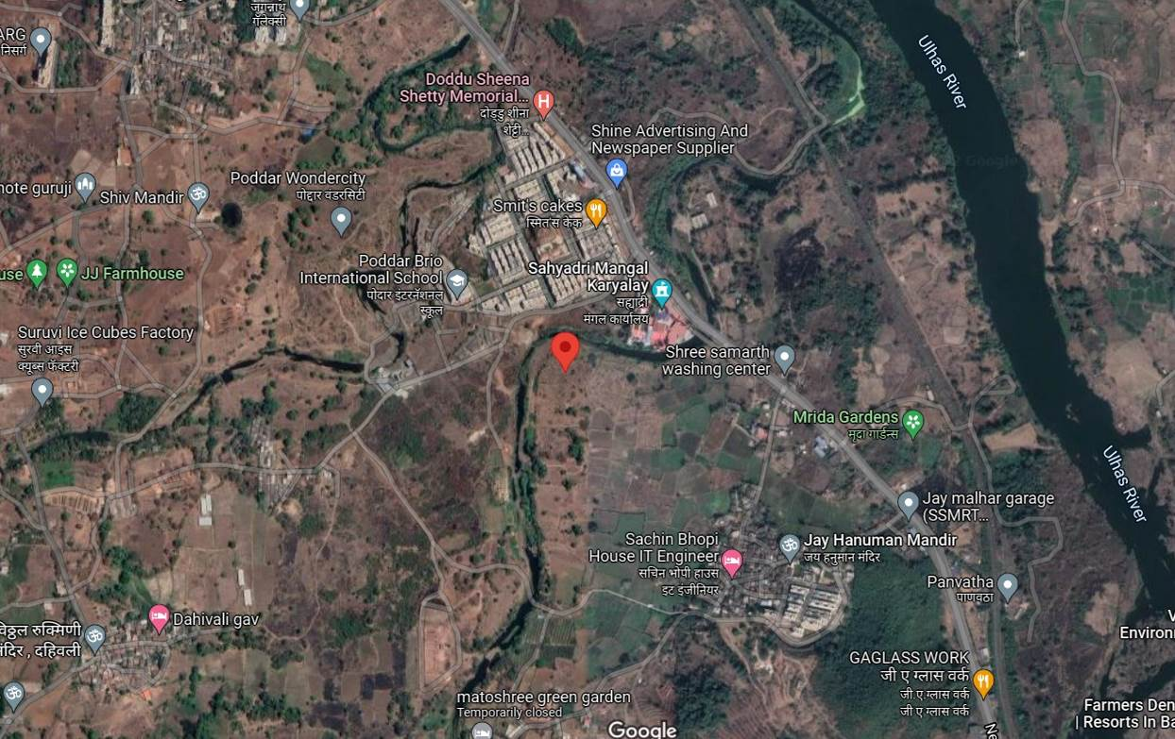

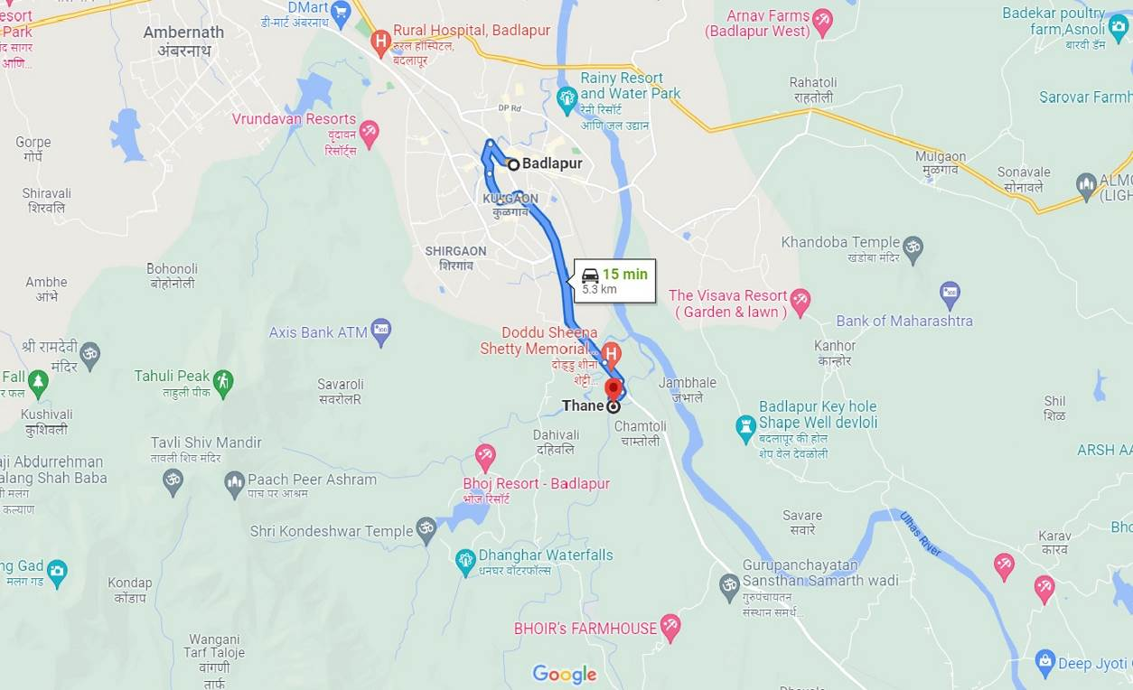

Longitude Latitude: 19°08’06.8”N 73°15’10.3”E
Note: The Blue line shows the route to site from nearest railway station (Badlapur – 5.3 Km.)

ROUTE MAP OF THE PROPERTY

(Land Bearing Survey No. 9 & Hissa No. 2)
Site u/r
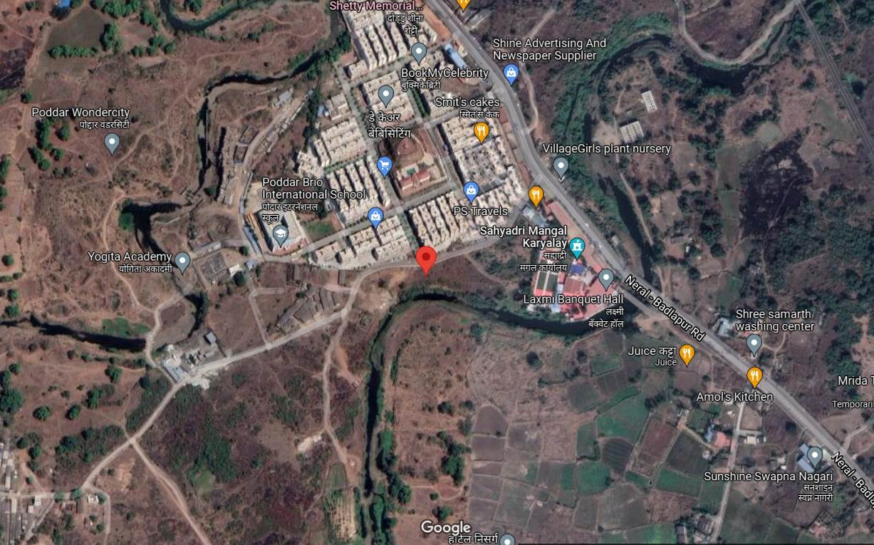

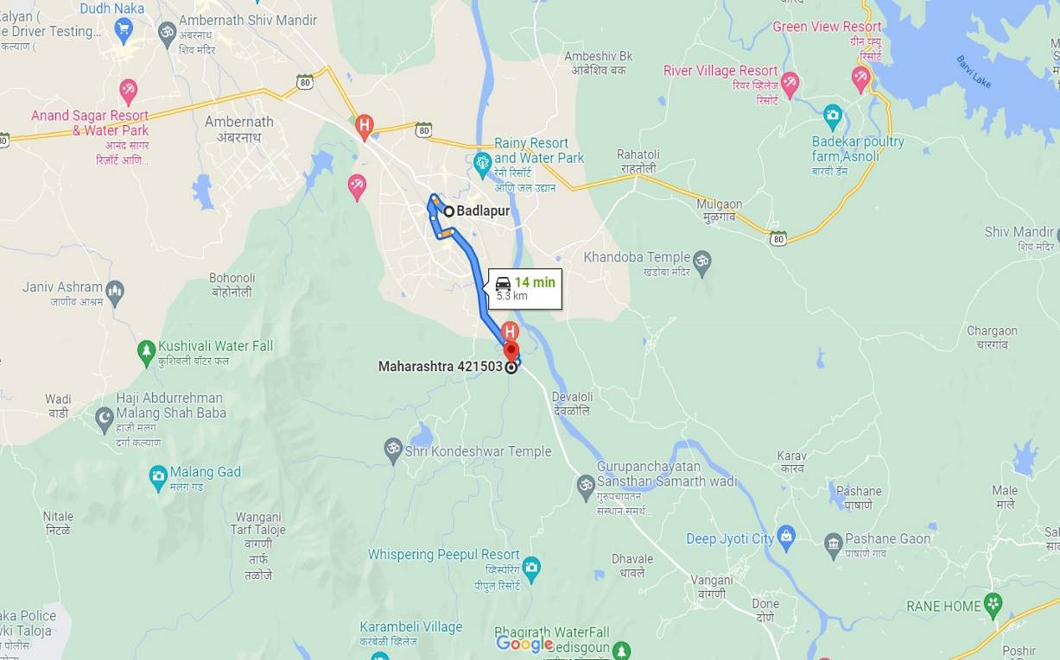

Longitude Latitude: 19°08'10.6"N 73°15'09.8"E
Note: The Blue line shows the route to site from nearest railway station (Badlapur – 5.3 Km.)

ROUTE MAP OF THE PROPERTY

(Land Bearing Survey No. 29 & Hissa No. 11A)
Site u/r
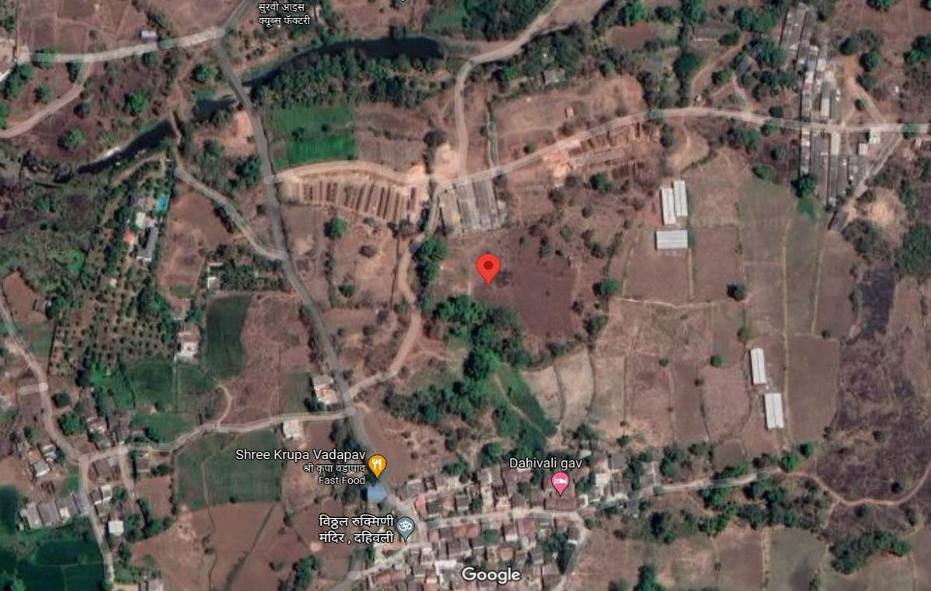

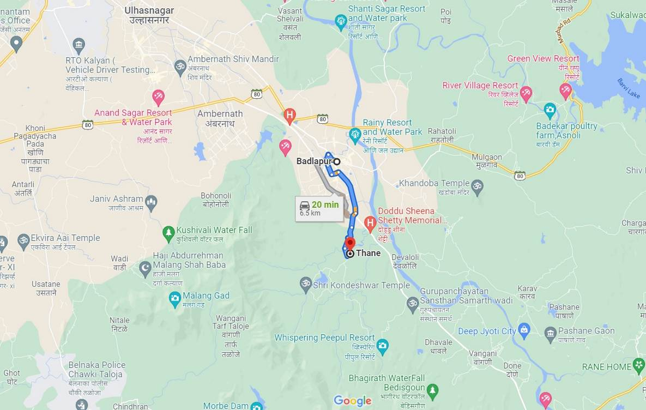

Longitude Latitude: 19°07'56.1"N 73°14'40.2"E
Note: The Blue line shows the route to site from nearest railway station (Badlapur – 6.5 Km.)

READY RECKONER RATE
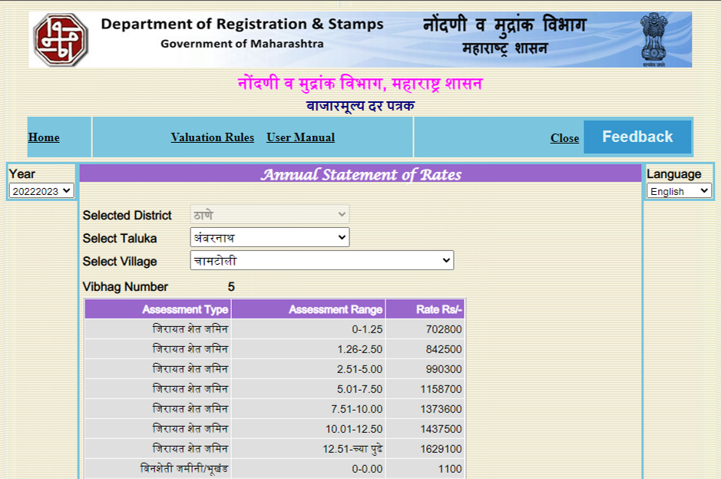

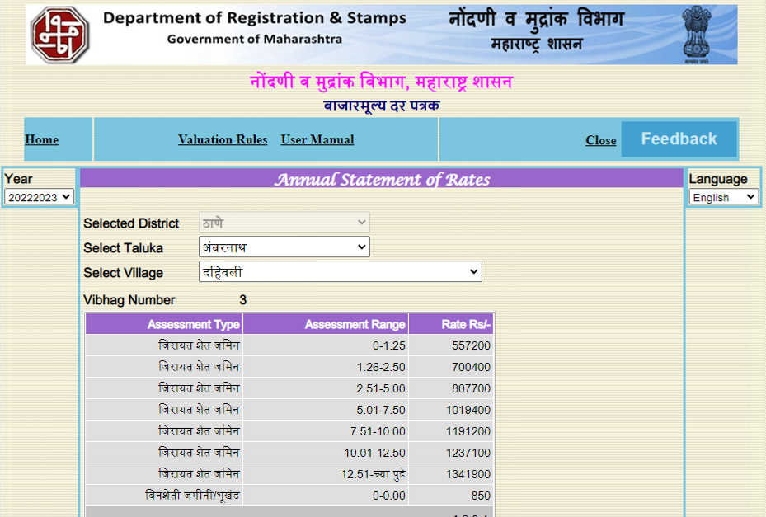

JUSTIFICATION FOR PRICE /RATE

The Market Value of the property is based on facts of markets discovered by us during our enquiries, however the government rate value in this case is less than the market value arrived by us. We are of the opinion that the value arrive by us will prove to be correct if an Auction of the subject property is carried out. As far as Market Value in Index II / Property Documents is concerned, it is not possible to comment on same, may be government rates are fixed by sampling during same point of time in part and whereas, Market values change every month.
In most of the cases the actual deal amount or Transaction value is not reflected in Index II / Property Documents because of various Market practices. As Valuer, we always try to give a value which is correct reflection of actual transaction value irrespective of any factors in market.
We Hope this will satisfy your requirements.

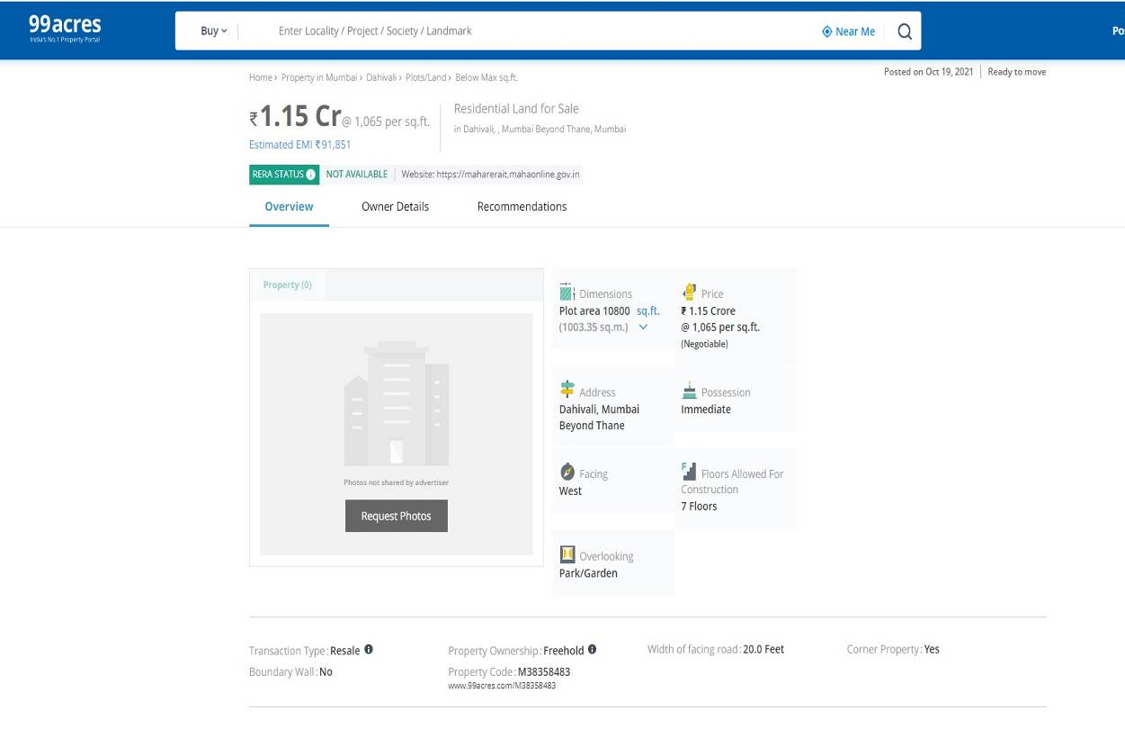
PRICE INDICATORS
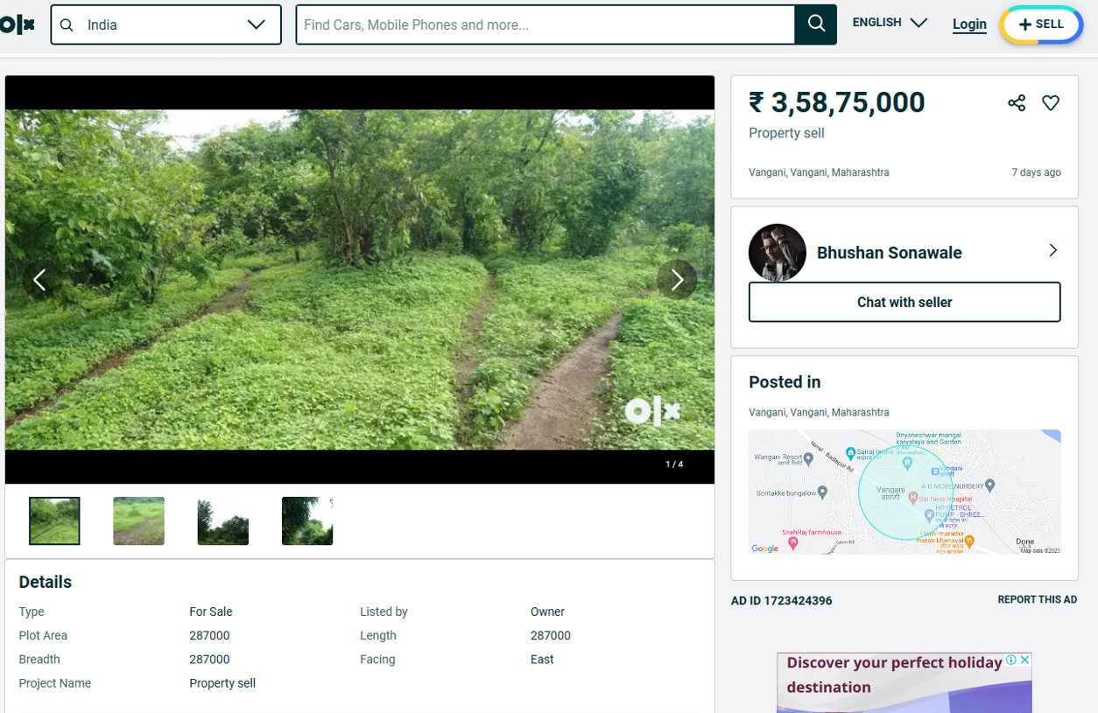

As a result of my appraisal and analysis, it is my considered opinion that the Fair Market Value for this particular above property in the prevailing condition with aforesaid specification is ` 14,18,40,000.00 (Rupees Fourteen Crore Eighteen Lakh Forty Thousand Only). The Realizable Value of the above property is ` 12,76,56,000.00 (Rupees Twelve Crore Seventy Six Lakh Fifty Six Thousand Only). The Distress value ` 11,34,72,000.00 (Rupees Eleven Crore Thirty Four Lakh Seventy Two Thousand Two Hundred Only).

Place: Mumbai
Date: 16.03.2023

Manoj B. Chalikwar
Registered Valuer
Chartered Engineer (India)
Reg. No. IBBI/RV/07/2018/10366

The undersigned has inspected the property detailed in the Valuation Report dated _______________________

on ____________________. We are satisfied that the fair and reasonable market value of the property is

`_________________________ (Rupees ________________________________________________________

________________________________________only).

Date
Signature
(Name & Designation of the Inspecting Official/s)

Countersigned
(BRANCH MANAGER)

Enclosures
 | Declaration-cum-undertaking from the valuer (Annexure- I) | Attached
(Annexure-I)

DECLARATION-CUM-UNDERTAKING

I, Manoj Chalikwar son of Shri. Baburao Chalikwar do hereby solemnly affirm and state that:

- I am a citizen of India.

- I will not undertake valuation of any assets in which I have a direct or indirect interest or become so interested at any time during a period of three years prior to my appointment as valuer or three years after the valuation of assets was conducted by me.

- The information furnished in my valuation report dated 13.03.2023 is true and correct to the best of my knowledge and belief and I have made an impartial and true valuation of the property.

- I/ my authorized representative have personally inspected the property on 10.03.2023. The work is not sub - contracted to any other valuer and carried out by myself.

- Valuation report is submitted in the format as prescribed by the bank.

- I have not been depanelled / delisted by any other bank and in case any such depanelment by other banks during my empanelment with you, I will inform you within 3 days of such depanelment.

- I have not been removed / dismissed from service / employment earlier.

- I have not been convicted of any offence and sentenced to a term of imprisonment

- I have not been found guilty of misconduct in my professional capacity.

- I have not been declared to be unsound mind

- I am not an undischarged bankrupt, or has not applied to be adjudicated as a bankrupt;

- I am not an undischarged insolvent.

- I have not been levied a penalty under section 271J of Income-tax Act, 1961 (43 of 1961) and time limit for filing appeal before Commissioner of Income-tax (Appeals) or Income-tax Appellate Tribunal, as the case may be has expired, or such penalty has been confirmed by Income-tax Appellate Tribunal, and five years have not elapsed after levy of such penalty

- I have not been convicted of an offence connected with any proceeding under the Income Tax Act 1961, Wealth Tax Act 1957 or Gift Tax Act 1958 and

- My PAN Card number as applicable is AERPC9086P

- I undertake to keep you informed of any events or happenings which would make me ineligible for empanelment as a valuer

- I have not concealed or suppressed any material information, facts and records and I have made a complete and full disclosure

- I have read the Handbook on Policy, Standards and procedure for Real Estate Valuation, 2011 of the IBA and this report is in conformity to the "Standards" enshrined for valuation in the Part - B of the above handbook to the best of my ability.

- I have read the International Valuation Standards (IVS) and the report submitted to the Bank for the respective asset class is in conformity to the "Standards" as enshrined for valuation in the IVS in "General Standards" and "Asset Standards" as applicable. The valuation report is submitted in the prescribed format of the bank.

- I am valuer registered with Insolvency & Bankruptcy Board of India (IBBI)

- My CIBIL Score and credit worthiness is as per Bank's guidelines.

- I am Chairman & Managing Director of the company, who is competent to sign this valuation report.

- I will undertake the valuation work on receipt of Letter of Engagement generated from the system (i.e. LLMS / LOS) only.

- Further, I hereby provide the following information.

 | Particulars | Valuer comment
 | Background information of the asset being valued; | The land was purchased by Poddar Housing and Development Ltd
Sr. No. | Survey No. | Agreement Date | Seller Name | Purchaser Name
1 | Survey No. 78/2 | 11.04.2018 | Shri. Shoba Nyaneshwar Kambri + 6 Others | Poddar Housing and Development Ltd
2 | Survey No. 78/4 | 10.04.2018 | Shri. Nyaneshwar Shivaji Kambri | Poddar Housing and Development Ltd
3 | Survey No. 9/2 | 28.04.2014 | Shri. Jinendra K. Nahar | Poddar Housing and Development Ltd
4 | Survey No. 29/11A | 09.09.2020 | Mr. Sanjay Babruvan Kulkarni | Poddar Housing and Development Ltd

 | Purpose of valuation and appointing authority | As per the request from STCI Finance Limited, Lower Parel to assess Fair Market Value of the property for banking purpose
 | Identity of the Valuer and any other experts involved in the valuation; | Manoj B. Chalikwar – Regd. Valuer  Prayush P. Parekh – Senior Valuation Engineer
 | Disclosure of Valuer interest or conflict, if any; | We have no interest, either direct or indirect, in the property valued. Further to state that we do not have relation or any connection with property owner / applicant directly or indirectly. Further to state that we are an independent Valuer and in no way related to property owner / applicant
 | Date of appointment, valuation date and date of report; | Date of Appointment – 09.03.2023  Valuation Date – 16.03.2023  Date of Report – 16.03.2023
 | Inspections and/or investigations undertaken; | Physical Inspection done on date 10.03.2023
 | Nature and sources of the information used or relied upon; | - Market Survey at the time of site visit  - Ready Reckoner rates / Circle rates  - Online search for Registered Transactions  - Online Price Indicators on real estate portals  - Enquiries with Real estate consultants  - Existing data of Valuation assignments carried out by us
 | Procedures adopted in carrying out the valuation and valuation standards followed; | Comparative Sales Method (For Land component)
 | Restrictions on use of the report, if any; | This valuation is for the use of the party to whom it is addressed and for no other purpose. No responsibility is accepted to any third party who may use or rely on the whole or any part of this valuation. The valuer has no pecuniary interest that would conflict with the proper valuation of the property.
- . | Major factors that were taken into account during the valuation; | Current market conditions, demand and supply position, industrial land size, location, sustained demand for industrial land, all round development of commercial and industrial application in the locality etc.
 | Caveats, limitations and disclaimers to the extent they explain or elucidate the limitations faced by valuer, which shall not be for the purpose of limiting his responsibility for the valuation report. | Attached

ASSUMPTIONS, DISCLAIMERS, LIMITATIONS & QUALIFICATIONS
Value Subject to Change
The subject appraisal exercise is based on prevailing market dynamics as on 16th March 2023 and does not take into account any unforeseeable developments which could impact the same in the future.
Our Investigations
We are not engaged to carry out all possible investigations in relation to the subject property. Where in our report we identify certain limitations to our investigations, this is to enable the reliant party to instruct further investigations where considered appropriate or where we recommend as necessary prior to reliance. Vastukala Consultants India Pvt. Ltd. (VCIPL) is not liable for any loss occasioned by a decision not to conduct further investigations
Assumptions
Assumptions are a necessary part of undertaking valuations. VCIPL adopts assumptions for the purpose of providing valuation advise because some matters are not capable of accurate calculations or fall outside the scope of our expertise, or out instructions. The reliant party accepts that the valuation contains certain specific assumptions and acknowledge and accept the risk of that if any of the assumptions adopted in the valuation are incorrect, then this may have an effect on the valuation.
Information Supplied by Others
The appraisal is based on the information provided by the client. The same has been assumed to be correct and has been used for appraisal exercise. Where it is stated in the report that another party has supplied information to VCIPL, this information is believed to be reliable but VCIPL can accept no responsibility if this should prove not to be so.
Future Matters
To the extent that the valuation includes any statement as to a future matter, that statement is provided as an estimate and/or opinion based on the information known to VCIPL at the date of this document. VCIPL does not warrant that such statements are accurate or correct.
Map and Plans
Any sketch, plan or map in this report is included to assist the reader while visualizing the property and assume no responsibility in connection with such matters.
Site Details
Based on inputs received from Client's representative and site visit conducted, we understand that the subject property is currently a non - contiguous and non-agricultural land parcel admeasuring 14,184.00 Sq. M. The property is owned by Poddar Housing and Development Ltd. At present, the property is Owner Occupied. Further, VCIPL has assumed that the subject property is free from any encroachment and is available as on the date of the appraisal.
Property Title
Based on our discussion with the Client, we understand that the property is owned Poddar Housing and Development Ltd. For the purpose of this appraisal exercise, we have assumed that the subject property has a clear title and is free from any encumbrances, disputes and claims. VCIPL has made no further enquiries with the relevant local authorities in this regard and does not certify the property as having a clear and marketable title. Further, no legal advice regarding the title and ownership of the subject property has been obtained for the purpose of this appraisal exercise. It has been assumed that the title deeds are clear and marketable.
Environmental Conditions
We have assumed that the subject property is not contaminated and is not adversely affected by any existing or proposed environmental law and any processes which are carried out on the property are regulated by environmental legislation and are properly licensed by the appropriate authorities.
Town Planning
The permissible land use, zoning, area statement adopted for purpose of this valuation is based on the documents provided by the Client's representative and the same has been adopted for this valuation purpose. VCIPL has assumed the same to be correct and permissible. VCIPL has not validated the same from any authority.
Area
Based on the documents, we understand that the subject property is non - contiguous and non-agricultural land parcel admeasuring 14,184.00 Sq. M.
Condition & Repair
In the absence of any information to the contrary, we have assumed that there are no abnormal ground conditions, nor archaeological remains present which might adversely affect the current or future occupation, development or value of the property. The property is free from rat, infestation, structural or latent defect. No currently known deleterious or hazardous materials or suspect techniques will be used in the construction of or subsequent alteration or additions to the property and comments made in the property details do not purport to express an opinion about, or advise upon, the condition of uninspected parts and should not be taken as making an implied representation or statement about such parts
Valuation Methodology
For the purpose of this valuation exercise, the valuation methodology used is Direct Comparison Approach Method and proposed Highest and Best Use model is used for analysing development potential.
The Direct Comparison Approach involves a comparison of the property being valued to similar properties that have actually been sold in arms - length transactions or are offered for sale. This approach demonstrates what buyers have historically been willing to pay (and sellers willing to accept) for similar properties in an open and competitive market and is particularly useful in estimating the value of the land and properties that are typically traded on a unit basis.
In case of inadequate recent transaction activity in the subject micro-market, the appraiser would collate details of older transactions. Subsequently, the appraiser would analyse rental / capital value trends in the subject micro-market in order to calculate the percentage increase / decrease in values since the date of the identified transactions. This percentage would then be adopted to project the current value of the same.
Where reliance has been placed upon external sources of information in applying the valuation methodologies, unless otherwise specifically instructed by Client and/or stated in the valuation, VCIPL has not independently verified that information and VCIPL does not advise nor accept it as reliable. The person or entity to whom the report is addressed acknowledges and accepts the risk that if any of the unverified information in the valuation is incorrect, then this may have an effect on the valuation.
Not a Structural Survey
We state that this is a valuation report and not a structural survey
Other
All measurements, areas and ages quoted in our report are approximate

Legal
We have not made any allowances with respect to any existing or proposed local legislation relating to taxation on realization of the sale value of the subject property. VCIPL is not required to give testimony or to appear in court by reason of this appraisal report, with reference to the property in question, unless arrangement has been made thereof. Further, no legal advice on any aspects has been obtained for the purpose of this appraisal exercise
Property specific assumptions
Based on inputs received from the client and site visit conducted, we understand that the subject property is currently vacant, non - contiguous and non-agricultural land parcel admeasuring 14,184.00 Sq. M.

ASSUMPTIONS, CAVEATS, LIMITATION AND DISCLAIMERS
- We assume no responsibility for matters of legal nature affecting the property appraised or the title thereto, nor do we render our opinion as to the title, which is assumed to be good and marketable.
- The property is valued as though under responsible ownership.
- It is assumed that the property is free of liens and encumbrances.
- It is assumed that there are no hidden or unapparent conditions of the subsoil or structure that would render it more or less valuable. No responsibility is assumed for such conditions or for engineering that might be required to discover such factors.
- There is no direct/ indirect interest in the property valued.
- The rates for valuation of the property are in accordance with the Govt. approved rates and prevailing market rates

DEFINITION OF VALUE FOR THIS SPECIFIC PURPOSE

This exercise is to assess Fair Market Value of the property under reference as on 16th March 2023.

The term Fair Market Value is defined as

“The most probable price, as of a specified date, in cash, terms equivalent to cash, or in other precisely revealed terms for which the specified property rights would sell after reasonable exposure in a competitive market under all conditions requisite to a fair sale, with the buyer and seller each acting prudently knowledgeably and for self interest assuming that neither is under undue duress”.

Fundamental assumptions and conditions presumed in this definition are:

1. Buyer and seller are motivated by self-interest.
2. Buyer and seller are well informed and are acting prudently.
3. The property is exposed for a reasonable time on the open market.
4. Payment is made in cash or equivalent or in specified financing terms.
DECLARATION OF PROFESSIONAL FEES CHARGED

We hereby declare that, our professional fees are not contingent upon the valuation findings. However, if the statute AND/OR clients demands that, the fees should be charged on the percentage of assessed value then, with the full knowledge of the AND/OR end user, it is being charged accordingly.

VALUATION OF THE PROPERTY PREMISES

Considering various parameters recorded, existing economic scenario, and the information that is available with reference to the development of neighborhood and method selected for valuation, we are of the opinion that, the property premises can be assessed and Fair Market Value for this particular purpose at ` 14,18,40,000.00 (Rupees Fourteen Crore Eighteen Lakh Forty Thousand Only).

Manoj B. Chalikwar
Registered Valuer
Chartered Engineer (India)
Reg. No. IBBI/RV/07/2018/10366

