5th LENDERS INDEPENDENT ENGINEER REPORT
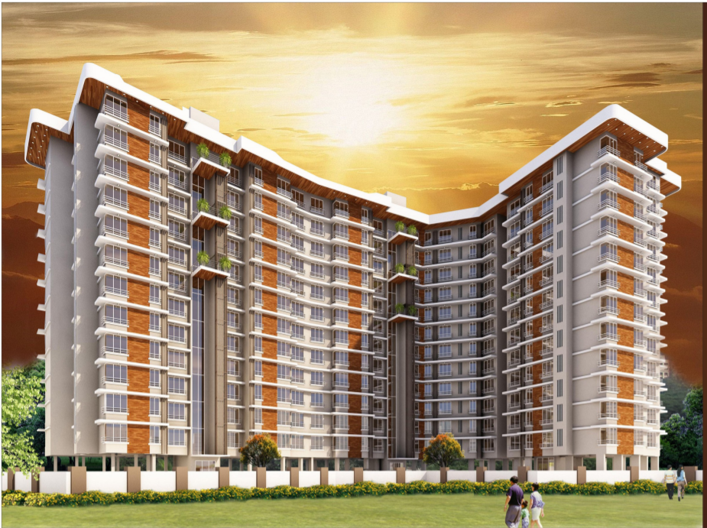

Details of the property under consideration:

Name of Project: Aryavrat Project

"Aryavrat Project", Proposed Redeveloped of Property on Land Bearing Final Plot No. 240 (part) of
TSP -IV of Mahim Division, Palan Sojpal Building "B", S. K. Bole Road, Dadar (West), Mumbai,
Pin Code - 400 028, State - Maharashtra, Country - India

Latitude Longitude: 19°01'13.0"N 72°50'20.3"E

Valuation Prepared for:

State Bank of India
Vashi Turbhe Branch
Devgiri Complex, Sector 19-C, APMC, Phase II, Near Dana Bazar, Vashi,
Navi Mumbai, State - Maharashtra, Country - India

Vastu/SBI/Mumbai/02/2023/29965/45694
25/08-544-PY
Date: - 25.02.2023

FIFTH LENDERS INDEPENDENT ENGINEER REPORT

To,
State Bank of India
Vashi Turbhe Branch
Devgiri Complex, Sector 19-C,
APMC, Phase II, Near Dana Bazar, Vashi,
Navi Mumbai, State - Maharashtra, Country - India.

Subject: Construction of Residential Building "Aryavrat Project", Proposed Redeveloped of Property on Land Bearing Final Plot No. 240 (part) of TSP -IV of Mahim Division, Palan Sojpal Building "B", S. K. Bole Road, Dadar (West), Mumbai, Pin Code - 400 028, State - Maharashtra, Country - India.

Ref: You’re Request for Lenders Independent Engineer Report of under Construction Building.
Dear Sir,
The Construction work as per approved plan was in progress during the site visit on 13th October 2022. Total expenditure occurred as on 30/09/2022 on this project by M/s. Chintamani Land and Housing LLP is ` 110.36 Cr. & as per CA Certificate actual total expenditure occurred as on 30/09/2022 is ` 111.67 Cr. Hence, release of Balance Amount as requested by M/s. Chintamani Land and Housing LLP if any is hereby recommended.
DECLARATION
- The information furnished in the report is based on our site visit Dated 13/10/2022 & Document Provided by Client.
- Vastukala 4th LIE Report of the project dated 30.11.2022.
- Appointed Architect’s “Irani Architects” Certificate: For Work completion upto, 30/09/2022 issued dated 23/11/2022.
- I have no direct and indirect interest in the property examined for report.
- I have not been found guilty of misconduct in my professional capacity.

Sharadkumar B. Chalikwar
Govt. Reg. Valuer
Chartered Engineer (India)
Reg. No. (N) CCIT/1-14/52/2008-09
Encl.: LIE report

Purpose & Methodology
• State Bank of India Banks and financial institutions require monitoring & an independent review of the progress of the sanctioned projects
VCIPL undertakes such study to independently review the progress of the project and put forward a comprehensive analysis

Advantages:
- Assurance on present practices
- Identification of risk
- Analyzing the performance of third parties
- Recommendations

The Methodology
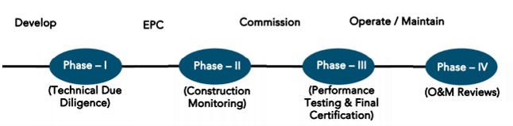
5th LENDERS INDEPENDENT ENGINEER REPORT
OF
"Aryavrat Project"
"Aryavrat Project", Proposed Redeveloped of Property on Land Bearing Final Plot No. 240 (part) of TSP -IV of Mahim Division, PalanSojpal Building "B", S. K. Bole Road, Dadar (West), Mumbai, Pin Code - 400 028,
State - Maharashtra, Country – India
Latitude Longitude: 19°01'13.0"N 72°50'20.3"E

NAME OF DEVELOPER: M/s. Chintamani Land and Housing LLP
Pursuant to instructions from State of India, Vashi Turbhe Branch, Navi Mumbai we have duly visited, inspected, surveyed & assessed the above said property on 13th October 2022 to determine the fair & reasonable market value of the said property/project as on Quarter ending 30th September 2022 for LIE purpose.

1. Location Details:
The property is situated at Final Plot No. 240 (part) of TSP -IV of Mahim Division, PalanSojpal Building "B", S. K. Bole Road, Dadar (West), Mumbai, Pin Code - 400 028. It is about 500 M. walking distance from Dadar railway station of Western railway line. Surface transport to the property is by buses, Auto, taxis & private vehicles. The property is in developed locality. All the amenities like shops, banks, hotels, markets, schools, hospitals, etc. are all available in the nearby locality. The locality is higher middle class & developed.

- Developer Details:
Name of builder | M/s. Chintamani Land and Housing LLP
Project Rera Registration Number | P51900024338
Registered office address | Office No. 60/62, Mirza Street, Mumbai - 400 003, State - Maharashtra, Country – India.
Contact details | Contact Person:  Mr. Manish Patel (Mobile No. 8286518638)
E – mail ID and website | accounts@chintamaniestates.com  www.chintamaniestates.com
3. Boundaries of the Property:
Direction | Particulars
On or towards North | C - Wing Palan Sojpal Building
On or towards South | SK Bole Road
On or towards East | A - Wing Palan Sojpal Building
On or towards West | Datta Niwas & Gyan Mandir Road

Introduction
As per Information on site M/s. Chintamani Land and Housing LLP has acquired land by conveyance agreement Dt.01.08.2012 admeasuring 3,145.50 Sq. M. bearing Final Plot No. 240 (part) of TSP -IV of Mahim Division, Palan Sojpal Building "B", S. K. Bole Road, Dadar (West), Mumbai, Pin Code - 400 028, State - Maharashtra, Country – India. For the Redevelopment of residential Building.

Area Statement:

Land:
Date | Particular | Area in Sq. M.
01.08.2012 | Final Plot No. 240 (part) | 3,145.50

- Copy of Agreement for Development Registered with Sub Registrar No. BBE - 2 / 5770 / 2012 dated 01.08.2012 between Mr. Sureshchandra alias Kishor Ratanshi Shah, Mr. Indra Kishor Shah & others (the Owners) AND M/s. Kumar Housing and Land Development (the Developers).

Building Area (As per Concession Plan):
Sr. No. | PROFORMA – A | Total
1 | Plot Area
 | Area as per Triangular Calculation | 3145.51
2 | Deduction for
 | a) Road Set back area | 162.82
 | b) Proposed Road Area
 | c) Any Reservation (R. G. & P.G.)
 | d) % amenity spaces as per DCR 56/57 (Sub Plot)
 | e) other
3 | Balance Area of The Plot (1-2) | 2982.69
4 | Deductions for 15% R.G. / 10% Amenity space (if deductible for Ind)
5 | Net Area of the Plot (3-4) | 2982.69
6 | Additions for Floor Space Index  a) 100% for D. P. Road / Set back, b) 33% as per DCR 32, c) % as per DCR 33 ( ), d) other | 162.82
7 | Total Area (5 + 6) | 3145.51
8 | For Space Index Permissible (As per Statement)
9 | For Space Index credit available by Development Rights (Restricted to % of the balance area vide 3 above DCR No.
10 | Permissible Floor Area (As per Statement) | 9436.53
10A | 5% additional FSI | 243.5
11 | Existing Floor Area
12 | Proposed Built up Area (Permissible) | 9680.03
13 | Excess Balcony area taken in the Floor Space Index
14A | Purely Residential Built up Area | 9311.39
14B | Remaining Non Residential Built up area | 350.87
14 | Total Built up Area Proposed (14A+14B) (As per old approved plan dated Prior to 06.01.2012 | 9662.26
15 | FSI Consumed on net holding = 14/3
B | Details of FSI availed as per DCR 31 (3) | Proposed
1 | Fungible Built up area component proposed vide DCPR 31(3) purely residential = | 2413.61
2 | Fungible Built up area component proposed vide DCPR 31(3) for Non residential = | 9.11
3 | Total Fungible Built up area vide DCPR 31(3) = (B.1+B.2) Rehab | 2422.72
 | Total Gross Built up area Proposed (14 + B.3) | 12084.98

List of Approvals:
- Copy of IOD No. CHE / CITY / 1110 / GN / 337 / New dated 05.09.2019 issued by Municipal Corporation of Greater Mumbai.
- Copy of IOD Certificate No. CHE / CITY / 1110 / GN / 337 / New dated 07.12.2017 issued by Municipal Corporation of Greater Mumbai.
- Copy of 1st Commencement Certificate No. CHE / CTY / 1110 / G / N / 337 / NEW / CC / 1 / NEW dated 07.12.2017 issued by Municipal Corporation of Greater Mumbai. This CC is issued up to top of Plinth level as per Zero FSI IOD issued on 05.09.2019.
- Copy of Plans (Concession Drawing) No. CHE / CITY / 1110 / GN / 337 / New dated 07.07.2020 issued by Municipal Corporation of Greater Mumbai.
Wing | Number of Floors
A | 2 Basements + Ground (part) + Stilt (part) + 1st to 17th upper floors.
B | 2 Basements + Ground (part) + Stilt (part) + 1st to 21st upper floors.
- Copy of 2nd Commencement Certificate No. CHE / CTY / 1110 / G / N / 337 / NEW / FCC / 1 / NEW dated 30.12.2021 issued by Municipal Corporation of Greater Mumbai. This CC is issued up to 15th floor of Wing A & 21st floor of Wing B valid upto 20.09.2022.
- Copy of Approved Plan No. CHE / CITY / 1110 / GN / 337 / New dated 28.06.2021 issued by Municipal Corporation of Greater Mumbai.
Wing | Number of Floors
A | 2 Basements + Ground (part) + Stilt (part) + 1st to 17th upper floors.
B | 2 Basements + Ground (part) + Stilt (part) + 1st to 21st upper floors.

LEVEL OF COMPLETION:

Rehab cum Sales Building (A & B Wing)
Sr. No | Floor | Construction area as per plan (Sq. ft.) | Completed area (Sq. ft.) | Work Completion as on 4th LIE Report | Work Completion as on 13.10.2022
1 | Basement 1 | 17,084.73 | 17,084.73 | Wing A & B slab work, block work & plaster work are completed | Wing A & B slab work, block work & plaster work are completed
2 | Basement 2 | 17,084.73 | 17,084.73 | Wing A & B slab work, block work & plaster work are completed | Wing A & B slab work, block work & plaster work are completed
3 | Ground / Stilt Floor | 20,313.93 | 20,313.93 | Wing A: Slab work is completed  Wing B: Slab work is completed, Block work is in Completed | Wing A: Slab work is completed  Wing B: Slab work is completed, Block work is in Completed
2 | 1st Floor | 9,407.41 | 9,407.41 | Wing A: Slab Work is completed.  Wing B: Slab work is completed, Block work & Plasterwork is in Completed | Wing A: Slab Work is completed.  Wing B: Slab work, 95% Blockwork, Plaster work, Door & Windows frame, Kitchen Platform, 50% toilet tiling work & waterproofing work at toilet block are completed.
3 | 2nd Floor | 9,980.27 | 4,990.14 | Wing B: Slab work is completed, Block work & Plasterwork is in Completed | Wing A: Slab Work is completed.  Wing B: Slab work, 95% Blockwork, Plaster work, Door & Windows frame, Kitchen Platform, 50% toilet tiling work & waterproofing work at toilet block are completed
4 | 3rd Floor | 9,980.27 | 4,990.14 | Wing B: Slab work is completed, Block work & Plasterwork is in Completed | Wing B: Slab work, 95% Blockwork, Plaster work, Door & Windows frame, Kitchen Platform, 50% toilet tiling work & waterproofing work at toilet block are completed
5 | 4th Floor | 9,980.27 | 4,990.14 | Wing B: Slab work is completed, Block work is in Completed | Wing B: Slab work, 95% Blockwork, Plaster work, Door & Windows frame, Kitchen Platform, & waterproofing work at toilet block are completed
6 | 5th Floor | 9,980.27 | 4,990.14 | Wing B: Slab work & 90% Blockwork is completed | Wing B: Slab work, 95% Blockwork, Door frame & Plaster work are completed
7 | 6th Floor | 9,980.27 | 4,990.14 | Wing B: Slab work is completed, Blockwork is in progress | Wing B: Slab work, 95% Blockwork & Plaster work are completed
8 | 7th Floor | 9,980.27 | 4,990.14 | Wing B: Slab work is completed | Wing B: Slab work & 95% Blockwork is completed
9 | 8th Floor | 10,056.48 | 5,028.24 | Wing B: Slab work is completed | Wing B: Slab work & 90% Blockwork is completed
10 | 9th Floor | 10,086.08 | 5,043.04 | Wing B: Slab work is completed | Wing B: Slab work & 25% blockwork are completed, Block work is in progress
11 | 10th Floor | 10,086.08 | 5,043.04 | Wing B: Slab work is completed | Wing B: Slab work is completed, Block work is in progress
12 | 11th Floor | 10,086.08 | 5,043.04 | Wing B: Slab work is completed | Wing B: Slab work is completed, Block work is in progress
13 | 12th Floor | 10,220.74 | 5,110.37 | Wing B: Shuttering work is in progress | Wing B: Slab work is completed, Block work is in progress
14 | 13th Floor | 10,220.74 | 5,110.37 |  | Wing B: Slab work is completed
15 | 14th Floor | 10,220.74 | 5,110.37 |  | Wing B: Slab work is completed
16 | 15th Floor | 10,417.18 | 5,208.59 |  | Wing B: Slab work is completed
17 | 16th Floor | 10,274.24 | 5,137.12 |  | Wing B: Slab work is completed
18 | 17th Floor | 8,176.33 | 4,088.17 |  | Wing B: Slab work is completed
19 | 18th Floor | 5,438.29 |  |  | Wing B: Shuttering work is in progress
20 | 19th Floor | 4,544.78
21 | 20th Floor | 4,588.59
22 | 21st Floor | 3,157.83
23 | Terrace Area / OHT | 788.25
24 | Fitness | 2,792.61
25 | STP | 1,752.70
Total Area in Sq. ft. |  | 2,46,680.19 | 1,48,744.09

Details of the Project as Financed By SBI:

Project Cost: (as per C.A. Certificate)
Particulars | Estimated Cost  (In Cr.) | Incurred Cost  (In Cr.)  30-09-2022 by M/s. D. J. Shah & Associates LLP | Incurred Cost  (In Cr.)  30-06-2022 by M/s. D. J. Shah & Associates LLP | Net
Land Cost | 23.67 | 24.13 | 23.98 | 0.15
Land clearance, temporary transit accommodation & overhead cost | 18.00 | 22.11 | 20.92 | 1.19
Construction cost of Building | 75.93 | 34.29 | 26.07 | 8.22
Premium Cost & BMC / FSI/ GOM Charges/ fees/ security Deposits | 24.29 | 17.84 | 17.37 | 0.46
On- site expenditure for development / Marketing / Advance for Project/ Administrative Cost / Fixed Assets | 11.11 | 10.88 | 8.33 | 2.55
Interest Cost | 13.68 | 2.42 | 1.58 | 0.84
Total | 166.98 | 111.67 | 98.26 | 13.41

- The Builder has incurred about 34.29 Cr. as construction cost, 22.11 Cr. for rent to tenants & 17.84 Cr. for approval cost till 30.09.2022 as per C.A. certificate issued by M/s. D. J. Shah & Associates LLP dated 18.10.2022.

Project Cost: (as per Bills):
Particulars | Incurred Cost (in Cr.) |  | Net
 | 30/09/2022 as per Bill (Inclusive GST) | 30/06/2022 as per Bill (Inclusive GST)
Land Cost | 23.87 | 23.87 | -
Land clearance, temporary transit accommodation & overhead cost | 22.26 | 20.92 | 1.34
Construction cost of Building | 34.89 | 26.32 | 8.57
Premium Cost & BMC / FSI/ GOM Charges/ fees/ security Deposits | 16.99 | 16.98 | -
On- site expenditure for development / Marketing / Advance for Project/ Administrative Cost / Fixed Assets | 9.94 | 9.10 | 0.84
Interest Cost | 2.42 | 1.58 | 0.84
Total | 110.36 | 98.77 | 11.59

Land Cost:
Land Cost Description
Sr. No. | Date | Description | Document | Total Cost in ` | Incurred Cost in `
1 | 01.08.2012 | Land Cost | As per Development Agreement | 21,00,00,000.00 | 21,00,00,000.00
2 |  | Stamp Duty |  | 1,20,43,250.00 | 1,20,43,250.00
3 |  | Reg. fees |  | 30,000.00 | 30,000.00
4 |  | Challan Fees. |  | 30,000.00 | 30,000.00
5 |  |  |  | 9,100.00 | 9,100.00
6 |  | Power of Attorney & Rectification Deed |  | 1,65,55,622.00 | 1,65,55,622.00
TOTAL |  |  |  | 23,86,67,972.00 | 23,86,67,972.00
As per conveyance deed.
Summary of Bills
Sr. No. | Particulars | Amount in `  (Till 30.09.2022) | Amount in `  (In Cr.) | Amount in `  (Till 30.06.2022) | Amount in `  (In Cr.) | Net in Cr.
1 | Premium Cost & BMC / FSI/ GOM Charges/ fees/ security Deposits | 16,98,79,377.00 | 16.99 | 16,98,47,657.00 | 16.98 | -
2 | Construction Cost | 34,88,71,242.00 | 34.89 | 26,31,64,432.00 | 26.32 | 8.57
3 | Professional Cost | 1,26,72,282.00 | 1.27 | 1,07,81,682.00 | 1.08 | 0.19
4 | Administrative & Marketing Cost | 8,67,24,212.00 | 8.67 | 8,01,83,869.00 | 8.02 | 0.65
TOTAL |  | 61,81,47,113.00 | 61.81 | 52,39,77,640.00 | 52.40 | 9.42
Note: Bills were provided by the client up to 30.09.2022.

Interest Cost:
Sr. No | Particulars | Estimate Amount in ` | Incurred Amount in ` till 30.09.2022 | Incurred Amount in ` till 30.06.2022 | Net Amount in `
1 | Interest Cost | 13,67,90,976.00 | 2,41,70,778.00 | 1,57,93,542.00 | 83,77,236.00
TOTAL |  | 13,67,90,976.00 | 2,41,70,77800 | 1,57,93,542.00 | 83,77,236.00
Interest Cost is based on discussion with the client which may get revised as per bank Interest rate & Payment Schedule.

Cost of Construction as on 30th September 2022 for (Wing A & B):
Plinth Area Calculation
Sr. No. | Floor | Construction area as per plan (Sq. ft.) | Completed area (Sq. ft.) | Rate per Sq. ft. | Full Value after completion | Percentage of work completed | Actual Expenditure till date in `
1 | Basement 1 | 17,084.73 | 17,084.73 | 3,600.00 | 6,15,05,028.00 | 60.00% | 3,69,03,017.00
2 | Basement 2 | 17,084.73 | 17,084.73 | 3,600.00 | 6,15,05,028.00 | 60.00% | 3,69,03,017.00
3 | Ground / Stilt Floor | 20,313.93 | 20,313.93 | 3,000.00 | 6,09,41,790.00 | 50.00% | 3,04,70,895.00
4 | 1st Floor | 9,407.41 | 9,407.41 | 3,000.00 | 2,82,22,230.00 | 60.00% | 1,69,33,338.00
5 | 2nd Floor | 9,980.27 | 4,990.14 | 3,000.00 | 2,99,40,810.00 | 60.00% | 1,79,64,486.00
6 | 3rd Floor | 9,980.27 | 4,990.14 | 3,000.00 | 2,99,40,810.00 | 60.00% | 1,79,64,486.00
7 | 4th Floor | 9,980.27 | 4,990.14 | 3,000.00 | 2,99,40,810.00 | 35.00% | 1,04,79,284.00
8 | 5th Floor | 9,980.27 | 4,990.14 | 3,000.00 | 2,99,40,810.00 | 35.00% | 1,04,79,284.00
9 | 6th Floor | 9,980.27 | 4,990.14 | 3,000.00 | 2,99,40,810.00 | 35.00% | 1,04,79,284.00
10 | 7th Floor | 9,980.27 | 4,990.14 | 3,000.00 | 2,99,40,810.00 | 35.00% | 1,04,79,284.00
11 | 8th Floor | 10,056.48 | 5,028.24 | 3,000.00 | 3,01,69,440.00 | 32.00% | 96,54,221.00
12 | 9th Floor | 10,086.08 | 5,043.04 | 3,000.00 | 3,02,58,240.00 | 28.00% | 84,72,307.00
13 | 10th Floor | 10,086.08 | 5,043.04 | 3,000.00 | 3,02,58,240.00 | 28.00% | 84,72,307.00
14 | 11th Floor | 10,086.08 | 5,043.04 | 3,000.00 | 3,02,58,240.00 | 28.00% | 84,72,307.00
15 | 12th Floor | 10,220.74 | 5,110.37 | 3,000.00 | 3,06,62,220.00 | 25.00% | 76,65,555.00
16 | 13th Floor | 10,220.74 | 5,110.37 | 3,000.00 | 3,06,62,220.00 | 25.00% | 76,65,555.00
17 | 14th Floor | 10,220.74 | 5,110.37 | 3,000.00 | 3,06,62,220.00 | 25.00% | 76,65,555.00
18 | 15th Floor | 10,417.18 | 5,208.59 | 3,000.00 | 3,12,51,540.00 | 25.00% | 78,12,885.00
19 | 16th Floor | 10,274.24 | 5,137.12 | 3,000.00 | 3,08,22,720.00 | 25.00% | 77,05,680.00
20 | 17th Floor | 8,176.33 | 4,088.17 | 3,000.00 | 2,45,28,990.00 | 25.00% | 61,32,248.00
21 | 18th Floor | 5,438.29 |  | 3,000.00 | 1,63,14,870.00 | 0.00% | -
22 | 19th Floor | 4,544.78 |  | 3,000.00 | 1,36,34,340.00 | 0.00% | -
23 | 20th Floor | 4,588.59 |  | 3,000.00 | 1,37,65,770.00 | 0.00% | -
24 | 21st Floor | 3,157.83 |  | 3,000.00 | 94,73,490.00 | 0.00% | -
25 | OHT | 788.25 |  | 3,000.00 | 23,64,750.00 | 0.00% | -
26 | Fitness | 2,792.61 |  | 3,000.00 | 83,77,830.00 | 0.00% | -
27 | STP | 1,752.70 |  | 2,300.00 | 40,31,210.00 | 0.00% | -
Total Area |  | 2,46,680.16 | 1,48,744.09 |  | 75,93,15,266.00 | 36.71% | 27,87,74,995.00

Note: Details of work completed is as per site visit dated 13.10.2022 but report is prepared for 30th September quarter 2022.

Particulars | Estimated Cost (in Cr.) | Incurred Cost (in Cr.) |  |  | Net as per bills
 |  | Issued dated 18.10.2022 till 30.09.2022 as per CA | As per Bills up to 30.09.2022 | As per Bills up to 30.06.2022
Land Cost | 23.67 | 24.13 | 23.87 | 23.87 | -
Land clearance, temporary transit accommodation & overhead cost | 18.00 | 22.11 | 22.26 | 20.92 | 1.34
Construction cost of Building | 75.93 | 34.29 | 34.89 | 26.32 | 8.57
Premium Cost & BMC / FSI/ GOM Charges/ fees/ security Deposits | 24.29 | 17.84 | 16.99 | 16.98 | -
On- site expenditure for development / Marketing / Advance for Project/ Administrative Cost / Fixed Assets | 11.11 | 10.88 | 9.94 | 9.10 | 0.84
Interest Cost | 13.68 | 2.42 | 2.42 | 1.58 | 0.84
Total | 166.98 | 111.67 | 110.36 | 98.77 | 11.59
Note: As per plinth area, calculation the work completed is up to 36.71% of total work, which comes to ` 27.88 Cr. However, company has incurred cost of ` 34.89 Cr. Which is inclusive of material on site.

Comparison of Cost incurred on dated 30.09.2022 & 30.06.2022
Particulars | As per Bill upto 30.09.2022 | As 4th LIE Report Bills upto 30.06.2022 | Net | % of net amount
Land Cost | 23.87 | 23.87 | - | 0.00%
Land clearance, temporary transit accommodation & overhead cost | 22.26 | 20.92 | 1.34 | 27.91%
Construction cost of Building | 34.89 | 26.32 | 8.57 | 57.98%
Premium Cost & BMC / FSI/ GOM Charges/ fees/ security Deposits | 16.99 | 16.98 | - | 0.00%
On- site expenditure for development / Marketing / Advance for Project/ Administrative Cost / Fixed Assets | 9.94 | 9.10 | 0.84 | 4.61%
Interest Cost | 2.42 | 1.58 | 0.84 | 9.50%
Total | 110.36 | 98.77 | 11.59 | 100.00%

% of Fund Utilised till 30th September 2022
Particulars | Estimated Project Cost (in Cr.) | Incurred cost as on 30.09.2022 | % of Estimated Project Cost | % of Incurred Cost
Land Cost | 23.67 | 23.87 | 100.84% | 14.30%
Land clearance, temporary transit accommodation & overhead cost | 18.00 | 22.26 | 123.67% | 13.33%
Construction cost of Building | 75.93 | 34.89 | 45.95% | 20.89%
Premium Cost & BMC / FSI/ GOM Charges/ fees/ security Deposits | 24.29 | 16.99 | 69.94% | 10.17%
On- site expenditure for development / Marketing / Advance for Project/ Administrative Cost/ Fixed Assets | 11.11 | 9.94 | 87.11% | 5.95%
Interest Cost | 13.68 | 2.42 | 17.67% | 1.45%
Total | 166.98 | 110.36 | 66.09% | 66.09%
Based on above Calculation it is found that Project Cost incurred till 30.09.2022 is Completed 66.09% of the Total Project Cost.

Means of Finance:
Sr. No. | Particulars | Exp. Cumulative (Cr.)
 | Equity share capital / Quassi Loan from Promoter | 61.20
 | Sales (Advance from customer) | 11.70
 | Secured loans | 35.54
 | Unsecured loans | 0.25
 | Total | 108.69
The Details of the Means of Finance are provided by Client Officer as on 30.09.2022.

Mandatory Arrangements:
Sr. No. | Particulars | Status
 | Rainwater Harvesting | To be executed after RCC Structure
 | Firefighting System | To be executed after RCC Structure
 | Solid Waste Management | To be executed after RCC Structure

Quality of Construction:
Sr. No. | Particulars | Status
 | Soundness of Structures | N.A. as Construction work is in progress
 | Look of Structures | N.A. as Construction work is in progress
 | Quality of Material Used | Good
 | Safety Measures for Construction/labour | Taken Care by Contractor

Schedule V/s. Actual Progress:
Activity | Date of Implementation | Date of Completion | Status
Land |  |  | Completed
Development of Land |  |  | Completed
Foundation Work |  |  | Completed
Basement 1 |  |  | Completed
Basement 2 |  |  | Completed
Ground Floor Slab |  |  | Slab work is completed
1st Floor Slab | Wing A: 30.04.2022 | Wing A: 05.05.2022  Wing B: 12.01.2022 | Wing A & B: Slab work is completed
2nd Floor Slab | Wing A: 15.05.2022 | Wing B: 28.01.2022 | Wing B Slab work is completed
3rd Floor Slab | Wing A: 30.05.2022 | Wing B: 11.02.2022 | Wing B Slab work is completed
4th Floor Slab | Wing A: 14.06.2022 | Wing B: 23.02.2022 | Wing B Slab work is completed
5th Floor Slab | Wing A: 29.06.2022 | Wing B: 07.03.2022 | Wing B Slab work is completed
6th Floor Slab | Wing A: 14.07.2022 | Wing B: 19.03.2022 | Wing B Slab work is completed
7th Floor Slab | Wing A: 29.07.2022 | Wing B: 31.03.2022 | Wing B Slab work is completed
8th Floor Slab | Wing A: 13.08.2022  Wing B: 14.04.2022 | Wing B: 12.04.2022 | Wing B Slab work is completed
9th Floor Slab | Wing A: 28.08.2022  Wing B: 28.04.2022 | Wing B: 28.04.2022 | Wing B Slab work is completed
10th Floor Slab | Wing A: 12.09.2022  Wing B: 12.05.2022 | Wing B: 15.05.2022 | Wing B Slab work is completed
11th Floor Slab | Wing A: 27.09.2022  Wing B: 26.05.2022 | Wing B: 31.05.2022 | Wing B Slab work is completed
12th Floor Slab | Wing A: 12.10.2022  Wing B: 09.06.2022 |  | Wing B Slab work is completed
13th Floor Slab | Wing A: 27.10.2022  Wing B: 25.06.2022 |  | Wing B Slab work is completed
14th Floor Slab | Wing A: 11.11.2022  Wing B: 10.07.2022 |  | Wing B Slab work is completed
15th Floor Slab | Wing A: 26.11.2022  Wing B: 26.07.2022 |  | Wing B Slab work is completed
16th Floor Slab | Wing A: 11.12.2022  Wing B: 09.08.2022 |  | Wing B Slab work is completed
17th Floor Slab | Wing A: 26.12.2022  Wing B: 25.08.2022 |  | Wing B Slab work is completed
18th Floor Slab | Wing B: 08.09.2022 |  | Wing B Shuttering work is in progress
19th Floor Slab | Wing B: 23.09.2022
20th Floor Slab | Wing B: 07.10.2022
21st Floor Slab | Wing B: 21.10.2022
Block work /Internal Plaster work | 01.02.2022 |  | Wing B: 1st to 8th block work is completed
Terrace Parapet wall / Overhead water tank / Lift Machine room / compound wall / External Plaster work
Electric Work
Water Proofing
Plumbing Work
Tiling / Marble Flooring
Door Frames
Window Installation
Staircase Flooring
Staircase Railing
Refuge Area Flooring
Internal Painting
External Painting
Lift Work
Fire Fighting Installation
Stack Parking
CP Fitting & Sanitary Work
Final Finishing & Fitting

Action initiated to complete the project in time:
For Rehab & Sales Building:
Wing A: 2nd Floor Slab work is completed.
Wing B: Till 17th floor slab work is completed, 1st to 8th blockwork is completed.

The developers have Major work on themselves only hence (all Manpower (Labour Contractor) and material resources) shall be enhanced by the Developer to meet the TimeLine. Detail periodically progress report needs to be checked for timely completion of project.

Multiple activists to be done for achieving the timely progress & detail periodically bar chart is to be submitted for the further next quarter.

Comments related to cost overrun if any:
The cost of Rehab cum Sales Building is ` 166.98 Cr.

Balance investment required for completion of project:
We opinion amount of ` 56.62 Cr. Will be required to complete the Project.

Mandatory Approval Status:
Sr. No. | Particulars | Name of Department | Status | Order Details
1A | IOD of Building | Municipal Corporation of Greater Mumbai | Obtained and available at site | CHE/CITY/1110/GN/337/New dated 07.12.2017
1B | IOD of Building | Municipal Corporation of Greater Mumbai | Obtained and available at site | CHE/CITY/1110/GN/337/New dated 05.09.2019
1C | Approved Plan | Municipal Corporation of Greater Mumbai | Obtained and available at site | CHE/CITY/1110/GN/337/New dated 05.09.2019
2A | First C.C. | Municipal Corporation of Greater Mumbai | Obtained and available at site | CHE/CTY/1110/G/N/337/NEW/CC/1/NEW dated 07.12.2017.
2B | Second C.C. | Municipal Corporation of Greater Mumbai | Obtained and available at site | CHE / CTY / 1110 / G / N / 337 / NEW / FCC / 1 / NEW dated 30.12.2021. This CC is issued up to 15th floor of Wing A & 21st floor of Wing B valid upto 20.09.2022.
2C | Third C.C. | Municipal Corporation of Greater Mumbai | Pending (Plinth Level to upper floor C.C.) | CHE / CITY / 1110 / GN / 337 / New dated 28.06.2021
3 | Occupancy | Municipal Corporation of Greater Mumbai | Pending (Project is not completed)

Status Insurance Coverage:
Information not provided by the Client.

Assumptions & Remarks:
- The adequacy of Engineering / Structural design is beyond the scope of our assignment.
- Estimated project completion date is 30/12/2023 for Rehab & Sales Building. The cost is certified based on the assumptions that the project will be completed within period. Few assumptions were made regarding inflation & cost rise etc. during construction period.

Sharadkumar B. Chalikwar
Govt. Reg. Valuer
Chartered Engineer (India)
Reg. No. (N) CCIT/1-14/52/2008-09

About the Project:
1. Introduction
a) | Project Name  (With Address & Phone Nos.) |  | "Aryavrat Project", Proposed Redeveloped of Property on Land Bearing Final Plot No. 240 (part) of TSP -IV of Mahim Division, Palan Sojpal Building "B", S. K. Bole Road, Dadar (West), Mumbai, Pin Code - 400 028, State - Maharashtra, Country – India  Contact Person:  Mr. Manish Patel (Mobile No. 8286518638)
b) | Purpose of Valuation |  | As per request from State Bank of India, Vashi Turbhe Branch, Navi Mumbai to assess fair market value of the Project for LIE purpose.
c) | Date of Inspection of Property |  | 13.10.2022
d) | Date of LIE Report |  | 25.02.2023
e) | Name of the Developer of Property  (in case of developer built properties) |  | M/s. Chintamani Land and Housing LLP  Office No. 60/62, Mirza Street, Mumbai - 400 003, State - Maharashtra, Country – India.
2. Physical Characteristics of the Property
a) | Location of the Property |  | "Aryavrat Project", Proposed Redeveloped of Property on Land Bearing Final Plot No. 240 (part) of TSP -IV of Mahim Division, Palan Sojpal Building "B", S. K. Bole Road, Dadar (West), Mumbai, Pin Code - 400 028, State - Maharashtra, Country – India
 | Brief description of the property
TYPE OF THE BUILDING
- Rehab cum Sales Building

Wing | Number of Floors
A | 2 Basements + Ground (part) + Stilt (part) + 1st to 17th upper floors as per approved plan.
B | 2 Basements + Ground (part) + Stilt (part) + 1st to 21st upper floors as per approved plan.

Rehab & Sales Building work is given on contract based for labour contract. Developer has grant to the labour contractor do the work of construction and completion includes Concrete work, Reinforcement work, Masonry, Internal Plaster, External Plaster and other miscellaneous work such as repairing, joints b/w concrete and masonry surface, etc. Bill must be paid on measurement of construction area. All the material requires for construction are provided by the Developer.
Lift & lift installation contract is not finalized till now.
Firefighting work contract is not finalized.

PROPOSED DATE OF COMPLETION & FUTURE LIFE:
Expected completion date as per RERA is 30th December 2023.
 | Nearby landmark |  | Near INOX Mall
 | Postal Address of the Property |  | "Aryavrat Project", Proposed Redeveloped of Property on Land Bearing Final Plot No. 240 (part) of TSP -IV of Mahim Division, Palan Sojpal Building "B", S. K. Bole Road, Dadar (West), Mumbai, Pin Code - 400 028, State - Maharashtra, Country – India
 | Area of the plot/land  (Supported by a plan) | Plot Area: 3145.51 Sq. M.
 | Type of Land: Solid, Rocky, Marsh land, reclaimed land, Water-logged, Land locked. | Solid land
 | Independent access/approach to the property etc. | Yes
 | Google Map Location of the Property with a neighborhood layout map | Provided
 | Details of roads abutting the property | 90.00 M. wide Rao Bahadur S. K. Bole Road
 | Description of adjoining property | Located in Higher Middle-class locality
 | Plot No. Survey No. | Final Plot No. 240 (part) of TSP -IV of Mahim Division
 | Ward/Village/Taluka | TPS IV, Mahim Division
 | Sub-Registry/Block | Mumbai – 1
 | District | Mumbai
b) | Boundaries of the Plot
 | As per Agreement | Actual
North | FP No. 227 TPS IV Mahim Division | C - Wing Palan Sojpal Building
South | SK Bole Road | SK Bole Road
East | FP No. 239 TPS IV Mahim Division | A - Wing PalanSojpal Building
West | FP No. 242 TPS IV Mahim Division | Datta Niwas & Gyan Mandir Road

4. Document Details and Legal Aspects of Property:
a) | Ownership Documents (Building Permission, Commencement Certificate & Status of Plan)
 | Sale Deed, Gift Deed, Lease Deed
 | - Copy of Affidavit cum Declaration dated 06.11.2019
 | - Copy of Name Fresh Certificate of Incorporation Consequent upon Change of Name dated 08.07.2015 the name of M/s. Chintamani Land and Housing LLP
 | - Copy of MHADA NOC No. R / NOC / F- 2316 / 1186 / MBRRB - 1 dated 10.02.2015 of M/s. Kumar Housing and Land Development
 | - Copy of Memorandum of Understanding for April 2014
 | - Copy of LLP Agreement date 11.04.2014 between Kumar Urban Development Ltd. (1st part) AND Kumar Housing Corporation Ltd. (the Second Part) AND KUL Developers Pvt. Ltd. (the 3rd Part) & others
 | - Copy of Agreement for Development Registered with Sub Registrar No. BBE - 2 / 5770 / 2012 dated 01.08.2012 between Mr. Suresh Chandra alias Kishor Ratanshi Shah, Mr. Indra Kishor Shah & others (the Owners) AND M/s. Kumar Housing and Land Development (the Developers)
 | - Copy of Deed of Partnership dated 15.03.2012 M/s. Kumar Urban Development Ltd. (the Party of the First Part) AND M/s. Kumar Housing Corporation Ltd. (the Party of the Second)
 | - Copy of Authority Letter dated 01.08.2012
 | - Copy of Non-Encumbrances Certificate of M/s. Chintamani Land and Housing LLP dated 05.11.2019
 | - Copy of RERA Registration Certificate of Project No. P51900024338 (Tower Wing - A & B) issued by Maharashtra Real Estate Regulatory Authority
 | - Copy of Title Certificate & Search Report from Adv. S. R. Mishra dated 24.02.2016
 | - Copy of CA Certificate dated 07.09.2020 issued by D. J. Shah & Associates Chartered Accountants
 | - Copy of Commencement Certificate No. CHE / CTY / 1110 / G / N / 337 / NEW / CC / 1 / NEW dated 07.12.2017 issued by Municipal Corporation of Greater Mumbai. This CC is issued upto top of Plinth level as per Zero FSI IOD issued on 05.09.2019
 | - Copy of IOD No. CHE / CITY / 1110 / GN / 337 / New dated 05.09.2019 issued by Municipal Corporation of Greater Mumbai
 | - Copy of IOD Certificate No. CHE / CITY / 1110 / GN / 337 / New dated 07.12.2017 issued by Municipal Corporation of Greater Mumbai
- Copy of Plans (Concession Drawing) No. CHE / CITY / 1110 / GN / 337 / New dated 07.07.2020 issued by Municipal Corporation of Greater Mumbai
Wing | Number of Floors
A | 2 Basements + Ground (part) + Stilt (part) + 1st to 17th upper floors.
B | 2 Basements + Ground (part) + Stilt (part) + 1st to 21st upper floors.

 | - Copy of Bills till 31.07.2020
 | - Copy of Bills from 01.08.2020 to 31.12.2021
 | - Copy of CA Certificate dated 06.01.2022 issued by D. J. Shah & Associates Chartered Accountants
 | - Copy of 2nd Commencement Certificate No. CHE / CTY / 1110 / G / N / 337 / NEW / FCC / 1 / NEW dated 30.12.2021 issued by Municipal Corporation of Greater Mumbai. This CC is issued up to 02th floor of Wing A & 21st floor of Wing B valid upto 20.09.2022.
- Copy of Approved Plan No. CHE / CITY / 1110 / GN / 337 / New dated 28.06.2021 issued by Municipal Corporation of Greater Mumbai.
Wing | Number of Floors
A | 2 Basements + Ground (part) + Stilt (part) + 1st to 17th upper floors.
B | 2 Basements + Ground (part) + Stilt (part) + 1st to 21st upper floors.

 | - Copy of Bills from 01.01.2022 to 31.03.2022
 | - Copy of CA Certificate dated 06.04.2022 issued by D. J. Shah & Associates Chartered Accountants
 | - Copy of Architect Certificate dated 20.03.2022 issued by M/s. Irani Architects.
 | - Copy of Engineer Certificate dated 06.04.2022 issued by Mr. Chandrakant T. Pandeshwar
 | - Copy of Bills from 01.04.2022 to 30.06.2022
 | - Copy of CA Certificate dated 07.07.2022 issued by D. J. Shah & Associates Chartered Accountants
 | - Copy of Architect Certificate dated 23.06.2022 issued by M/s. Irani Architects.
 | - Copy of Engineer Certificate dated 06.07.2022 issued by Mr. Chandrakant T. Pandeshwar

b) | Documents verified for present LIE report
 | - Copy of Bills from 01.07.2022 to 30.09.2022
 | - Copy of CA Certificate dated 18.10.2022 issued by D. J. Shah & Associates Chartered Accountants
Actual Site Photographs as on 13.10.2022
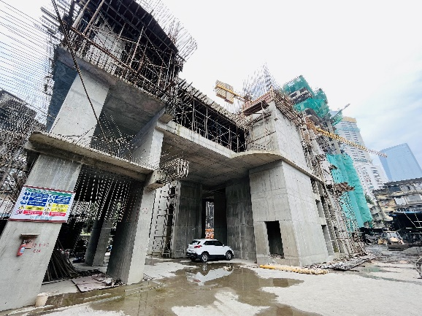
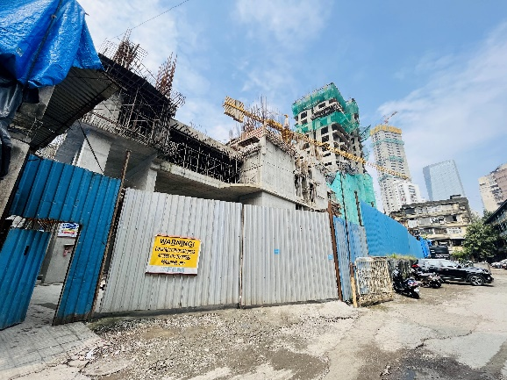
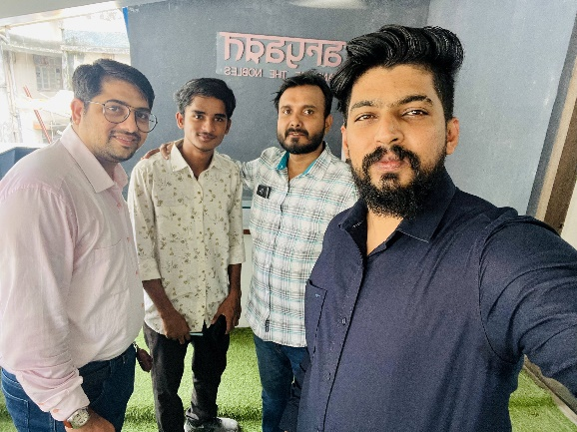
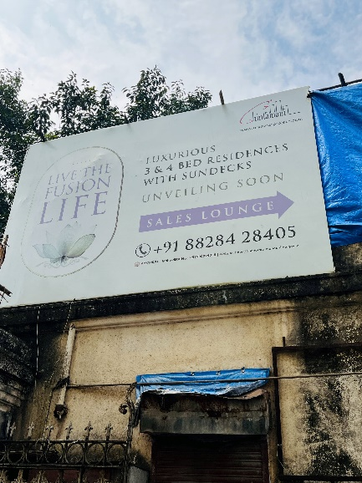
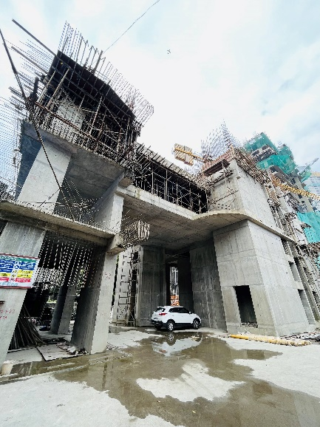
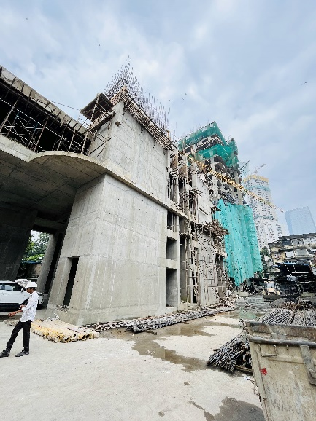
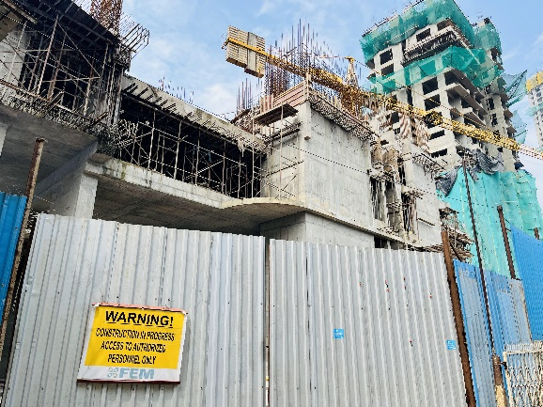
Actual Site Photographs of Wing A as on 13.10.2022
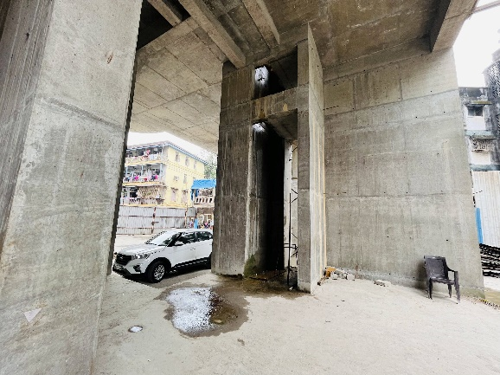
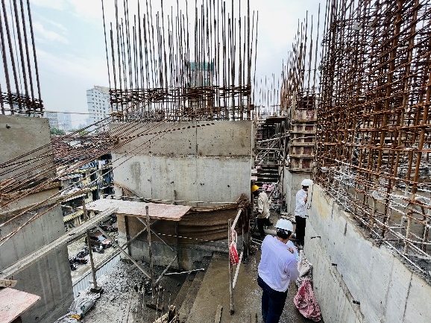
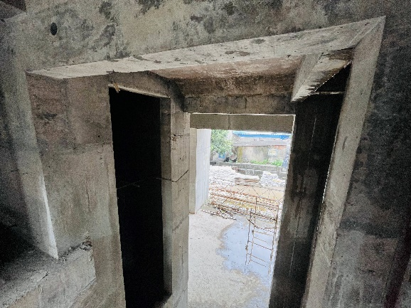
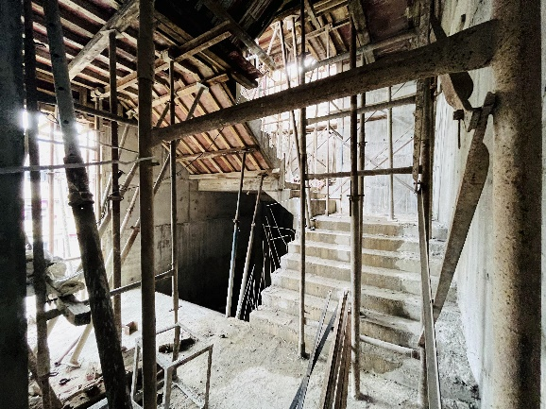
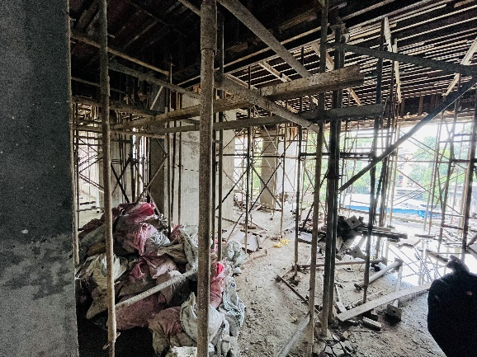
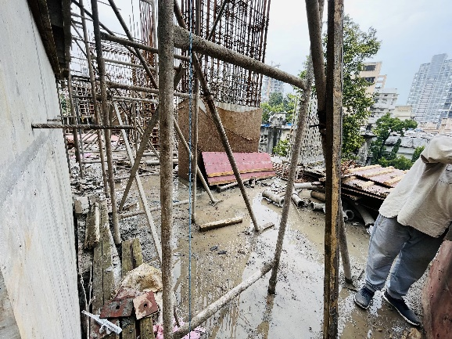
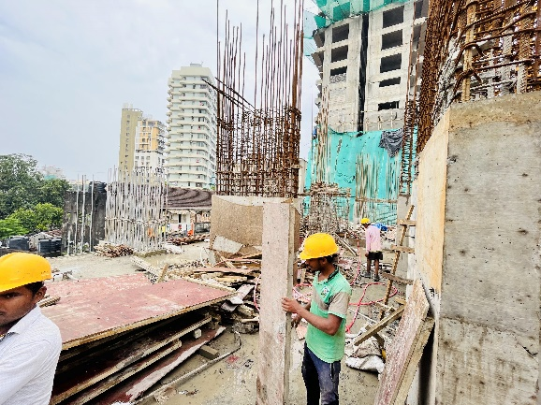
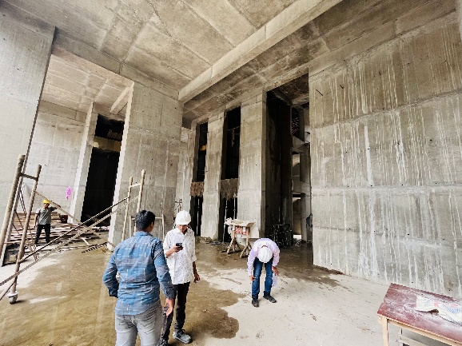
Actual Site Photographs of Wing B as on 13.10.2022
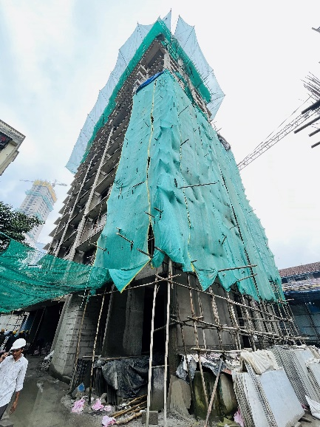
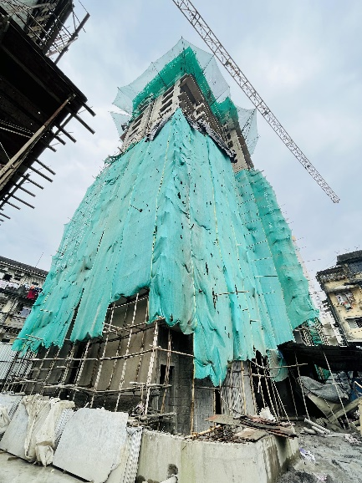
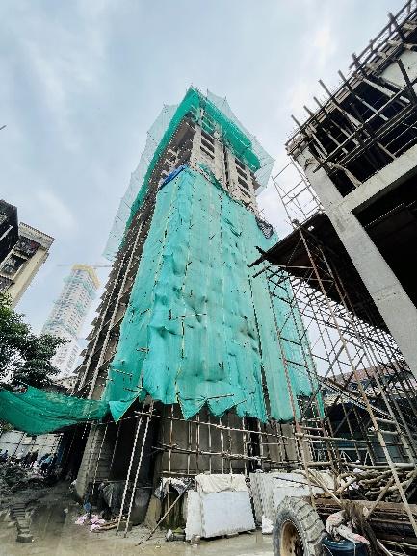
.
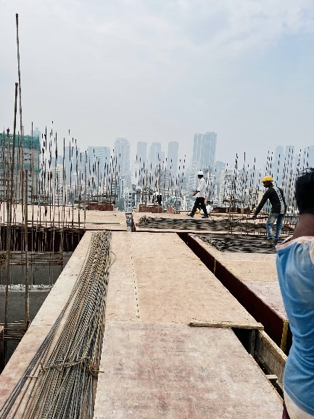
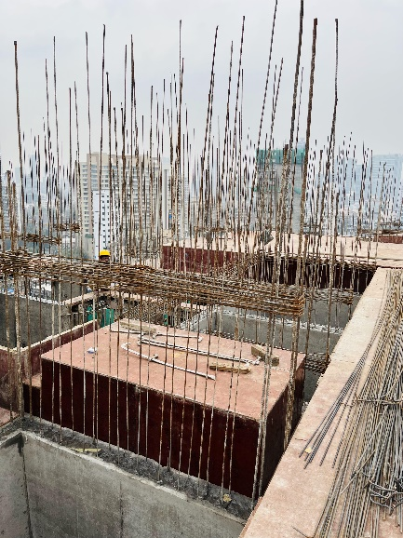
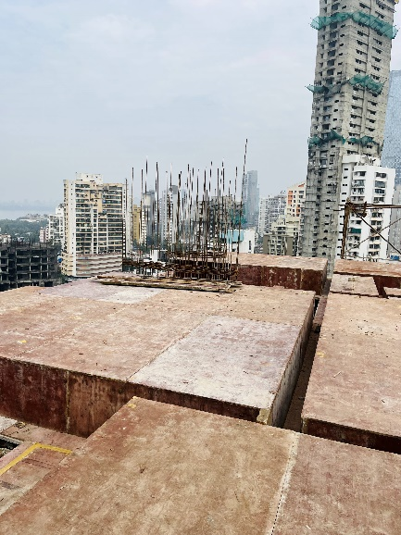
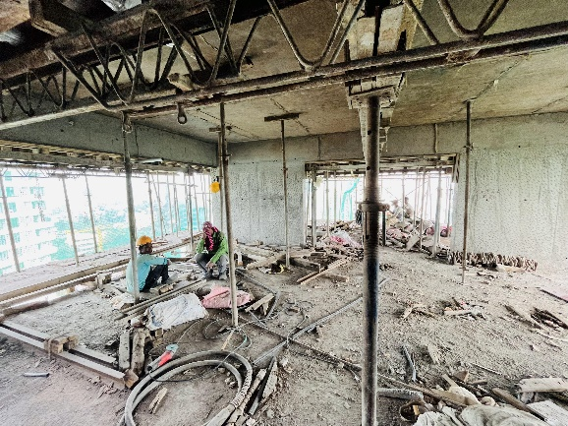
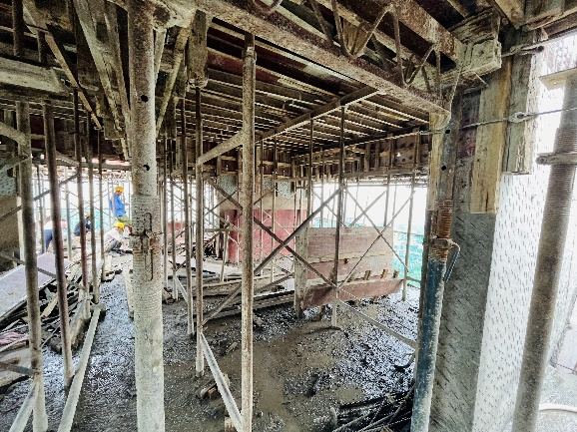
Actual Site Photographs of Wing B as on 13.10.2022
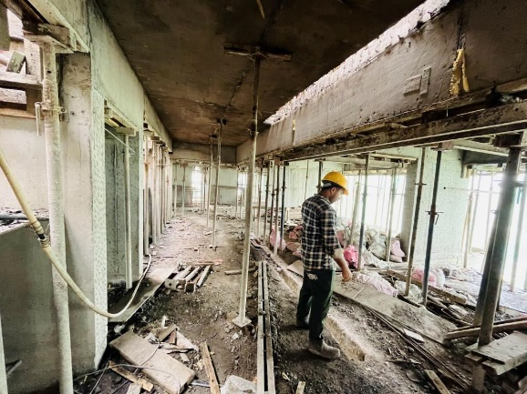
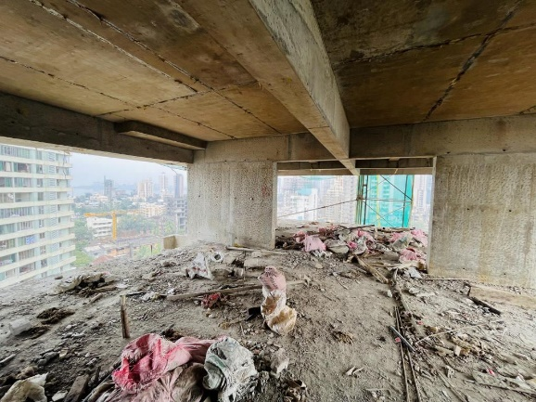

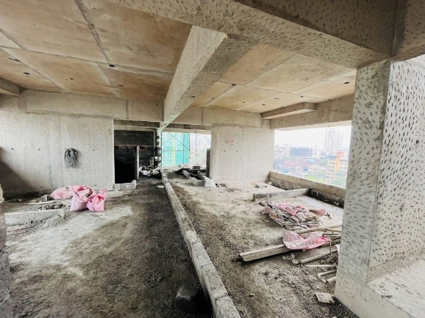
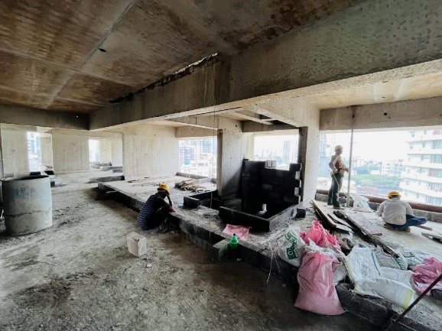
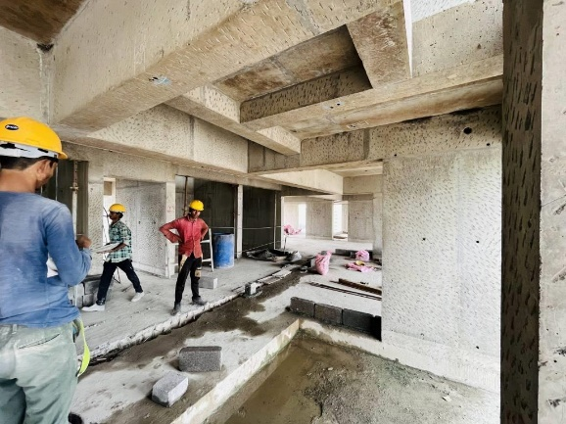
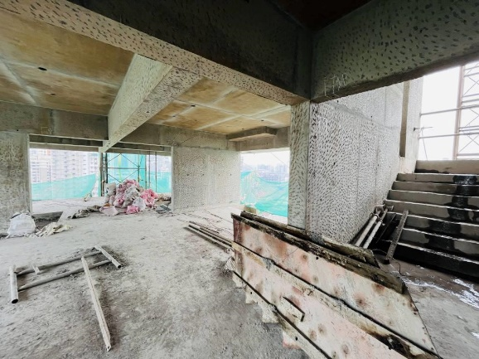
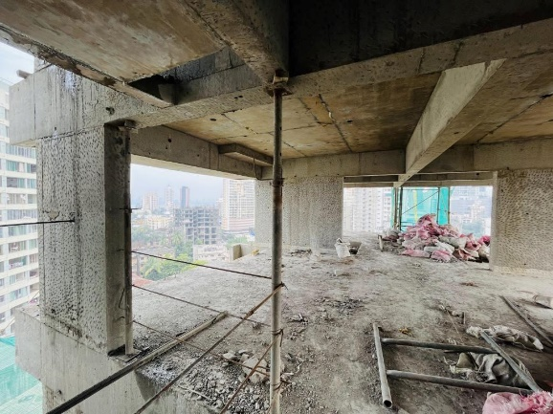
Actual Site Photographs of Wing B as on 13.10.2022
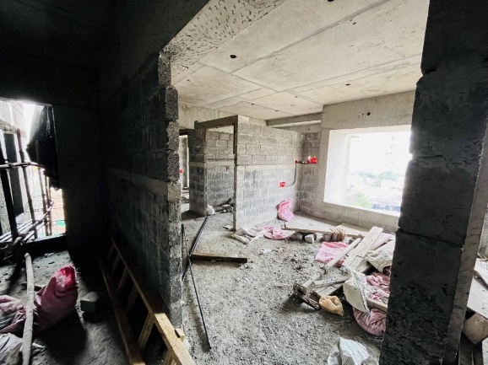
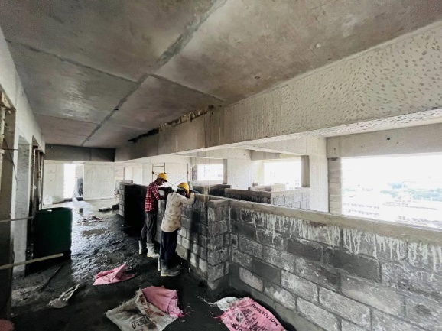
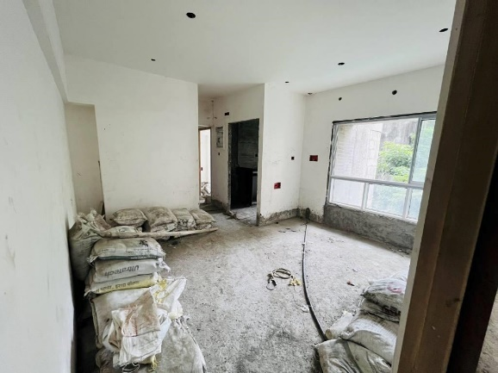
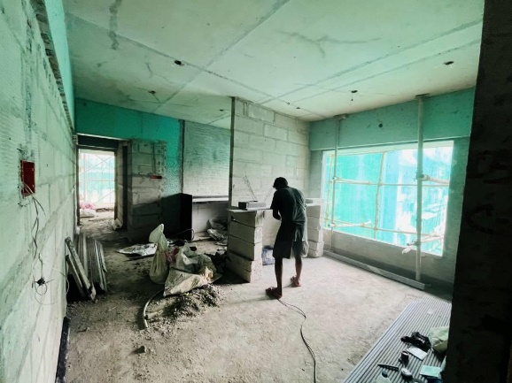
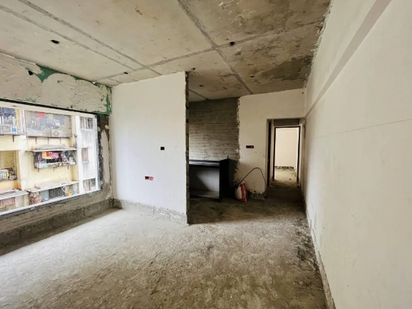
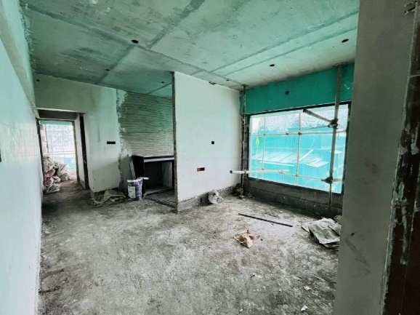
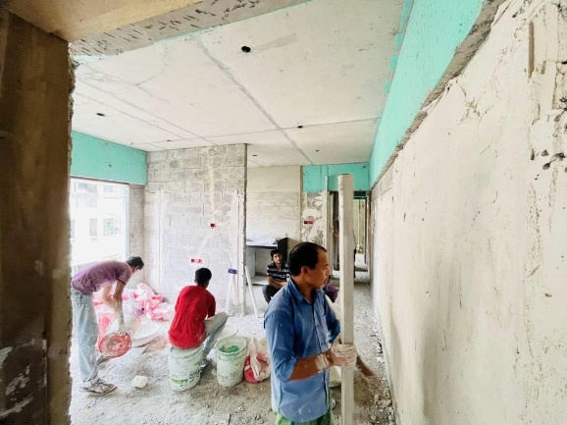
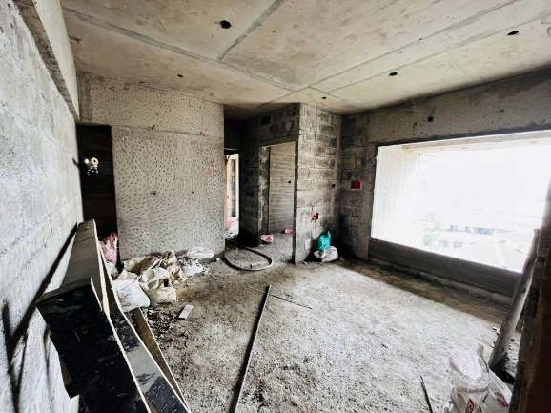
Actual Site Photographs of Wing B as on 13.10.2022
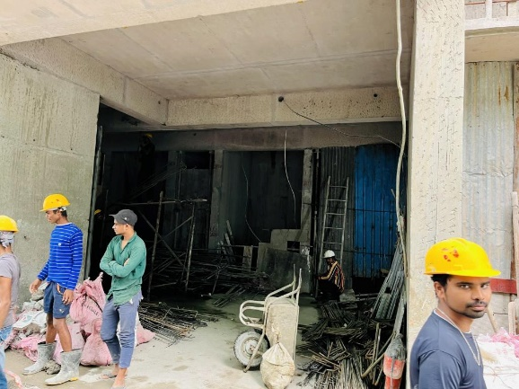
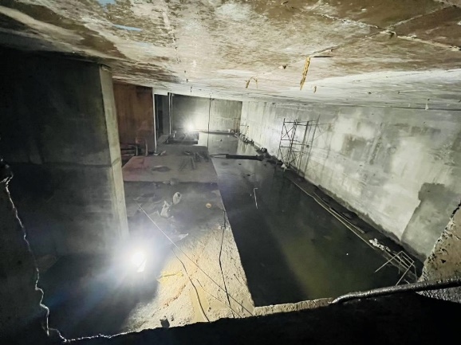
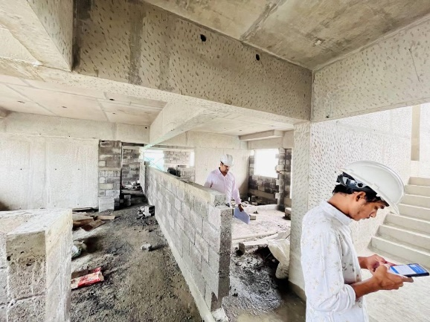
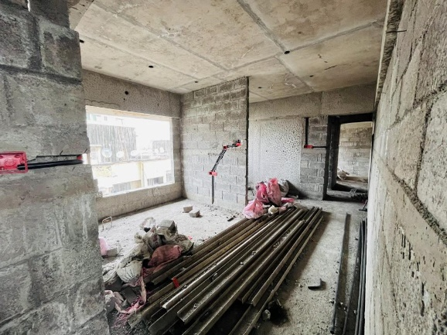
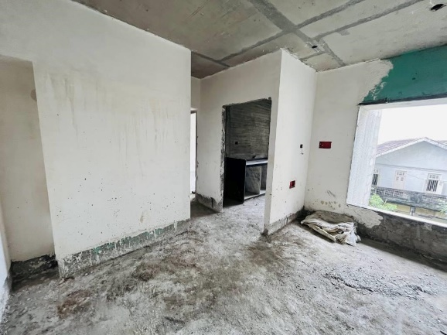
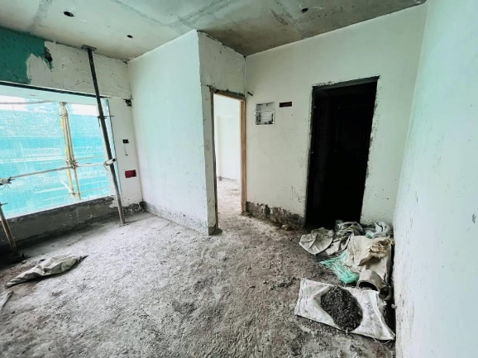
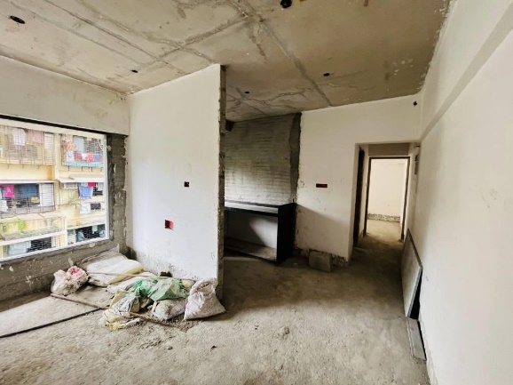
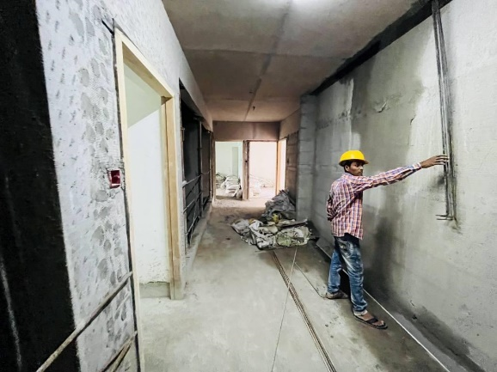
Route Map of the property
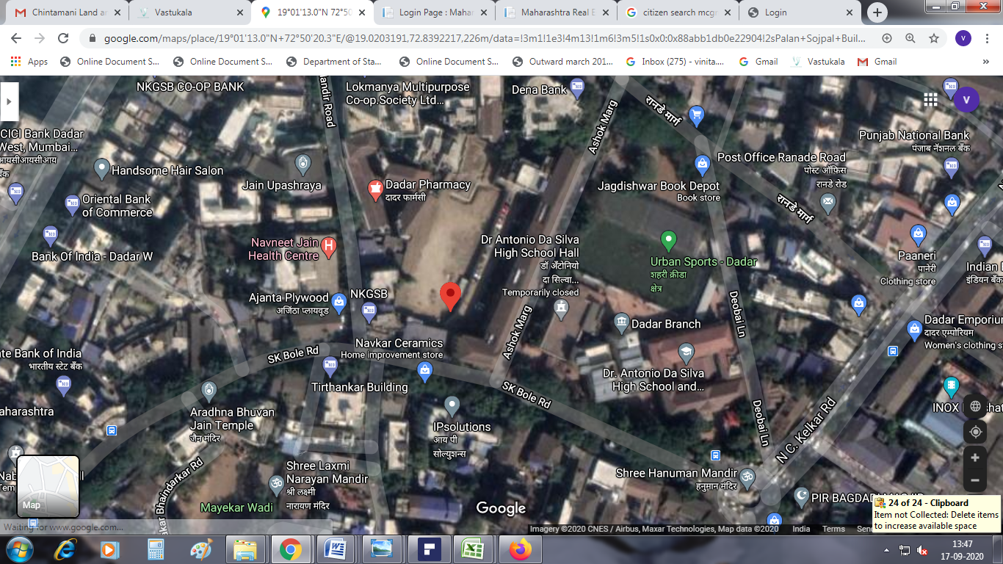
Site u/r

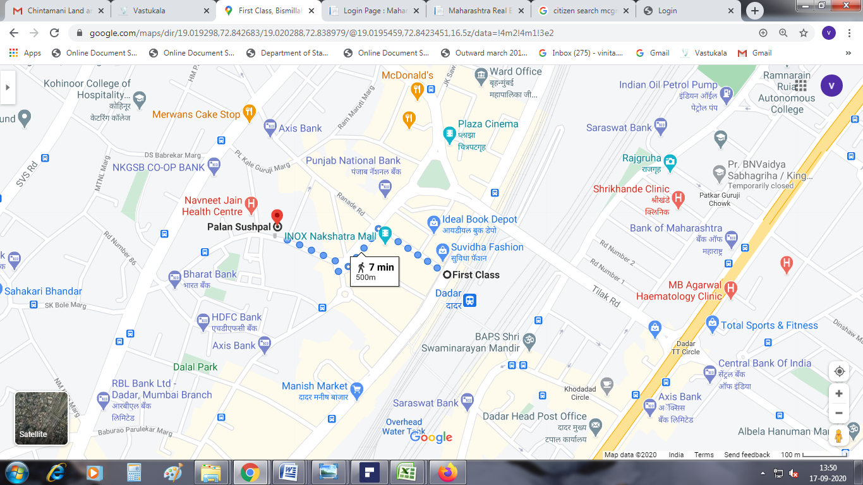

Latitude Longitude: 19°01'13.0"N 72°50'20.3"E

Note: The Blue line shows the route to site from nearest railway station (Dadar Station –500 M.)
Chartered Accountant (FORM 3) Certificate dated 18.10.2022.
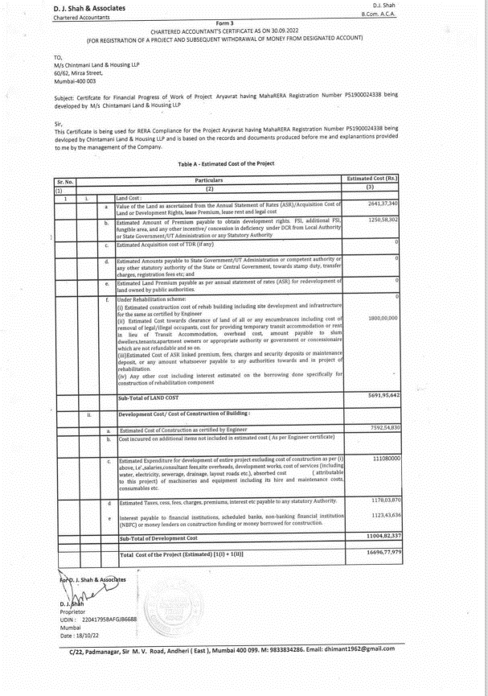

Chartered Accountant (FORM 3) Certificate dated 18.10.2022.
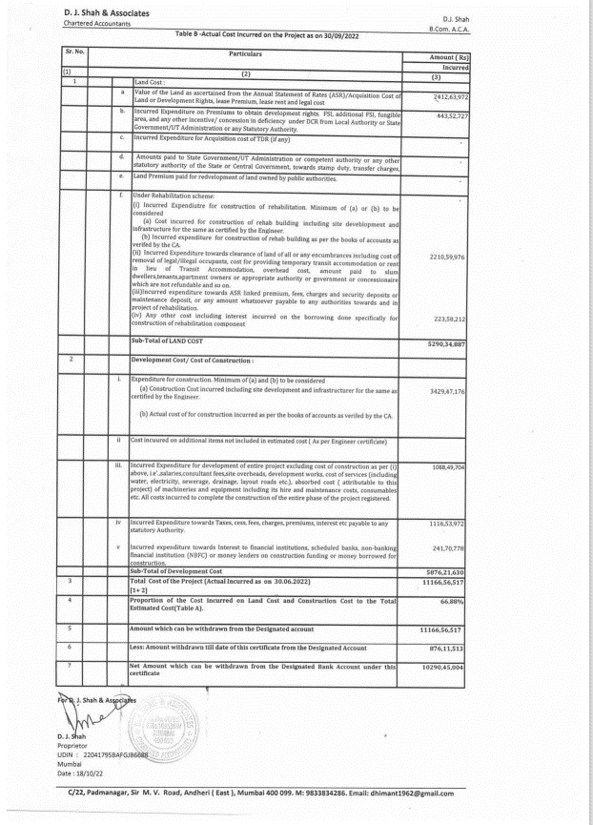

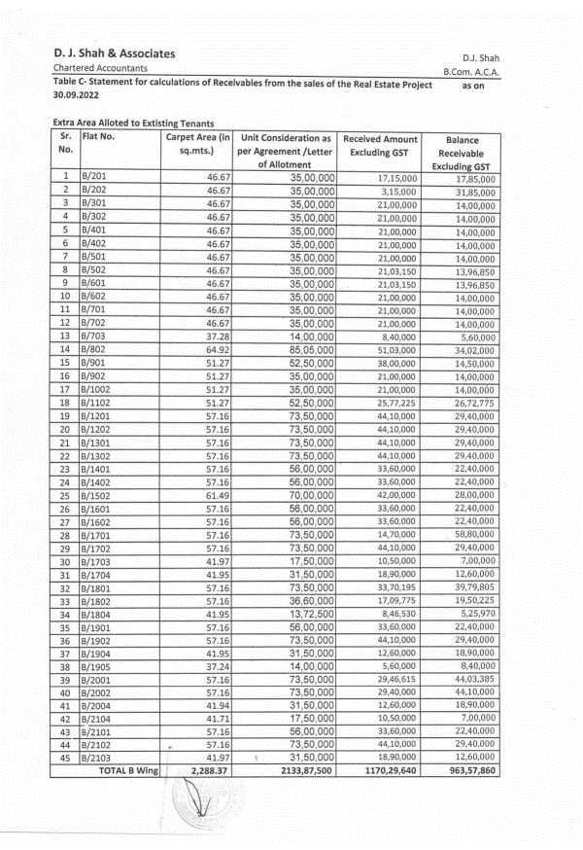
Chartered Accountant (FORM 3) Certificate dated 18.10.2022.

Chartered Accountant (FORM 3) Certificate dated 18.10.2022.
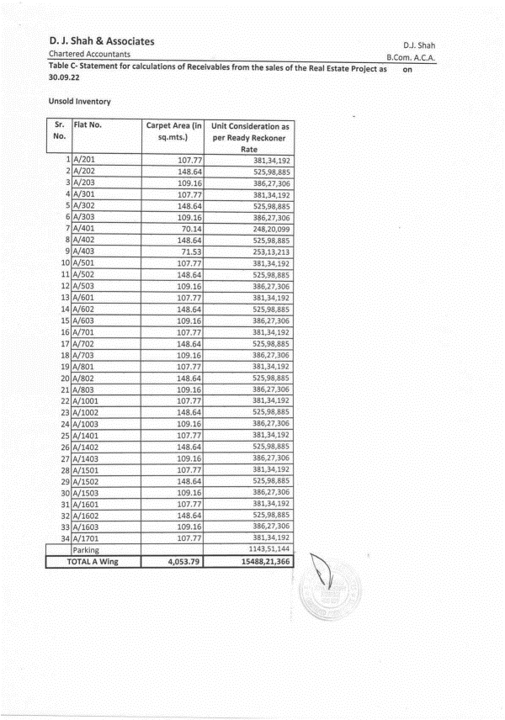

Chartered Accountant (FORM 3) Certificate dated 18.10.2022.
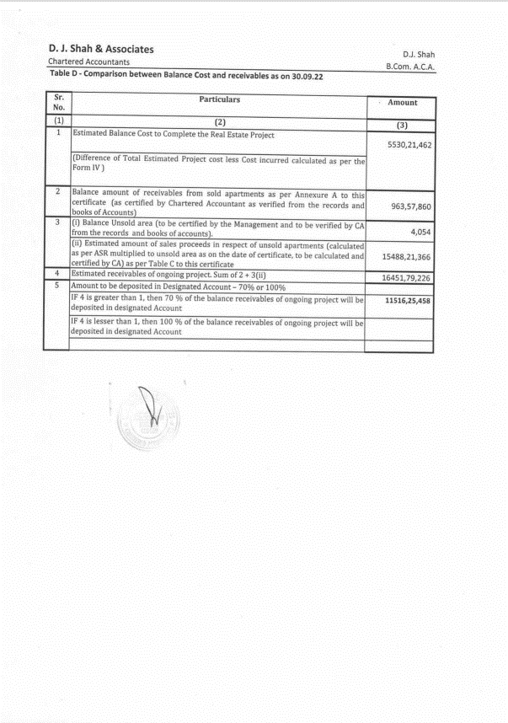

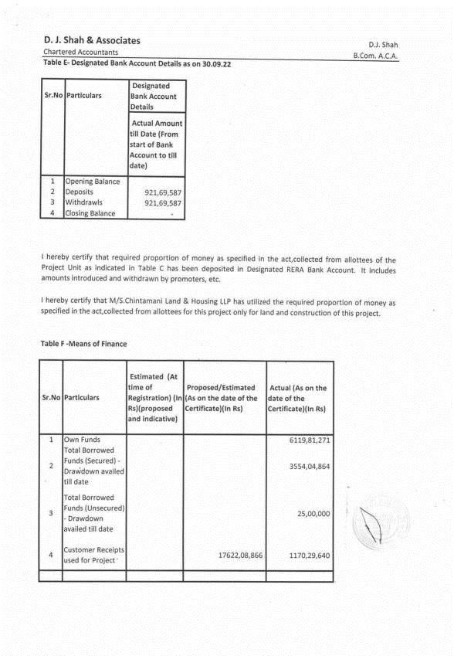
Chartered Accountant (FORM 3) Certificate dated 18.10.2022.

Chartered Accountant (FORM 3) Certificate dated 18.10.2022.
